A000-Mex-Taino-Duho

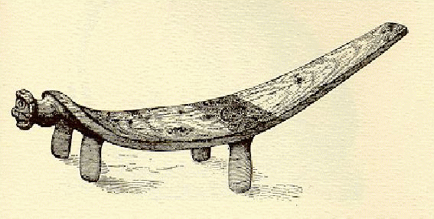

The Dujo is the sacred ceremonial stool of a chieftain. At its front is the head of Chieftain Guayaba, lord of Coabey, the underworld, where reside the ancestral dead.

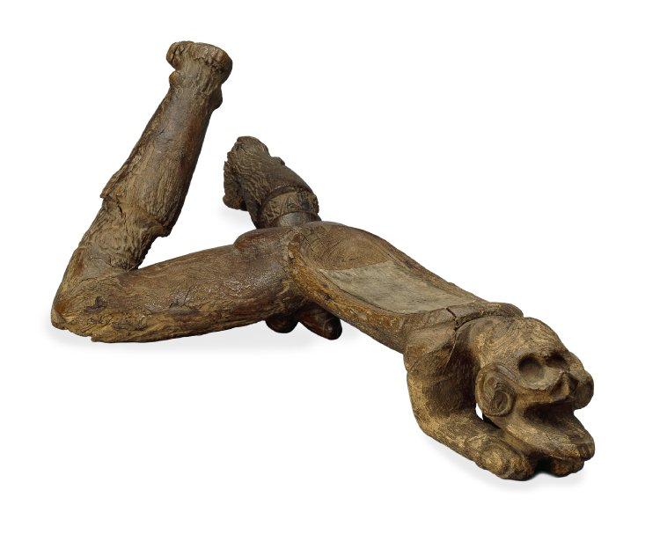

### • Museum number

Am.9753

### • Description

Duho or platter made of wood featuring an ithyphallic male figure.

### • Culture/period

* [Taino (Chican Ostionoid)](http://www.britishmuseum.org/research/collection_online/search.aspx?matcult=7956) [term details](http://www.britishmuseum.org/research/search_the_collection_database/term_details.aspx?scopeType=matcult&scopeId=7956)

### • Date

* 1297-1405 (Calibrated radiocarbon dates)

### • Findspot

* [Excavated/Findspot: Puerto Plata, Isabella (?)](http://www.britishmuseum.org/research/collection_online/search.aspx?place=11287&plaA=11287-3-1)
* (Americas,Caribbean,Greater Antilles,Hispaniola,Dominican Republic,Puerto Plata)

### • Materials

* [wood](http://www.britishmuseum.org/research/collection_online/search.aspx?material=17523)

### • Dimensions

* Height: 21 centimetres
* Width: 29.5 centimetres
* Depth: 72 centimetres

• See Christy correspondence (presumably to A W Franks):  
(1) Letter, Capt. Melfort Campbell, 3 Feby - Some short time ago I presented Mr Webb of Newstead Abbey with an Indian or Carib Idol found at S. Domingo in a Cavern formerly frequented by the old Inhabitants of this place, but as the idol in question is of a somewhat indecent nature, Mr Webb does not for propriety's sake exhibit it in his Museum, and is therefore anxious to get rid of this 'White Elephant', Would the idol be useful for the Museum under your care? It is this sort of thing (from memory at least) [sketch] made of lignum vitae, worm eaten and I have the British Consuls Certificate about its being found....'  
(2) Letter, Capt Melfort Campbell, 3 March 1876 - Indian Idol has been sent to BM, now enclose 'papers authenticating the genuineness of the said idol'  
(3) Certificate: Porto Plata, Santo Domingo. This is to Certify that the Carving now forwarded and presented by General Segunda Imbert was found in a Cave at Isabella about 30 Miles from Porto Plata Santo Domingo. Supposed to have been made about the year 1370. - The wood is Lignum vitae. The Cave was Inhabited by Indians before Columbus discovered the Island. Theodore Farrington, British Consul.  
(4) Letter to Melfort Campbell, President of Turks Island from General Imbert, Grand Turk May 1870 - in Spanish, with English translation:  
I have the pleasure to remit to your Honor the 'Indian Idol' together with its corresponding Certificate, praying that your Honor will accept the same as a curiosity from my unfortunate country (Though deserving a better fate.)McEwan 2009  
The consequences of inhaling hallucinogenic snuff are explicitly represented in this crouching male "cemi" (spirit being). The unusual view of the underside reveals the skeletal ribcage and prominent sexual organ that embodies the potent masculinity of a founding male ancestor. His toes are tightly bunched and he holds his clenched fists clasped to his face in a rigid, contorted posture typical of someone in the grip of a powerful hallucinatory trance. The exaggerated calf muscles shown on this and other male sculptures were produced by tightly bound ligatures designed to enhance their hardness and visibility. The elongated head is also the result of binding to achieve aesthetic ideals. The object was carefully shaped to serve as a low stool or perhaps doubled as a neck-rest.

[Less](http://www.britishmuseum.org/#see-more)

### • Bibliography

* McEwan 2009 p. 119 [bibliographic details](http://www.britishmuseum.org/research/search_the_collection_database/term_details.aspx?bibId=7049)

### • Location

Not on display

### • Exhibition history

Exhibited:

2008, Apr-Sept, Barcelona, Museo Barbier-Mueller D'Art Precolombi, 'Caribbean Before Columbus'  
2008 Sept -2009 Jan, Santiago de Compostela, Fundacion Caixa Galiciade, 'Caribbean Before Columbus'  
2009, Jan-Apr, Madrid, Museo de America, 'Caribbean Before Columbus'

2012 10 Apr-29 Jul, Quai Branly, Paris; Masters of Chaos   
2012 31 Aug-02 Dec, Kunst-und Austellunghalle de Bunderrespublik, Bonn; Masters of Chaos  
2013 31 Jan-19 May, Fundació la Caixa, Madrid; Masters of Chaos

### • Acquisition name

* [Collected by: Gen Imbert](http://www.britishmuseum.org/research/collection_online/search.aspx?people=38721&peoA=38721-3-7) [biography](http://www.britishmuseum.org/research/search_the_collection_database/term_details.aspx?bioId=38721)
* [Donated by: Alexander Augustus Melfort Campbell](http://www.britishmuseum.org/research/collection_online/search.aspx?people=41051&peoA=41051-3-9) [biography](http://www.britishmuseum.org/research/search_the_collection_database/term_details.aspx?bioId=41051)

### • Acquisition date

1876

The seat is made from the dense hardwood called [Lignum vitae](https://en.wikipedia.org/wiki/Lignum_vitae). In this case the Lignum vitae is from the [*Guaiacum officinale*](https://en.wikipedia.org/wiki/Guaiacum_officinale) tree.[[1]](https://en.wikipedia.org/wiki/Taino_Ritual_Seat#cite_note-bm-1) This tree's flowers are the national flower of [Jamaica](https://en.wikipedia.org/wiki/Jamaica).[[2]](https://en.wikipedia.org/wiki/Taino_Ritual_Seat#cite_note-2) The small chair is made in the form of a man on all fours. The head is decorated with gold and the figure is carved with male genitals underneath.[[3]](https://en.wikipedia.org/wiki/Taino_Ritual_Seat#cite_note-3)

**Importance**

Duhos are carved seats found in the houses of Taino caciques or [chiefs](https://en.wikipedia.org/wiki/Paramount_chief) throughout the [Caribbean](https://en.wikipedia.org/wiki/Caribbean) region. Duhos “figured prominently in the maintenance of Taino political and ideological systems . . . [and were] . . . literally seats of power, prestige, and ritual.” Duhos made of wood and stone have both been found, though those made of wood tend not to last as well as the stone chairs and are, therefore, much rarer.[[4]](https://en.wikipedia.org/wiki/Taino_Ritual_Seat#cite_note-4) This seat is one of two Taíno seats called *Duho* in the British Museum that were originally found on the island of [Hispaniola](https://en.wikipedia.org/wiki/Hispaniola). The other is also modelled anthropomorphically on a man, but in that case the resemblance to a man on his stomach is more proportional.[[5]](https://en.wikipedia.org/wiki/Taino_Ritual_Seat#cite_note-timeline-5)[[6]](https://en.wikipedia.org/wiki/Taino_Ritual_Seat#cite_note-6) There is another wooden duho in the collections of the [British Museum](https://en.wikipedia.org/wiki/British_Museum) that was found on the island of [Eleuthera](https://en.wikipedia.org/wiki/Eleuthera) in the [Bahamas](https://en.wikipedia.org/wiki/Bahamas).[[7]](https://en.wikipedia.org/wiki/Taino_Ritual_Seat#cite_note-7)

**Purpose**

Some of the first people that Christopher Columbus met in the American continent were the [Taino](https://en.wikipedia.org/wiki/Taino) people. Their 7,000-year-old civilisation did not benefit from pre-colonial contact as many were later enslaved or died of disease. It was noted by early explorers that some of their time the Taino people were using [hallucinogenic](https://en.wikipedia.org/wiki/Hallucinogenic) drugs. The drug and the [pipes](https://en.wikipedia.org/wiki/Smoking_pipe) that were used are called [cohoba](https://en.wikipedia.org/wiki/Cohoba). It is likely that one of these chiefs used this seat to smoke these drugs. The British Museum's seat has a bowl above the figures head, which may have been used to hold [cohoba](https://en.wikipedia.org/wiki/Cohoba) during rituals involving the [Zemi](https://en.wikipedia.org/wiki/Zemi) gods.[[8]](https://en.wikipedia.org/wiki/Taino_Ritual_Seat#cite_note-heil-8)

**History of the World**

This chair from the British Museum was chosen to be one of the [History of the World in 100 Objects](https://en.wikipedia.org/wiki/A_History_of_the_World_in_100_Objects) which was a series of radio programmes that started in 2010 and that were created in a partnership between the [BBC](https://en.wikipedia.org/wiki/BBC) and the British Museum.[[9]](https://en.wikipedia.org/wiki/Taino_Ritual_Seat#cite_note-ahotw-9)

**See also**

* [Zemi Figures from Vere, Jamaica](https://en.wikipedia.org/wiki/Zemi_Figures_from_Vere,_Jamaica)

**References**

|  |  |
| --- | --- |
| https://upload.wikimedia.org/wikipedia/en/thumb/4/4a/Commons-logo.svg/30px-Commons-logo.svg.png | Wikimedia Commons has media related to [***Taino Ritual Seat***](https://commons.wikimedia.org/wiki/Category:Taino_Ritual_Seat). |

• [Taino ritual seat](http://www.britishmuseum.org/explore/highlights/highlight_objects/aoa/t/taino_ritual_seat.aspx), British Museum, accessed 6 October 2010

• • [*"National Symbols"*](http://www.jis.gov.jm/special_sections/Independence/symbols.html)*. Emancipation & Independence. Jamaica Information Service. Retrieved 2010-10-07.*

• • British Museum Collection [[1]](http://www.britishmuseum.org/research/collection_online/collection_object_details.aspx?objectId=651811&partId=1&place=27462&plaA=27462-3-1&page=1)

• • Conrad, Geoffrey W., John W. Foster, and Charles D. Beeker, “Organic artifacts from the Manantial de la Aleta, Dominican Republic: preliminary observations and interpretations”, *Journal of Caribbean Archaeology*. 2:6, 2001.

• • [*"The Taíno of the West Indies"*](http://www.worldtimelines.org.uk/world/americas/central_meso/AD1000-1521/taino)*. World Tim Line. British Museum. Retrieved 7 October 2010.*

• • British Museum Collection [[2]](http://www.britishmuseum.org/research/collection_online/collection_object_details.aspx?objectId=664915&partId=1&place=11287&plaA=11287-3-1&page=1)

• • British Museum Collection [[3]](http://www.britishmuseum.org/research/collection_online/collection_object_details.aspx?objectId=659469&partId=1&place=9650&plaA=9650-3-2&page=1)

• • ["Deity Figure (Zemi) Dominican Republic; Taino (1979.206.380)"](http://www.metmuseum.org/toah/ho/08/canc/ho_1979.206.380.htm) In Heilbrunn Timeline of Art History. New York: The Metropolitan Museum of Art, 2000 October 2006; retrieved 22 September 2009

• [*Taíno Ritual Seat "Taíno Ritual Seat"*](http://www.bbc.co.uk/ahistoryoftheworld/objects/nknww6EoQO-nKTncBvhNbw) *Check |url= scheme (*[*help*](https://en.wikipedia.org/wiki/Help:CS1_errors#bad_url)*). BBC. Retrieved 11 October 2010.*

