AM,C-Taino-Celt-Types

# The Ceremonial Taino petaloid hatchet and its relation to the Maya hatchet god Kawil

* Posted by [Miguel Sobaoko Koromo Sague](http://indigenouscaribbean.ning.com/profile/MiguelSobaokoKoromosague) on August 2, 2008 at 11:54pm in [Archaeology of the Circum-Caribbean](http://indigenouscaribbean.ning.com/group/archaeologyofthecircumcaribbean)
* [Back to Archaeology of the Circum-Caribbean Discussions](http://indigenouscaribbean.ning.com/group/archaeologyofthecircumcaribbean/forum)

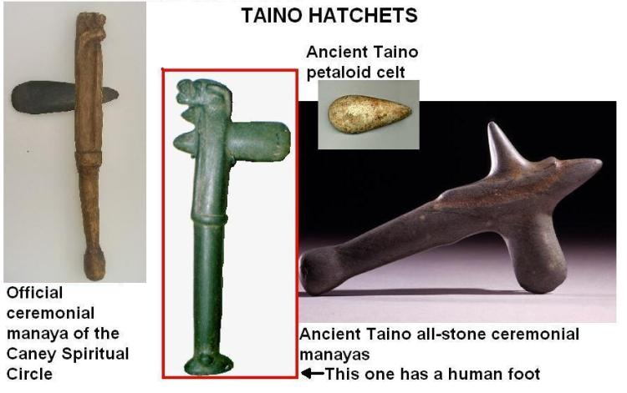

The Ceremonial Taino Petaloid Hatchet and its Relation to the Maya Hatchet God Kawil

Miguel A Sague Machiran

Caney Indigenous Spiritual Circle

The ancient Taino word for ceremonial hatchet is "manaya". These so-called "petaloid celt" hatchets are very common and get their archeological name "petaloid" because the actual tear-like stone blade is shaped like a flower petal. The petaloid hatchet blades have an interesting history in Cuba. In that island the Yoruba African people who were brought as   
slaves by the Spanish, often found these stones in the fields as they   
were working, and for reasons that until now seemed to elude me they   
identified them with thunder-bolts, and associated them with their   
Yoruba orisha-diety, Chango. In relation to this post I would like to point out that as in the case of all of the other Regla De Osha orisha-deities, Chango has special colors which are unique to him. His colors are red and white. He is portrayed as wearing a red and white crown and carries a double-headed red and white hatchet in one hand.   
  
Some time back I did a fairly thorough personal study of the Taino   
hatchets in all of their manifestations. Most of my study was done with the help of the book by the Cuban archeologist Rene Herrera Fritot, titled [Estudio De Las Hachas Antillanas](http://www.cubaarqueologica.org/document/fritot.pdf) The many images of Taino hatches in this book gave me access to a very wide assortment of these objects and allowed me the opportunity to compare the many manifestations in which they were modeled.   
  
As I mentioned earlier, most of these axes were created with a stone   
blade, carefully ground and polished to the shape of a smooth petal-   
shaped or tear-drop shaped celt. This blade was then fitted or hafted   
into a wooden handle to create the traditional Taino hatchet. On rare   
occasions a complete hatchet was fashioned out of one piece of stone,   
carefully shaped and polished to look like the original objects which   
in fact have a wooden handle.

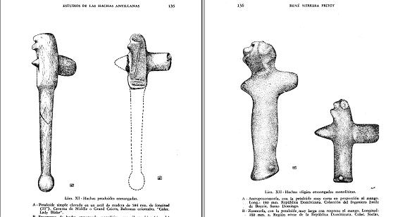

*illustrations from Fritot’s book

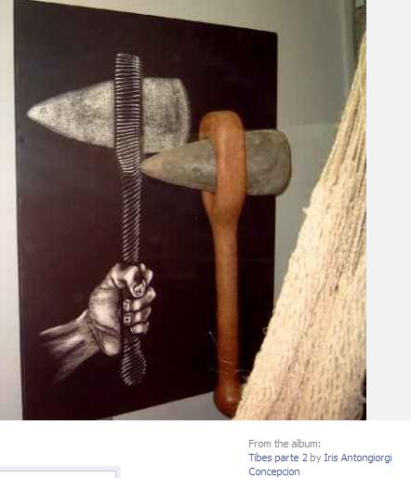

*Replica of a Taino petaloid ax housed at the Tibes Museum Ponce, Puerto Rico; photo by Iris Antogiorgi Concepcion

There seemed to be a tendency for the Taino craftsman to sometimes replace the original material that was traditionally used to create a ritual object with another material. Sometimes wood is replaced with stone. In the case of the manaya the wooden handle is replaced by a stone one rendering an object that is totally made of stone.  
I found one example of a beautifully crafted all-stone manaya in the   
pages of Fritot’s book. Curiously this particular piece had a   
carefully and skillfully shaped human foot complete with ankle bone protrusions carved at the end of the handle in place of the usual knob that you find there to keep the axe handle from flying out of the user's hand in the midst of work. It was as if the artist had an understanding of this object as being a living deity, like a cemi (Taino living deity image), and provided it with a foot as all cemies have.

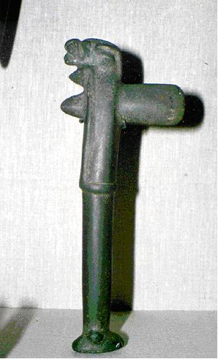

*illustration from Fritot’s book

It is obvious that these hatchets were considered to have   
spiritual significance because many of them have images of spirit   
beings attached to them, mostly at the top, the "head" of the hatchet.   
  
If one thinks of the hatchet as being a living sacred being, and you   
image it as having parts of a body in the same way that a human being   
has, then the bottom end of the handle (be it wooden or be it stone)   
would be the foot (and it's obvious that the Taino ancestors saw that   
part of the handle as a foot because of the example that I mentioned   
before with the carving of the foot at the bottom end). The top end   
would be the head and the petal-shaped blade would be assumed to be   
piercing this "head". I mention all of these facts because they play   
an important role in the more recent research that I have been doing   
lately in the field of Maya symbolism.

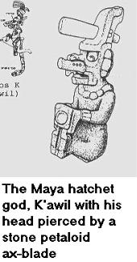

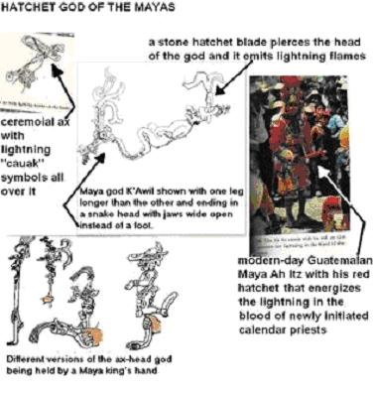

It turns out that the Classic era Maya, according to Schelle and Frew   
in their book [Maya Cosmos](http://www.amazon.com/gp/reader/0688140696/ref=sib_dp_pt) worshipped a special deity, known among scholars by the name “God K” now sometimes   
identified as [K'awil](http://www.famsi.org/research/alexander/godkceramic.pdf), who was imaged as a hatchet. He either had only   
one leg (which in a way was imaged as the handle of the tool) or he   
had two legs but one was a lot longer than the other (sometimes   
ending in a snake head instead of a foot) and he appeared to be   
spinning on his longer leg. This deity often was represented as   
having the stone blade of a hatchet piercing his forehead and   
oftentimes that blade was represented as a thunderbolt. Remember that   
the Yoruba slaves in Cuba associated the Taino stone hatchet blades   
that they found in the fields with thunderbolts of their orisha-deity   
Chango. It is possible that the Tainos who these Yorubas met when   
they were brought to Cuba instructed them as to a relationship   
between the hatchet and a Taino thunder spirit or storm spirit of   
some kind. This could be the reason that the Yorubas associated the   
stone axe-heads with Chango.   
  
The ancient Maya god K'awil was a deity associated with transformation. He seems to have been very strongly connected with the spiritual transition   
that a leader underwent at the moment when he assumed the authority   
of kingship. Oftentimes Classic Maya rulers would have themselves   
represented on carvings with a K'awil axe-blade piercing their   
forehead to symbolize a moment of deep personal transformation (for   
example on the day when the king would assume the throne). Oftentimes   
these stone celts sticking out of their foreheads would be shown   
smoking to represent that these were not ordinary axe-heads, they   
were fiery thunderbolt axe-heads.

In her publication [“God K on Maya Ceramic Vessels”](http://www.famsi.org/research/alexander/godkceramic.pdf) the scholar Helen Alexander introduces this entity and describes the identification of the so-called “God K” of Classic era Maya imagery with the Maya deity K’awil, and his association with the process of transformation in these words:

*“A study of these categories reveals the character of God K. He is the power behind*

*conjuring, transformation and transcendence in Maya ritual practice…. He is also the power of the Rain God’s lightning ax that splits the earth”*

and

*“God K, or* *K’awil, appears as part of a verbal phrase, usually ‘ch’am k’awil’ as on K2572,*

*or as the object of a verb as on K3150. One could object that in the verbal phrase ‘ch’am*

*K’awil’* *K’awil* *is actually the object of the verb,* *ch’am. While grammatically this may*

*be the case, I believe* *K’awil* *is part of the active verb just as the written hieroglyph for*

*the verb suggests in which the smoking* *K’awil* *mirror sits in the hand. One might*

*paraphrase it something like ‘grasping,* *k’awiling’. In the act of grasping* *K’awil, such as*

*a scepter, the lord is not only acting like* *K’awil, he is becoming* *K’awil. The whole sense*

*of the phrase is active.* *K’awil* *is not a passive receiver of the action. In addition, the*

*glyph for* *K’awil* *appears in conjuring scenes…”*

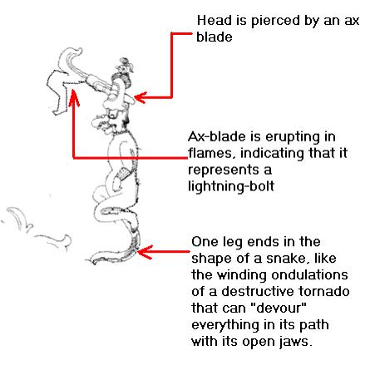  
The deity K'awil was represented as a human-like being (although with a strange nose) but he was also represented as a hand-held hatchet or a hatchet-like scepter, and as such the Maya drawings of these hatchets look exactly like the Taino hatchets. It is understood in the Maya symbology that the top of the hatchet is in fact the head of K'awil pierced by the petal-shaped stone thunder-   
bolt blade, while the bottom end is his one foot. Oftentimes the   
images of these hatchets are decorated with glyph designs   
called "cauak signs" These signs represent thunder. Nowadays the   
modern manifestation of this spirit is a character in modern Quiche   
Maya tradition called "Ah Itz" (loosely translated "Master of the   
sacred substance") This character is personified by a man in special   
regalia during traditional Mayan calendar ceremonies. His regalia   
includes red and white clothes, a red and white headress that looks very much like a crown and a red and white hatchet. His task during these ceremonies is to activate a special energy that the Quiches believe exists in their calendar day-keepers. This energy is referred to as "lightning in the blood". The Ah Itz   
walk around the crowd during the ceremonies touching the holy day-   
keepers and activating the lightning in their blood. The job of this character is obviously of a transformational nature, indicating the fundamental transition of the new day-keepers from the level of mere trainees to full-fledged practicioners.  
  
It is very probable that red and white were the colors already   
associated with the thunder spirit Chango when the Yoruba came over   
from Africa. But in light of the fact that red and white are also colors associated in Maya tradition with this thunder-ax entity, and in light of the fact that the ancient Maya and the ancient Tainos appear to have interchanged religious beliefs, it is, in my opinion, possible also that the African immigrants would have arrived at a conflation of the Taino stone hatchet with their own thunder spirit, Chango and his red-and-white color scheme, because the Tainos told them that they also used the bright red achiote paint   
called bija to represent thunder and transformation. It is possible   
that they told the Africans that the hatchet was a spirit in itself,   
a spirit of transformation related to the Maya K'awil, who, as I have already mentioned, appears to also sport a red-and-white color scheme. It seems evident that the Taino hatchet was a personified hatchet-shaped cemi, whose   
forehead was pierced by a thunder-blade just like the Maya spirit K’awil. Remember that there is now incontrovertible proof of physical cultural contact between the Tainos and the Mayas evidenced, among other things, by the discovery of a Taino manatee-bone vomic spatula at the Maya site of Altun Ha in Belize by a Canadian archeological team under the direction of [Royal Ontario Museum archeologist David Pendergast.](http://www.cubanet.org/CNews/y99/ago99/16e12.htm) It is also widely understood that many ancient Taino traditions survived in the African religious syncretism known as “Santeria” of later years.  
  
  
The Maya worshipped a spirit that they called "Hun-Rakan" and   
sometimes "Hurakan". For a long time I have attempted to discover   
what relationship, if any, this Maya spirit had with our own Taino storm spirit   
Hurakan. The fact that the Maya Hurakan also was associated with   
spinning storms such as tornadoes and hurricanes seems to be strong   
evidence that this spirit was shared in common by both the Tainos and   
the Mayas.   
The Mayas imaged the characteristics of Hurakan to be strongly associated   
to those of K'awil. That is why they associated K'awil's gyrating   
dance on his one foot with the turning, spiral of the tornado's lower   
tip and with the spinning motion of the hurricane. So in a way the   
Maya Hurakan was also seen as a spirit of transformation just like K’awil. There is also evidence that the spinning motion of the Big and Little Dipper constellations are likewise associated with the god Hun Rakan or Hurakan.  
  
I believe that the Taino hatchet was more than just a sacred   
ceremonial object or tool. I believe that it was perceived as a living cemi,   
a spirit of lightning and thunder in its own right just like the Maya   
hatchet spirit K'awil. I believe that the ancient Tainos imaged this   
spiritual being as a transforming character, who represented the power or the process that takes a person from one level of existence to another, changing that person, transforming that person, perhaps in an evolutionary manner much the same way in which an image of a Maya king holding the hatchet scepter of K’awil represented his transition from being a mere high-rank individual to accessing the exalted and divine position of KING.

In ancient Taino symbolism it is very probable that the act of grasping the decorative manaya, carved completely out of stone, was a sign of a kind of transition or transformation via which the kasike achieved an exalted level of authority, transmuting from mere human to a much higher level of importance at the moment of accession to the dujo throne. With this elevation one could assume also a higher level of ability. This ability could be expressed in the skill to manage the responsibility of authority. There is, in my opinion, no more important factor of a ruler’s ability or skill than the wisdom to rule well. Wisdom is most effectively achieved through experience.  
  
This is well in keeping with Caney Circle belief that the manaya is the tool   
of Guakar, the Taino spirit of harsh experience and the wisdom that is accessed through that experience, because I can not imagine a personal life-event more transformational than a moment of acquisition of experience-based wisdom through the fundamental process of trial and error.

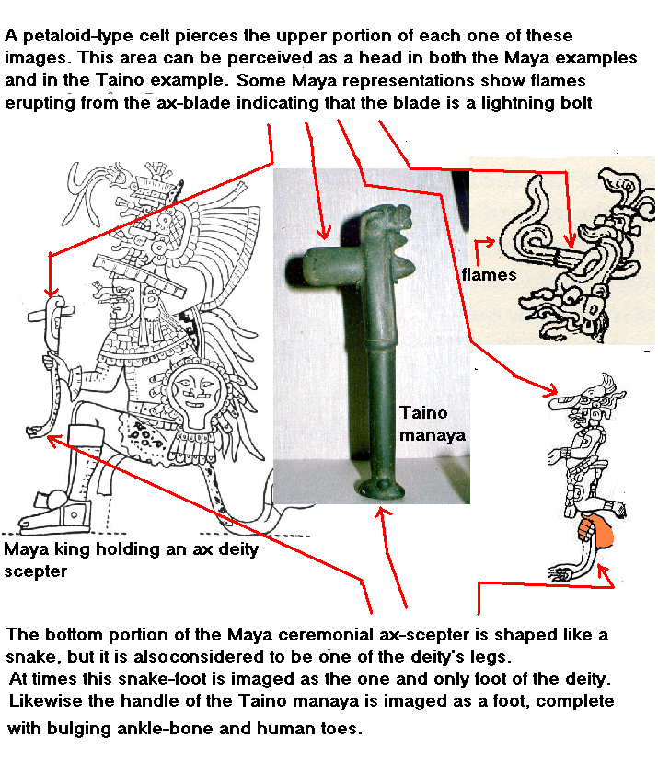

Hurakan, Guakar, the manaya hatchet, K'awil, God K, the manikin scepter, Ah Itz...These are all  
related spirits.  
  
* <http://www.ancientmexico.com/content/gods/bolondzacab.html>  
* <http://en.wikipedia.org/wiki/Tezcatlipoca>  
The Tezcatlipoca figure goes back to earlier Mesoamerican deities worshipped by the Olmec and Maya. Similarities exist with the patron deity of the K'iche' Maya as described in the Popol Vuh. A central figure of the Popol Vuh was the god Tohil whose name means "obsidian" and who was associated with sacrifice. Also the Classic Maya god of rulership and thunder known to modern Mayanists as "God K", or the "Manikin Scepter" and to the classic Maya as K'awil was depicted with a smoking obsidian knife in his forehead and one leg replaced with a snake.[6]  
  
* Carolyn Elaine Tate "Yaxchilan" p.94  
[http://books.google.com/books?id=4Yn_h2hKJZAC&pg=PA94&lpg=P...](http://books.google.com/books?id=4Yn_h2hKJZAC&pg=PA94&lpg=PA94&dq=maya+god+k+manikin+scepter&source=web&ots=iT8OaMSDKO&sig=Gn053HJbNbzr5WYW9BP-bXDLqeg&hl=en&sa=X&oi=book_result&resnum=1&ct=result)

Tags: [Caney](http://indigenouscaribbean.ning.com/group/archaeologyofthecircumcaribbean/forum/topic/listForTag?tag=Caney), [Freidle](http://indigenouscaribbean.ning.com/group/archaeologyofthecircumcaribbean/forum/topic/listForTag?tag=Freidle), [Indigenous](http://indigenouscaribbean.ning.com/group/archaeologyofthecircumcaribbean/forum/topic/listForTag?tag=Indigenous), [K](http://indigenouscaribbean.ning.com/group/archaeologyofthecircumcaribbean/forum/topic/listForTag?tag=K), [Kawil](http://indigenouscaribbean.ning.com/group/archaeologyofthecircumcaribbean/forum/topic/listForTag?tag=Kawil), [Maya](http://indigenouscaribbean.ning.com/group/archaeologyofthecircumcaribbean/forum/topic/listForTag?tag=Maya), [Schelle](http://indigenouscaribbean.ning.com/group/archaeologyofthecircumcaribbean/forum/topic/listForTag?tag=Schelle), [Spiritual](http://indigenouscaribbean.ning.com/group/archaeologyofthecircumcaribbean/forum/topic/listForTag?tag=Spiritual), [ax](http://indigenouscaribbean.ning.com/group/archaeologyofthecircumcaribbean/forum/topic/listForTag?tag=ax), [axe](http://indigenouscaribbean.ning.com/group/archaeologyofthecircumcaribbean/forum/topic/listForTag?tag=axe), [More…](http://indigenouscaribbean.ning.com/group/archaeologyofthecircumcaribbean/forum/topics/the-ceremonial-taino-petaloid)

[Share](http://indigenouscaribbean.ning.com/main/sharing/share?id=2030313%253ATopic%253A8138) [Facebook](http://www.facebook.com/share.php?u=http%3A%2F%2Findigenouscaribbean.ning.com%2Fgroup%2Farchaeologyofthecircumcaribbean%2Fforum%2Ftopics%2Fthe-ceremonial-taino-petaloid%3Fxg_source%3Dfacebookshare&t=)

Views: 2395

Attachments:

* [Rene fritot.pdf](http://indigenouscaribbean.ning.com/group/archaeologyofthecircumcaribbean/forum/attachment/download?id=2030313%3AUploadedFi58%3A8137), 3.7 MB

### Replies to This Discussion

[Permalink](http://indigenouscaribbean.ning.com/xn/detail/2030313:Comment:8393) Reply by [Frank AkuTurey(Sky Seer)](http://indigenouscaribbean.ning.com/group/archaeologyofthecircumcaribbean/forum/topic/listForContributor?user=2xr58glmrlf7k) on August 4, 2008 at 10:46pm

Thank you Beike!,I had just earlier read on my own about the vometic spatula(I have a real nice replica of one from P.R.circa 1,000 B.C.E.The red and white already was in use for Chango in Africa-and the red is for energy,fire,force,electricity...the white also for the light generated with that energy and the bolt that"splits the skies"...his axe however is made of wood and is double-headed;the stone celts are what is kept in a separate container.and BUT in Africa the celts are quite different in shape;obviously in Cuba,they indeed borrowed the shape of itfrom the Taino,and included the SIZE of the celt,as an adjunct to the altar set-up.Bo'Matum Beike.

[Permalink](http://indigenouscaribbean.ning.com/xn/detail/2030313:Comment:8400) Reply by [Miguel Sobaoko Koromo Sague](http://indigenouscaribbean.ning.com/group/archaeologyofthecircumcaribbean/forum/topic/listForContributor?user=eodd24ms3pli) on August 5, 2008 at 1:30am

Tau Brother  
I appreciate the clarification, datiao. I sense that these parallels between the two cultures i.e. an identification between axe heads and thunder; the association between the colors red/white and a male deity that controls lightning, these parallels and many others indicate a parallel spiritual enlightenment that both cultural complexes, the Yorubas in Africa and the Tainos and Mayas in tropical America arrived at independently. I am certain that this is what made it so easy and so natural for the cultures to merge in the Caribbean into what ethnologists call "synchretism". Bo Matun to you my datiao.

[Permalink](http://indigenouscaribbean.ning.com/xn/detail/2030313:Comment:56699) Reply by [Miguel Sobaoko Koromo Sague](http://indigenouscaribbean.ning.com/group/archaeologyofthecircumcaribbean/forum/topic/listForContributor?user=eodd24ms3pli) on January 2, 2011 at 1:35pm

I think that it is important to note that in Taino mythology the spirit Guakar, whose name means "Our Harsh Menstrual Cramps" is, in our opinion, a spirit of hardship and sacrifice, who personifies the painful experience that accompanies the process of "Trial and Error". It is generally accepted that it is through the process of trial and error and the experiencing of painful mistakes sometimes characterized as the "School of Hard Knocks" that humans learn to progress and prosper. We believe that the harsh cramps spirit personifies that process. We image him as one of the two twin sons of the Cosmic Earth and Water Mother Ata Bey, powerful and wielding a stone-blade manaya hatchet.

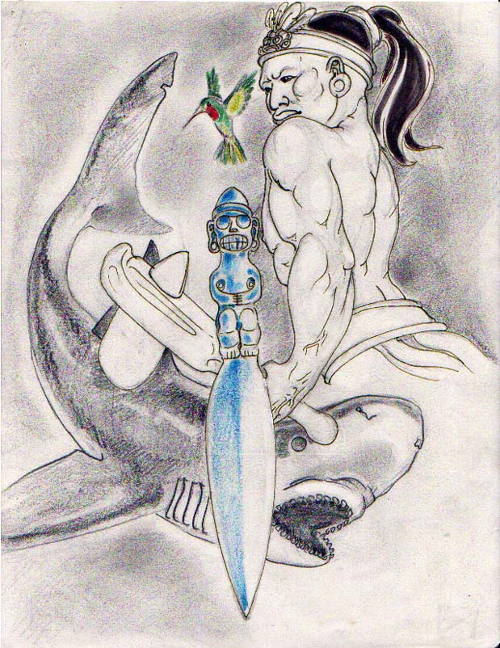

The original concept still exists here that no true transformation or significant transition to a higher form of being can take place without a form of painful sacrifice like the pains of birth. Wisdom, like any other higher level of being, can not be accessed without the pain of Trial and Error. In the same way as the ancient Mayas associated the king's accession with the sacrifice that the monarch himself had to endure before he could assume the throne, so in Taino tradition, the manaya symbolized the pain of Guakar which all humans must suffer before rising to the next level of personal evolution.

In the Caney Circle tradition we associate this entity with the manifestation of Ata Bey called GuaBanCex. This manifestation of the Cosmic Matriarch is less a nurturing mother and more a fierce matron whose attributes include the ability to unleash powerful and catastrophic natural forces such as hurricanes, but in Caney tradition also tornadoes, earthquakes, volcano eruptions and others.  The ancient Tainos described her as having two male attendants, ne of whom was the thunder spirit Guatauba, the drummer.

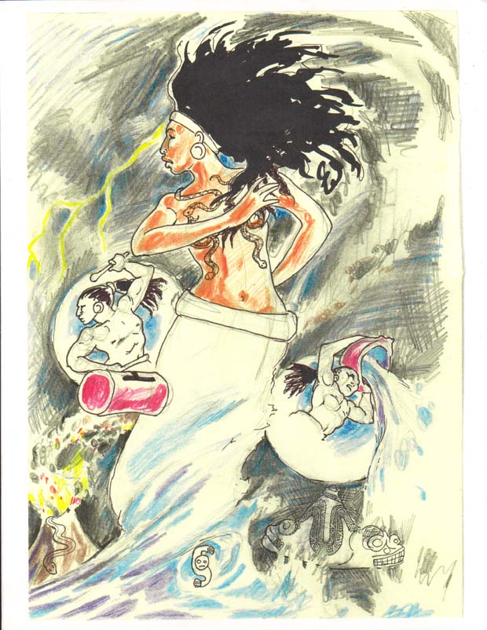

Identified with the breast-volcano serpent cemi, this entity appears as the enabler of Guakar, who after all, is her own son.

