DIS-AM,C-Mezcala-Figurine

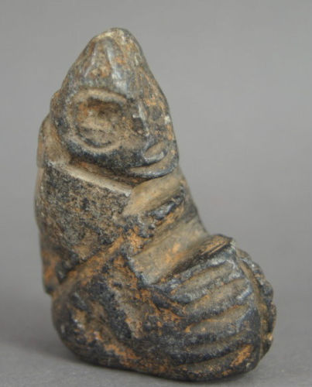 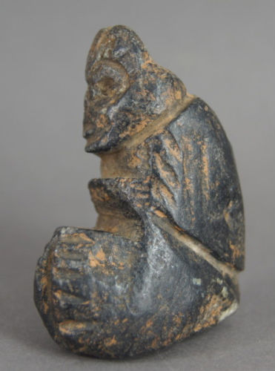 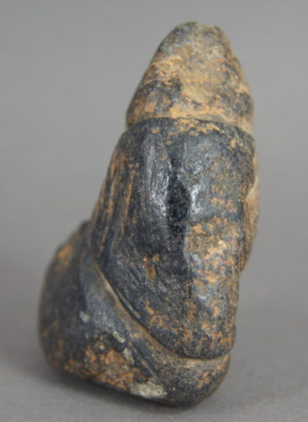 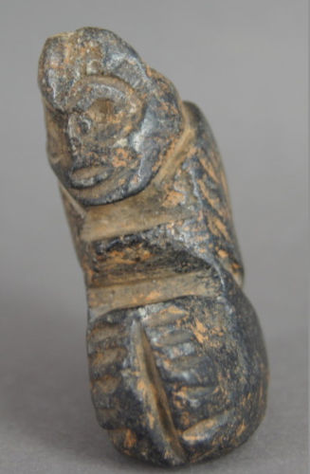

2.2 in tall

This was sold as being Taino but I believe it is Mezcala.

1 item sold by [alembix](http://www.ebay.com/usr/alembix?_trksid=p2057872.m2749.l2754)

|  |  |  |
| --- | --- | --- |
| [antique Taino Zemi small fetish,hardstone w/ patina caribbean area usa free ship](http://www.ebay.com/itm/172027939917?_trksid=p2057872.m2749.l2649&ssPageName=STRK%3AMEBIDX%3AIT)  ( 172027939917 )  Delivered on Thu, Mar 31  Tracking number: [**Tracking number**9405909699939817329418](javascript:;)  [Add note](javascript:;) | ITEM PRICE:  US $265.00 |  |

|  |  |
| --- | --- |
| ORDER DATEMar 28, 2016 | ORDER TOTAL  US $250.00  + US $60.00  shipping  **Order Taino Zemi Pre Columbian** [Leave feedback - ORDER DATE Mar 28, 2016](http://feedback.ebay.com/ws/eBayISAPI.dll?LeaveFeedbackShow&useridto=artetaino&transactID=0&item=152024056864&_trksid=p2057872.m2749.l2665)[View order details](http://payments.ebay.com/ws/eBayISAPI.dll?ViewPaymentStatus&transId=0&itemid=152024056864&_trksid=p2057872.m2749.l2673) - ORDER DATE Mar 28, 2016  [More actions - ORDER DATE Mar 28, 2016](http://www.ebay.com/myb/PurchaseHistory) |

1 item sold by [artetaino](http://www.ebay.com/usr/artetaino?_trksid=p2057872.m2749.l2754)