DIS-MEX-Jalisco-Warrior

Pre-Columbian Jalisco seated figure of a warrior, holding a staff or rain stick wearing a large crested helmet with protective cylindrical body armor, and with nearly 100 % of original red ochre banding pigment. H:  15-3/4″ Provenance, Ex: [PALMYRA HERITAGE](http://the-maac.com/gallery/palmyra-heritage)

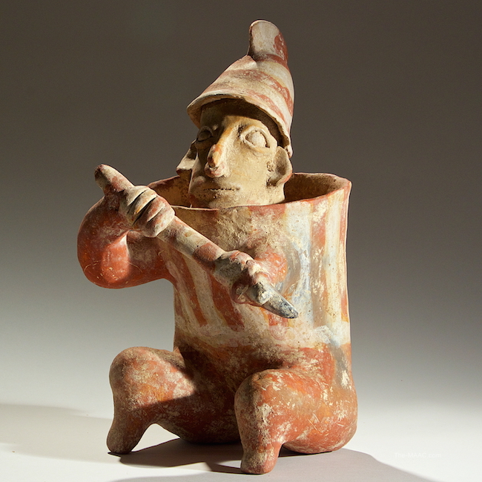

Pre-Columbian Jalisco Warrior in armor, characteristically holding a staff across its body. Pottery, West Mexico, 100 BCE Height: 15-3/4″ [Ex Palmyra Heritage: Gallery 16/212.319.1077].

This powerful figurine depicts a Jalisco warrior, a common subject in Jalisco pottery. The figure’s protective stance suggests that it was likely a tomb guardian, but its warrior aspect was metaphorically apotropaic or spiritually protective as it was placed within the tomb of a warrior to guard the tomb and its dead from evil intruders. Warriors occur in Mesoamerican funerary art as hand-fired figures, remarkable in their individuality, that the ancient artist invoked who sculptured them.

Pd 1400 USD, Est 3500.