AM,C-Taino-Cemis-Stone-Minature

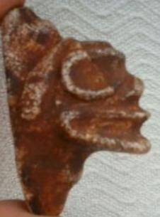 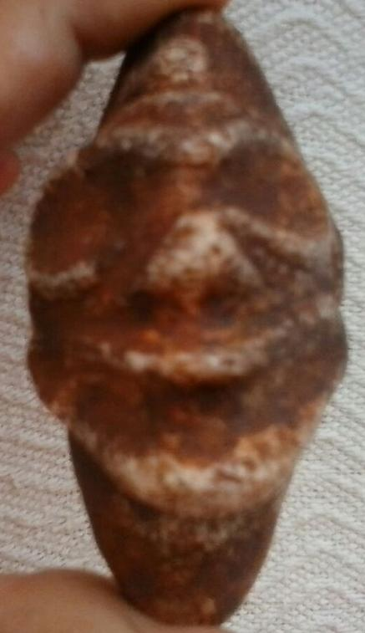

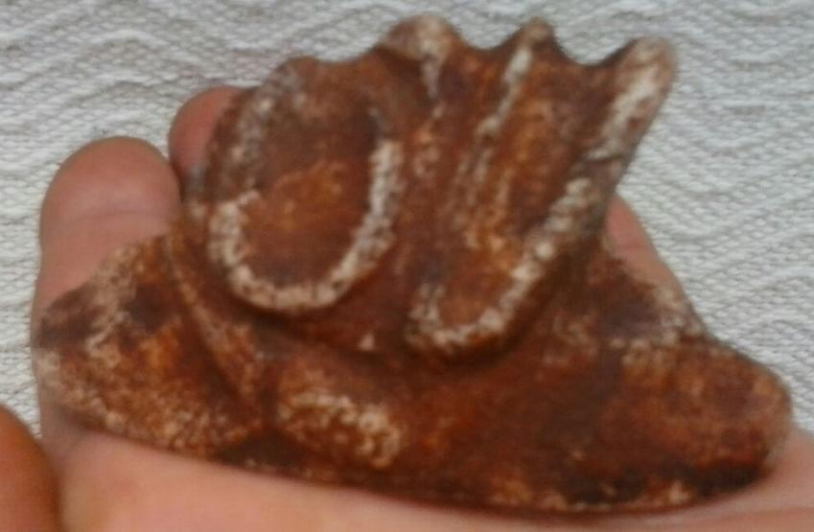

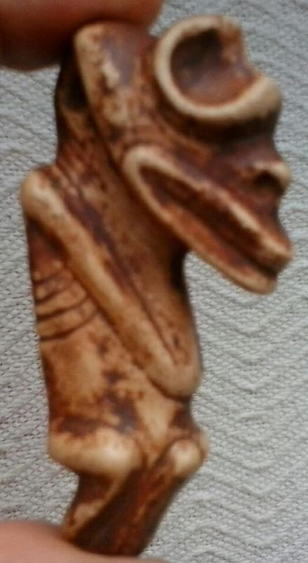 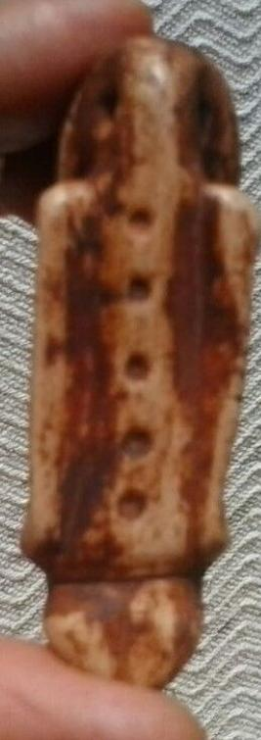

Sold by [miuarez](http://myworld.ebay.com/miuarez) ( [0](http://feedback.ebay.com/ws/eBayISAPI.dll?ViewFeedback&userid=miuarez) )

### Delivery package 1 of 1

Estimated delivery Wednesday, Mar 30, 2016 - Wednesday, Apr 6, 2016

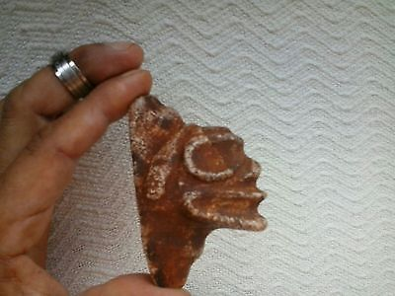

#### [Taino stone head Zemi Pre Columbian](http://www.ebay.com/itm/272167100010)

|  |  |
| --- | --- |
| Item price | $90.00 |
| Quantity | 1 |
| Item number | 272167100010 |
| Shipping service | Standard Shipping from outside US |

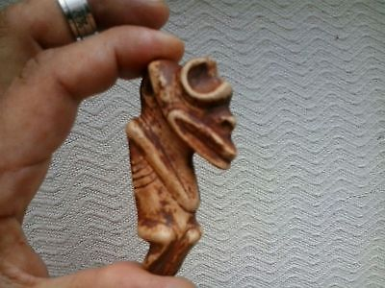

#### [Taino Large Stone Pendant Pre Columbian](http://www.ebay.com/itm/272167110573)

|  |  |
| --- | --- |
| Item price | $80.00 |
| Quantity | 1 |
| Item number | 272167110573 |
| Shipping service | Standard Shipping from outside US |