AM,C-Taino-Symbolism-RA

# Taino Cave Paintings

Centuries ago, man left his imprint on caves and rocks during his travels through his natural habitat. These imprints depicted his beliefs, religious rituals, social and political organizations, tools from everyday life, and even extinct plants and animal species. Fortunately, some have lasted until today. Thanks to the Taino heritage of art, we have insight into our past.

There are two classifications of cave art:  
Pictography: cave art represented with painted on colors.  
Petrography: cave art engraved or carved on rocks.

The aboriginal Tainos, using plants such as bixa (a concoction of seeds of this plant and vermilion used by the indigenes to daub their bodies), genipap, natural charcoal, animal fat, stone axes, conchs, and yautia juice demonstrated their ability to express their cosmic, mythological beliefs and culture.

The island of Hispanola, known by the aborigines as Babeque or Haiti possesses the largest and richest heritage of cave art in the Caribbean, and probably the most important collection in the Americas.

TainoGallery.com artisans have invested many years of study to insure the authenticity of their work. Each piece is hand made and painted, ensuring that no two are alike.

The entire process of digging the Earth, mixing to the right consistency, rolling, curing, shaping, carving, firing, painting and waxing are done on the premesis.

The symbols inscribed on each object carried a significance for the Taino people. Below is an overview of the these icons.

Join us in celebration of the magical expressions of the Tainos with your purchase of art featured here at [TainoGallery.com](http://www.tainogallery.com/).

## Taino Symbols

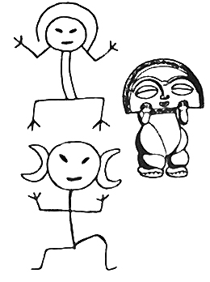

Moon: The moon rises from the cave of Mautiatibuel (son of the dawn or god of daybreak) at dusk, to which the moon returns when the sun rises.

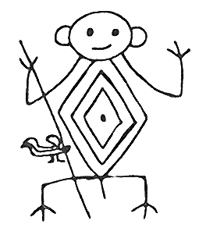

Hunter or Warrior: A person in charge of hunting for food for their Taino tribe. He was also the protector against the Caribe Indians.

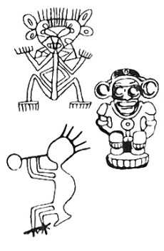

Shaman or Behique: A shaman who knew everything about plants, natural medicine, and herbs. He was also a priest and led the Cohoba and Batey religious rituals.

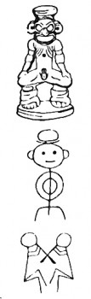

God of Cohoba: This god carried a plate on his head containing a powder that the Tainos inhaled during a magical religious ceremony causing hallucinations and enabling them to contact the gods. This was the Cohoba ritual, the most important ceremony for the Tainos.

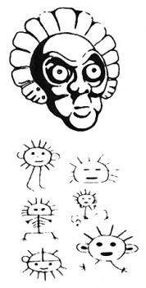

Anthropomorphous sun: The sun rises from the cave of Cacique Mautiatibuel (son of the dawn or god of daybreak) at dawn, to which the sun returns when the moon rises.

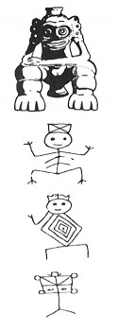

Anthropomorphous Cacique: The chief of a territory called a Cacicazgo. From his chair (dujo), he would serve as judge and administer justice. He scheduled all planting, harvesting and hunting activities. Since the tribe did not have a written language, he was also the historian who maintained the historical memory of the tribe known as the ‘Areito’, transmitted from generation to generation by songs and dances under a tree or on a batey.

Anthropomorphous ball-player: The ball game was very popular among the Tainos. It consisted of keeping the ball in the air by using one’s entire body except the hands. The balls were made of cupey tree resin.

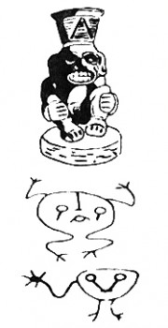

Boinayel: God of rain. Big tears flowed from his eyes and fell on the farmland to fertilize yuca plants and enable them to grow.

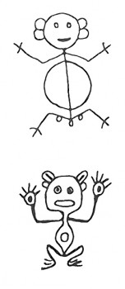

Toa: According to the mythology, the god Guahoyona, in order to avoid incest, abducted all the women of the island, leaving the kids alone with their fathers. In the evening the kids, starving, scream ‘toa, toa’ their cry to be breastfed. But their mothers were far away on Matimino Island (maybe present day Martinica or Women Island). They cried so long that they were transformed into frogs, toads and coquies.

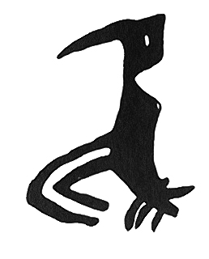

Inriri or Woodpecker: The Taino mythology tells that the god Guahoyona, in order to avoid incest, abducted all the women of the island leaving the men alone. The men were desperate to have sex, so they found some creatures. Then with the help of Dimivan Caracaracol (God of Scabbiness) they managed to trap these creatures, which were asexual. The woodpecker (Inriri) was charged with pecking a hole in these asexual creatures to recreate the female organ, so they could have sex again and avoid incest.

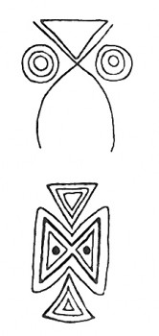

Owl: Taino mythology states that human life started in the Cacibajagua Cave. Since the owl lives in dark places, like caves, it was associated with the origin of life. Owl designs are also found on pots, bottles, or mashers.

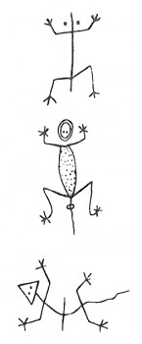

Iguanaboina: This is the mix of iguana, saurian, and the dark serpent, called Boina. It’s usually represented as humanized serpents or lizards. Boinayel, Boina’s son, represents the clouds full of water. The Iguana’s back represents sunny weather and the lizard represents the shining sun and calm weather.

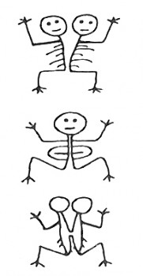

Twins or Siameses: They were born in the same painted cave as the sun (day) and the moon (night), so were the rain (Boinayel) and the drought (Marohu). The twins represent the vital forces of nature, the positive and the negative.

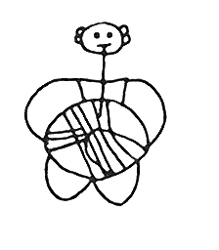

Atabey or Atabeyra: Mother of the clear spring water, also protector of women in labor. Represents the eternal, invisible, and supreme creator of everything. She is the Mother of Yucahu Vagua Maorocoti, which means white yuca, as powerful as the sea and the mountains.

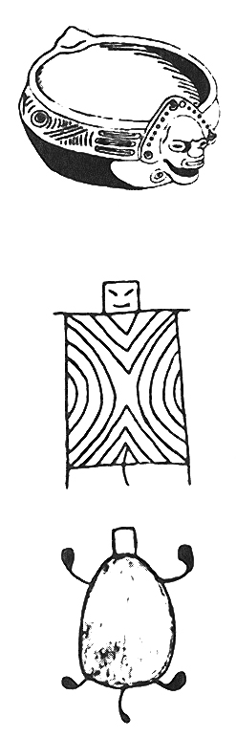

Caguama, Turtles or Tortoise: Mother of humankind, she is the representation of the fertilized uterus, origin of life, which started in the town of Arajuaco, her settlement. Arahuaco is between Columbia and Venezuela, along the Orinoco and Amazon Rivers, from which the Tainos originate. Caguama emerged from the swollen back of Dimivan Caracaracol after sputum was thrown on her back by Bayamanaco, he is the old spirit of fire, promoter of the origin of the mankind.

Bat: Taino mythology tells that life originated in a cave, called Cacibajagua, the same name given to the bat, which was associated with the origin of life. This figure is commonly found on mashers, pots, plates and amulets.

Areito Dancers: The Areito was a party, a song, a dance, and a rhythm, all at the same time. Since they had no written history, they passed it on from generation to generation through their dances and songs.

Masks: Through the masks, the Tainos perpetuated the most important faces of men and women from their tribes, and also from their mystic and real animals.

Fish: According to Taino mythology, when Yayael (son of Yaya - grand creator), died, his bones were kept inside a vase (made of the fig tree) in the ‘caney’ (Taino houses). One day, Dimivan Caracaracol and his brother broke the vase that held Yayael’s remains, and a host of fish and water poured out, creating the sea.

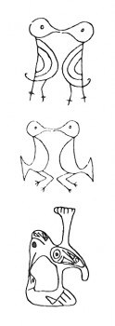

Eternal Lovers: Representation of two zoomorphic figures in a possible love scenes. In Taino society, private property didn’t exist and hunting, fishing and agriculture were for the benefit of the whole tribe. Possibly, the scene where the two zoomorphic figures share food lip-to-lip represents the solidarity, equality and fellowship as well as the fertility of motherhood.

Conch or Snail: Played an important role in the Taino’s everyday and religious life in:  
Origin of the form Yucaju Vagua Maorocoti (white yuca).  
Used as hallucinogen in the Cohoba ritual.  
Important source of nutrients for the Tainos’ diet.  
Instrument used to make wood canoes.  
As a decoration for the body, collars, beads and somageras.  
Principal communication device.