Arc-Lepidoptera

A common classification of the [Lepidoptera](https://en.wikipedia.org/wiki/Lepidoptera) involves their differentiation into [butterflies](https://en.wikipedia.org/wiki/Butterfly) and [moths](https://en.wikipedia.org/wiki/Moth). Butterflies are a natural [monophyletic](https://en.wikipedia.org/wiki/Monophyletic) group, often given the sub-order **Rhopalocera**, which includes [Papilionoidea](https://en.wikipedia.org/wiki/Papilionoidea) (true butterflies), [Hesperiidae](https://en.wikipedia.org/wiki/Hesperiidae) (skippers), and [Hedylidae](https://en.wikipedia.org/wiki/Hedylidae) (butterfly moths). In this taxonomic scheme moths belong to the sub-order **Heterocera**. Other taxonomic schemes have been proposed; the most common putting the butterflies into the sub-order [Ditrysia](https://en.wikipedia.org/wiki/Ditrysia) and then the "super-family" [Papilionoidea](https://en.wikipedia.org/wiki/Papilionoidea), and ignoring a classification for moths. None of the taxonomic schemes are perfect, however, and [taxonomists](https://en.wikipedia.org/wiki/Taxonomist) commonly argue over how to define the obvious differences between butterflies and moths.

While the butterflies form a [monophyletic](https://en.wikipedia.org/wiki/Monophyly) group, the moths, which comprise the rest of the Lepidoptera, do not. Many attempts have been made to group the superfamilies of the Lepidoptera into natural groups, most of which fail because one of the two groups is not monophyletic: Microlepidotera and Macrolepidoptera, Heterocera and Rhopalocera, Jugatae and Frenatae, Monotrysia and Ditrysia.[[1]](https://en.wikipedia.org/wiki/Comparison_of_butterflies_and_moths" \l "cite_note-scoble-1)

Although the rules for distinguishing these groups are not completely hard and fast, one very good guiding principle is that butterflies have thin antennae and (with one exception) have small balls or clubs at the end of their antennae. Moth antennae can be quite varied in appearance, but in particular lack the club end. The divisions are named by this principle: "club-antennae" (Rhopalocera) or "varied-antennae" (Heterocera).

The following families of Lepidoptera are usually considered butterflies:

* [Swallowtails](https://en.wikipedia.org/wiki/Swallowtail_butterfly) and [Birdwings](https://en.wikipedia.org/wiki/Birdwing), [Papilionidae](https://en.wikipedia.org/wiki/Papilionidae)
* [Whites](https://en.wikipedia.org/wiki/Pieridae) or Yellow-Whites, [Pieridae](https://en.wikipedia.org/wiki/Pieridae)
* [Blues and Coppers](https://en.wikipedia.org/wiki/Lycaenidae) or Gossamer-Winged Butterflies, [Lycaenidae](https://en.wikipedia.org/wiki/Lycaenidae)
* [Metalmark butterflies](https://en.wikipedia.org/wiki/Riodinidae), [Riodinidae](https://en.wikipedia.org/wiki/Riodinidae)
* [Brush-footed butterflies](https://en.wikipedia.org/wiki/Brush-footed_butterfly), [Nymphalidae](https://en.wikipedia.org/wiki/Nymphalidae) which contain the following 13 subfamilies:
  + the snout butterflies or [Libytheinae](https://en.wikipedia.org/wiki/Libytheinae) (formerly the [family](https://en.wikipedia.org/wiki/Family_(biology)) Libytheidae).
  + the Danaids or [Danainae](https://en.wikipedia.org/wiki/Danainae) (formerly the family Danaidae).
  + the [Tellervinae](https://en.wikipedia.org/w/index.php?title=Tellervinae&action=edit&redlink=1).
  + the glasswings or [Ithomiinae](https://en.wikipedia.org/wiki/Ithomiinae).
  + the [Calinaginae](https://en.wikipedia.org/wiki/Calinaginae).
  + the morphos and owls or [Morphinae](https://en.wikipedia.org/wiki/Morphinae) (including the owls as tribe Brassolini).
  + the Browns or [Satyrinae](https://en.wikipedia.org/wiki/Satyrinae) (formerly the family Satyridae).
  + the [Charaxinae](https://en.wikipedia.org/wiki/Charaxinae) (preponas and leaf butterflies).
  + the [Biblidinae](https://en.wikipedia.org/wiki/Biblidinae).
  + the [Apaturinae](https://en.wikipedia.org/wiki/Apaturinae).
  + the nymphs or [Nymphalinae](https://en.wikipedia.org/wiki/Nymphalinae).
  + the [Limenitidinae](https://en.wikipedia.org/wiki/Limenitidinae) (especially the adelphas) (formerly the family Limenitididae).
  + the tropical longwings or [Heliconiinae](https://en.wikipedia.org/wiki/Heliconiinae).

The family [Hesperiidae](https://en.wikipedia.org/wiki/Hesperiidae), or the *Skippers*, often considered as butterflies, have significant morphological differences from butterflies and moths.

The other families of the Lepidoptera are considered moths.

## Morphological differences

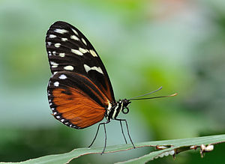

A [Tiger Longwing butterfly](https://en.wikipedia.org/wiki/Heliconius_hecale) (*Heliconius hecale*) - note the clubbed antennae and slender body

### Shape and structure of antennae

The most obvious difference is in the feelers, or [antennae](https://en.wikipedia.org/wiki/Antenna_(biology)). Most butterflies have thin slender filamentous antennae which are club-shaped at the end. Moths, on the other hand, often have comb-like or feathery antennae, or filamentous and unclubbed.[[2]](https://en.wikipedia.org/wiki/Comparison_of_butterflies_and_moths" \l "cite_note-2)[[3]](https://en.wikipedia.org/wiki/Comparison_of_butterflies_and_moths" \l "cite_note-3) This distinction is the basis for the earliest taxonomic divisions in the Lepidoptera: the *Rhopalocera* ("clubbed horn", the butterflies) and the *Heterocera* ("varied horn", the moths).

There are, however, exceptions to this rule and a few moths (the families [Castniidae](https://en.wikipedia.org/wiki/Castniidae), [Uraniidae](https://en.wikipedia.org/wiki/Uraniidae), [Apoprogonidae](https://en.wikipedia.org/wiki/Apoprogonidae), and [Sematuridae](https://en.wikipedia.org/wiki/Sematuridae)[[4]](https://en.wikipedia.org/wiki/Comparison_of_butterflies_and_moths" \l "cite_note-Scott-4)) have clubbed antennae. Some butterflies, like [*Pseudopontia paradoxa*](https://en.wikipedia.org/wiki/Pseudopontia_paradoxa) from the forests of central [Africa](https://en.wikipedia.org/wiki/Africa), lack the club ends. The [Hesperiids](https://en.wikipedia.org/wiki/Hesperioidea) often have an angle to the tip of the antenna.

### Wing-coupling mechanisms

Many moths have a [frenulum](https://en.wikipedia.org/wiki/Frenulum) which is a filament arising from the hindwing and coupling (matching up) with barbs on the forewing. The frenulum can be observed only when a specimen is in hand. Some moths have a lobe on the forewing called a jugum that helps in coupling with the hindwing. Butterflies, however, lack these structures.

### Pupae

Most moth [caterpillars](https://en.wikipedia.org/wiki/Caterpillars) spin a [cocoon](https://en.wikipedia.org/wiki/Cocoon_(silk)) made of silk within which they [metamorphose](https://en.wikipedia.org/wiki/Metamorphosis_(biology)) into the [pupal stage](https://en.wikipedia.org/wiki/Pupa). Most butterfly caterpillars, on the other hand, form an exposed pupa, also termed a [chrysalis](https://en.wikipedia.org/wiki/Chrysalis).

* 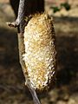

Moths typically form a cocoon

* 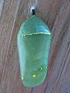

Butterflies typically form a chrysalis

There are many exceptions to this rule, however. For example, the [Hawk moths](https://en.wikipedia.org/wiki/Hawk_moth) form an exposed pupa which is underground. [Gypsy moths](https://en.wikipedia.org/wiki/Gypsy_moth) sometimes form butterfly-style pupae, hanging on twigs or tree bark, although usually they create flimsy cocoons out of silk strands and a few leaves, partially exposing the pupa. The plume winged moths of the family [Pterophoridae](https://en.wikipedia.org/wiki/Pterophoridae) also pupates without a cocoon and the pupa resembles the chrysalis of the [pierid](https://en.wikipedia.org/wiki/Pieridae) butterfly. A few Skipper butterfly larvae also make crude cocoons in which they pupate, exposing the pupa a bit. The [*Parnassius*](https://en.wikipedia.org/wiki/Parnassius) butterfly larvae make a flimsy cocoon for pupation and they pupate near the ground surface between debris.

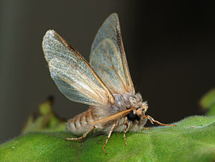

[Pine Processionary](https://en.wikipedia.org/wiki/Pine_Processionary) moth (*Thaumetopoea pityocampa*) - note the feathered antennae and fat furry body

### Colouration of the wings

Most butterflies have bright colours on their wings. Nocturnal moths on the other hand are usually plain brown, grey, white or black and often with obscuring patterns of zigzags or swirls which help [camouflage](https://en.wikipedia.org/wiki/Camouflage) them from predators as they rest during the day. However, many day-flying moths are brightly coloured, particularly if they are [toxic](https://en.wikipedia.org/wiki/Toxicity). These diurnal species evolved to locate their mates visually and not primarily by [pheromone](https://en.wikipedia.org/wiki/Pheromone) as their drab nocturnal cousins.[[4]](https://en.wikipedia.org/wiki/Comparison_of_butterflies_and_moths" \l "cite_note-Scott-4) A few butterflies are also plain-colored, like the [Cabbage White](https://en.wikipedia.org/wiki/Pieris_rapae) butterfly or the [Baron](https://en.wikipedia.org/wiki/Euthalia_aconthea) butterfly.

### Structure of the body

Moths tend to have stout and hairy or furry-looking bodies, while butterflies have slender and smoother abdomens. Moths have larger scales on their wings which makes them look more dense and fluffy. Butterflies on the other hand possess fine scales. This difference is possibly due to the need for moths to conserve heat during the cooler nights, or to confound [echolocation](https://en.wikipedia.org/wiki/Animal_echolocation) by bats, whereas butterflies are able to absorb [sunlight](https://en.wikipedia.org/wiki/Sunlight).

### Eye types

Despite appearances, butterflies and moths have different types of [compound eyes](https://en.wikipedia.org/wiki/Eye" \l "Compound_eyes). Though not universal, moths very commonly have [superposition eyes](https://en.wikipedia.org/wiki/Eye" \l "Superposition_eyes), while butterflies equally commonly favor [apposition eyes](https://en.wikipedia.org/wiki/Eye" \l "Apposition_eyes). This is due to the superposition eye's adaptations for low light environments suiting the nocturnal moths, and the apposition eye's superior resolution and potential for color vision benefiting the more diurnal butterflies.[[5]](https://en.wikipedia.org/wiki/Comparison_of_butterflies_and_moths" \l "cite_note-5)

There are several exceptions to this rule, such as with the diurnal [Zygaenidae](https://en.wikipedia.org/wiki/Zygaenidae) and Sytomidae families of moths, both of which have apposition eyes, or the nocturnal [Hedyloidea](https://en.wikipedia.org/wiki/Hedyloidea) family of butterflies, which are nocturnal and feature superposition eyes.[[6]](https://en.wikipedia.org/wiki/Comparison_of_butterflies_and_moths" \l "cite_note-6) In most cases where one species is found to be using the opposite type of eye than expected, it is because they are active during the opposite time of day than is normal for other butterflies or moths

## Behavioural differences

### Time of activity

Most moths are [nocturnal](https://en.wikipedia.org/wiki/Nocturnal) or [crepuscular](https://en.wikipedia.org/wiki/Crepuscular) while most butterflies are [diurnal](https://en.wikipedia.org/wiki/Diurnal_animal). There are however exceptions, including the sometimes-[diurnal](https://en.wikipedia.org/wiki/Diurnal_animal) [Gypsy moth](https://en.wikipedia.org/wiki/Gypsy_moth) and the spectacular "[Uraniidae](https://en.wikipedia.org/wiki/Uraniidae)" or Sunset moths.

### Resting posture

Moths usually rest with their wings spread out to their sides. Butterflies frequently fold their wings above their backs when they are perched although they will occasionally "bask" with their wings spread for short periods. However, some butterflies, like the [skippers](https://en.wikipedia.org/wiki/Skipper_(butterfly)), may hold their wings either flat, or folded, or even in-between (the so-called "jet plane" position) when perched.

* 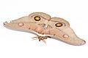

Typical moth resting posture

* 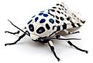

Alternative moth resting posture

* 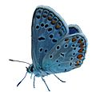

Typical butterfly resting posture

Most moths also occasionally fold their wings above their backs when they are in a certain spot (like when there is no room to fully spread their wings).

A sometimes confusing family can be the "[Geometridae](https://en.wikipedia.org/wiki/Geometridae)" (such as the [Winter moth](https://en.wikipedia.org/wiki/Winter_moth)) because the adults often rest with their wings folded vertically. These moths have thin bodies and large wings like many butterflies but may be distinguished easily by structural differences in their antennae (e.g. [bipectinate](https://en.wikipedia.org/w/index.php?title=Bipectinate&action=edit&redlink=1)).

### Examples of exceptions to the general moth/butterfly distinctions

* 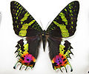

[*Chrysiridia rhipheus*](https://en.wikipedia.org/wiki/Chrysiridia_rhipheus) ([Uraniidae](https://en.wikipedia.org/wiki/Uraniidae)), the day-flying Madagascan sunset moth, has butterfly-like colours

* 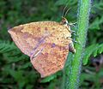

*Tetragonus* sp., a day-flying [Callidulid](https://en.wikipedia.org/wiki/Callidulidae) moth holds its wings like a butterfly but lacks the knobbed antennae

* 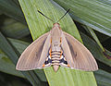

The day-flying [*Paysandisia archon*](https://en.wikipedia.org/wiki/Paysandisia_archon) has clubbed antennae like other moths of family [Castniidae](https://en.wikipedia.org/wiki/Castniidae)

## See also

* [Lepidoptera](https://en.wikipedia.org/wiki/Lepidoptera)
* [Papilionoidea](https://en.wikipedia.org/wiki/Papilionoidea)
* [Hesperioidea](https://en.wikipedia.org/wiki/Hesperioidea)
* [Caterpillar](https://en.wikipedia.org/wiki/Caterpillar)

## References

• Scoble, MJ 1995. The Lepidoptera: form, function and diversity. Oxford, UK: The Oxford University Press; 404 p.

• • [Australian Museum - What are the differences between butterflies and moths?](http://australianmuseum.net.au/What-are-the-differences-between-butterflies-and-moths) Copyright © Australian Museum - Retrieved June 29, 2010.

• • [[1]](http://www.loc.gov/rr/scitech/mysteries/butterflymoth.html)

• • Scott, James A. (1992). [*The Butterflies of North America: A Natural History and Field Guide*](http://books.google.com/books?id=Oa5m8gZcGjMC&pg=PA94&lpg=PA94&dq=Uraniidae+antenna). Calif.: Stanford University Press. p. 94*. Retrieved Apr 2011*. Check date values in: |access-date= ([help](https://en.wikipedia.org/wiki/Help:CS1_errors" \l "bad_date))

• • Greiner, Birgit (16 December 2005). [*"Adaptations for Nocturnal Vision in Insect Apposition Eyes"*](http://www4.lu.se/upload/GreinerThesis.pdf) (PDF). Lund University*. Retrieved 11 May 2012*.

• Yack, Jayne; Stephanie E. Johnson; Sarah G. Brown; Eric J. Warrant (14 November 2007). "The eyes of Macrosoma sp. (Lepidoptera: Hedyloidea): a nocturnal butterfly with superposition optics.". Arthropod Structure & Development. **36** (1): 11–22. [*doi*](https://en.wikipedia.org/wiki/Digital_object_identifier):[*10.1016/j.asd.2006.07.001*](https://dx.doi.org/10.1016%2Fj.asd.2006.07.001). [*PMID*](https://en.wikipedia.org/wiki/PubMed_Identifier) [*18089084*](https://www.ncbi.nlm.nih.gov/pubmed/18089084).

In common [cladistic](https://en.wikipedia.org/wiki/Cladistics) usage, a **monophyletic** group is a [taxon](https://en.wikipedia.org/wiki/Taxon) (group of organisms) which forms a [clade](https://en.wikipedia.org/wiki/Clade), meaning that it consists of an ancestral [species](https://en.wikipedia.org/wiki/Species) and all its descendants. The term is synonymous with the uncommon term **holophyly**. Monophyletic groups are typically characterized by shared derived characteristics ([synapomorphies](https://en.wikipedia.org/wiki/Synapomorphy)).

Monophyly is contrasted with [paraphyly](https://en.wikipedia.org/wiki/Paraphyly) and [polyphyly](https://en.wikipedia.org/wiki/Polyphyly), as shown in the second diagram. A *paraphyletic* group consists of all of the descendants of a common ancestor *minus* one or more monophyletic groups. Thus, a paraphyletic group is 'nearly' monophyletic (hence the prefix 'para', meaning 'near' or 'alongside'.) A *polyphyletic* group is characterized by [convergent](https://en.wikipedia.org/wiki/Convergent_evolution) features or habits (for example, night-active primates, fruit trees, aquatic insects); the features by which the group is differentiated from others are not inherited from a common ancestor.

These definitions have taken some time to be accepted. When the cladistic school of thought became mainstream in the 1960s, several alternative definitions were in use. Indeed, taxonomists sometimes used terms without defining them, leading to confusion in the early literature,[[1]](https://en.wikipedia.org/wiki/Monophyly" \l "cite_note-Hennig1966-1) a confusion which persists.[[2]](https://en.wikipedia.org/wiki/Monophyly" \l "cite_note-aub2015-2)

## Contents

* [1](https://en.wikipedia.org/wiki/Monophyly" \l "Definitions) Definitions
* [2](https://en.wikipedia.org/wiki/Monophyly" \l "See_also) See also
* [3](https://en.wikipedia.org/wiki/Monophyly" \l "References) References
* [4](https://en.wikipedia.org/wiki/Monophyly" \l "External_links) External links

## Definitions

On the broadest scale, definitions fall into two groups.

* [Willi Hennig](https://en.wikipedia.org/wiki/Willi_Hennig) (1966:148) defined monophyly as groups based on [synapomorphy](https://en.wikipedia.org/wiki/Synapomorphy) (in contrast to paraphyletic groups, based on [symplesiomorphy](https://en.wikipedia.org/wiki/Symplesiomorphy), and polyphyletic groups, based on [convergence](https://en.wikipedia.org/wiki/Convergent_evolution)). Some authors have sought to define monophyly to include paraphyly as any two or more groups sharing a common ancestor.[[2]](https://en.wikipedia.org/wiki/Monophyly" \l "cite_note-aub2015-2)[[3]](https://en.wikipedia.org/wiki/Monophyly" \l "cite_note-Colless1972-3)[[4]](https://en.wikipedia.org/wiki/Monophyly" \l "cite_note-Envall2007-4)[[5]](https://en.wikipedia.org/wiki/Monophyly" \l "cite_note-Ashlock1971-5) However, this broader definition encompasses both monophyletic and paraphyletic groups as defined above. Therefore, most scientists today restrict the term "monophyletic" to refer to groups consisting of all the descendants of one (hypothetical) common ancestor.[[1]](https://en.wikipedia.org/wiki/Monophyly" \l "cite_note-Hennig1966-1) However, when considering taxonomic groups such as genera and species, the most appropriate nature of their common ancestor is unclear. Assuming that it would be one individual or mating pair is unrealistic for sexually reproducing species, which are by definition interbreeding populations.[[6]](https://en.wikipedia.org/wiki/Monophyly" \l "cite_note-Simpson1961-6)
* Monophyly and associated terms are restricted to discussions of taxa, and are not necessarily accurate when used to describe what Hennig called tokogenetic relationships—now referred to as genealogies. Some argue that using a broader definition, such as a species and all its descendants, does not really work to define a genus.[[6]](https://en.wikipedia.org/wiki/Monophyly" \l "cite_note-Simpson1961-6) According to D. M. Stamos, a satisfactory cladistic definition of a species or genus is impossible because many species (and even genera) may form by "budding" from an existing species, leaving the parent species paraphyletic; or the species or genera may be the result of [hybrid speciation](https://en.wikipedia.org/wiki/Hybrid_speciation).[[7]](https://en.wikipedia.org/wiki/Monophyly" \l "cite_note-7)

## See also

* [Glossary of scientific naming](https://en.wikipedia.org/wiki/Glossary_of_scientific_naming)
* [Clade](https://en.wikipedia.org/wiki/Clade)
* [Paraphyly](https://en.wikipedia.org/wiki/Paraphyly)
* [Polyphyly](https://en.wikipedia.org/wiki/Polyphyly)
* [Crown group](https://en.wikipedia.org/wiki/Crown_group)

## References

• Hennig, Willi; Davis, D. (Translator); Zangerl, R. (Translator) (1999) [1966]. Phylogenetic Systematics (Illinois Reissue ed.). Board of Trustees of the University of Illinois. pp. 72–77. [*ISBN*](https://en.wikipedia.org/wiki/International_Standard_Book_Number) [*0-252-06814-9*](https://en.wikipedia.org/wiki/Special:BookSources/0-252-06814-9).

• • Aubert, D. 2015. A formal analysis of phylogenetic terminology: Towards a reconsideration of the current paradigm in systematics. *Phytoneuron* **2015-66**:1–54.

• • Colless, Donald H. (March 1972). "Monophyly". Systematic Zoology. Society of Systematic Biologists. **21** (1): 126–128. [*doi*](https://en.wikipedia.org/wiki/Digital_object_identifier):[*10.2307/2412266*](https://dx.doi.org/10.2307%2F2412266). [*JSTOR*](https://en.wikipedia.org/wiki/JSTOR) [*2412266*](https://www.jstor.org/stable/2412266).

• • Envall, Mats (2008). "On the difference between mono-, holo-, and paraphyletic groups: a consistent distinction of process and pattern". Biological Journal of the Linnean Society. **94**: 217. [*doi*](https://en.wikipedia.org/wiki/Digital_object_identifier):[*10.1111/j.1095-8312.2008.00984.x*](https://dx.doi.org/10.1111%2Fj.1095-8312.2008.00984.x).

• • Ashlock, Peter D. (March 1971). "Monophyly and Associated Terms". Systematic Zoology. Society of Systematic Biologists. **20** (1): 63–69. [*doi*](https://en.wikipedia.org/wiki/Digital_object_identifier):[*10.2307/2412223*](https://dx.doi.org/10.2307%2F2412223). [*JSTOR*](https://en.wikipedia.org/wiki/JSTOR) [*2412223*](https://www.jstor.org/stable/2412223).

• • Simpson, George (1961). Principles of Animal Taxonomy. New York: Columbia University Press. [*ISBN*](https://en.wikipedia.org/wiki/International_Standard_Book_Number) [*0-231-02427-4*](https://en.wikipedia.org/wiki/Special:BookSources/0-231-02427-4).

• Stamos, D.N. (2003). *[The species problem : biological species, ontology, and the metaphysics of biology](https://books.google.com/books?id=jPAjv5FsKMYC&pg=PA260&lpg=PA260&dq=defining+species+cladistically'&source=bl&ots=JAR0SfYZFh&sig=C0KyC4IvpYgCNlEeqhyRWiIVeCA&hl=no&sa=X&ei=z37vUZj2OITptQad04CgCQ&ved=0CFcQ6AEwBg" \l "v=onepage&q=defining spe )*. Lanham, Md. [u.a.]: Lexington Books. pp. 261–268. [*ISBN*](https://en.wikipedia.org/wiki/International_Standard_Book_Number) [*0739105035*](https://en.wikipedia.org/wiki/Special:BookSources/0739105035).

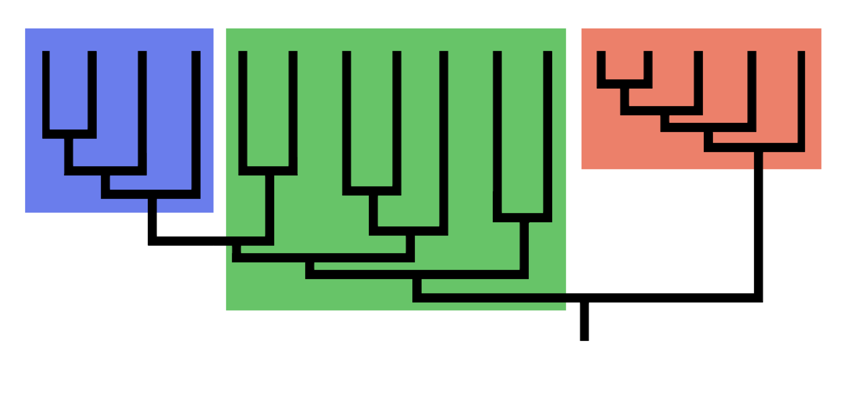[Phylogenetic tree](https://en.wikipedia.org/wiki/Phylogenetic_tree), the blue (left) and red (right) groups represent monophyletic groups, the green group (centre) being paraphyletic. 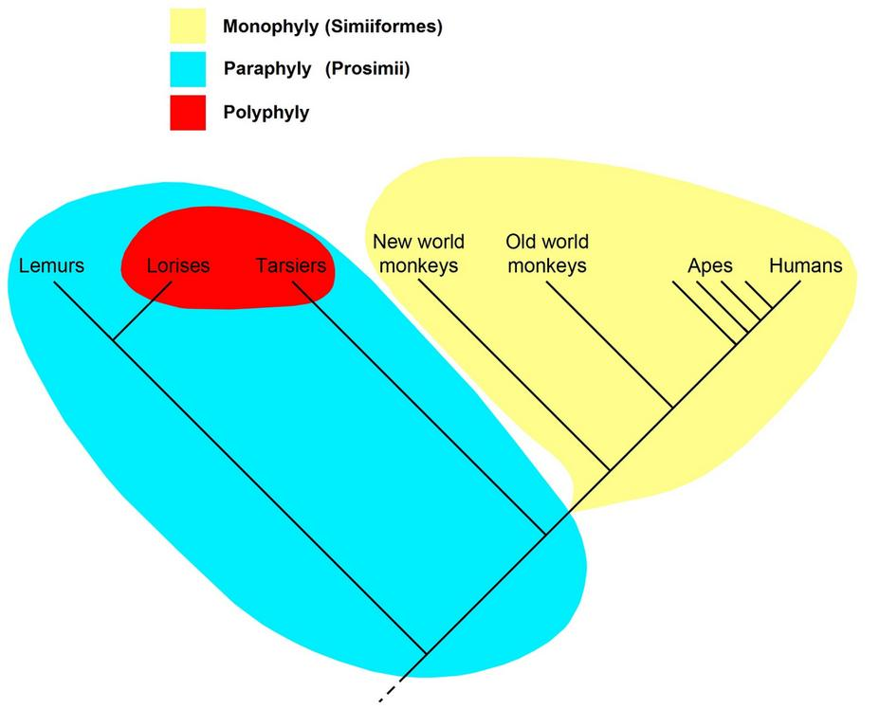

Cladogram of the [primates](https://en.wikipedia.org/wiki/Primate), showing a **monophyletic group** (the simians, in yellow), a [**paraphyletic group**](https://en.wikipedia.org/wiki/Paraphyletic_group) (the prosimians, in blue, including the red patch), and a [**polyphyletic group**](https://en.wikipedia.org/wiki/Polyphyly) (the night-active primates, the [lorises](https://en.wikipedia.org/wiki/Loris) and the [tarsiers](https://en.wikipedia.org/wiki/Tarsier), in red)

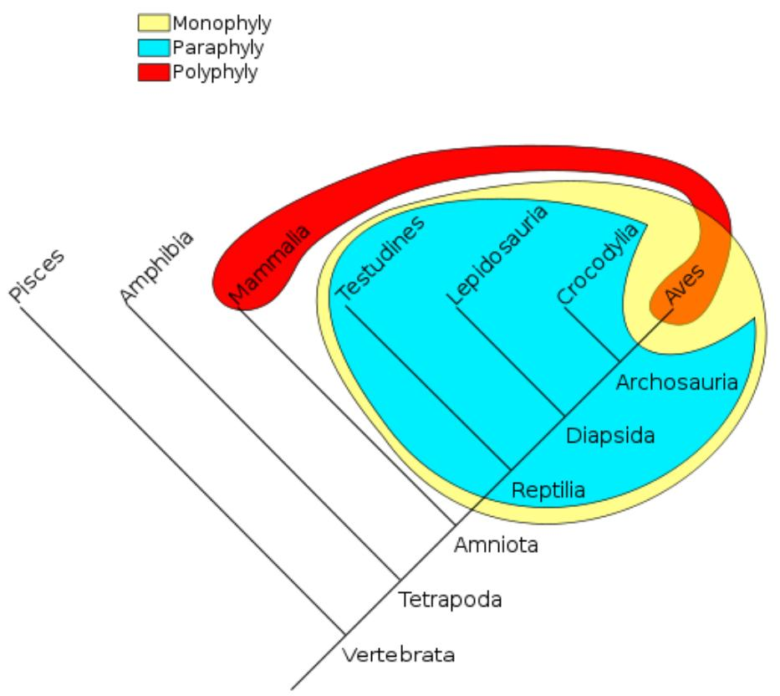

Phylogenetic groups: A monophyletic taxon contains a common ancestor and all of its descendants. Diagram: in yellow, the group of "reptiles and birds". A paraphyletic taxon contains its most recent common ancestor, but does not contain all the descendants of that ancestor. Diagram: in cyan, the reptiles. A polyphyletic taxon does not contain the most recent common ancestor of all its members. Diagram: in red, the group of [all warm-blooded animals](https://en.wikipedia.org/wiki/Homeothermy) is [polyphyletic](https://en.wikipedia.org/wiki/Polyphyly).