DIS-AM,C-Taino-2016-April

Taino carved pendent Very Old / Very Rare- Pre Columbian

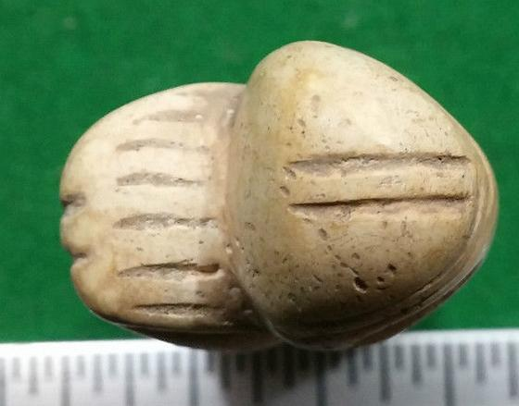 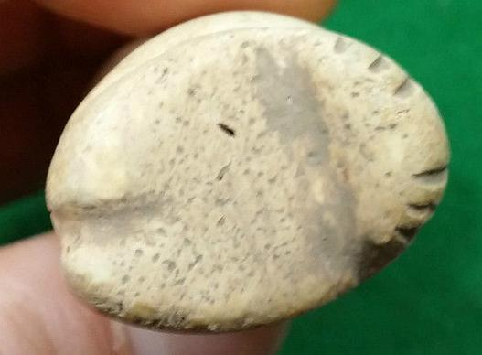

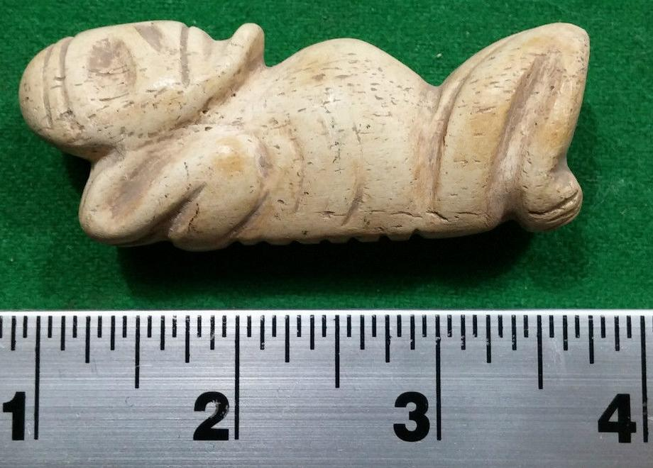 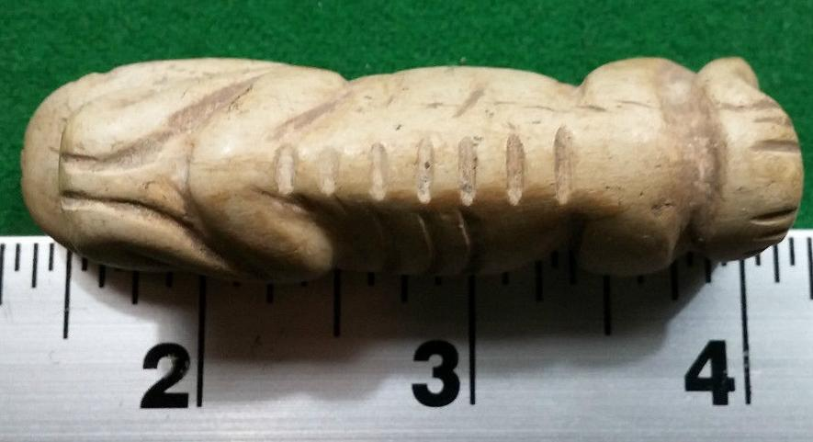 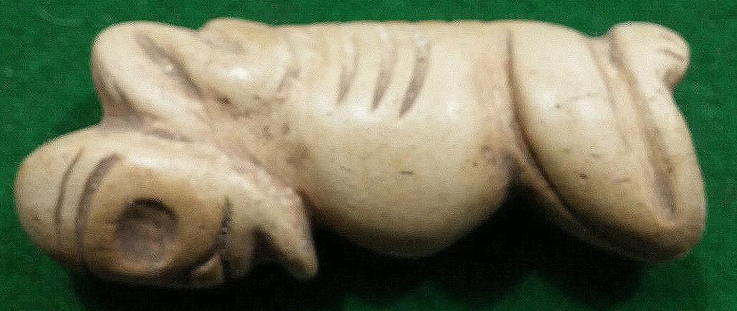

|  |  |
| --- | --- |
| ORDER DATEApr 13, 2016 | ORDER TOTAL  US $3,287.00  + US $259.35  shipping  **Order Taino carving pendent - Pre Columbian,NWC North West Coast Stone Bowl with grinder,NWC North West Coast Stone Bowl,Taino Stone Club Head - Pre Columbian ,Taino Spatula - (Vomit Stick) Cerimonial - Pre Columbian ,Taino Shell carved Amulet Pre Columbian,Taino carved pendent Very Old / Very Rare - Pre Columbian,Taino carving Neckless pendent - Pre Columbian,Taino Stone Carving - Pre Columbian Double head axe,Taino Stone Carving - Pre Columbian Very Large ,Taino Stone Carving - Pre Columbian Very Large,Taino Shell carved Amulet Pre Columbian Very rare,Taino Stone Carving - Pre Columbian Very Large Cerimonial Edged Axe Head** [View order details - ORDER DATE Apr 13, 2016](http://payments.ebay.com/ws/eBayISAPI.dll?ViewPaymentStatus&transId=0&itemid=162030668345&_trksid=p2057872.m2749.l2673)[Contact seller](http://contact.ebay.com/ws/eBayISAPI.dll?ShowSellerFAQ&requested=user1billion&iid=162030668345&redirect=0&_trksid=p2057872.m2749.l2652) - ORDER DATE Apr 13, 2016  [More actions - ORDER DATE Apr 13, 2016](http://www.ebay.com/myb/PurchaseHistory) |

13 items sold by [user1billion](http://www.ebay.com/usr/user1billion?_trksid=p2057872.m2749.l2754)

|  |  |  |
| --- | --- | --- |
| [Taino carving pendent - Pre Columbian](http://www.ebay.com/itm/162030668345?_trksid=p2057872.m2749.l2649&ssPageName=STRK%3AMEBIDX%3AIT)  ( 162030668345 )  Estimated delivery Tue, Apr 26 - Tue, May 03  [Add note](javascript:;) | ITEM PRICE:  US $49.00 | **Item Taino carving pendent - Pre Columbian Orders 162030668345-0-0**[Leave feedback](http://feedback.ebay.com/ws/eBayISAPI.dll?LeaveFeedbackShow&useridto=user1billion&transactID=0&item=162030668345&_trksid=p2057872.m2749.l2665)[Return this item](http://postorder.ebay.com/Return/ReturnViewSelectedItem?transactionId=0&itemId=162030668345&_trksid=p2057872.m2749.l3185)  [More actions](http://www.ebay.com/myb/PurchaseHistory) |

|  |  |  |
| --- | --- | --- |
| [NWC North West Coast Stone Bowl with grinder](http://www.ebay.com/itm/162030675421?_trksid=p2057872.m2749.l2649&ssPageName=STRK%3AMEBIDX%3AIT)  ( 162030675421 )  Estimated delivery Tue, Apr 26 - Tue, May 03  [Add note](javascript:;) | ITEM PRICE:  US $349.00 | **Item NWC North West Coast Stone Bowl with grinder Orders 162030675421-0-0**[Leave feedback](http://feedback.ebay.com/ws/eBayISAPI.dll?LeaveFeedbackShow&useridto=user1billion&transactID=0&item=162030675421&_trksid=p2057872.m2749.l2665)[Return this item](http://postorder.ebay.com/Return/ReturnViewSelectedItem?transactionId=0&itemId=162030675421&_trksid=p2057872.m2749.l3185)  [More actions](http://www.ebay.com/myb/PurchaseHistory) |

|  |  |  |
| --- | --- | --- |
| [NWC North West Coast Stone Bowl](http://www.ebay.com/itm/162030675422?_trksid=p2057872.m2749.l2649&ssPageName=STRK%3AMEBIDX%3AIT)  ( 162030675422 )  Estimated delivery Tue, Apr 26 - Tue, May 03  [Add note](javascript:;) | ITEM PRICE:  US $349.00 | **Item NWC North West Coast Stone Bowl Orders 162030675422-0-0**[Leave feedback](http://feedback.ebay.com/ws/eBayISAPI.dll?LeaveFeedbackShow&useridto=user1billion&transactID=0&item=162030675422&_trksid=p2057872.m2749.l2665)[Return this item](http://postorder.ebay.com/Return/ReturnViewSelectedItem?transactionId=0&itemId=162030675422&_trksid=p2057872.m2749.l3185)  [More actions](http://www.ebay.com/myb/PurchaseHistory) |

|  |  |  |
| --- | --- | --- |
| [Taino Stone Club Head - Pre Columbian](http://www.ebay.com/itm/162030675424?_trksid=p2057872.m2749.l2649&ssPageName=STRK%3AMEBIDX%3AIT)  ( 162030675424 )  Estimated delivery Tue, Apr 26 - Tue, May 03  [Add note](javascript:;) | ITEM PRICE:  US $349.00 | **Item Taino Stone Club Head - Pre Columbian Orders 162030675424-0-0**[Leave feedback](http://feedback.ebay.com/ws/eBayISAPI.dll?LeaveFeedbackShow&useridto=user1billion&transactID=0&item=162030675424&_trksid=p2057872.m2749.l2665)[Return this item](http://postorder.ebay.com/Return/ReturnViewSelectedItem?transactionId=0&itemId=162030675424&_trksid=p2057872.m2749.l3185)  [More actions](http://www.ebay.com/myb/PurchaseHistory) |

|  |  |  |
| --- | --- | --- |
| [Taino Spatula - (Vomit Stick) Cerimonial - Pre Columbian](http://www.ebay.com/itm/162030676433?_trksid=p2057872.m2749.l2649&ssPageName=STRK%3AMEBIDX%3AIT)  ( 162030676433 )  Estimated delivery Tue, Apr 26 - Tue, May 03  [Add note](javascript:;) | ITEM PRICE:  US $149.00 | **Item Taino Spatula - (Vomit Stick) Cerimonial - Pre Columbian Orders 162030676433-0-0**[Leave feedback](http://feedback.ebay.com/ws/eBayISAPI.dll?LeaveFeedbackShow&useridto=user1billion&transactID=0&item=162030676433&_trksid=p2057872.m2749.l2665)[Return this item](http://postorder.ebay.com/Return/ReturnViewSelectedItem?transactionId=0&itemId=162030676433&_trksid=p2057872.m2749.l3185)  [More actions](http://www.ebay.com/myb/PurchaseHistory) |

|  |  |  |
| --- | --- | --- |
| [Taino Shell carved Amulet Pre Columbian](http://www.ebay.com/itm/162030676437?_trksid=p2057872.m2749.l2649&ssPageName=STRK%3AMEBIDX%3AIT)  ( 162030676437 )  Estimated delivery Tue, Apr 26 - Tue, May 03  [Add note](javascript:;) | ITEM PRICE:  US $149.00 | **Item Taino Shell carved Amulet Pre Columbian Orders 162030676437-0-0**[Leave feedback](http://feedback.ebay.com/ws/eBayISAPI.dll?LeaveFeedbackShow&useridto=user1billion&transactID=0&item=162030676437&_trksid=p2057872.m2749.l2665)[Return this item](http://postorder.ebay.com/Return/ReturnViewSelectedItem?transactionId=0&itemId=162030676437&_trksid=p2057872.m2749.l3185)  [More actions](http://www.ebay.com/myb/PurchaseHistory) |

|  |  |  |
| --- | --- | --- |
| [Taino carved pendent Very Old / Very Rare - Pre Columbian](http://www.ebay.com/itm/272203206538?_trksid=p2057872.m2749.l2649&ssPageName=STRK%3AMEBIDX%3AIT)  ( 272203206538 )  Estimated delivery Tue, Apr 26 - Tue, May 03  [Add note](javascript:;) | ITEM PRICE:  US $49.00 | **Item Taino carved pendent Very Old / Very Rare - Pre Columbian Orders 272203206538-0-0**[Leave feedback](http://feedback.ebay.com/ws/eBayISAPI.dll?LeaveFeedbackShow&useridto=user1billion&transactID=0&item=272203206538&_trksid=p2057872.m2749.l2665)[Return this item](http://postorder.ebay.com/Return/ReturnViewSelectedItem?transactionId=0&itemId=272203206538&_trksid=p2057872.m2749.l3185)  [More actions](http://www.ebay.com/myb/PurchaseHistory) |

|  |  |  |
| --- | --- | --- |
| [Taino carving Neckless pendent - Pre Columbian](http://www.ebay.com/itm/272203206543?_trksid=p2057872.m2749.l2649&ssPageName=STRK%3AMEBIDX%3AIT)  ( 272203206543 )  Estimated delivery Tue, Apr 26 - Tue, May 03  [Add note](javascript:;) | ITEM PRICE:  US $49.00 | **Item Taino carving Neckless pendent - Pre Columbian Orders 272203206543-0-0**[Leave feedback](http://feedback.ebay.com/ws/eBayISAPI.dll?LeaveFeedbackShow&useridto=user1billion&transactID=0&item=272203206543&_trksid=p2057872.m2749.l2665)[Return this item](http://postorder.ebay.com/Return/ReturnViewSelectedItem?transactionId=0&itemId=272203206543&_trksid=p2057872.m2749.l3185)  [More actions](http://www.ebay.com/myb/PurchaseHistory) |

|  |  |  |
| --- | --- | --- |
| [Taino Stone Carving - Pre Columbian Double head axe](http://www.ebay.com/itm/272203217371?_trksid=p2057872.m2749.l2649&ssPageName=STRK%3AMEBIDX%3AIT)  ( 272203217371 )  Estimated delivery Tue, Apr 26 - Tue, May 03  [Add note](javascript:;) | ITEM PRICE:  US $349.00 | **Item Taino Stone Carving - Pre Columbian Double head axe Orders 272203217371-0-0**[Leave feedback](http://feedback.ebay.com/ws/eBayISAPI.dll?LeaveFeedbackShow&useridto=user1billion&transactID=0&item=272203217371&_trksid=p2057872.m2749.l2665)[Return this item](http://postorder.ebay.com/Return/ReturnViewSelectedItem?transactionId=0&itemId=272203217371&_trksid=p2057872.m2749.l3185)  [More actions](http://www.ebay.com/myb/PurchaseHistory) |

|  |  |  |
| --- | --- | --- |
| [Taino Stone Carving - Pre Columbian Very Large](http://www.ebay.com/itm/272203217374?_trksid=p2057872.m2749.l2649&ssPageName=STRK%3AMEBIDX%3AIT)  ( 272203217374 )  Estimated delivery Tue, Apr 26 - Tue, May 03  [Add note](javascript:;) | ITEM PRICE:  US $349.00 | **Item Taino Stone Carving - Pre Columbian Very Large Orders 272203217374-0-0**[Leave feedback](http://feedback.ebay.com/ws/eBayISAPI.dll?LeaveFeedbackShow&useridto=user1billion&transactID=0&item=272203217374&_trksid=p2057872.m2749.l2665)[Return this item](http://postorder.ebay.com/Return/ReturnViewSelectedItem?transactionId=0&itemId=272203217374&_trksid=p2057872.m2749.l3185)  [More actions](http://www.ebay.com/myb/PurchaseHistory) |

|  |  |  |
| --- | --- | --- |
| [Taino Stone Carving - Pre Columbian Very Large](http://www.ebay.com/itm/272203217378?_trksid=p2057872.m2749.l2649&ssPageName=STRK%3AMEBIDX%3AIT)  ( 272203217378 )  Estimated delivery Tue, Apr 26 - Tue, May 03  [Add note](javascript:;) | ITEM PRICE:  US $349.00 | **Item Taino Stone Carving - Pre Columbian Very Large Orders 272203217378-0-0**[Leave feedback](http://feedback.ebay.com/ws/eBayISAPI.dll?LeaveFeedbackShow&useridto=user1billion&transactID=0&item=272203217378&_trksid=p2057872.m2749.l2665)[Return this item](http://postorder.ebay.com/Return/ReturnViewSelectedItem?transactionId=0&itemId=272203217378&_trksid=p2057872.m2749.l3185)  [More actions](http://www.ebay.com/myb/PurchaseHistory) |

|  |  |  |
| --- | --- | --- |
| [Taino Shell carved Amulet Pre Columbian Very rare](http://www.ebay.com/itm/272203219231?_trksid=p2057872.m2749.l2649&ssPageName=STRK%3AMEBIDX%3AIT)  ( 272203219231 )  Estimated delivery Tue, Apr 26 - Tue, May 03  [Add note](javascript:;) | ITEM PRICE:  US $149.00 | **Item Taino Shell carved Amulet Pre Columbian Very rare Orders 272203219231-0-0**[Leave feedback](http://feedback.ebay.com/ws/eBayISAPI.dll?LeaveFeedbackShow&useridto=user1billion&transactID=0&item=272203219231&_trksid=p2057872.m2749.l2665)[Return this item](http://postorder.ebay.com/Return/ReturnViewSelectedItem?transactionId=0&itemId=272203219231&_trksid=p2057872.m2749.l3185)  [More actions](http://www.ebay.com/myb/PurchaseHistory) |

|  |  |  |  |  |  |
| --- | --- | --- | --- | --- | --- |
| [Taino Stone Carving - Pre Columbian Very Large Cerimonial Edged Axe Head](http://www.ebay.com/itm/272203220315?_trksid=p2057872.m2749.l2649&ssPageName=STRK%3AMEBIDX%3AIT)  ( 272203220315 )  Estimated delivery Tue, Apr 26 - Tue, May 03  [Add note](javascript:;) | | | | ITEM PRICE:  US $599.00 | **Item Taino Stone Carving - Pre Columbian Very Large Cerimonial Edged Axe Head Orders 272203220315-0-0**[Leave feedback](http://feedback.ebay.com/ws/eBayISAPI.dll?LeaveFeedbackShow&useridto=user1billion&transactID=0&item=272203220315&_trksid=p2057872.m2749.l2665)[Return this item](http://postorder.ebay.com/Return/ReturnViewSelectedItem?transactionId=0&itemId=272203220315&_trksid=p2057872.m2749.l3185)  [More actions](http://www.ebay.com/myb/PurchaseHistory) |
|  | ORDER DATEApr 09, 2016 | ORDER TOTAL  US $235.16  + US $8.00  shipping  **Order Taino Characterized Anthropic Pendant, Pre-Columbian,Taino Serpent-like Pendant. Pre-Columbian,Taino Spirit Cemi, Idol, Pre-Columbian** [View order details - ORDER DATE Apr 09, 2016](http://payments.ebay.com/ws/eBayISAPI.dll?ViewPaymentStatus&transId=0&itemid=252339000775&_trksid=p2057872.m2749.l2673)[Contact seller](http://contact.ebay.com/ws/eBayISAPI.dll?ShowSellerFAQ&requested=flapast&iid=252339000775&redirect=0&_trksid=p2057872.m2749.l2652) - ORDER DATE Apr 09, 2016  [More actions - ORDER DATE Apr 09, 2016](http://www.ebay.com/myb/PurchaseHistory) |  | | |

3 items sold by [flapast](http://www.ebay.com/usr/flapast?_trksid=p2057872.m2749.l2754)

|  |  |  |
| --- | --- | --- |
| [Taino Characterized Anthropic Pendant, Pre-Columbian](http://www.ebay.com/itm/252339000775?_trksid=p2057872.m2749.l2649&ssPageName=STRK%3AMEBIDX%3AIT)  ( 252339000775 )  Estimated delivery Sat, Apr 16  Tracking number: [**Tracking number**9400109699937494634688](javascript:;)  [Add note](javascript:;) | ITEM PRICE:  US $47.66 | **Item Taino Characterized Anthropic Pendant, Pre-Columbian Orders 252339000775-0-0**[Leave feedback](http://feedback.ebay.com/ws/eBayISAPI.dll?LeaveFeedbackShow&useridto=flapast&transactID=0&item=252339000775&_trksid=p2057872.m2749.l2665)[Return this item](http://postorder.ebay.com/Return/ReturnViewSelectedItem?transactionId=0&itemId=252339000775&_trksid=p2057872.m2749.l3185)  [More actions](http://www.ebay.com/myb/PurchaseHistory) |

|  |  |  |
| --- | --- | --- |
| [Taino Serpent-like Pendant. Pre-Columbian](http://www.ebay.com/itm/252339225716?_trksid=p2057872.m2749.l2649&ssPageName=STRK%3AMEBIDX%3AIT)  ( 252339225716 )  Estimated delivery Sat, Apr 16  Tracking number: [**Tracking number**9400109699937494634688](javascript:;)  [Add note](javascript:;) | ITEM PRICE:  US $50.00 | **Item Taino Serpent-like Pendant. Pre-Columbian Orders 252339225716-0-0**[Leave feedback](http://feedback.ebay.com/ws/eBayISAPI.dll?LeaveFeedbackShow&useridto=flapast&transactID=0&item=252339225716&_trksid=p2057872.m2749.l2665)[Return this item](http://postorder.ebay.com/Return/ReturnViewSelectedItem?transactionId=0&itemId=252339225716&_trksid=p2057872.m2749.l3185)  [More actions](http://www.ebay.com/myb/PurchaseHistory) |

|  |  |  |  |  |
| --- | --- | --- | --- | --- |
| [Taino Spirit Cemi, Idol, Pre-Columbian](http://www.ebay.com/itm/262362866451?_trksid=p2057872.m2749.l2649&ssPageName=STRK%3AMEBIDX%3AIT)  ( 262362866451 )  Estimated delivery Sat, Apr 16  Tracking number: [**Tracking number**9400109699937494634688](javascript:;)  [Add note](javascript:;) | | | | ITEM PRICE:  US $137.50 |
|  | ORDER DATEMar 30, 2016 | ORDER TOTAL  US $199.00  Free shipping  **Order Taino ceremonial Cohoba clay female inhaler or smoking snuffering** [Leave feedback - ORDER DATE Mar 30, 2016](http://feedback.ebay.com/ws/eBayISAPI.dll?LeaveFeedbackShow&useridto=guayacanex&transactID=0&item=331807922678&_trksid=p2057872.m2749.l2665)[View order details](http://payments.ebay.com/ws/eBayISAPI.dll?ViewPaymentStatus&transId=0&itemid=331807922678&_trksid=p2057872.m2749.l2673) - ORDER DATE Mar 30, 2016  [More actions - ORDER DATE Mar 30, 2016](http://www.ebay.com/myb/PurchaseHistory) |  | |

1 item sold by [guayacanex](http://www.ebay.com/usr/guayacanex?_trksid=p2057872.m2749.l2754)

|  |  |  |  |  |
| --- | --- | --- | --- | --- |
| [Taino ceremonial Cohoba clay female inhaler or smoking snuffering](http://www.ebay.com/itm/331807922678?_trksid=p2057872.m2749.l2649&ssPageName=STRK%3AMEBIDX%3AIT)  ( 331807922678 )  Estimated delivery Fri, May 13 - Wed, Jun 01  Tracking number: [**Tracking number**RR150428796DO](javascript:;)  [Add note](javascript:;) | | | | ITEM PRICE:  US $199.00 |
|  | ORDER DATEMar 28, 2016 | ORDER TOTAL  US $124.00  + US $14.00  shipping  **Order FERTILITY-EFFIGY, North Western PUERTO RICO, 19th Century Find** [Leave feedback - ORDER DATE Mar 28, 2016](http://feedback.ebay.com/ws/eBayISAPI.dll?LeaveFeedbackShow&useridto=saltrento&transactID=0&item=172142340886&_trksid=p2057872.m2749.l2665)[View order details](http://payments.ebay.com/ws/eBayISAPI.dll?ViewPaymentStatus&transId=0&itemid=172142340886&_trksid=p2057872.m2749.l2673) - ORDER DATE Mar 28, 2016  [More actions - ORDER DATE Mar 28, 2016](http://www.ebay.com/myb/PurchaseHistory) |  | |

1 item sold by [saltrento](http://www.ebay.com/usr/saltrento?_trksid=p2057872.m2749.l2754)

|  |  |  |  |  |  |
| --- | --- | --- | --- | --- | --- |
| [FERTILITY-EFFIGY, North Western PUERTO RICO, 19th Century Find](http://www.ebay.com/itm/172142340886?_trksid=p2057872.m2749.l2649&ssPageName=STRK%3AMEBIDX%3AIT)  ( 172142340886 )  Delivered on Thu, Mar 31  Tracking number: [**Tracking number**9405509699938339648795](javascript:;)  [Add note](javascript:;) | | | | ITEM PRICE:  US $124.00 |  |
|  | ORDER DATEMar 28, 2016 | ORDER TOTAL  US $265.00  Free shipping  **Order antique Taino Zemi small fetish,hardstone w/ patina caribbean area usa free ship** [Leave feedback - ORDER DATE Mar 28, 2016](http://feedback.ebay.com/ws/eBayISAPI.dll?LeaveFeedbackShow&useridto=alembix&transactID=1524699328007&item=172027939917&_trksid=p2057872.m2749.l2665)[View order details](http://payments.ebay.com/ws/eBayISAPI.dll?ViewPaymentStatus&transId=1524699328007&itemid=172027939917&_trksid=p2057872.m2749.l2673) - ORDER DATE Mar 28, 2016  [More actions - ORDER DATE Mar 28, 2016](http://www.ebay.com/myb/PurchaseHistory) |  | | |

1 item sold by [alembix](http://www.ebay.com/usr/alembix?_trksid=p2057872.m2749.l2754)

|  |  |  |
| --- | --- | --- |
| [antique Taino Zemi small fetish,hardstone w/ patina caribbean area usa free ship](http://www.ebay.com/itm/172027939917?_trksid=p2057872.m2749.l2649&ssPageName=STRK%3AMEBIDX%3AIT)  ( 172027939917 )  Delivered on Thu, Mar 31  Tracking number: [**Tracking number**9405909699939817329418](javascript:;)  [Add note](javascript:;) | ITEM PRICE:  US $265.00 |  |

|  |  |
| --- | --- |
| ORDER DATEMar 28, 2016 | ORDER TOTAL  US $250.00  + US $60.00  shipping  **Order Taino Zemi Pre Columbian** [Leave feedback - ORDER DATE Mar 28, 2016](http://feedback.ebay.com/ws/eBayISAPI.dll?LeaveFeedbackShow&useridto=artetaino&transactID=0&item=152024056864&_trksid=p2057872.m2749.l2665)[View order details](http://payments.ebay.com/ws/eBayISAPI.dll?ViewPaymentStatus&transId=0&itemid=152024056864&_trksid=p2057872.m2749.l2673) - ORDER DATE Mar 28, 2016  [More actions - ORDER DATE Mar 28, 2016](http://www.ebay.com/myb/PurchaseHistory) |

1 item sold by [artetaino](http://www.ebay.com/usr/artetaino?_trksid=p2057872.m2749.l2754)

|  |  |  |  |
| --- | --- | --- | --- |
| [Taino Zemi Pre Columbian](http://www.ebay.com/itm/152024056864?_trksid=p2057872.m2749.l2649&ssPageName=STRK%3AMEBIDX%3AIT)  ( 152024056864 )  Delivered on Fri, Apr 01  Tracking number: [**Tracking number**1ZV8200Y6640059677](javascript:;) | | | |
|  | ORDER DATEMar 28, 2016 | ORDER TOTAL  US $265.00  Free shipping  **Order antique Taino Zemi small fetish,hardstone w/ patina caribbean area usa free ship** [Leave feedback - ORDER DATE Mar 28, 2016](http://feedback.ebay.com/ws/eBayISAPI.dll?LeaveFeedbackShow&useridto=alembix&transactID=1524699328007&item=172027939917&_trksid=p2057872.m2749.l2665)[View order details](http://payments.ebay.com/ws/eBayISAPI.dll?ViewPaymentStatus&transId=1524699328007&itemid=172027939917&_trksid=p2057872.m2749.l2673) - ORDER DATE Mar 28, 2016  [More actions - ORDER DATE Mar 28, 2016](http://www.ebay.com/myb/PurchaseHistory) |  |

1 item sold by [alembix](http://www.ebay.com/usr/alembix?_trksid=p2057872.m2749.l2754)

|  |  |  |
| --- | --- | --- |
| [antique Taino Zemi small fetish,hardstone w/ patina caribbean area usa free ship](http://www.ebay.com/itm/172027939917?_trksid=p2057872.m2749.l2649&ssPageName=STRK%3AMEBIDX%3AIT)  ( 172027939917 )  Delivered on Thu, Mar 31  Tracking number: [**Tracking number**9405909699939817329418](javascript:;)  [Add note](javascript:;) | ITEM PRICE:  US $265.00 |  |

|  |  |
| --- | --- |
| ORDER DATEMar 28, 2016 | ORDER TOTAL  US $250.00  + US $60.00  shipping  **Order Taino Zemi Pre Columbian** [Leave feedback - ORDER DATE Mar 28, 2016](http://feedback.ebay.com/ws/eBayISAPI.dll?LeaveFeedbackShow&useridto=artetaino&transactID=0&item=152024056864&_trksid=p2057872.m2749.l2665)[View order details](http://payments.ebay.com/ws/eBayISAPI.dll?ViewPaymentStatus&transId=0&itemid=152024056864&_trksid=p2057872.m2749.l2673) - ORDER DATE Mar 28, 2016  [More actions - ORDER DATE Mar 28, 2016](http://www.ebay.com/myb/PurchaseHistory) |

1 item sold by [artetaino](http://www.ebay.com/usr/artetaino?_trksid=p2057872.m2749.l2754)

|  |  |  |  |
| --- | --- | --- | --- |
| [Taino Zemi Pre Columbian](http://www.ebay.com/itm/152024056864?_trksid=p2057872.m2749.l2649&ssPageName=STRK%3AMEBIDX%3AIT)  ( 152024056864 )  Delivered on Fri, Apr 01  Tracking number: [**Tracking number**1ZV8200Y6640059677](javascript:;) | | | |
|  | ORDER DATEMar 26, 2016 | ORDER TOTAL  US $112.50  + US $7.00  shipping  **Order Taino Owl Face Cohoba Hallucinogenic Inhaler pre-Columbian** [Leave feedback - ORDER DATE Mar 26, 2016](http://feedback.ebay.com/ws/eBayISAPI.dll?LeaveFeedbackShow&useridto=flapast&transactID=0&item=262339688374&_trksid=p2057872.m2749.l2665)[View order details](http://payments.ebay.com/ws/eBayISAPI.dll?ViewPaymentStatus&transId=0&itemid=262339688374&_trksid=p2057872.m2749.l2673) - ORDER DATE Mar 26, 2016  [More actions - ORDER DATE Mar 26, 2016](http://www.ebay.com/myb/PurchaseHistory) |  |

1 item sold by [flapast](http://www.ebay.com/usr/flapast?_trksid=p2057872.m2749.l2754)

|  |  |  |
| --- | --- | --- |
| [Taino Owl Face Cohoba Hallucinogenic Inhaler pre-Columbian](http://www.ebay.com/itm/262339688374?_trksid=p2057872.m2749.l2649&ssPageName=STRK%3AMEBIDX%3AIT)  ( 262339688374 )  Delivered on Wed, Mar 30  Tracking number: [**Tracking number**9400109699938335806790](javascript:;)  [Add note](javascript:;) | ITEM PRICE:  US $112.50 |  |

|  |  |  |  |
| --- | --- | --- | --- |
| ORDER DATE | | | |
|  | ORDER DATEMar 25, 2016 | ORDER TOTAL  US $299.00  Free shipping  **Order Taino water Jar of clay with a monky faces each side and special details** [Leave feedback - ORDER DATE Mar 25, 2016](http://feedback.ebay.com/ws/eBayISAPI.dll?LeaveFeedbackShow&useridto=guayacanex&transactID=0&item=231878750286&_trksid=p2057872.m2749.l2665)[View order details](http://payments.ebay.com/ws/eBayISAPI.dll?ViewPaymentStatus&transId=0&itemid=231878750286&_trksid=p2057872.m2749.l2673) - ORDER DATE Mar 25, 2016  [More actions - ORDER DATE Mar 25, 2016](http://www.ebay.com/myb/PurchaseHistory) |  |

1 item sold by [guayacanex](http://www.ebay.com/usr/guayacanex?_trksid=p2057872.m2749.l2754)

|  |  |  |  |  |
| --- | --- | --- | --- | --- |
| [Taino water Jar of clay with a monky faces each side and special details](http://www.ebay.com/itm/231878750286?_trksid=p2057872.m2749.l2649&ssPageName=STRK%3AMEBIDX%3AIT)  ( 231878750286 )  Estimated delivery Tue, May 10 - Thu, May 26  Tracking number: [**Tracking number**RR150051415DO](javascript:;)  [Add note](javascript:;) | | | | ITEM PRICE:  US $299.00 |
|  | ORDER DATEMar 22, 2016 | ORDER TOTAL  US $99.99  + US $10.92  shipping  **Order ORIG $399. PRE COLUMBIAN TAINO FIGURE 7➕" PROVENANCE** [Leave feedback - ORDER DATE Mar 22, 2016](http://feedback.ebay.com/ws/eBayISAPI.dll?LeaveFeedbackShow&useridto=primitifstuffgallery&transactID=1711234933012&item=222058876885&_trksid=p2057872.m2749.l2665)[View order details](http://payments.ebay.com/ws/eBayISAPI.dll?ViewPaymentStatus&transId=1711234933012&itemid=222058876885&_trksid=p2057872.m2749.l2673) - ORDER DATE Mar 22, 2016  [More actions - ORDER DATE Mar 22, 2016](http://www.ebay.com/myb/PurchaseHistory) |  | |

1 item sold by [primitifstuffgallery](http://www.ebay.com/usr/primitifstuffgallery?_trksid=p2057872.m2749.l2754)

|  |  |  |  |  |  |
| --- | --- | --- | --- | --- | --- |
| [ORIG $399. PRE COLUMBIAN TAINO FIGURE 7➕" PROVENANCE](http://www.ebay.com/itm/222058876885?_trksid=p2057872.m2749.l2649&ssPageName=STRK%3AMEBIDX%3AIT)  ( 222058876885 )  Delivered on Mon, Mar 28  Tracking number: [**Tracking number**9405509699939811213708](javascript:;)  [Add note](javascript:;) | | | | ITEM PRICE:  US $99.99 |  |
|  | Mar 20, 2016 | ORDER TOTAL  US $299.00  + US $12.00  shipping  **Order TAINO PRE- COLUMBIAN STONE AXE WITH TOAD** [Leave feedback - ORDER DATE Mar 20, 2016](http://feedback.ebay.com/ws/eBayISAPI.dll?LeaveFeedbackShow&useridto=the*caciques&transactID=0&item=111935489056&_trksid=p2057872.m2749.l2665)[View order details](http://payments.ebay.com/ws/eBayISAPI.dll?ViewPaymentStatus&transId=0&itemid=111935489056&_trksid=p2057872.m2749.l2673) - ORDER DATE Mar 20, 2016  [More actions - ORDER DATE Mar 20, 2016](http://www.ebay.com/myb/PurchaseHistory) |  | | |

1 item sold by [the*caciques](http://www.ebay.com/usr/the*caciques?_trksid=p2057872.m2749.l2754)

|  |  |  |  |  |
| --- | --- | --- | --- | --- |
| [TAINO PRE- COLUMBIAN STONE AXE WITH TOAD](http://www.ebay.com/itm/111935489056?_trksid=p2057872.m2749.l2649&ssPageName=STRK%3AMEBIDX%3AIT)  ( 111935489056 )  Delivered on Wed, Mar 23  Tracking number: [**Tracking number**9505513939436081128417](javascript:;)  [Add note](javascript:;) | | | | ITEM PRICE:  US $299.00 |
|  | ORDER DATEMar 19, 2016 | ORDER TOTAL  US $170.00  + US $100.00  shipping  **Order Taino stone head Zemi Pre Columbian,Taino Large Stone Pendant Pre Columbian** [View order details - ORDER DATE Mar 19, 2016](http://payments.ebay.com/ws/eBayISAPI.dll?ViewPaymentStatus&transId=0&itemid=272167100010&_trksid=p2057872.m2749.l2673)[Contact seller](http://contact.ebay.com/ws/eBayISAPI.dll?ShowSellerFAQ&requested=miuarez&iid=272167100010&redirect=0&_trksid=p2057872.m2749.l2652) - ORDER DATE Mar 19, 2016  [More actions - ORDER DATE Mar 19, 2016](http://www.ebay.com/myb/PurchaseHistory) |  | |

2 items sold by [miuarez](http://www.ebay.com/usr/miuarez?_trksid=p2057872.m2749.l2754)

|  |  |  |
| --- | --- | --- |
| [Taino stone head Zemi Pre Columbian](http://www.ebay.com/itm/272167100010?_trksid=p2057872.m2749.l2649&ssPageName=STRK%3AMEBIDX%3AIT)  ( 272167100010 )  Estimated delivery Wed, Mar 30 - Wed, Apr 06  Tracking number: [**Tracking number**RR130227209DO](javascript:;)  [Add note](javascript:;) | ITEM PRICE:  US $90.00 | **Item Taino stone head Zemi Pre Columbian Orders 272167100010-0-0**[Leave feedback](http://feedback.ebay.com/ws/eBayISAPI.dll?LeaveFeedbackShow&useridto=miuarez&transactID=0&item=272167100010&_trksid=p2057872.m2749.l2665)[Return this item](http://postorder.ebay.com/Return/ReturnViewSelectedItem?transactionId=0&itemId=272167100010&_trksid=p2057872.m2749.l3185)  [More actions](http://www.ebay.com/myb/PurchaseHistory) |

|  |  |  |  |  |
| --- | --- | --- | --- | --- |
| [Taino Large Stone Pendant Pre Columbian](http://www.ebay.com/itm/272167110573?_trksid=p2057872.m2749.l2649&ssPageName=STRK%3AMEBIDX%3AIT)  ( 272167110573 )  Estimated delivery Wed, Mar 30 - Wed, Apr 06  Tracking number: [**Tracking number**RR130227209DO](javascript:;)  [Add note](javascript:;) | | | | ITEM PRICE:  US $80.00 |
|  | DER DATEMar 19, 2016 | ORDER TOTAL  US $150.00  + US $90.00  shipping  **Order Taino set of 3 Zemi Pre Columbian** [Leave feedback - ORDER DATE Mar 19, 2016](http://feedback.ebay.com/ws/eBayISAPI.dll?LeaveFeedbackShow&useridto=artetaino&transactID=0&item=152009656699&_trksid=p2057872.m2749.l2665)[View order details](http://payments.ebay.com/ws/eBayISAPI.dll?ViewPaymentStatus&transId=0&itemid=152009656699&_trksid=p2057872.m2749.l2673) - ORDER DATE Mar 19, 2016  [More actions - ORDER DATE Mar 19, 2016](http://www.ebay.com/myb/PurchaseHistory) |  | |

1 item sold by [artetaino](http://www.ebay.com/usr/artetaino?_trksid=p2057872.m2749.l2754)

|  |  |  |  |  |  |
| --- | --- | --- | --- | --- | --- |
| [Taino set of 3 Zemi Pre Columbian](http://www.ebay.com/itm/152009656699?_trksid=p2057872.m2749.l2649&ssPageName=STRK%3AMEBIDX%3AIT)  ( 152009656699 )  Estimated delivery Wed, Mar 23 - Tue, Mar 29  Tracking number: [**Tracking number**RR130227208DO](javascript:;)  [Add note](javascript:;) | | | | ITEM PRICE:  US $150.00 |  |
|  | ORDER DATEMar 15, 2016 | ORDER TOTAL  US $598.00  Free shipping  **Order Taino head of stone,Taino Zemi of stone/mother earth in excellent condition** [View order details - ORDER DATE Mar 15, 2016](http://payments.ebay.com/ws/eBayISAPI.dll?ViewPaymentStatus&transId=0&itemid=331798108152&_trksid=p2057872.m2749.l2673)[Contact seller](http://contact.ebay.com/ws/eBayISAPI.dll?ShowSellerFAQ&requested=guayacanex&iid=331798108152&redirect=0&_trksid=p2057872.m2749.l2652) - ORDER DATE Mar 15, 2016  [More actions - ORDER DATE Mar 15, 2016](http://www.ebay.com/myb/PurchaseHistory) |  | | |

2 items sold by [guayacanex](http://www.ebay.com/usr/guayacanex?_trksid=p2057872.m2749.l2754)

|  |  |  |
| --- | --- | --- |
| [Taino head of stone](http://www.ebay.com/itm/331798108152?_trksid=p2057872.m2749.l2649&ssPageName=STRK%3AMEBIDX%3AIT)  ( 331798108152 )  Estimated delivery Fri, Apr 29 - Wed, May 18  Tracking number: [**Tracking number**CP150051413DO](javascript:;)  [Add note](javascript:;) | ITEM PRICE:  US $399.00 | **Item Taino head of stone Orders 331798108152-0-0**[Leave feedback](http://feedback.ebay.com/ws/eBayISAPI.dll?LeaveFeedbackShow&useridto=guayacanex&transactID=0&item=331798108152&_trksid=p2057872.m2749.l2665)[Return this item](http://postorder.ebay.com/Return/ReturnViewSelectedItem?transactionId=0&itemId=331798108152&_trksid=p2057872.m2749.l3185)  [More actions](http://www.ebay.com/myb/PurchaseHistory) |

|  |  |  |  |  |
| --- | --- | --- | --- | --- |
| [Taino Zemi of stone/mother earth in excellent condition](http://www.ebay.com/itm/331798113138?_trksid=p2057872.m2749.l2649&ssPageName=STRK%3AMEBIDX%3AIT)  ( 331798113138 )  Estimated delivery Fri, Apr 29 - Wed, May 18  Tracking number: [**Tracking number**CP150051413DO](javascript:;)  [Add note](javascript:;) | | | | ITEM PRICE:  US $199.00 |
|  | ORDER DATEMar 15, 2016 | ORDER TOTAL  US $140.00  + US $20.00  shipping  **Order Pre columbian taino BUTTERFLY stone axe ! Ex Drouot auctions !!!** [Leave feedback - ORDER DATE Mar 15, 2016](http://feedback.ebay.com/ws/eBayISAPI.dll?LeaveFeedbackShow&useridto=malichigdane&transactID=1817675208015&item=252067630710&_trksid=p2057872.m2749.l2665)[View order details](http://payments.ebay.com/ws/eBayISAPI.dll?ViewPaymentStatus&transId=1817675208015&itemid=252067630710&_trksid=p2057872.m2749.l2673) - ORDER DATE Mar 15, 2016  [More actions - ORDER DATE Mar 15, 2016](http://www.ebay.com/myb/PurchaseHistory) |  | |

1 item sold by [malichigdane](http://www.ebay.com/usr/malichigdane?_trksid=p2057872.m2749.l2754)

|  |  |  |
| --- | --- | --- |
| [Pre columbian taino BUTTERFLY stone axe ! Ex Drouot auctions !!!](http://www.ebay.com/itm/252067630710?_trksid=p2057872.m2749.l2649&ssPageName=STRK%3AMEBIDX%3AIT)  ( 252067630710 )  Estimated delivery Tue, Apr 05 - Wed, Apr 13  [Add note](javascript:;) | ITEM PRICE:  US $140.00 |  |

|  |  |
| --- | --- |
| ORDER DATEMar 15, 2016 | ORDER TOTAL  US $149.00  + US $19.95  shipping  **Order Taino Ceremonial Stone Axe** [Leave feedback - ORDER DATE Mar 15, 2016](http://feedback.ebay.com/ws/eBayISAPI.dll?LeaveFeedbackShow&useridto=user1billion&transactID=1620338681017&item=272146622429&_trksid=p2057872.m2749.l2665)[View order details](http://payments.ebay.com/ws/eBayISAPI.dll?ViewPaymentStatus&transId=1620338681017&itemid=272146622429&_trksid=p2057872.m2749.l2673) - ORDER DATE Mar 15, 2016  [More actions - ORDER DATE Mar 15, 2016](http://www.ebay.com/myb/PurchaseHistory) |

1 item sold by [user1billion](http://www.ebay.com/usr/user1billion?_trksid=p2057872.m2749.l2754)

|  |  |  |  |  |
| --- | --- | --- | --- | --- |
| [Taino Ceremonial Stone Axe](http://www.ebay.com/itm/272146622429?_trksid=p2057872.m2749.l2649&ssPageName=STRK%3AMEBIDX%3AIT)  ( 272146622429 )  Delivered on Fri, Mar 25  Tracking number: [**Tracking number**CX563031949CA](javascript:;)  [Add note](javascript:;) | | | | ITEM PRICE:  US $149.00 |
|  | RDER DATEMar 15, 2016 | ORDER TOTAL  US $125.00  + US $12.00  shipping  **Order Taino pottery bowl terracotta decorative art sculpture vessel Puerto Rico 7.5 in** [Leave feedback - ORDER DATE Mar 15, 2016](http://feedback.ebay.com/ws/eBayISAPI.dll?LeaveFeedbackShow&useridto=schaferjewelers&transactID=1245615519009&item=191826952291&_trksid=p2057872.m2749.l2665)[View order details](http://payments.ebay.com/ws/eBayISAPI.dll?ViewPaymentStatus&transId=1245615519009&itemid=191826952291&_trksid=p2057872.m2749.l2673) - ORDER DATE Mar 15, 2016  [More actions - ORDER DATE Mar 15, 2016](http://www.ebay.com/myb/PurchaseHistory) |  | |

1 item sold by [schaferjewelers](http://www.ebay.com/usr/schaferjewelers?_trksid=p2057872.m2749.l2754)

|  |  |  |  |  |
| --- | --- | --- | --- | --- |
| [Taino pottery bowl terracotta decorative art sculpture vessel Puerto Rico 7.5 in](http://www.ebay.com/itm/191826952291?_trksid=p2057872.m2749.l2649&ssPageName=STRK%3AMEBIDX%3AIT)  ( 191826952291 )  Delivered on Thu, Mar 17  Tracking number: [**Tracking number**9405909699938302386400](javascript:;)  [Add note](javascript:;) | | | | ITEM PRICE:  US $125.00 |
|  | ORDER DATEMar 14, 2016 | ORDER TOTAL  US $300.00  + US $90.00  shipping  **Order Taino Stone Cemi Two Heads Figure Pre Columbian** [Leave feedback - ORDER DATE Mar 14, 2016](http://feedback.ebay.com/ws/eBayISAPI.dll?LeaveFeedbackShow&useridto=miuarez&transactID=0&item=272159643073&_trksid=p2057872.m2749.l2665)[View order details](http://payments.ebay.com/ws/eBayISAPI.dll?ViewPaymentStatus&transId=0&itemid=272159643073&_trksid=p2057872.m2749.l2673) - ORDER DATE Mar 14, 2016  [More actions - ORDER DATE Mar 14, 2016](http://www.ebay.com/myb/PurchaseHistory) |  | |

1 item sold by [miuarez](http://www.ebay.com/usr/miuarez?_trksid=p2057872.m2749.l2754)

|  |  |  |
| --- | --- | --- |
| [Taino Stone Cemi Two Heads Figure Pre Columbian](http://www.ebay.com/itm/272159643073?_trksid=p2057872.m2749.l2649&ssPageName=STRK%3AMEBIDX%3AIT)  ( 272159643073 )  Delivered on Fri, Mar 18  Tracking number: [**Tracking number**1Z22062V6771284978](javascript:;)  [Add note](javascript:;) | ITEM PRICE:  US $300.00 |  |

|  |  |
| --- | --- |
| ORDER DATEMar 14, 2016 | ORDER TOTAL  US $143.00  + US $15.00  shipping  **Order ED 1356 PRE=COLUMBIAN MAYAN/ AZTEC ARTIFACT / UNKNOWN PURPOSED OF USED.** [Leave feedback - ORDER DATE Mar 14, 2016](http://feedback.ebay.com/ws/eBayISAPI.dll?LeaveFeedbackShow&useridto=no69surrender&transactID=0&item=201537930892&_trksid=p2057872.m2749.l2665)[View order details](http://payments.ebay.com/ws/eBayISAPI.dll?ViewPaymentStatus&transId=0&itemid=201537930892&_trksid=p2057872.m2749.l2673) - ORDER DATE Mar 14, 2016  [More actions - ORDER DATE Mar 14, 2016](http://www.ebay.com/myb/PurchaseHistory) |

1 item sold by [no69surrender](http://www.ebay.com/usr/no69surrender?_trksid=p2057872.m2749.l2754)

|  |  |  |  |  |
| --- | --- | --- | --- | --- |
| [ED 1356 PRE=COLUMBIAN MAYAN/ AZTEC ARTIFACT / UNKNOWN PURPOSED OF USED.](http://www.ebay.com/itm/201537930892?_trksid=p2057872.m2749.l2649&ssPageName=STRK%3AMEBIDX%3AIT)  ( 201537930892 )  Delivered on Wed, Mar 16  Tracking number: [**Tracking number**9505513807026074185309](javascript:;)  [Add note](javascript:;) | | | | ITEM PRICE:  US $143.00 |
|  | ORDER DATEMar 12, 2016 | ORDER TOTAL  US $100.00  + US $10.00  shipping  **Order TAINO PRE-COLUMBIAN STONE ARTIFACT ( snake )** [Leave feedback - ORDER DATE Mar 12, 2016](http://feedback.ebay.com/ws/eBayISAPI.dll?LeaveFeedbackShow&useridto=jeanpier_360&transactID=0&item=262321521315&_trksid=p2057872.m2749.l2665)[View order details](http://payments.ebay.com/ws/eBayISAPI.dll?ViewPaymentStatus&transId=0&itemid=262321521315&_trksid=p2057872.m2749.l2673) - ORDER DATE Mar 12, 2016  [More actions - ORDER DATE Mar 12, 2016](http://www.ebay.com/myb/PurchaseHistory) |  | |

1 item sold by [jeanpier_360](http://www.ebay.com/usr/jeanpier_360?_trksid=p2057872.m2749.l2754)

|  |  |  |
| --- | --- | --- |
| [TAINO PRE-COLUMBIAN STONE ARTIFACT ( snake )](http://www.ebay.com/itm/262321521315?_trksid=p2057872.m2749.l2649&ssPageName=STRK%3AMEBIDX%3AIT)  ( 262321521315 )  Delivered on Wed, Mar 16  Tracking number: [**Tracking number**23150610000041950450](javascript:;)  [Add note](javascript:;) | ITEM PRICE:  US $100.00 |  |

|  |  |
| --- | --- |
| ORDER DATEMar 12, 2016 | ORDER TOTAL  US $299.00  + US $10.00  shipping  **Order TAINO PRE-COLUMBIAN BLACK STONE TRI- POINTER** [Leave feedback - ORDER DATE Mar 12, 2016](http://feedback.ebay.com/ws/eBayISAPI.dll?LeaveFeedbackShow&useridto=jeanpier_360&transactID=0&item=262320838223&_trksid=p2057872.m2749.l2665)[View order details](http://payments.ebay.com/ws/eBayISAPI.dll?ViewPaymentStatus&transId=0&itemid=262320838223&_trksid=p2057872.m2749.l2673) - ORDER DATE Mar 12, 2016  [More actions - ORDER DATE Mar 12, 2016](http://www.ebay.com/myb/PurchaseHistory) |

1 item sold by [jeanpier_360](http://www.ebay.com/usr/jeanpier_360?_trksid=p2057872.m2749.l2754)

|  |  |  |
| --- | --- | --- |
| [TAINO PRE-COLUMBIAN BLACK STONE TRI- POINTER](http://www.ebay.com/itm/262320838223?_trksid=p2057872.m2749.l2649&ssPageName=STRK%3AMEBIDX%3AIT)  ( 262320838223 )  Delivered on Wed, Mar 16  Tracking number: [**Tracking number**23150610000041950436](javascript:;)  [Add note](javascript:;) | ITEM PRICE:  US $299.00 |  |

|  |  |  |  |
| --- | --- | --- | --- |
| ORDER DATEMar 11, 2016 | | | |
|  | ORDER DATEMar 09, 2016 | ORDER TOTAL  US $249.00  + US $19.95  shipping  **Order Taino Stone Bird Hand Maul (Grinder) - Pre Columbian** [Leave feedback - ORDER DATE Mar 09, 2016](http://feedback.ebay.com/ws/eBayISAPI.dll?LeaveFeedbackShow&useridto=user1billion&transactID=1617772238017&item=272153334517&_trksid=p2057872.m2749.l2665)[View order details](http://payments.ebay.com/ws/eBayISAPI.dll?ViewPaymentStatus&transId=1617772238017&itemid=272153334517&_trksid=p2057872.m2749.l2673) - ORDER DATE Mar 09, 2016  [More actions - ORDER DATE Mar 09, 2016](http://www.ebay.com/myb/PurchaseHistory) |  |

1 item sold by [user1billion](http://www.ebay.com/usr/user1billion?_trksid=p2057872.m2749.l2754)

|  |  |  |  |  |
| --- | --- | --- | --- | --- |
| [Taino Stone Bird Hand Maul (Grinder) - Pre Columbian](http://www.ebay.com/itm/272153334517?_trksid=p2057872.m2749.l2649&ssPageName=STRK%3AMEBIDX%3AIT)  ( 272153334517 )  Delivered on Thu, Mar 31  Tracking number: [**Tracking number**CX563031935CA](javascript:;)  [Add note](javascript:;) | | | | ITEM PRICE:  US $249.00 |
|  | ORDER DATEMar 06, 2016 | ORDER TOTAL  US $300.00  + US $80.00  shipping  **Order Taino Stone Pestle Pre Columbian** [Leave feedback - ORDER DATE Mar 06, 2016](http://feedback.ebay.com/ws/eBayISAPI.dll?LeaveFeedbackShow&useridto=miuarez&transactID=0&item=272150055151&_trksid=p2057872.m2749.l2665)[View order details](http://payments.ebay.com/ws/eBayISAPI.dll?ViewPaymentStatus&transId=0&itemid=272150055151&_trksid=p2057872.m2749.l2673) - ORDER DATE Mar 06, 2016  [More actions - ORDER DATE Mar 06, 2016](http://www.ebay.com/myb/PurchaseHistory) |  | |

1 item sold by [miuarez](http://www.ebay.com/usr/miuarez?_trksid=p2057872.m2749.l2754)

|  |  |  |  |  |  |
| --- | --- | --- | --- | --- | --- |
| [Taino Stone Pestle Pre Columbian](http://www.ebay.com/itm/272150055151?_trksid=p2057872.m2749.l2649&ssPageName=STRK%3AMEBIDX%3AIT)  ( 272150055151 )  Delivered on Thu, Mar 10  Tracking number: [**Tracking number**1ZV821E20464174168](javascript:;)  [Add note](javascript:;) | | | | ITEM PRICE:  US $300.00 |  |
|  | ORDER DATEMar 03, 2016 | ORDER TOTAL  US $199.00  + US $19.95  shipping  **Order Taino Stone Dagger, Looks like it is made from a Marble Type Stone** [Leave feedback - ORDER DATE Mar 03, 2016](http://feedback.ebay.com/ws/eBayISAPI.dll?LeaveFeedbackShow&useridto=user1billion&transactID=1375911856006&item=161989517868&_trksid=p2057872.m2749.l2665)[View order details](http://payments.ebay.com/ws/eBayISAPI.dll?ViewPaymentStatus&transId=1375911856006&itemid=161989517868&_trksid=p2057872.m2749.l2673) - ORDER DATE Mar 03, 2016  [More actions - ORDER DATE Mar 03, 2016](http://www.ebay.com/myb/PurchaseHistory) |  | | |

1 item sold by [user1billion](http://www.ebay.com/usr/user1billion?_trksid=p2057872.m2749.l2754)

|  |  |  |  |  |  |
| --- | --- | --- | --- | --- | --- |
| [Taino Stone Dagger, Looks like it is made from a Marble Type Stone](http://www.ebay.com/itm/161989517868?_trksid=p2057872.m2749.l2649&ssPageName=STRK%3AMEBIDX%3AIT)  ( 161989517868 )  Delivered on Wed, Mar 16  Tracking number: [**Tracking number**CX561146192CA](javascript:;)  [Add note](javascript:;) | | | | ITEM PRICE:  US $199.00 |  |
|  | ORDER DATEMar 03, 2016 | ORDER TOTAL  US $300.00  + US $15.95  shipping  **Order TAINO THREE POINTER - #17** [Leave feedback - ORDER DATE Mar 03, 2016](http://feedback.ebay.com/ws/eBayISAPI.dll?LeaveFeedbackShow&useridto=antiquesatozz&transactID=1290552164013&item=231863913376&_trksid=p2057872.m2749.l2665)[View order details](http://payments.ebay.com/ws/eBayISAPI.dll?ViewPaymentStatus&transId=1290552164013&itemid=231863913376&_trksid=p2057872.m2749.l2673) - ORDER DATE Mar 03, 2016  [More actions - ORDER DATE Mar 03, 2016](http://www.ebay.com/myb/PurchaseHistory) |  | | |

1 item sold by [antiquesatozz](http://www.ebay.com/usr/antiquesatozz?_trksid=p2057872.m2749.l2754)

|  |  |  |  |  |
| --- | --- | --- | --- | --- |
| [TAINO THREE POINTER - #17](http://www.ebay.com/itm/231863913376?_trksid=p2057872.m2749.l2649&ssPageName=STRK%3AMEBIDX%3AIT)  ( 231863913376 )  Delivered on Sat, Mar 05  Tracking number: [**Tracking number**23110770000065340546](javascript:;)  [Add note](javascript:;) | | | | ITEM PRICE:  US $300.00 |
|  | ORDER DATEMar 02, 2016 | ORDER TOTAL  US $99.00  + US $19.95  shipping  **Order Taino carving with Small personal Cohoba Bowl - Pre Columbian** [Leave feedback - ORDER DATE Mar 02, 2016](http://feedback.ebay.com/ws/eBayISAPI.dll?LeaveFeedbackShow&useridto=user1billion&transactID=1614199326017&item=272153336390&_trksid=p2057872.m2749.l2665)[View order details](http://payments.ebay.com/ws/eBayISAPI.dll?ViewPaymentStatus&transId=1614199326017&itemid=272153336390&_trksid=p2057872.m2749.l2673) - ORDER DATE Mar 02, 2016  [More actions - ORDER DATE Mar 02, 2016](http://www.ebay.com/myb/PurchaseHistory) |  | |

1 item sold by [user1billion](http://www.ebay.com/usr/user1billion?_trksid=p2057872.m2749.l2754)

|  |  |  |
| --- | --- | --- |
| [Taino carving with Small personal Cohoba Bowl - Pre Columbian](http://www.ebay.com/itm/272153336390?_trksid=p2057872.m2749.l2649&ssPageName=STRK%3AMEBIDX%3AIT)  ( 272153336390 )  Delivered on Fri, Mar 11  Tracking number: [**Tracking number**LM040171079CA](javascript:;)  [Add note](javascript:;) | ITEM PRICE:  US $99.00 |  |