DIS-AM,C-Taino-Celt-Casimiroid-Ceremonial-Stone

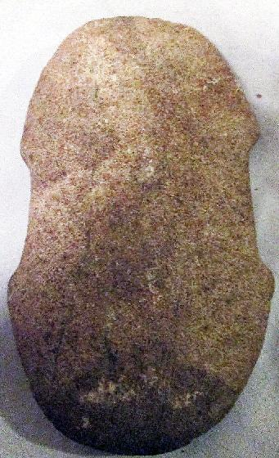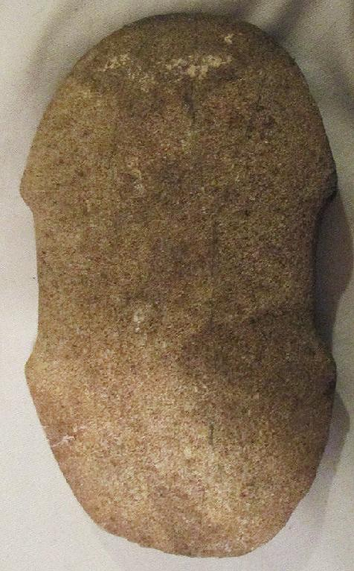

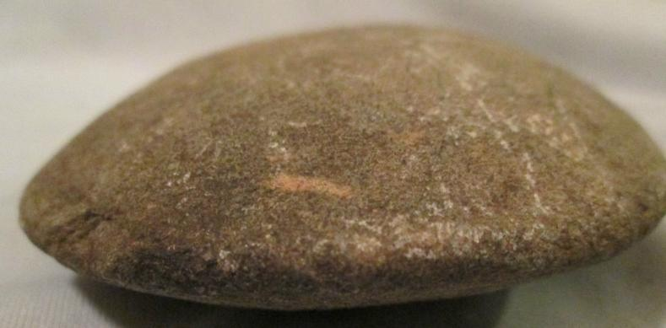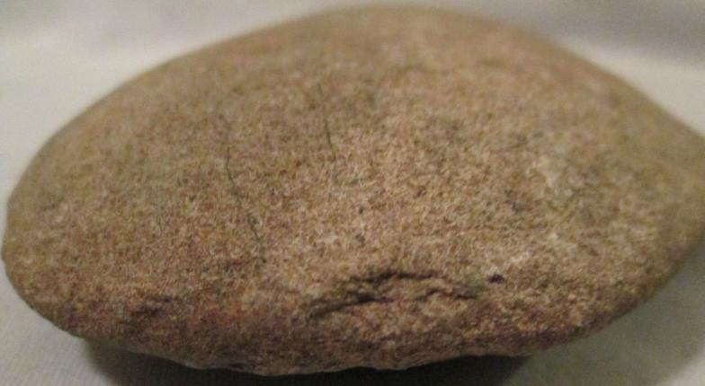

# Order details

## Sales order

Sold by [antiquesatozz](http://myworld.ebay.com/antiquesatozz) ( [447](http://feedback.ebay.com/ws/eBayISAPI.dll?ViewFeedback&userid=antiquesatozz) )

### Delivery package 1 of 1

Estimated delivery Wednesday, Dec 30, 2015

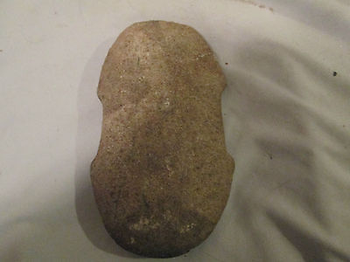

#### [Pre-Columbian TAINO Axe Head](http://www.ebay.com/itm/331712531625)

|  |  |
| --- | --- |
| Item price | $175.00 |
| Quantity | 1 |
| Item number | 331712531625 |
| Shipping service | Economy Shipping |

## Shipping address

Ralph J Coffman Jr

149 Atlantic Ave

Swampscott MA 01907-2427

United States

## Order total

|  |  |
| --- | --- |
| Subtotal | $175.00 |
| Shipping | $15.95 |

**Total**

$190.95

Order placed on

Saturday, Dec 19, 2015

Payment method

PayPal

Payment date

Saturday, Dec 19, 2015

