DIS-AM,C-Taino-Celt-Petaloid

**LARGE TAINO STONE CELT**

Country: Hispaniola, Caribbean

Period: 800 - 1500 A.D.

Size: 7-3/4 (19.5 cm) L

Description:

Large cream-green stone, petaloid celt, beautifully fashioned and retains its original matte finish.

The slender body terminates in a fine point, convex faces and rounded cutting edge tapers to a

sharp blade edge.  Nice smooth surface with some mineral deposits.  Some scratches on surface

otherwise intact.  A free custom display stand is included.

(Please note that it photographs more brown than cream.)

Provenance: Private collection, NYC

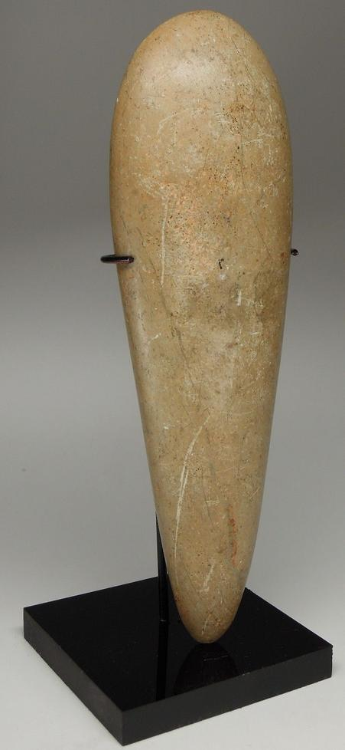 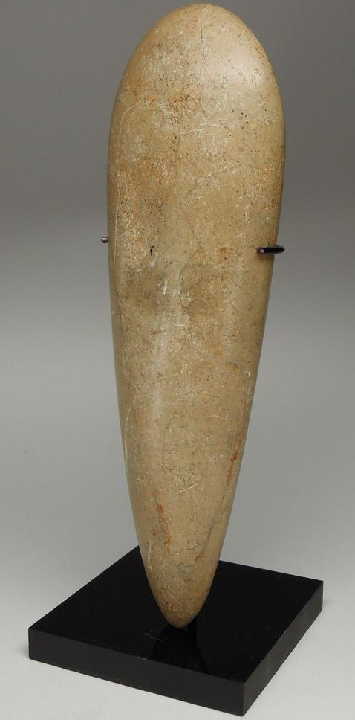 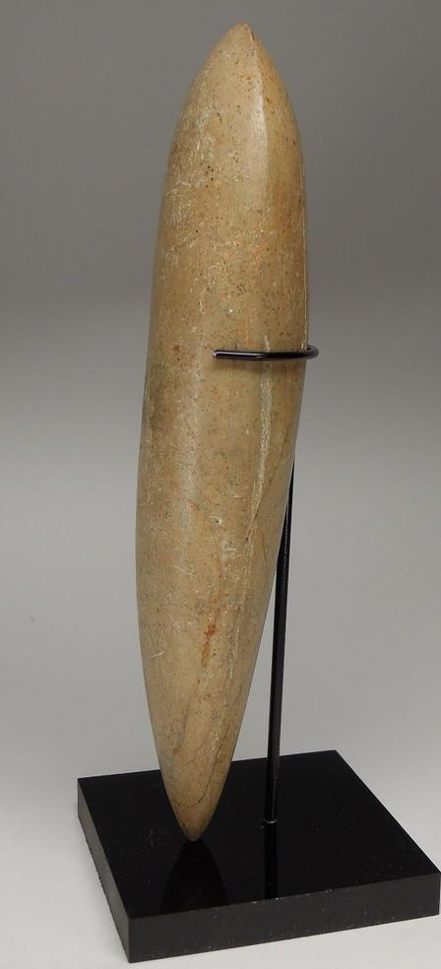 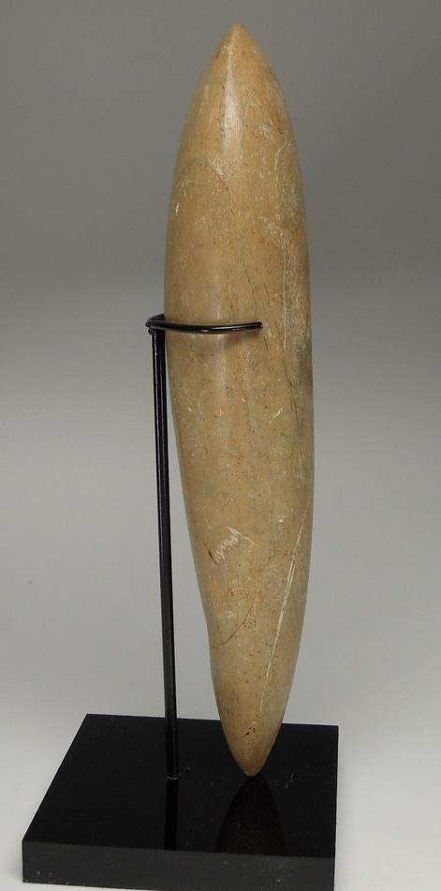 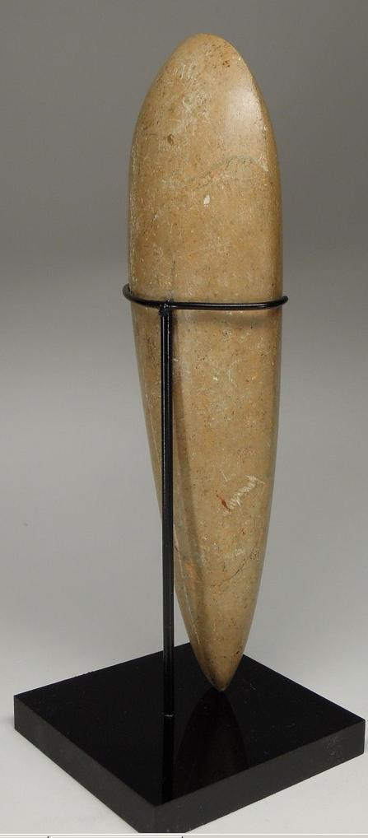 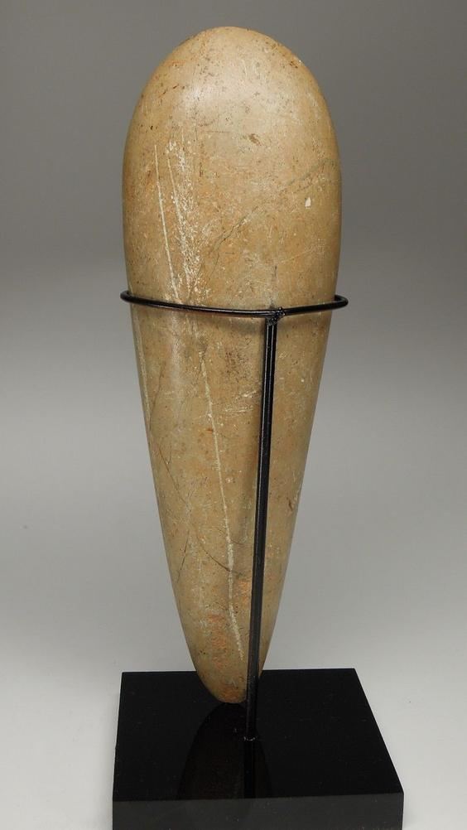

### Delivery package 1 of 1

Estimated delivery Thursday, Dec 24, 2015 - Wednesday, Dec 30, 2015

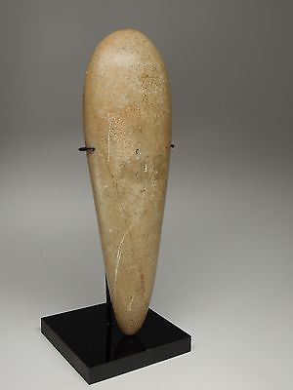

#### [PRE-COLUMBIAN TAINO STONE CELT - LARGE](http://www.ebay.com/itm/151891609333)

|  |  |
| --- | --- |
| Item price | $275.00 |
| Quantity | 1 |
| Item number | 151891609333 |
| Shipping service | USPS Priority Mail Large Flat Rate Box |

## Shipping address

Ralph J Coffman Jr

149 Atlantic Ave

Swampscott MA 01907-2427

United States

## Order total

|  |  |
| --- | --- |
| Subtotal | $1,071.94 |
| Shipping | $21.94 |

**Total**

$1,093.88