DIS-AM,C-Taino-Cemi-Anthropomorphic-Frog

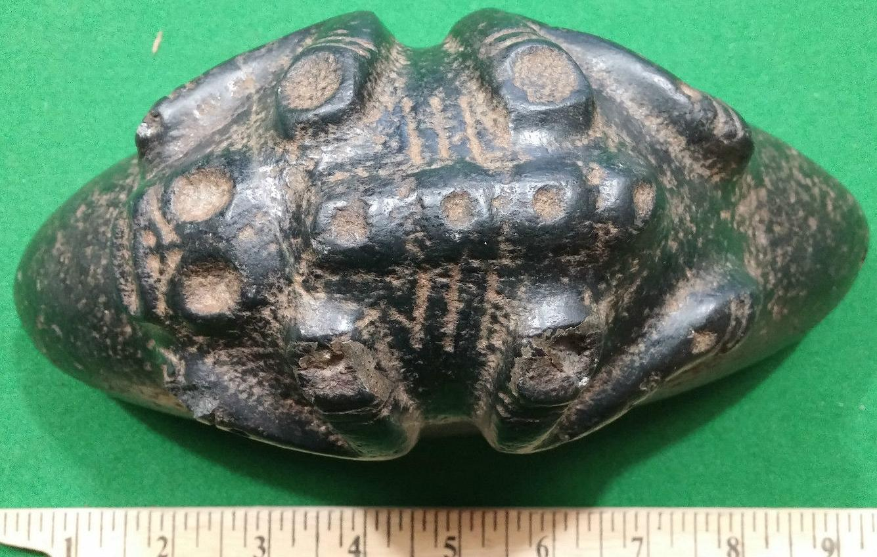

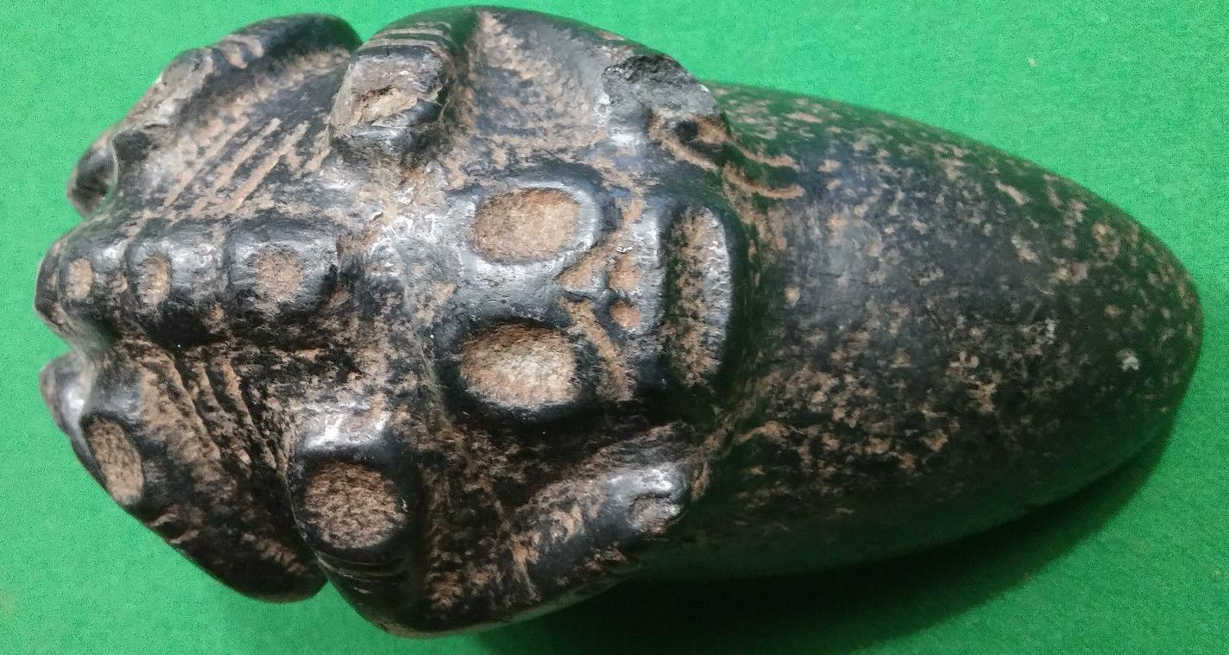

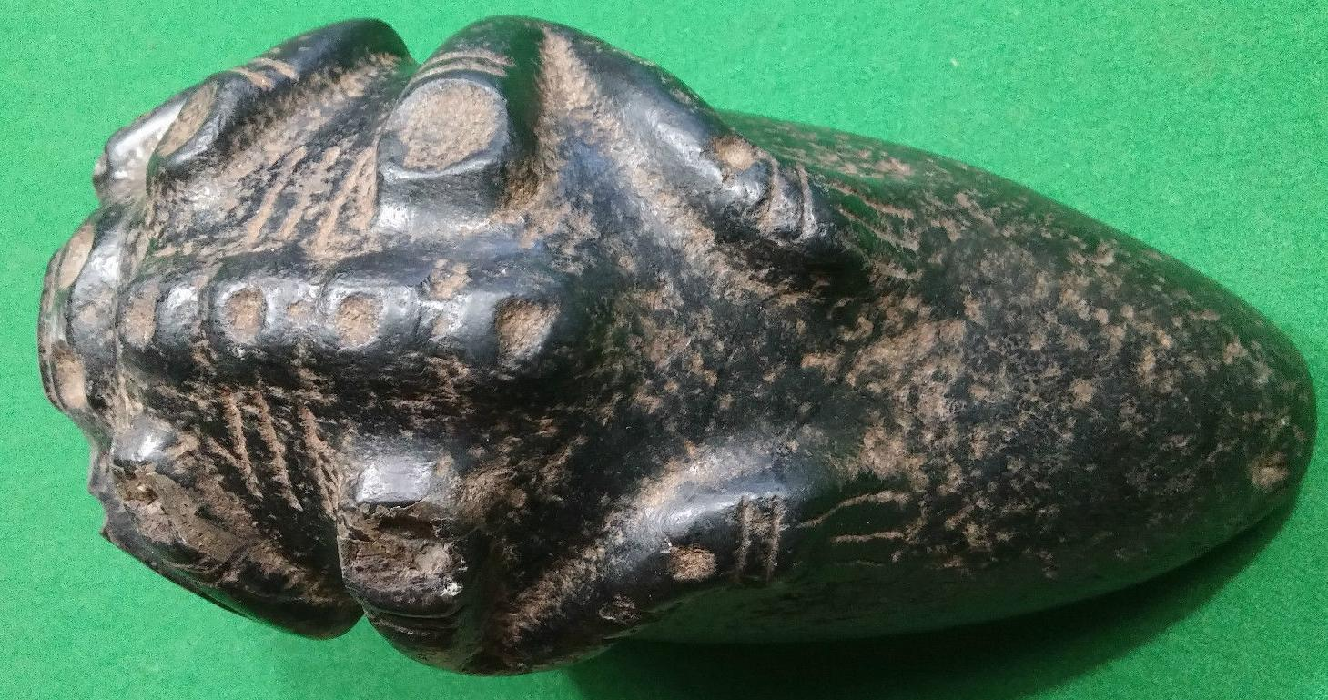

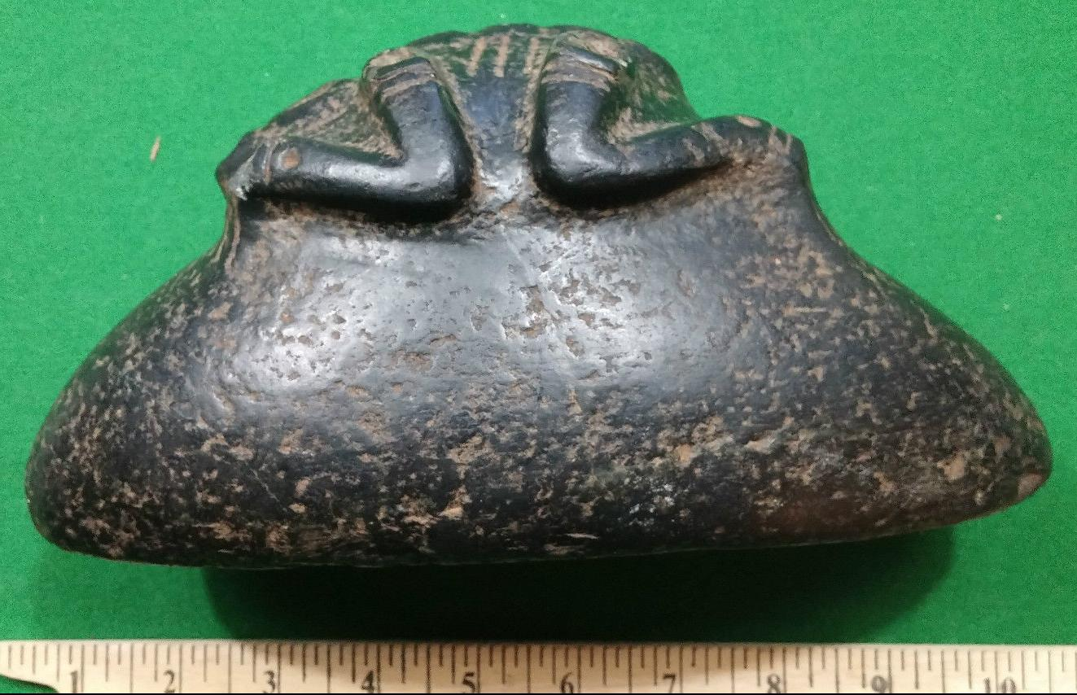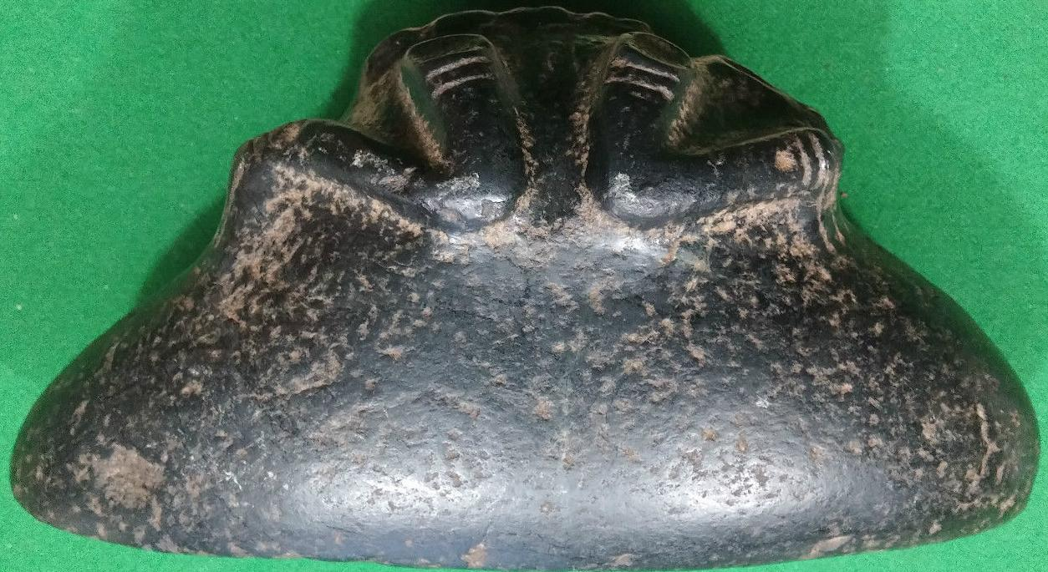

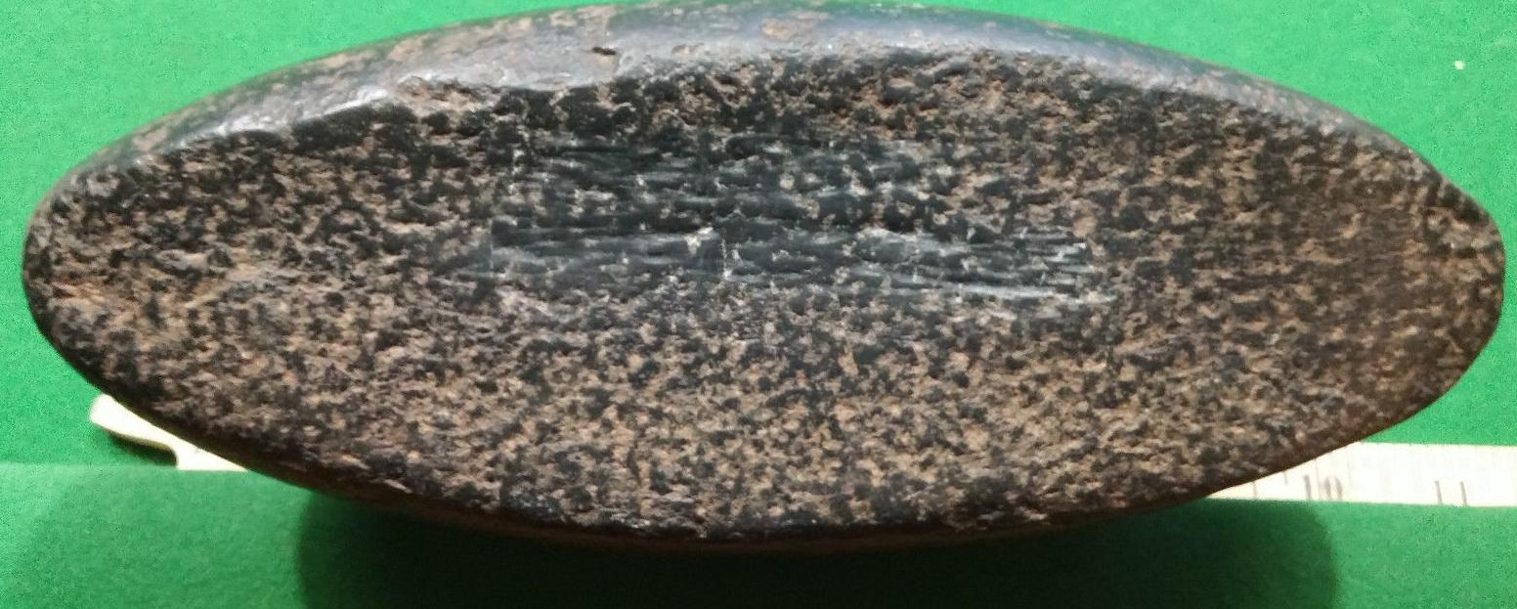

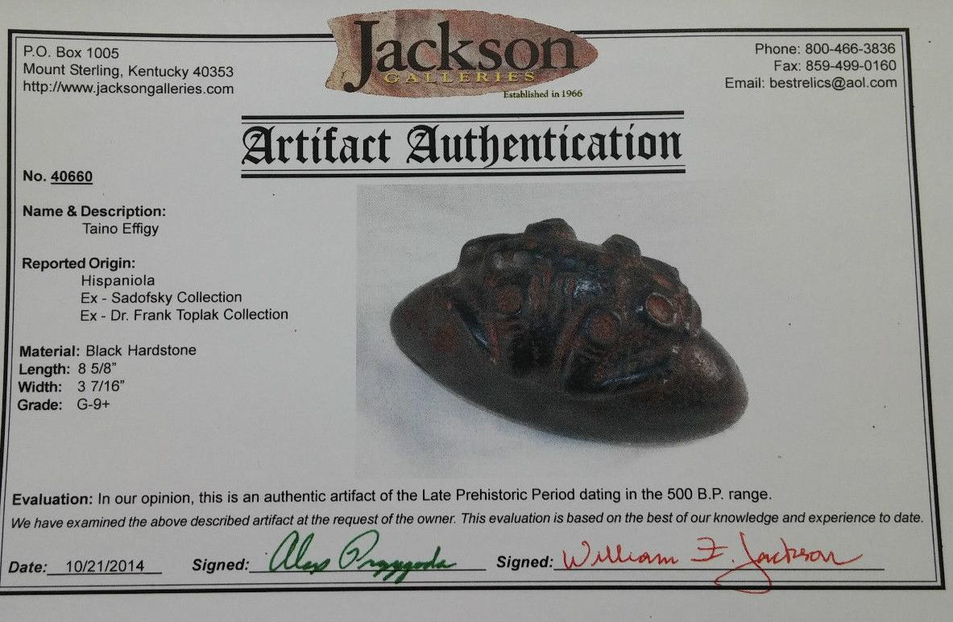

Sold by [user1billion](http://myworld.ebay.com/user1billion) ( [778](http://feedback.ebay.com/ws/eBayISAPI.dll?ViewFeedback&userid=user1billion) )

### Delivery package 1 of 1

Estimated delivery Monday, Jan 11, 2016 - Monday, Jan 18, 2016

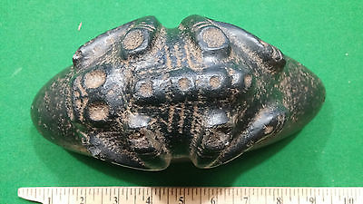

#### [Taino Stone Carving - Pre Columbian - Jackson Gallery Papers](http://www.ebay.com/itm/272084620456)

|  |  |
| --- | --- |
| Item price | $750.00 |
| Quantity | 1 |
| Item number | 272084620456 |
| Shipping service | Standard Int'l Shipping |

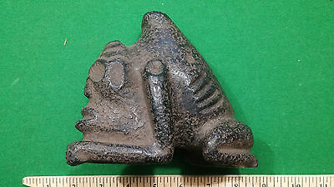

#### [Taino Stone Carving - Pre Columbian](http://www.ebay.com/itm/272084622152)

|  |  |
| --- | --- |
| Item price | $281.00 |
| Quantity | 1 |
| Item number | 272084622152 |
| Shipping service | Standard Int'l Shipping |