DIS-AM,C-Taino-Cemi-Woodpecker

7.25 in high

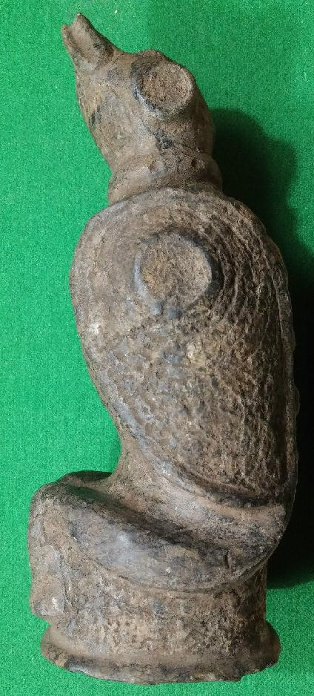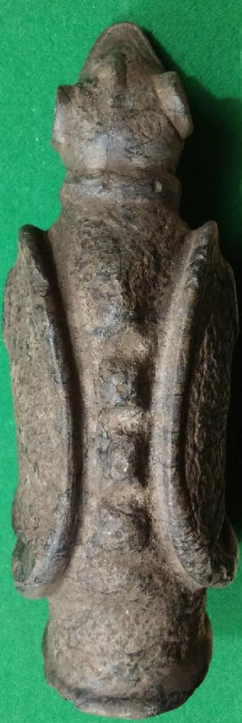

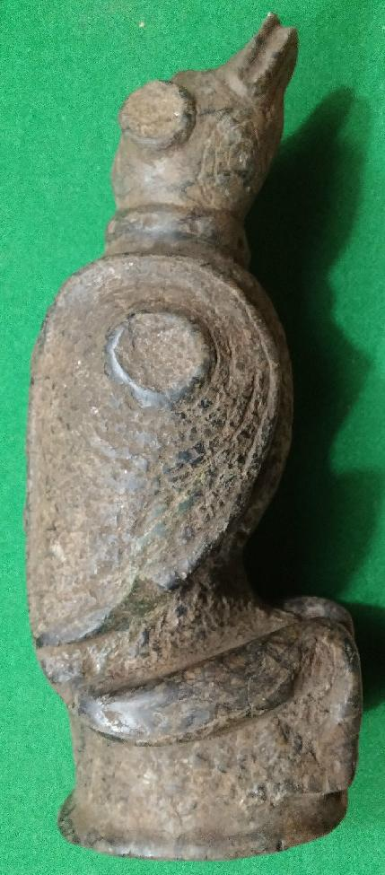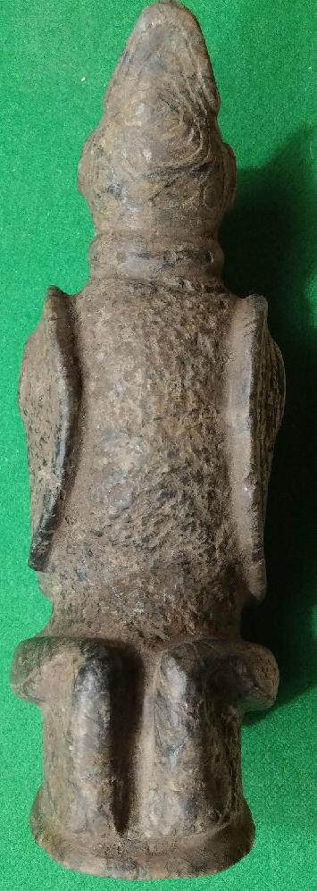

# Order details

## Sales order

Sold by [user1billion](http://myworld.ebay.com/user1billion) ( [833](http://feedback.ebay.com/ws/eBayISAPI.dll?ViewFeedback&userid=user1billion) )

### Delivery package 1 of 1

Delivered on Thursday, Mar 31, 2016

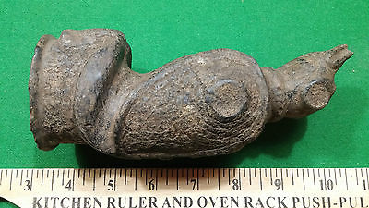

#### [Taino Stone Bird Hand Maul (Grinder) - Pre Columbian](http://www.ebay.com/itm/272153334517)

|  |  |
| --- | --- |
| Item price | $249.00 |
| Quantity | 1 |
| Item number | 272153334517 |
| Shipping service | Standard Int'l Shipping |

## Sales order

Sold by [timelesstfc](http://myworld.ebay.com/timelesstfc) ( [353](http://feedback.ebay.com/ws/eBayISAPI.dll?ViewFeedback&userid=timelesstfc) )

### Delivery package 1 of 1

Delivered on Wednesday, Mar 23, 2016

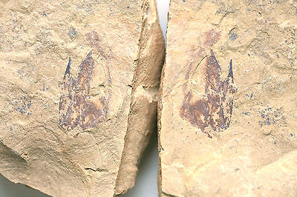

#### [Timelesstfc - Early Cambrian Anomalocaris tooth-like prongs fossil](http://www.ebay.com/itm/301886803407)

|  |  |
| --- | --- |
| Item price | $150.00 |
| Quantity | 1 |
| Item number | 301886803407 |
| Shipping service | Economy Shipping |

## Sales order

Sold by [goldensestateser...](http://myworld.ebay.com/goldensestateservices2) ( [525](http://feedback.ebay.com/ws/eBayISAPI.dll?ViewFeedback&userid=goldensestateservices2) )

### Delivery package 1 of 1

Delivered on Tuesday, Mar 15, 2016

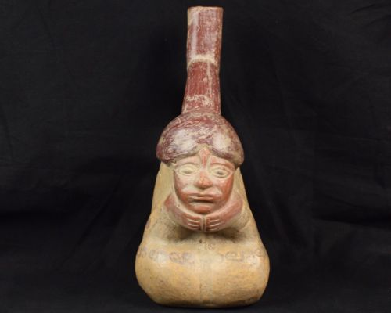

#### [Pre Columbian Vessel Human Figure Replica? Unknown](http://www.ebay.com/itm/162002468567)

|  |  |
| --- | --- |
| Item price | $74.95 |
| Quantity | 1 |
| Item number | 162002468567 |
| Shipping service | USPS Priority Mail |

## Shipping address

Ralph J Coffman Jr

149 Atlantic Ave

Swampscott MA 01907-2427

United States

## Order total

|  |  |
| --- | --- |
| Subtotal | $473.95 |
| Shipping | $54.40 |

**Total**

$528.35

Order placed on

Friday, Mar 11, 2016

Payment method

PayPal

Payment date

Friday, Mar 11, 2016