DIS-AM,C-Taino-Cemí-Bird-Dove

Ceremonial *cemí* carved from fine-grained basalt in the form of possibly a dove. Length: 9 1/8 in.

The wings provide three geometric forms: concentric circles for the sun god, triangles for the *conucos* or yucca mounds the source of sacred food, and spirals for the passage of wind and rain in the *hurrican* season to fructify the earth with water. In a lost mythology the bird sculptured here (probably a dove) was possibly the harbinger of the coming of the rainy *hurrican* season.

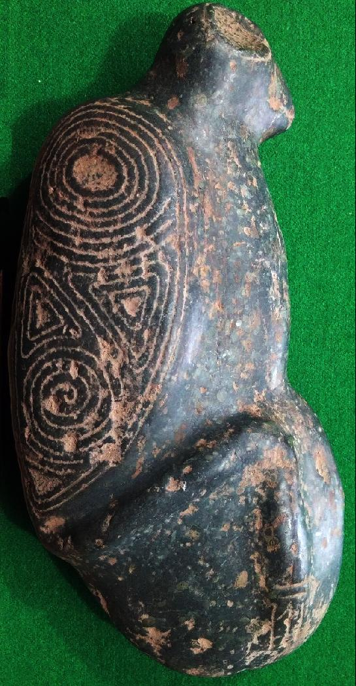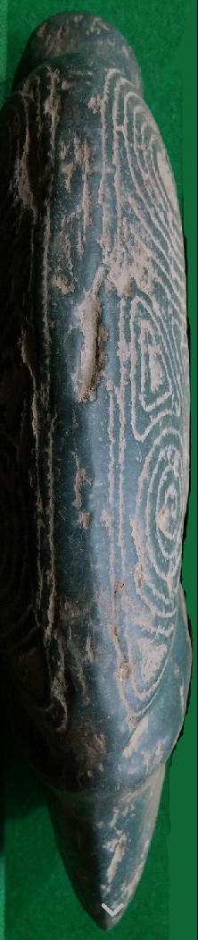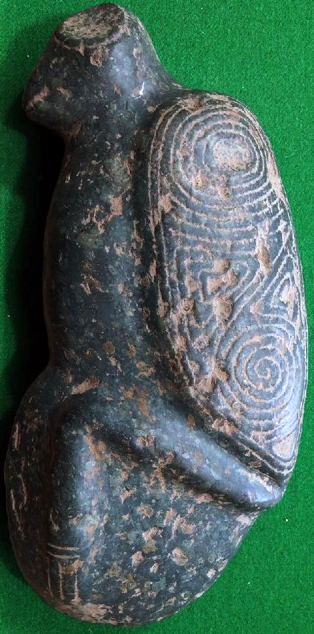

# Order details

## Sales order

Sold by [user1billion](http://myworld.ebay.com/user1billion) ( [787](http://feedback.ebay.com/ws/eBayISAPI.dll?ViewFeedback&userid=user1billion) )

### Delivery package 1 of 1

Estimated delivery Tuesday, Jan 26, 2016 - Tuesday, Feb 2, 2016

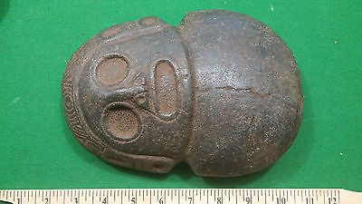

#### [Taino Stone Carving - Pre Columbian Very Large Double Edged Axe Head](http://www.ebay.com/itm/272098227060)

|  |  |
| --- | --- |
| Item price | $449.00 |
| Quantity | 1 |
| Item number | 272098227060 |
| Shipping service | Standard Int'l Shipping |

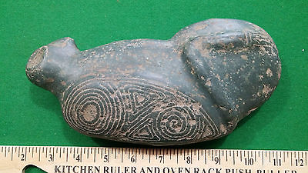

#### [Taino Stone Carving Axe Head - Pre Columbian](http://www.ebay.com/itm/272098227121)

|  |  |
| --- | --- |
| Item price | $259.00 |
| Quantity | 1 |
| Item number | 272098227121 |
| Shipping service | Standard Int'l Shipping |

## Shipping address

Ralph J Coffman Jr

149 Atlantic Ave

Swampscott MA 01907-2427

United States

## Order total

|  |  |
| --- | --- |
| Subtotal | $708.00 |
| Shipping | $39.90 |

**Total**

$747.90