DIS-AM,C-Taino-Cemí-Turkey-

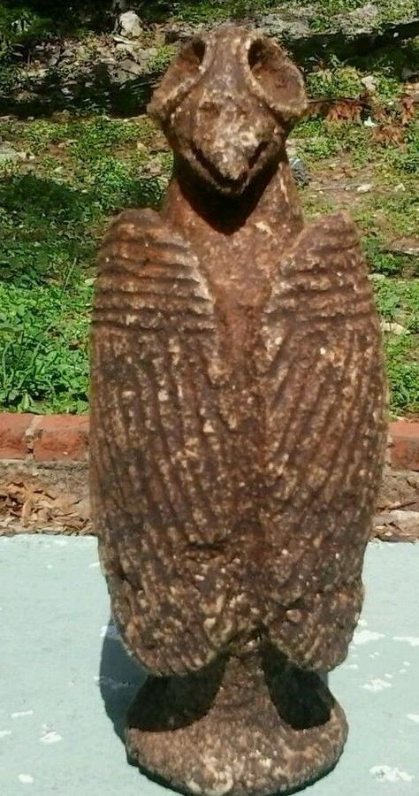

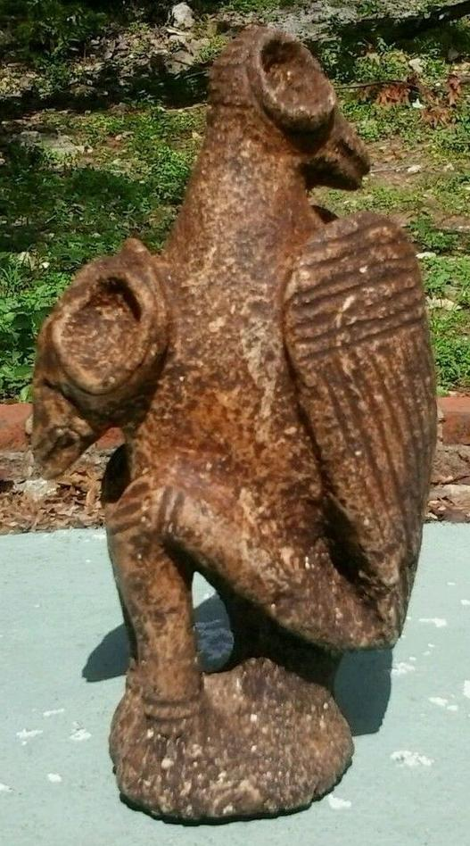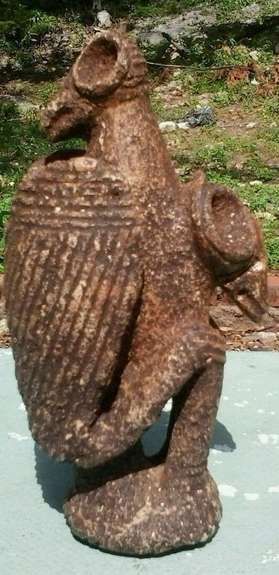

Estimated delivery Thursday, Mar 17, 2016 - Tuesday, Mar 22, 2016

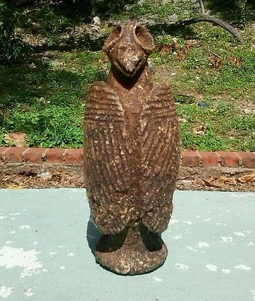

#### [Taino Stone Cemi Two Heads Figure Pre Columbian](http://www.ebay.com/itm/272159643073)

|  |  |
| --- | --- |
| Item price | $300.00 |
| Quantity | 1 |
| Item number | 272159643073 |
| Shipping service | Expedited Shipping from outside US |

## Shipping address

Ralph J Coffman Jr

149 Atlantic Ave

Swampscott MA 01907-2427

United States

## Order total

|  |  |
| --- | --- |
| Subtotal | $300.00 |
| Shipping | $90.00 |

**Total**

$390.00

Order placed onMonday, Mar 14, 2016 Payment methodPayPal Payment dateMonday, Mar 14, 201