DIS-AM,C-Taino-Pendant-Bird-Human

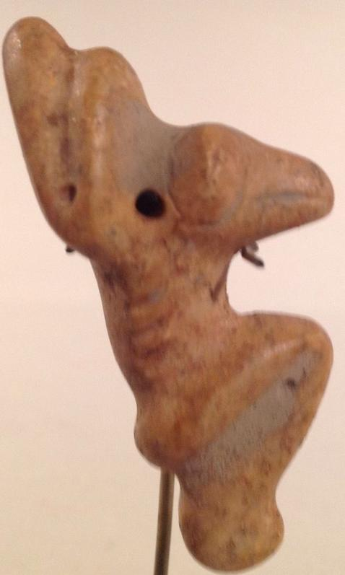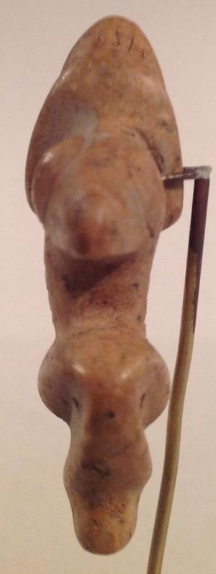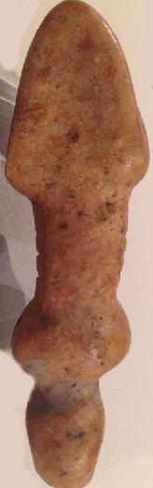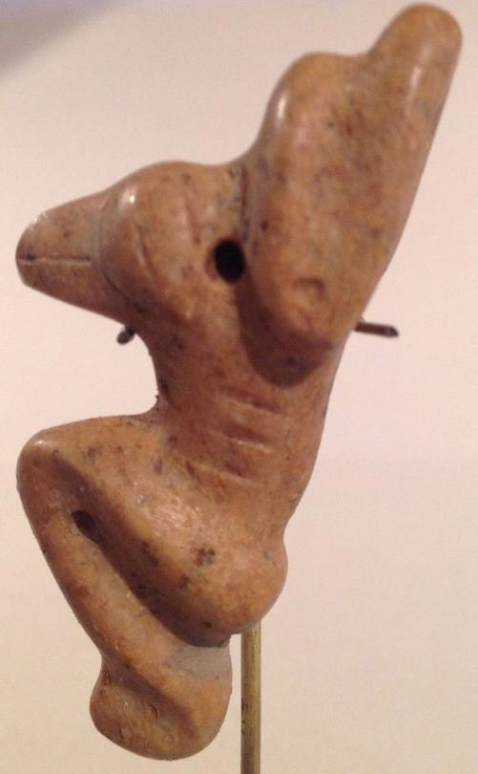

### Delivery package 1 of 1

Estimated delivery Wednesday, Dec 23, 2015 - Monday, Dec 28, 2015

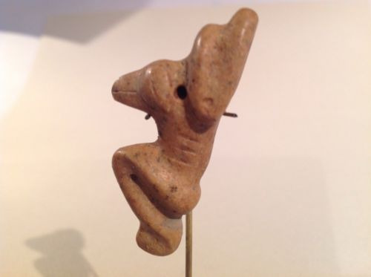

#### [Taino Stone Pendant, Bird-Human Transformation, Pre Columbian](http://www.ebay.com/itm/262187077871)

|  |  |
| --- | --- |
| Item price | $160.50 |
| Quantity | 1 |
| Item number | 262187077871 |
| Shipping service | USPS Priority Mail |

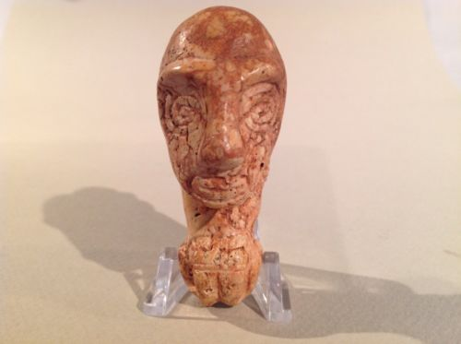

## Shipping address

Ralph J Coffman Jr

149 Atlantic Ave

Swampscott MA 01907-2427

United States

## Order total

|  |  |
| --- | --- |
| Subtotal | $465.50 |
| Shipping | Free |

**Total**

$465.50

#### [Taino Pendant Anthropic Figure, Pre Columbian](http://www.ebay.com/itm/262187093894)

|  |  |
| --- | --- |
| Item price | $305.00 |
| Quantity | 1 |
| Item number | 262187093894 |
| Shipping service | Economy Shipping |