DIS-AM,C-Taino-Pendants-2015-1-16

The pendant appears to be made of Jasper and is made of smooth even fine grained stone. The face is gently worn and may have been rubbed during ceremony, though features are clearly represented. A bulge at the waist indicates fertility, as well as the raised hands behind head. Typical female birthing pose. Measures 7.2cm or 2.8". Originally from the island of Hispaniola and dates ca. 1000-1500 C.E.

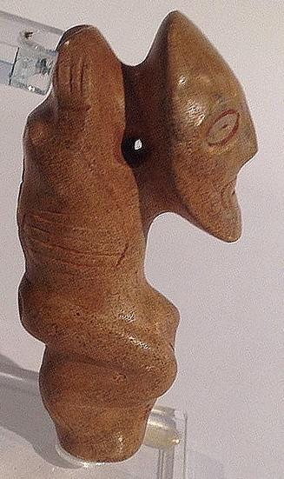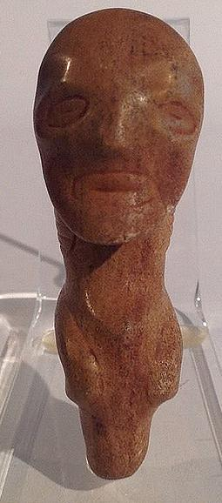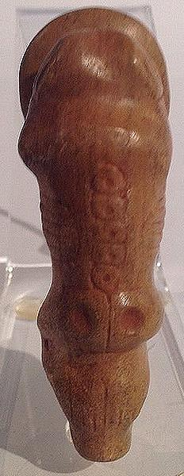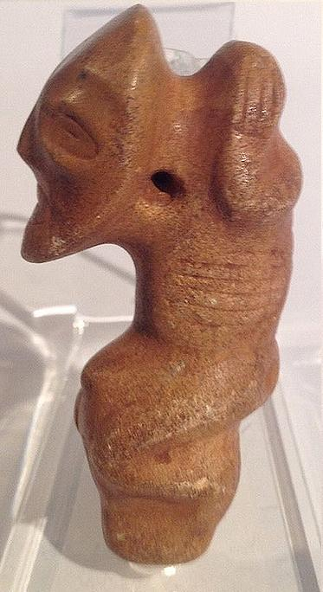

"V" shaped symbols engraved on front and back are symbolic of feminine pubic area. Vertical lines between legs are simplistic symbols for the vagina. The bird is associated with the sky and rain and is an assistant to Atabey goddess of fresh water and rain. Made of fine gray hard stone. Measures 6.2 cm. or 2.4 in. Originally from the Dominican Republic and dating ca. 1000-1500 C.E.

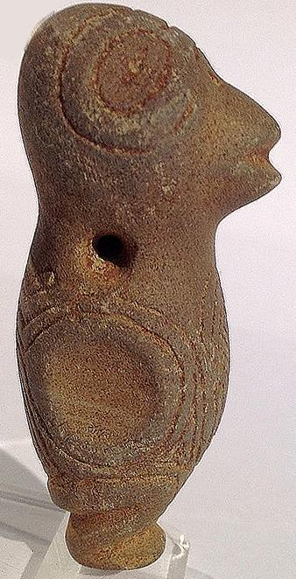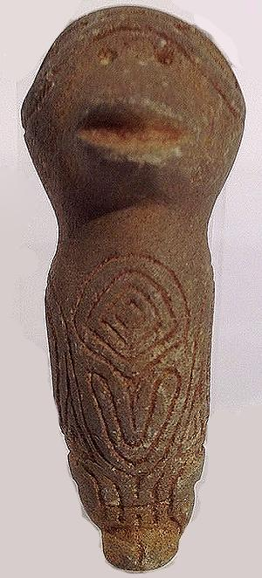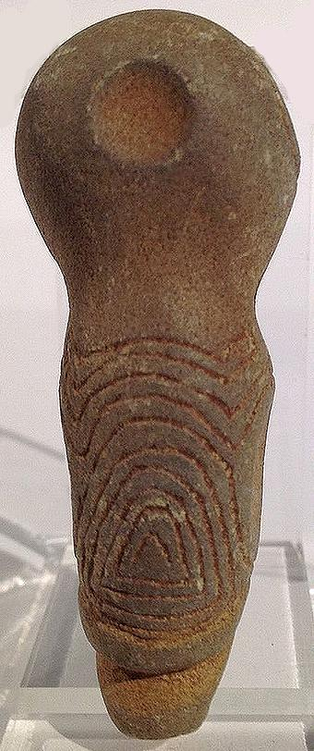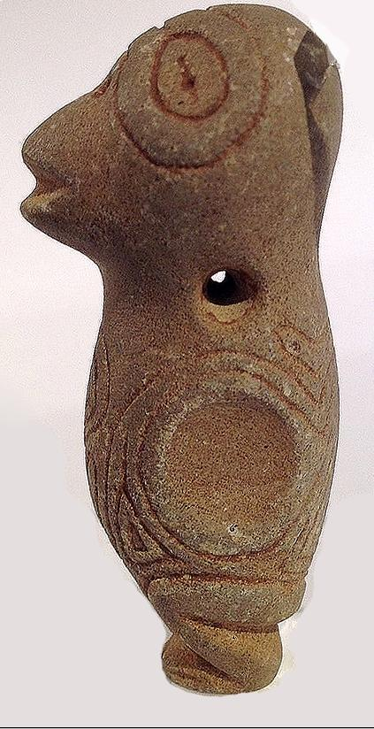

Attractive, tan green serpentine with dark spots of color. Subject is kneeling as if in reverent position. Head is tilted skyward with mouth open as if appealing to the gods. Very object of devotion to worldly deities. Nice head band. Shoulders form v at back. Measures 6.2 cm. or 2.4 in. Originally from the Dominican Republic, dating ca. 1000-1500 C.E.

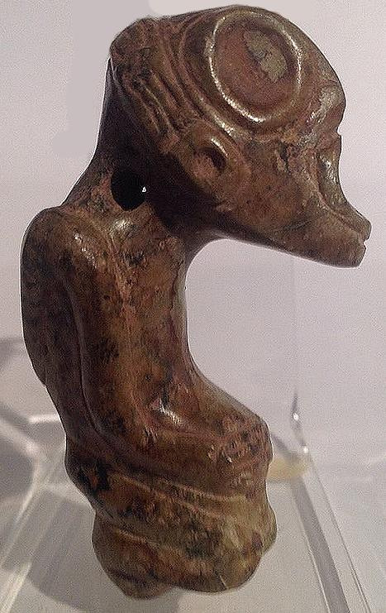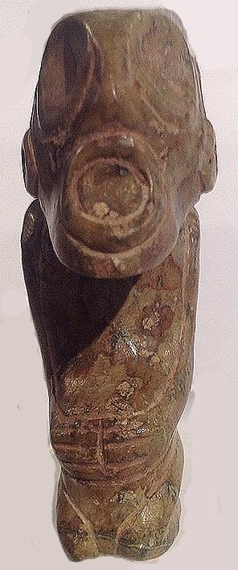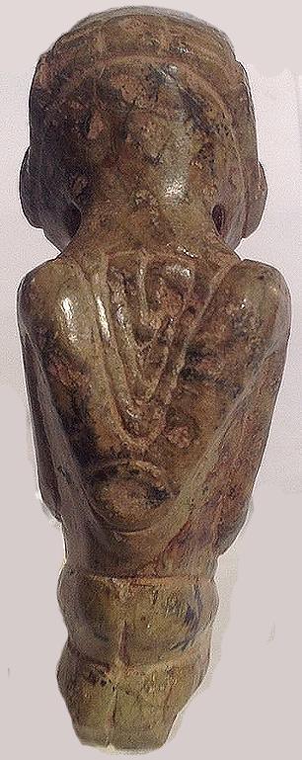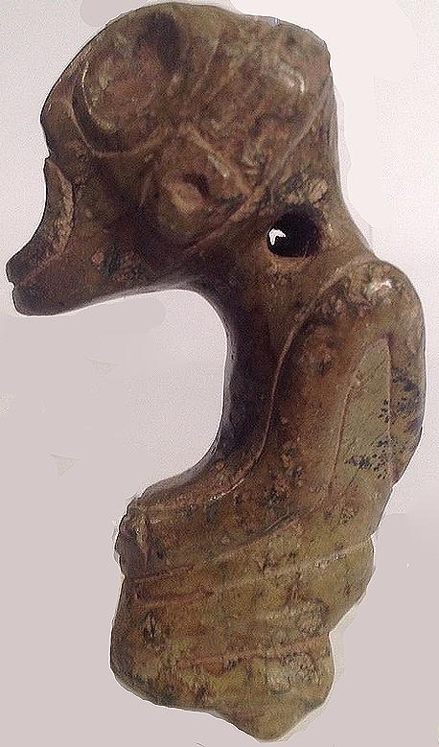

Made of highly polished marble, depicting a fertile cacique. The color at the end of the penis seems odd, so guessing he had extension surgery. I will submit this as a restoration but not sure. Subject holds knees and has a broad proud smile, I would too. Measures 6.4cm or 2.5". Originally from the Dominican Republic. Dating ca. 1000-1500 C.E.

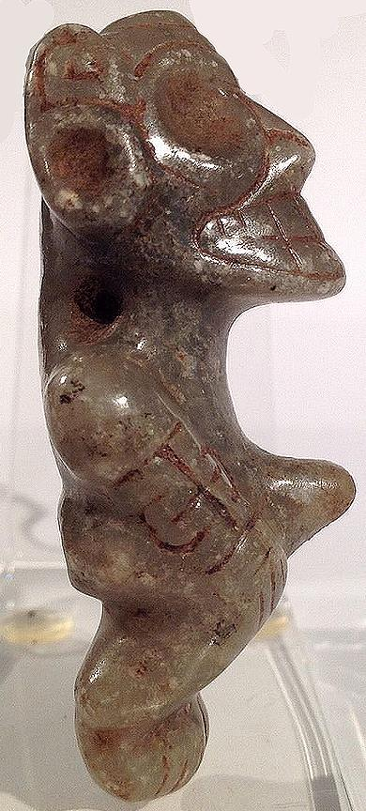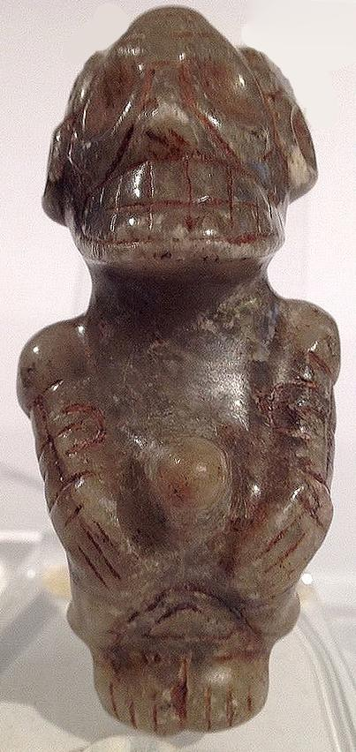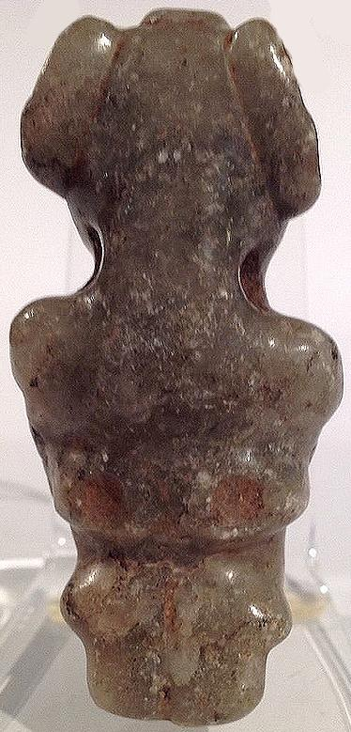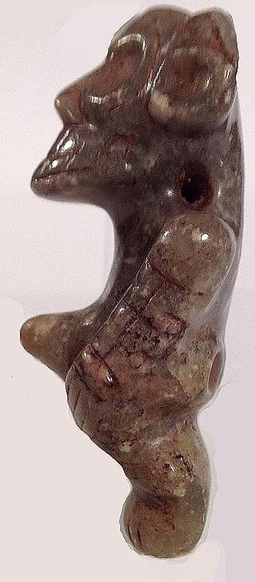

This piece is made of silicified sandstone. A little grainy to the touch. Pronounced birthing bulge, hands pushing belly and grimacing face all typical symbolic references for Atabey goddess of fertility. Measures 7.0 cm. or 2.7 in. Originally from the Dominican Republic and dating ca. 1000-1500 C.E.

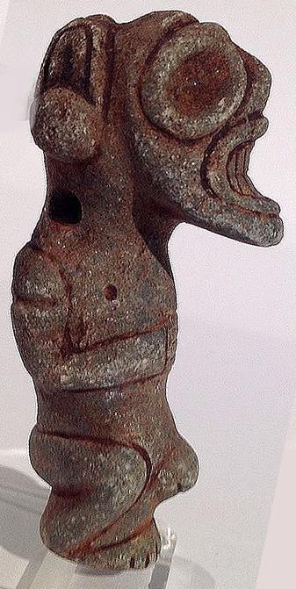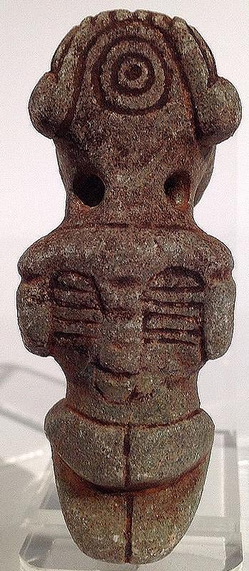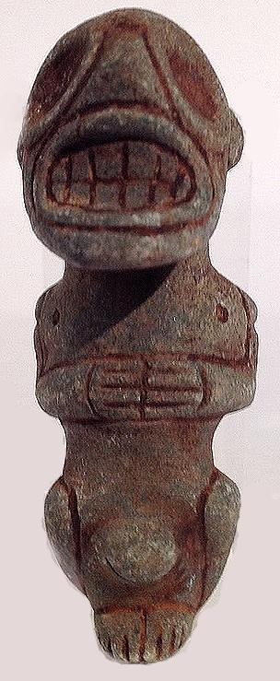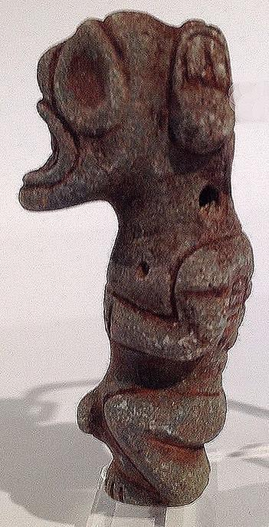

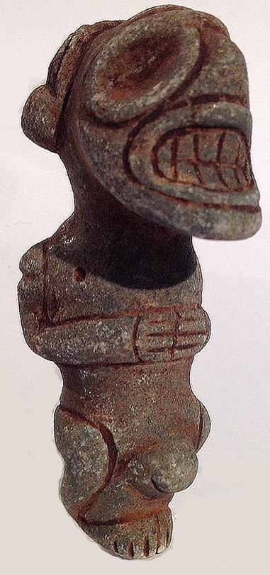

This pendant is made of manatee bone, likely from a jaw or mandible. The owl face motif has spiral eyes likely indicating a hallucinogenic trance state in which spirals were one of the entoptic images visually experienced. Birds, especially nocturnal birds such as owls, were the shaman’s ally to help him navigate the spiritual universe especially during the darkness of night. When the piece is turned 180 degrees another face can be seen. This duality of conjoined images is a common Taino design feature often occurring in spiritual art. The pendant measures 8.0 cm. or 3.1 in. and is attributed to the Dominican Republic. Dating ca. 1000-1500 C.E.

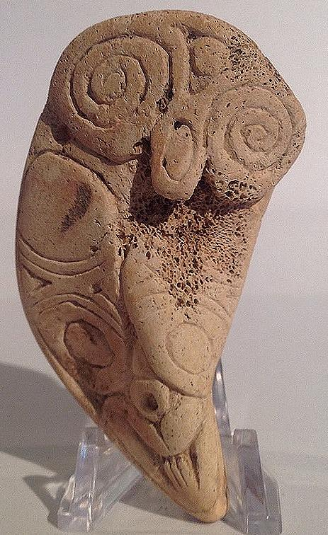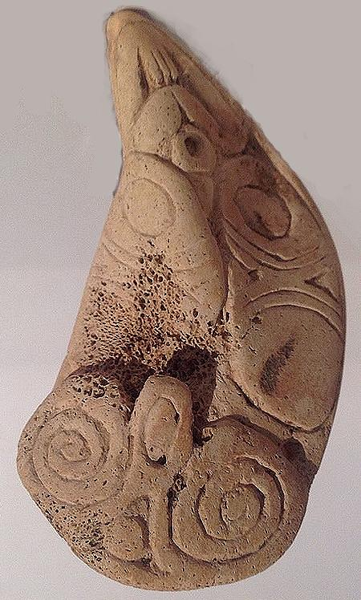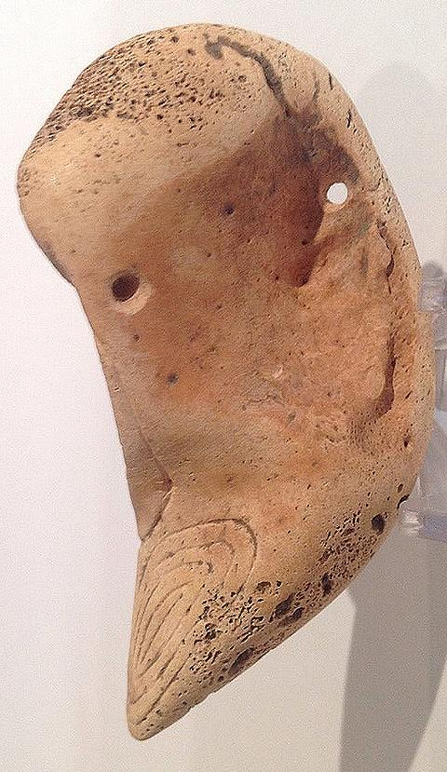

Rather small manatee bone pendant depicting a goddess pushing her belly and vaginal symbol at base. Nice little compact figure. Length 4.4 cm. or 1.7 in.originally from Hispaniola. Dating ca. 1000-1500 C.E.

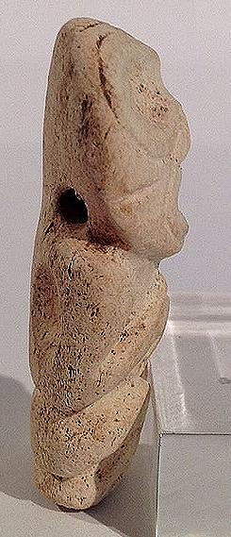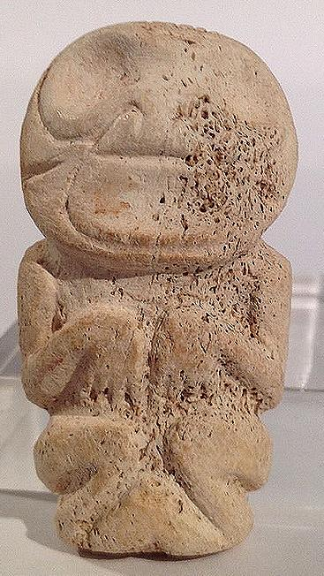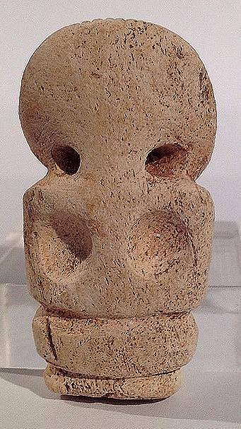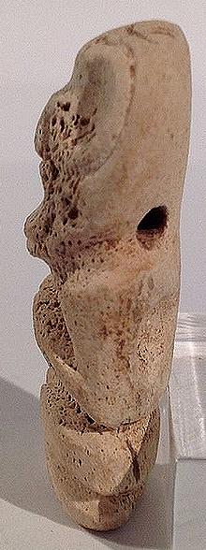

Female symbolic details define the bird mother: typical birthing pose with hands on belly pushing and baby bulge between knees. Birds are closely associated with femininity because of their care for the young. The little bird mother is well conceived and fully decorated front and back. A secondary bird face appears on beak. She is likely made of naturally stained marble. Length is 5.2 cm. or 2 in. 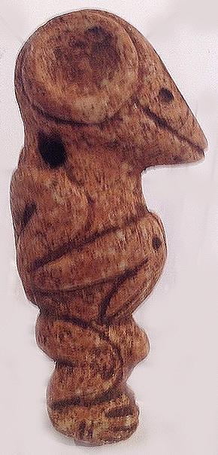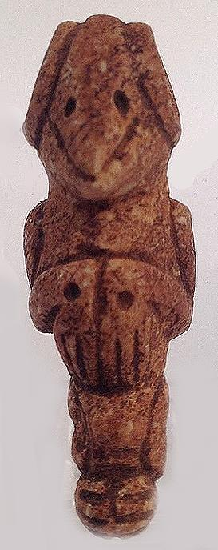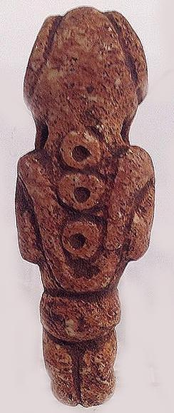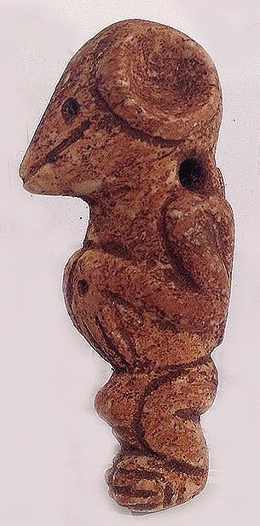

Sold by [flapast](http://myworld.ebay.com/flapast) ( [13311](http://feedback.ebay.com/ws/eBayISAPI.dll?ViewFeedback&userid=flapast) )

### Delivery package 1 of 1

Estimated delivery Monday, Jan 25, 2016

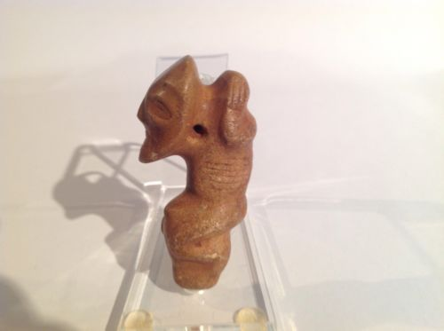

#### [Taino Stone Pendant Anthropic Female Figure, Pre Columbian](http://www.ebay.com/itm/252240642082)

|  |  |
| --- | --- |
| Item price | $112.50 |
| Quantity | 1 |
| Item number | 252240642082 |
| Shipping service | USPS First Class Package |

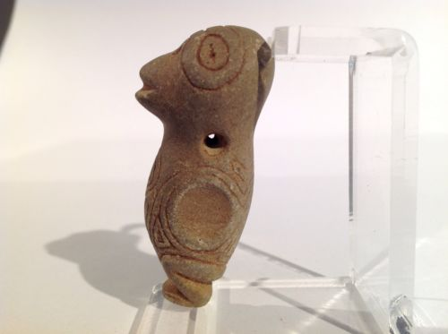

#### [Taino Stone Bird Woman Pendant, Pre Columbian](http://www.ebay.com/itm/252241215035)

|  |  |
| --- | --- |
| Item price | $75.00 |
| Quantity | 1 |
| Item number | 252241215035 |
| Shipping service | USPS First Class Package |

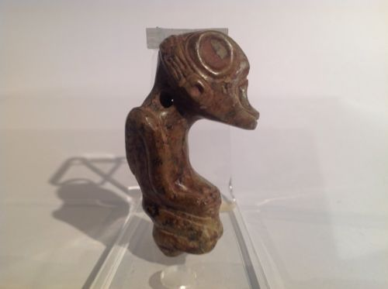

#### [Taino, Serpentine Pendant Anthropic Figure Pre Columbian](http://www.ebay.com/itm/262228120730)

|  |  |
| --- | --- |
| Item price | $190.27 |
| Quantity | 1 |
| Item number | 262228120730 |
| Shipping service | USPS First Class Package |

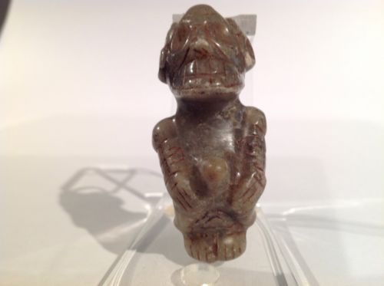

#### [Taino Marble Anthropic Cacique Pendant. Pre Columbian](http://www.ebay.com/itm/262228144371)

|  |  |
| --- | --- |
| Item price | $207.50 |
| Quantity | 1 |
| Item number | 262228144371 |
| Shipping service | USPS First Class Package |

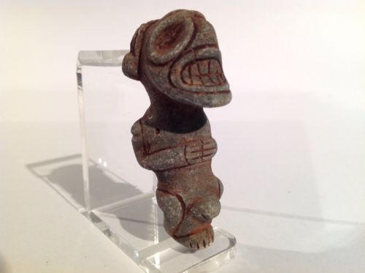

#### [Taino Stone Pendant, Atabey Goddess Of Fertility Pre Columbian](http://www.ebay.com/itm/262228662198)

|  |  |
| --- | --- |
| Item price | $132.50 |
| Quantity | 1 |
| Item number | 262228662198 |
| Shipping service | USPS First Class Package |

## Shipping address

Ralph J Coffman Jr

149 Atlantic Ave

Swampscott MA 01907-2427

United States

## Order total

|  |  |
| --- | --- |
| Subtotal | $867.77 |
| Shipping | $42.00 |

**Total**

$909.77

Order placed on

Saturday, Jan 16, 2016

Payment method

PayPal

Payment date

Saturday, Jan 16, 2016

Sold by [flapast](http://myworld.ebay.com/flapast) ( [13311](http://feedback.ebay.com/ws/eBayISAPI.dll?ViewFeedback&userid=flapast) )

### Delivery package 1 of 1

Estimated delivery Tuesday, Jan 26, 2016

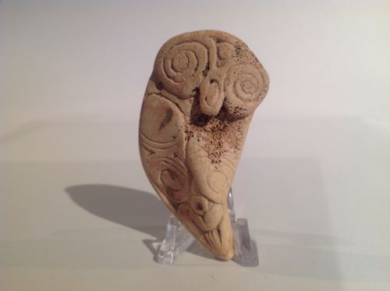

#### [Taino Large Bird Like Figural Pendant, Pre Columbian](http://www.ebay.com/itm/252240691373)

|  |  |
| --- | --- |
| Item price | $50.00 |
| Quantity | 1 |
| Item number | 252240691373 |
| Shipping service | Economy Shipping |

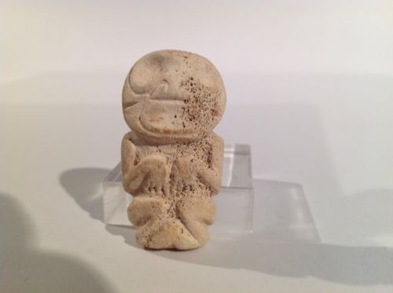

#### [Taino Anthropic Pendant, Female Goddess, Pre Columbian](http://www.ebay.com/itm/252241232950)

|  |  |
| --- | --- |
| Item price | $100.00 |
| Quantity | 1 |
| Item number | 252241232950 |
| Shipping service | Economy Shipping |

Sold by [flapast](http://myworld.ebay.com/flapast) ( [13311](http://feedback.ebay.com/ws/eBayISAPI.dll?ViewFeedback&userid=flapast) )

### Delivery package 1 of 1

Estimated delivery Monday, Jan 25, 2016

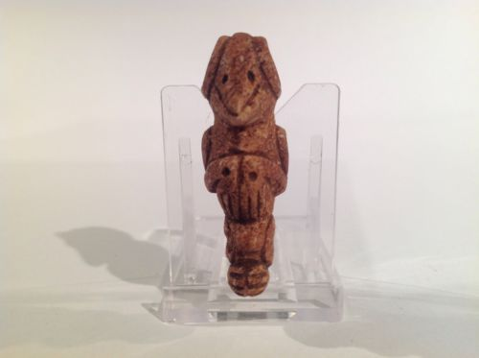

#### [Taino Stone Bird Mam (female) Transformation Pre Columbian](http://www.ebay.com/itm/252241262679)

|  |  |
| --- | --- |
| Item price | $70.00 |
| Quantity | 1 |
| Item number | 252241262679 |
| Shipping service | USPS First Class Package |

## Shipping address

Ralph J Coffman Jr

149 Atlantic Ave

Swampscott MA 01907-2427

United States

## Order total

|  |  |
| --- | --- |
| Subtotal | $70.00 |
| Shipping | $6.00 |

**Total**

$76.00

Order placed on

Saturday, Jan 16, 2016

Payment method

PayPal

Payment date

Saturday, Jan 16, 2016