DIS-AM,C-Taino-Snake-

The *Bohuitihu* priests of the patron mother goddess *Guabancex* when commissionedto visit the sick and infirmed, they would cover their faces with charcoal in order to assume the metaphoric pallor of the patients they were visiting. It is this metaphoric commonality the *Bohuitihu* assumed the disorder that would put them in the same psycho-physiological demeanor that they could then assume with the ill and then begin the process of mutual healing. The role of healing psychology was prominent in this endeavor. The connection with the mother goddess was essential also, since “These priests always carried the image of the *cemí* and were known by her name so they were called *cemís* as well *bhiu*” (Pané in Mendez 1957, I: 74). *Bohiqu*e is another name for the priest *bohuitihu*, derived from the phoneme *bohio*-house and *boa* –serpent. Since the priests received healing powers from snakes they relied on them when they were in danger, especially in the acts of healing the sick when they were required to travel outside of their bodies, as “the *cemís* came to their rescue in the form of serpents (Pané in Mendez 1957, I: 23). Therefore, this stone sculpture of a serpent would have been such a *cemí* that was brought to the place of healing, with the tail encircling a solar disc motif of the patron mother goddess *Guabancex*. It is also possible that the encircled tail also was a receptacle for some of the *cohoba* powder that was used in the purification ceremony.

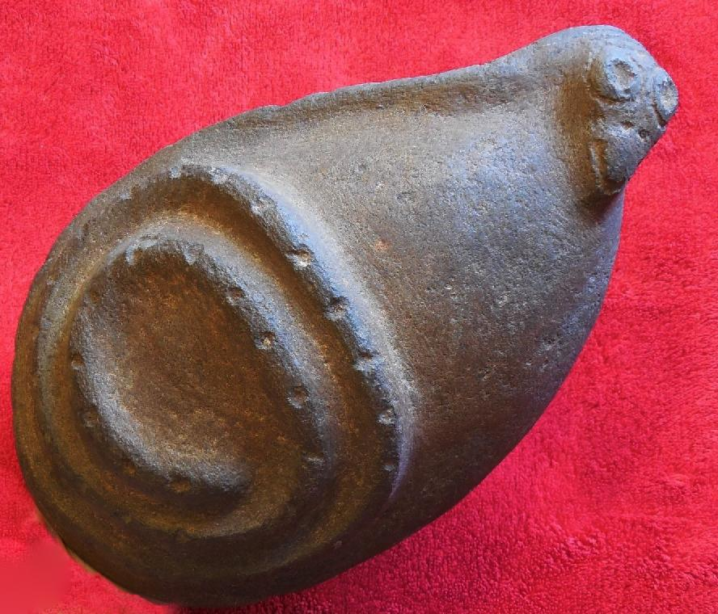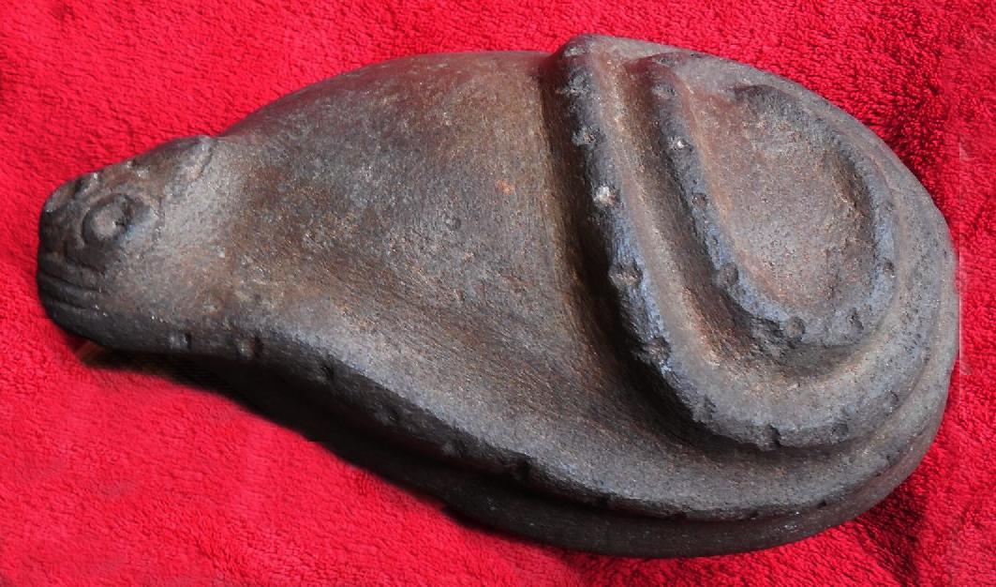

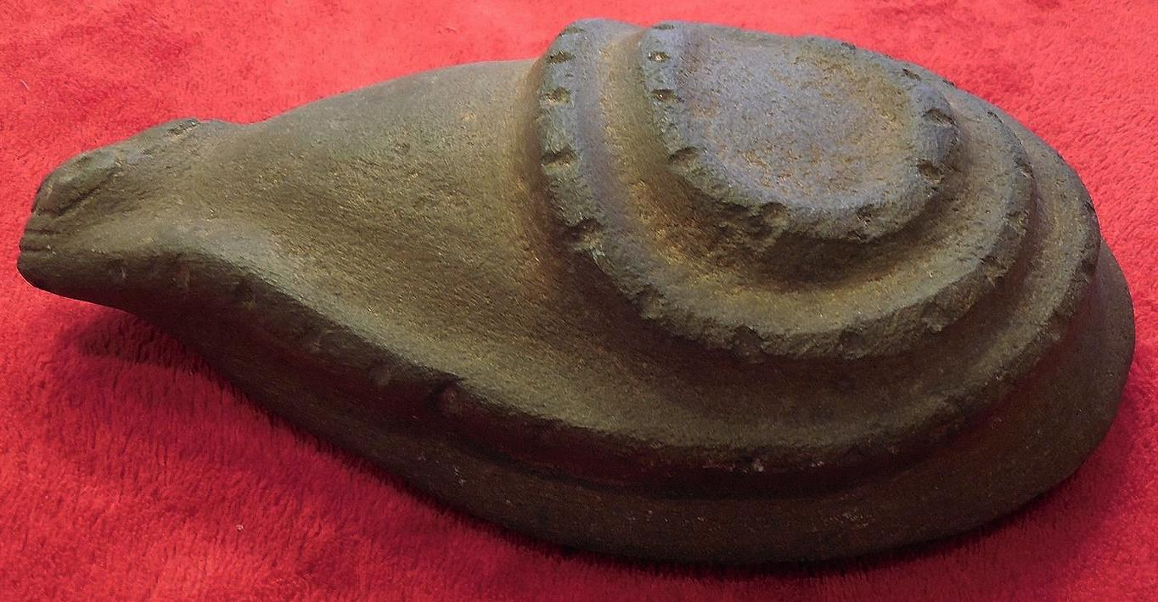

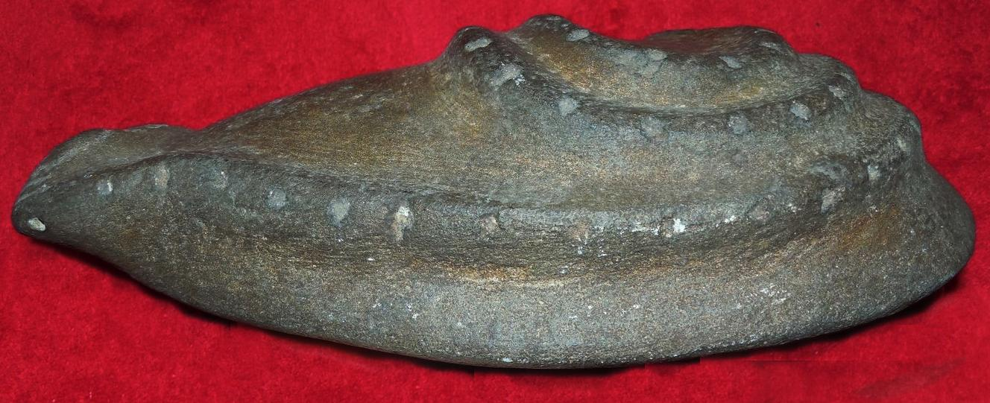

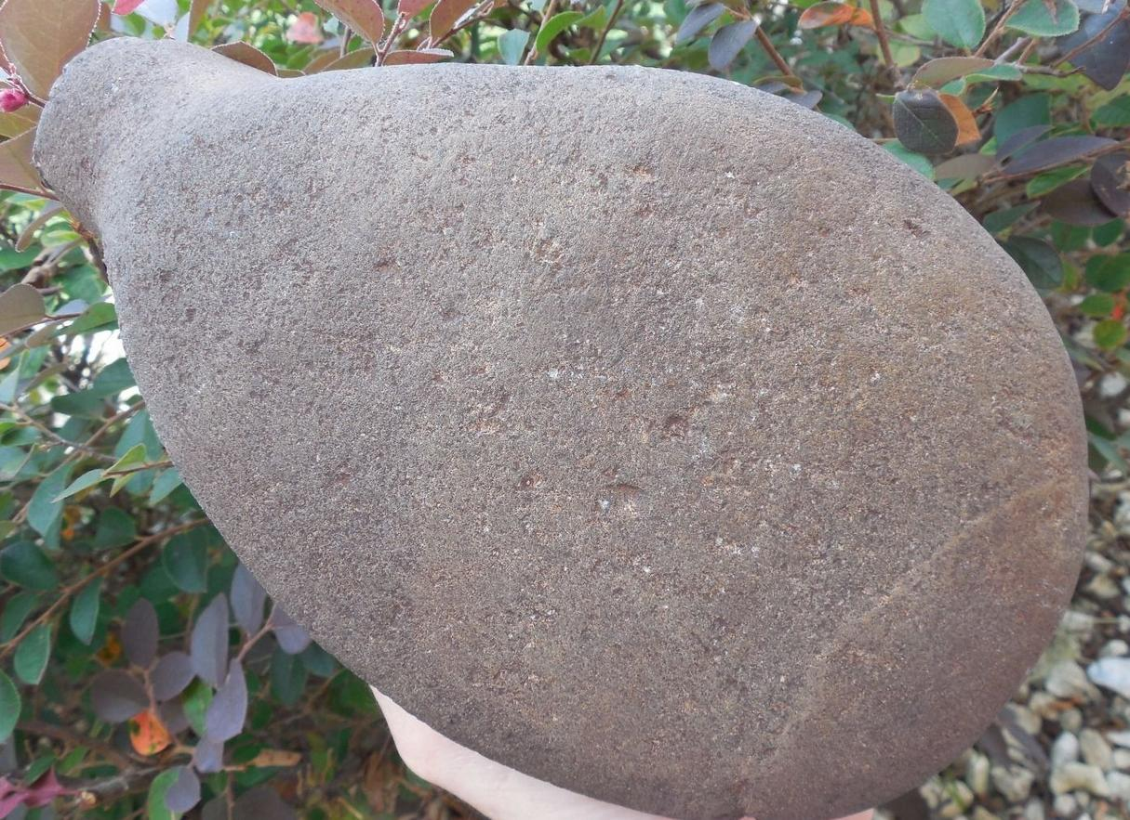

References

# Méndez, Eugenio Fernández. 1957. Crónicas de Puerto Rico desde la conquista hasta nuestros días. San Juan, Ediciones del Gobierno, Estado Libre Asociado de Puerto Rico, 1957.