DIS-AM,C-Taino-*Yucahuguamá*

Mask and Tripointer-Atlantika Collection.

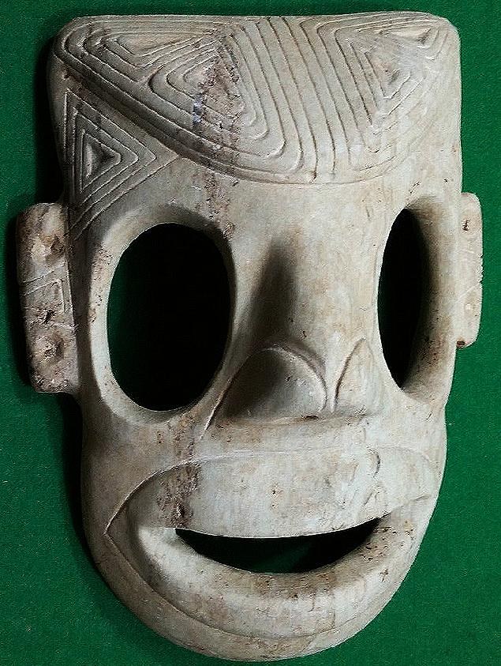

Mask: Length: 9 1/8 in., marble. Dominican Republic.

This very rare large mask carved from marble by a master sculptor may once have had hammered *guanín* gold eye inserts and *guanín* gold earrings. The design grammar of the elaborately inscribed ears and forehead can be seen in the close-ups below. The triangular motif recalls the shape of the trigonal or three-pointed sculptures that evoke both the shape of the holy Taíno mountain Cauta and the shape of the yucca mounds in which they grew their holy staple food. Note that these triangular motifs are inscribed on the ears, the temples and the cranium of this anthropomorphic mask to further ensure its sacredness. The deity or lord of the yucca was *Yucahuguamá* which translates as “*cacique* of the yucca” (Zayas y Alfonso 1914: 247, “indio principal”; Bidó 2014:92, “ Señor, Cacique”). In a portion of Christopher Columbus’ diary quoted by his son Ferdinand it was recorded “It once happened that some Christians [Columbus’ men] entered such a house [with *cemís*] with them [the Taínos], and the *cemí* gave a loud cry and spoke in their language, from which it became clear that the statue was artfully constructed. It was in fact hollow, and to the lower part was attached a blowgun or trumpet which was connected to a dark side of the house, covered by branches and leaves, where was hidden a person who said whatever the cacique wanted him to say … .” (Colón 1959, Ch. 62, 151-152.)

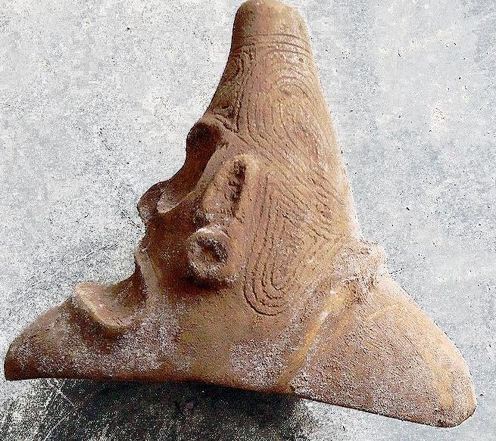

Three-pointed stone: Silicified sandstone.

The apex of three-pointed stones has been thought to be the conucos or mound from which the yucca plant sprouts. Hence, its geometrical shape is a metaphor for fructification, and this is why so many otherwise blank spaces are filled with these triangular shapes so that the object so decorated will invoke fruitfulness.

References

Bidó, Rafael Garcia. 2014. *Voces de Bohio vocabulario la cultura Taína*. 2nd ed. Santo Domingo: the author.

# Colón, Fernando. [1959] *The life of the admiral Christopher Columbus*. Translated from *Historie del S.D. Fernando Colombo; nelle qualis'ha paritcolare, & vera relatione della vita, & de' fatti dell'Ammiraglio D. Cristoforo Colombo, suo padre*, annotated, and with a new introduction by Benjamin Keen. New Brunswick, N.J.: Rutgers University Press, [1959]

Zayas y Alfonso, Alfredo. 1914. *Lexicografia antillana. Diccionario de voces usadas por los aborigines de las antillas mayors y algunas de las menorees y considerations acerca de su significado y de su formación.* Havana: El Siglo XX de Aurelio Miranda.

