DIS-AM,C-Ttaino-tripointer-

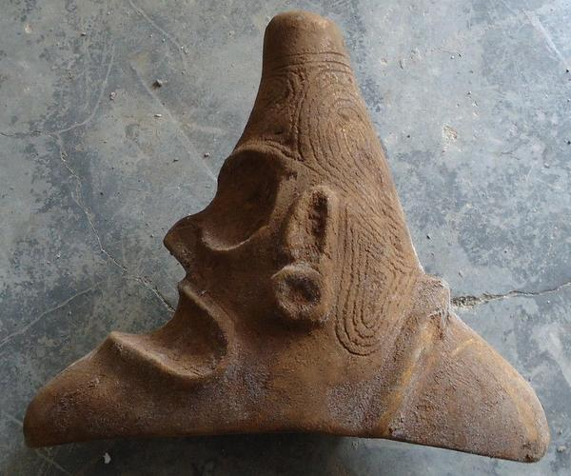 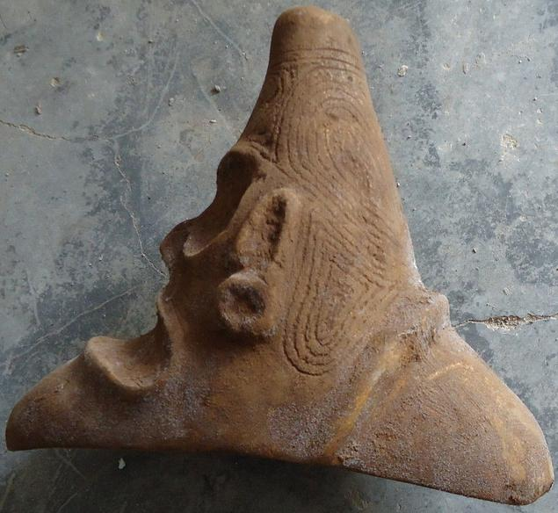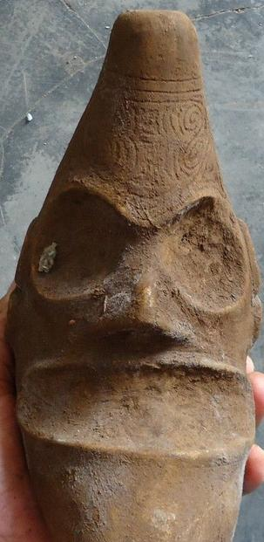 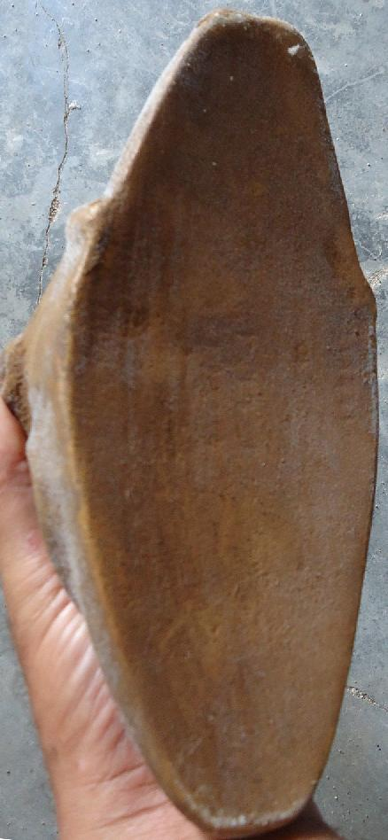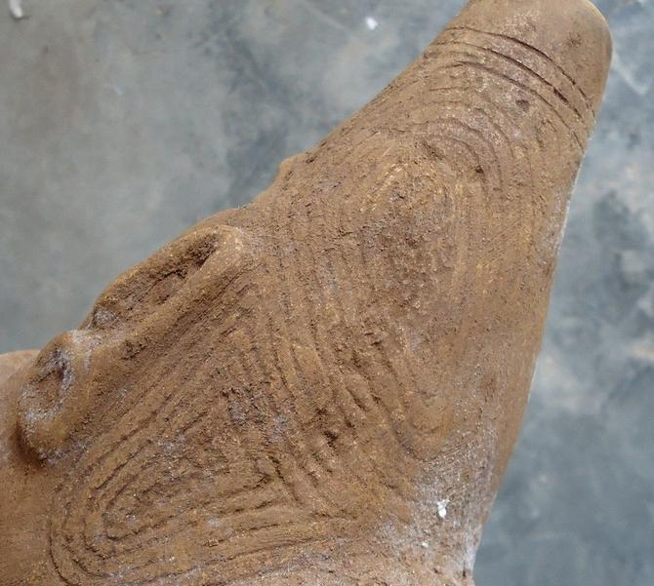

Sold by [guayacanex](http://myworld.ebay.com/guayacanex) ( [484](http://feedback.ebay.com/ws/eBayISAPI.dll?ViewFeedback&userid=guayacanex) )

### Delivery package 1 of 1

Estimated delivery Tuesday, Feb 2, 2016 - Thursday, Feb 18, 2016

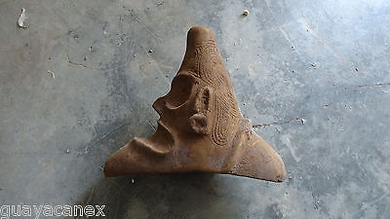

#### [Taino stone Tripointer in excellent condition](http://www.ebay.com/itm/331734490398)

|  |  |
| --- | --- |
| Item price | $339.00 |
| Quantity | 1 |
| Item number | 331734490398 |
| Shipping service | Economy Shipping |