Rc-Taino-birds--trans

bats day concealed by in a crevice near the entrance of the cave Sanabe, Cotui  
The Taino associated to pre-humans with bats bats represented physically and symbolically the spirits of their deceased loved ones and all CEMIS called spiritual guides. Interesting note is said that when kakikes and inhaling the hallucinogenic drug bejikes cojoba to communicate more easily with their CEMIS

the bee hummingbird (formerly found on all the islands, but today only in Cuba in Middle Caicos) was called by the Guani Taino word pointing nobility.

Ani ani Crotophaga a type of cuckoo

Guaraguao a type of red-tailed hawk

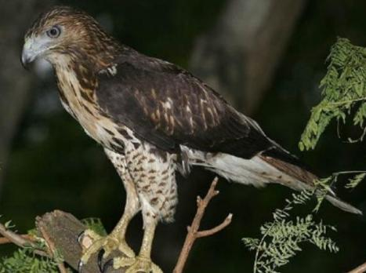

***Buteo jamaicensis*** *jamaicensis*

([Gmelin](https://en.wikipedia.org/wiki/Johann_Friedrich_Gmelin), 1788)

bejeques (Aeonium haworthii)



Crotophagia ani Family: [Cuculidae](http://www.xeno-canto.org/explore/taxonomy?f=Cuculidae) (Cuckoos)

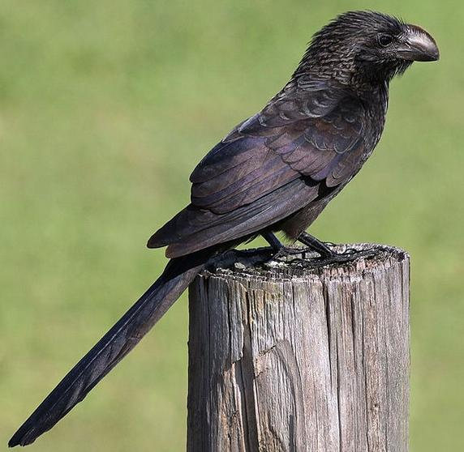

Photo by [Charlesjsharp](https://commons.wikimedia.org/wiki/User:Charlesjsharp) - Own work, from [Sharp Photography,](http://www.sharpphotography.co.uk/)  • Created: 17 February 2016

• [Location: 19° 20′ 19.71″ N, 81° 22′ 27.84″ W](https://tools.wmflabs.org/geohack/geohack.php?pagename=File:Smooth-billed_ani_(Crotophaga_ani)_GC.JPG&params=19.338807_N_81.3744_W_&language=en), the Crotophagia ani is a large land bird in the [cuckoo](https://en.wikipedia.org/wiki/Cuckoo) family.

The symbol was the owl Maquetaurie Guava (Múcaro in Taino) A bird with such sharp vision at night, that it could see into divine world