Dis-MEX-Michoacan-Figurines

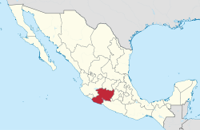

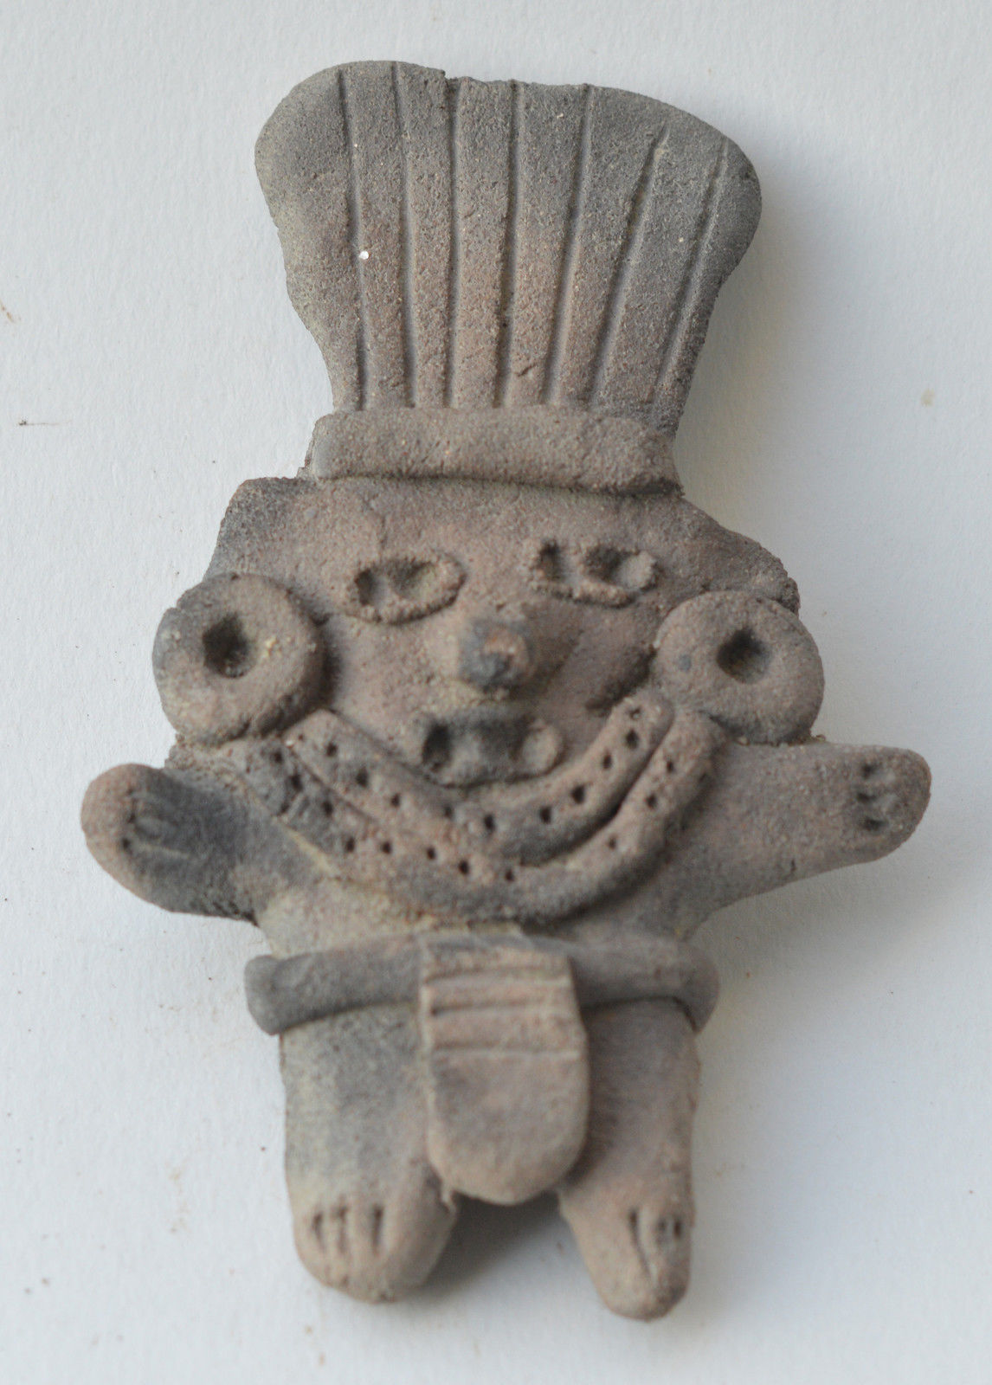 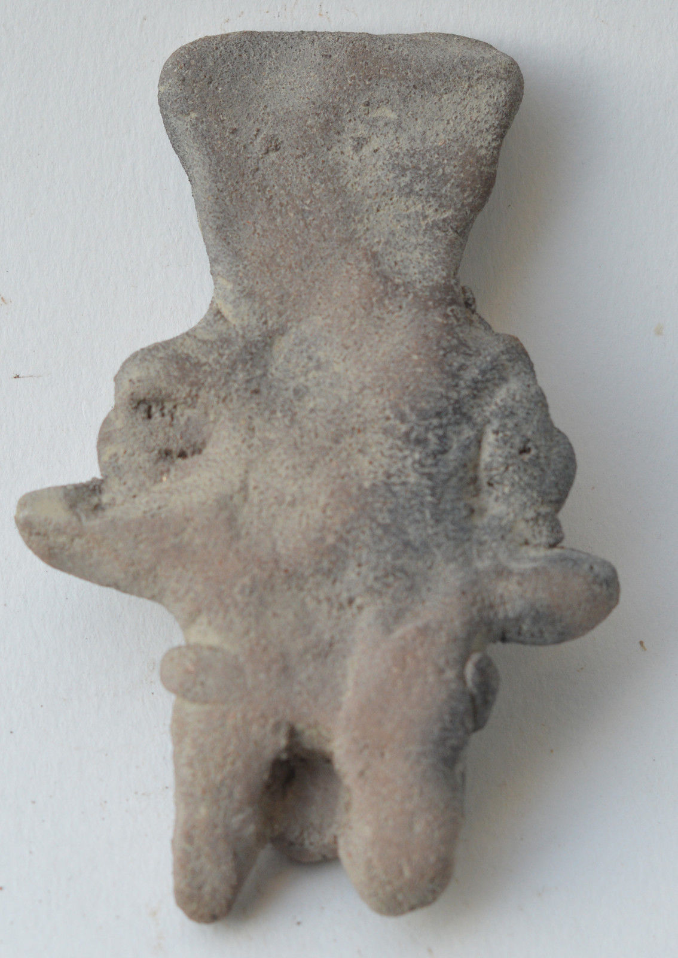

Formal Label:

Accession Number:

Date or Time Horizon: 500 BCE

Geographical Area: Mexico

Cultural Affiliation: Michoacan

Medium: Terracotta

Dimensions: 9 cm

Weight:

Provenance:

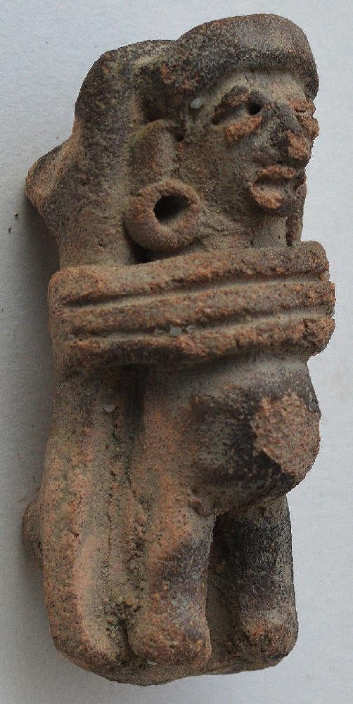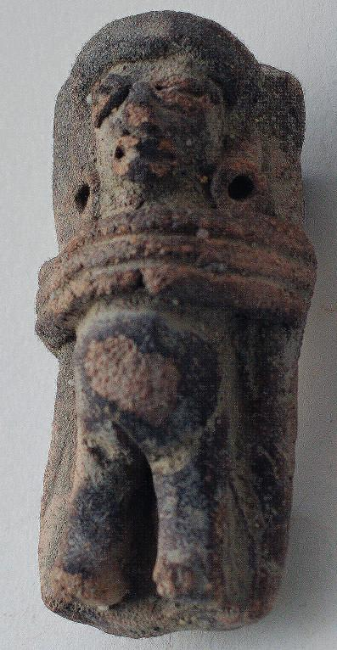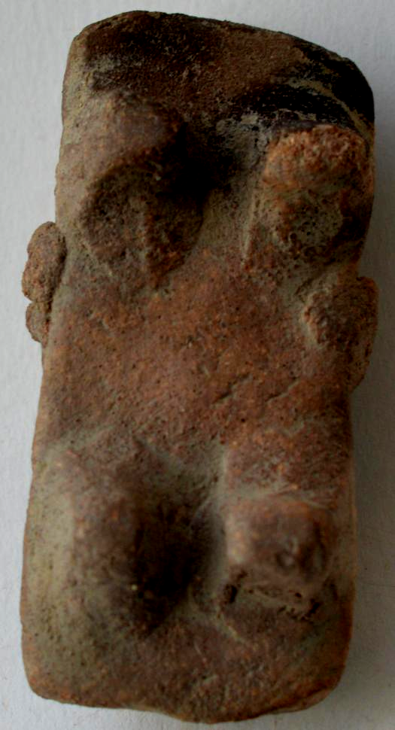

Formal Label:

Accession Number:

Date or Time Horizon:

Geographical Area:

Cultural Affiliation:

Media:

Dimensions: H 4.5 cm

Weight:

Provenance:

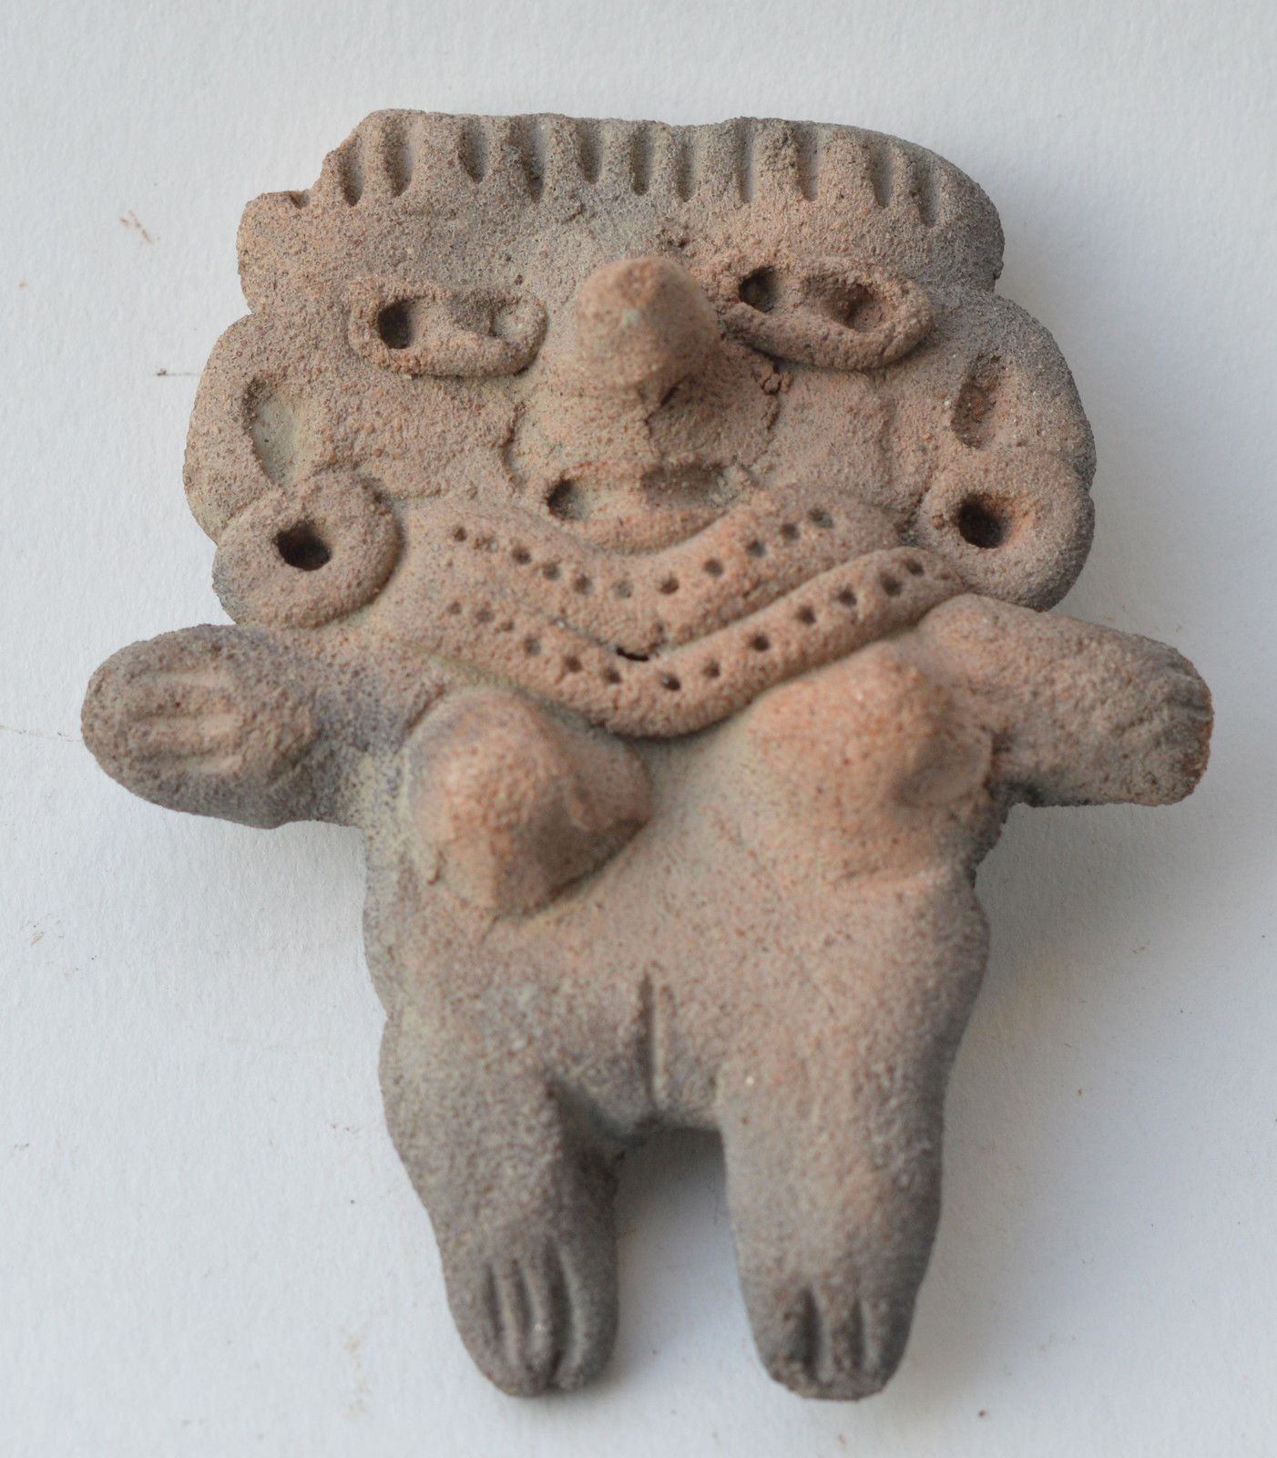 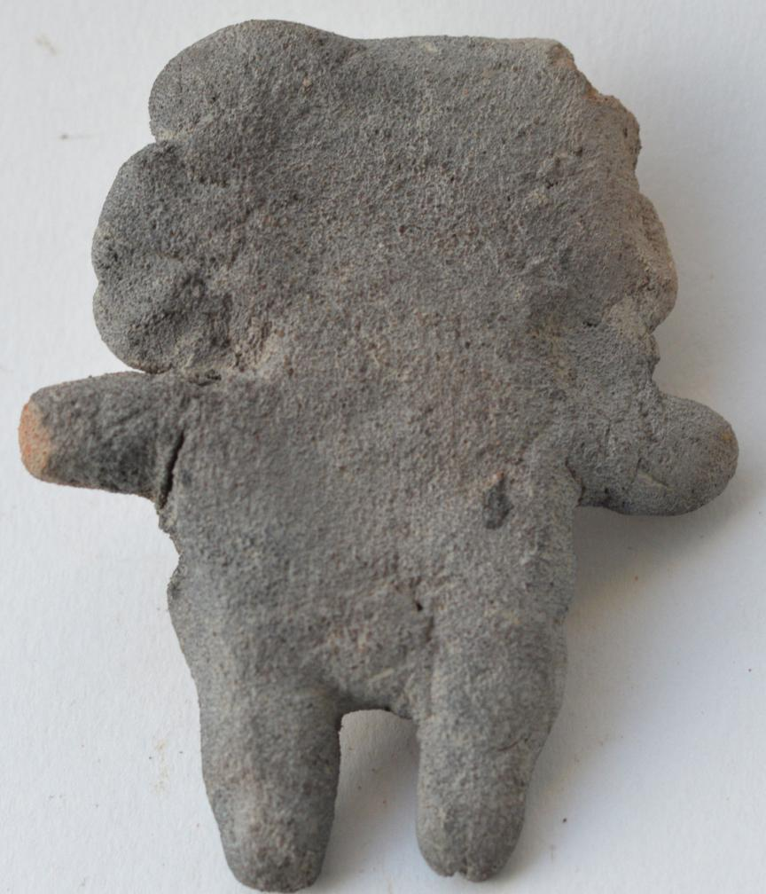

Formal Label:

Accession Number:

Date or Time Horizon:

Geographical Area:

Cultural Affiliation:

Media:

Dimensions: H 8 cm

Weight:

Provenance:

Sold by [qtroncollector](http://myworld.ebay.com/qtroncollector) ( [139](http://feedback.ebay.com/ws/eBayISAPI.dll?ViewFeedback&userid=qtroncollector) )

Estimated delivery Wednesday, Jan 4, 2017 - Friday, Jan 13, 2017

#### [Central Mexico figure terracotta pottery pre columbian.](http://www.ebay.com/itm/262734547749)

|  |  |
| --- | --- |
| Item price | $78.00 |
| Quantity | 1 |
| Item number | 262734547749 |
| Shipping service | Economy Shipping |

#### [Michoacan figurine warrior terracotta pottery pre columbian Mexico.](http://www.ebay.com/itm/262734564620)

|  |  |
| --- | --- |
| Item price | $78.00 |
| Quantity | 1 |
| Item number | 262734564620 |
| Shipping service | Economy Shipping |

#### [Michoacan figure pregnant in bed terracotta pottery pre columbian Mexico.](http://www.ebay.com/itm/262734567717)

|  |  |
| --- | --- |
| Item price | $75.00 |
| Quantity | 1 |
| Item number | 262734567717 |
| Shipping service | Economy Shipping |

#### [Michoacan figurine idol terracotta pottery pre columbian Mexico.](http://www.ebay.com/itm/262734570857)

|  |  |
| --- | --- |
| Item price | $69.00 |
| Quantity | 1 |
| Item number | 262734570857 |
| Shipping service | Economy Shipping |