Dis-MEX-Michoacan

The name Michoacán is from [Nahuatl](https://en.wikipedia.org/wiki/Nahuatl): *Michhuahcān* from *michhuah* ("possessor of fish") and -*cān* (place of) and means "place of the fishermen" referring to those who fish on *Lago de Pátzcuaro* [Lake Pátzcuaro](https://en.wikipedia.org/wiki/Lake_Pátzcuaro).[[10]](https://en.wikipedia.org/wiki/Michoacán" \l "cite_note-introduccion-10) In pre-Hispanic times, the area was the home of the [Purépecha Empire](https://en.wikipedia.org/wiki/Purépecha_Empire), which rivaled the [Aztec Empire](https://en.wikipedia.org/wiki/Aztec_Empire) at the time of Spanish encounter.

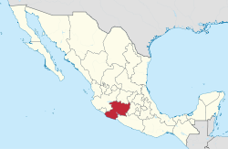 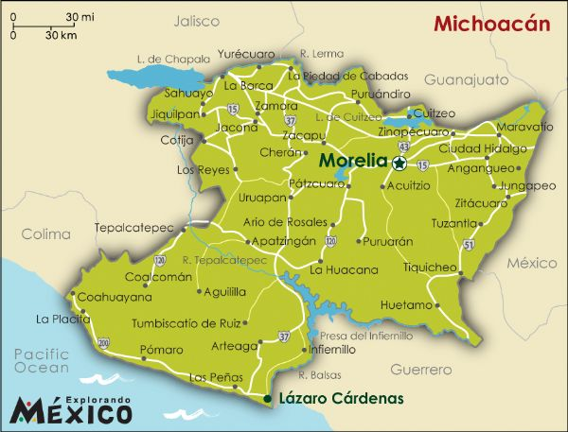

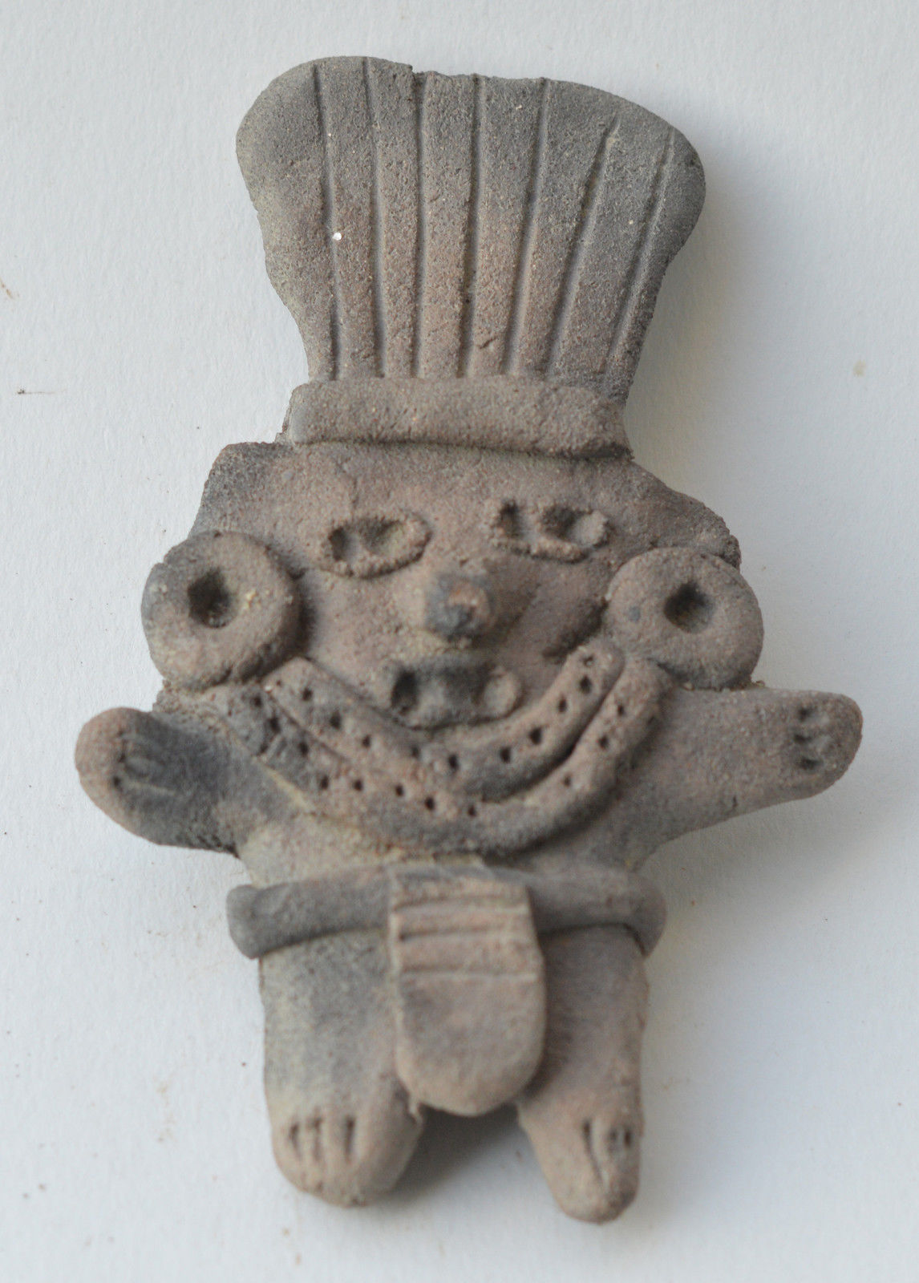 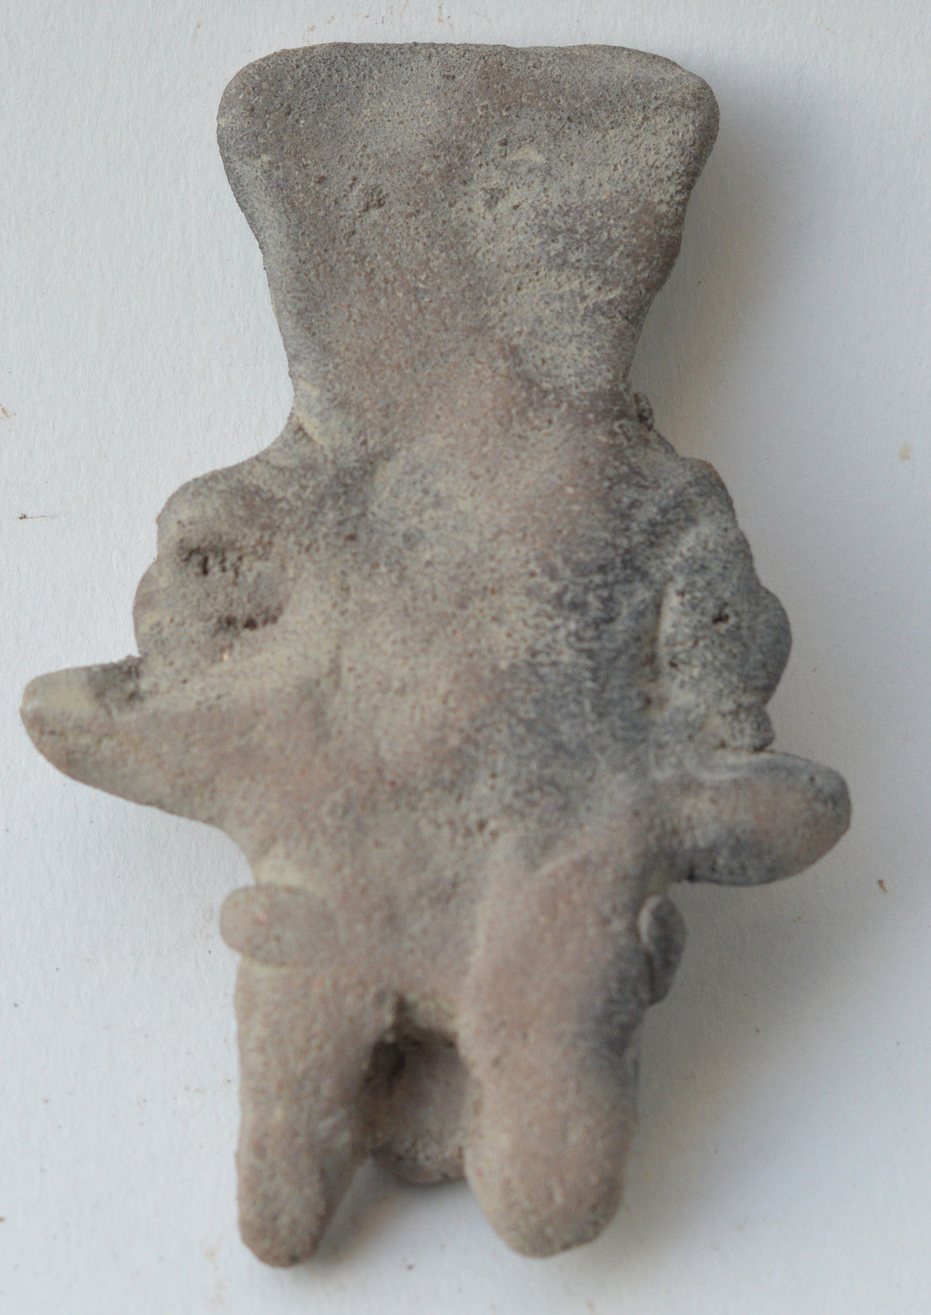

Formal Label:

Accession Number:

Date or Time Horizon: 500 BCE

Geographical Area: Mexico

Cultural Affiliation: Michoacan

Medium: Terracotta

Dimensions: 9 cm

Weight:

Provenance:

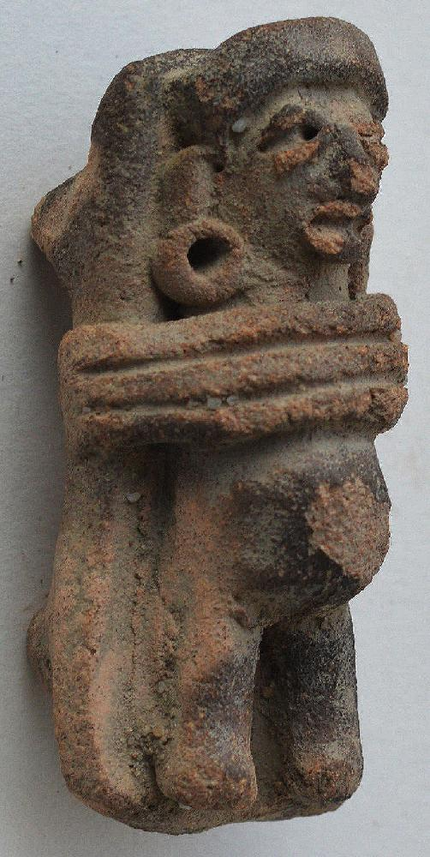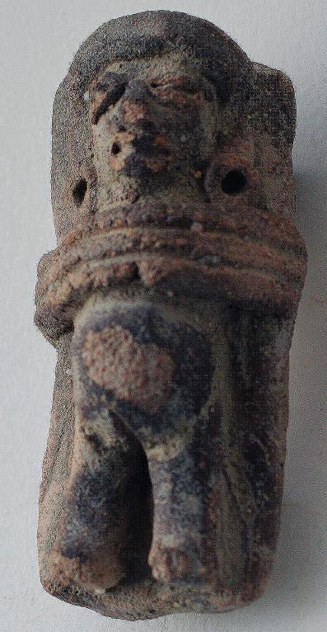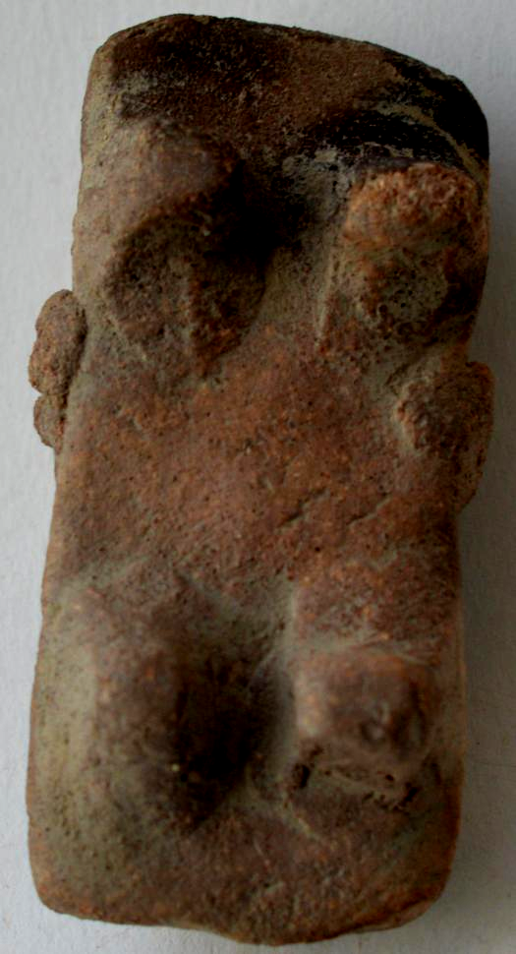

Formal Label:

Accession Number:

Date or Time Horizon:

Geographical Area:

Cultural Affiliation:

Media:

Dimensions: H 4.5 cm

Weight:

Provenance:

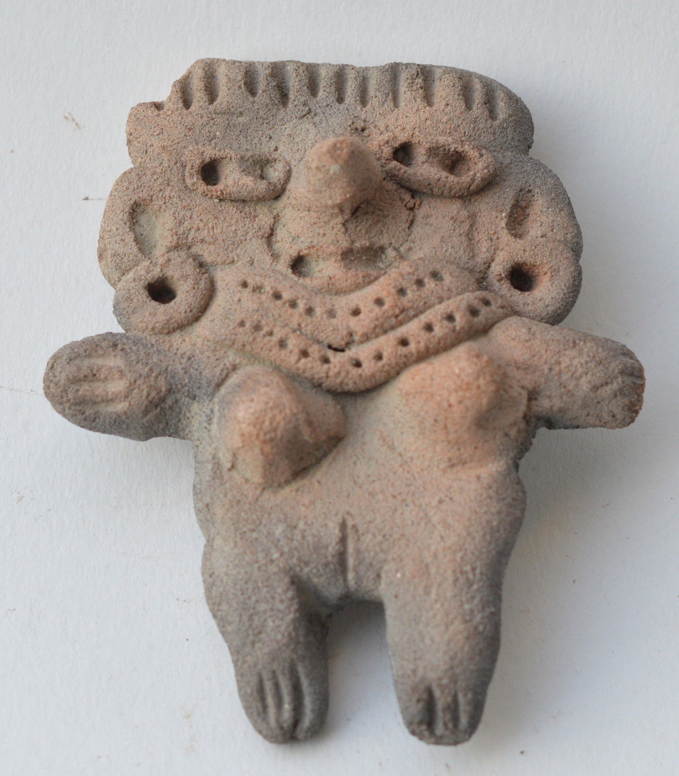 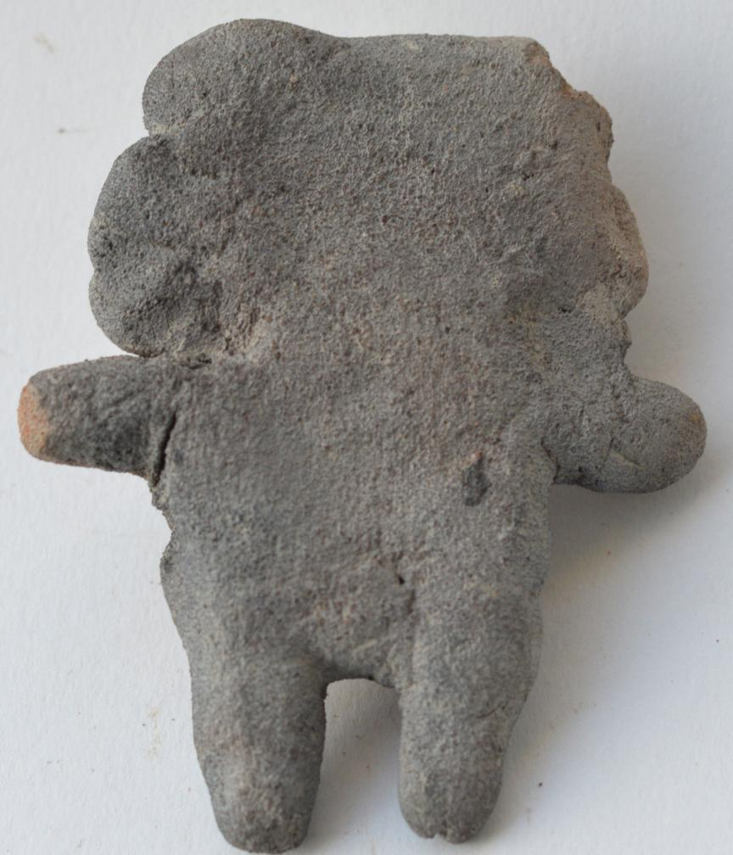

Formal Label:

Accession Number:

Date or Time Horizon:

Geographical Area:

Cultural Affiliation:

Media:

Dimensions: H 8 cm

Weight:

Provenance:

The name Michoacán is from [Nahuatl](https://en.wikipedia.org/wiki/Nahuatl): Michhuahcān  from michhuah ("possessor of fish") and -cān (place of) and means "place of the fishermen" referring to those who fish on [Lake Pátzcuaro](https://en.wikipedia.org/wiki/Lake_Pátzcuaro).[[10]](https://en.wikipedia.org/wiki/Michoacán" \l "cite_note-introduccion-10) In pre-Hispanic times, the area was the home of the [Purépecha Empire](https://en.wikipedia.org/wiki/Purépecha_Empire), which rivaled the [Aztec Empire](https://en.wikipedia.org/wiki/Aztec_Empire) at the time of Spanish encounter. According to the archeological evidence, there has been human habitation within the territory of the Mexican state of Michoacán for at least 10,000 years.[[11]](https://en.wikipedia.org/wiki/Michoacán" \l "cite_note-elochis-11) In the pre-Hispanic period, there were waves of migration into the area, including the Pirinda, [Nahua](https://en.wikipedia.org/wiki/Nahua_peoples), Huetamo, Colima,[Purépecha](https://en.wikipedia.org/wiki/Purépecha_people) and other peoples.[[12]](https://en.wikipedia.org/wiki/Michoacán" \l "cite_note-prehis-12) There are sites of formal settlements from all Mesoamerican period. Important sites include [El Opeño](https://en.wikipedia.org/wiki/El_Opeño) and those in [Curutarán](https://en.wikipedia.org/w/index.php?title=Curutarán&action=edit&redlink=1), [Tepalcatepec](https://en.wikipedia.org/wiki/Tepalcatepec), [Apatzingán](https://en.wikipedia.org/wiki/Apatzingán),[Zinapécuaro](https://en.wikipedia.org/w/index.php?title=Zinapécuaro&action=edit&redlink=1) and [Coalcomán](https://en.wikipedia.org/wiki/Coalcomán_de_Vázquez_Pallares). The territory has been inhabited by the Nahua, [Otomi](https://en.wikipedia.org/wiki/Otomi_people),[Matlatzinca](https://en.wikipedia.org/wiki/Matlatzinca_people), [Pirinda](https://en.wikipedia.org/w/index.php?title=Pirinda_people&action=edit&redlink=1) and Teco peoples as well as the Purépecha.[[11]](https://en.wikipedia.org/wiki/Michoacán" \l "cite_note-elochis-11)

The main pre-Hispanic civilization of the state is that of the Purépecha, which was centered in the Lake Pátzcuaro area.[[11]](https://en.wikipedia.org/wiki/Michoacán" \l "cite_note-elochis-11) Before the 13th century, both Nahua and Purépecha peoples were here, sustaining themselves by agriculture and fishing. The Purépecha are descendants of a late arrival of [Chichimeca](https://en.wikipedia.org/wiki/Chichimeca) who came from the north. At Lake Patzcuaro, they came upon people with similar cultures to their own but who were more technically and socially advanced. The formation of the Purépechan state in the 13th century, when these people started their own dominion at Uayameo, today [Santa Fé de la Laguna](https://en.wikipedia.org/w/index.php?title=Santa_Fé_de_la_Laguna&action=edit&redlink=1), and becoming dominant over the entire Lake Patzcuaro area by the 15th century. Conquest of neighboring tribes and territories occurred etween 1401 and 1450, as they absorbed peoples with different cultures and languages into the empire. By the late 15th century, this state rivaled that of the Aztec, having expanded their territory over much of what is now Michoacán and into part of [Colima](https://en.wikipedia.org/wiki/Colima), [Nayarit](https://en.wikipedia.org/wiki/Nayarit), [Querétaro](https://en.wikipedia.org/wiki/Querétaro), [Guanajuato](https://en.wikipedia.org/wiki/Guanajuato),[Guerrero](https://en.wikipedia.org/wiki/Guerrero) and [Jalisco](https://en.wikipedia.org/wiki/Jalisco). The Aztec attempted to invade the Purépecha but were repelled. Because of this attack, the Purépecha later denied the Aztecs aid in their defense of [Tenochtitlan](https://en.wikipedia.org/wiki/Tenochtitlan) against the Spanish.[[11]](https://en.wikipedia.org/wiki/Michoacán" \l "cite_note-elochis-11)[[12]](https://en.wikipedia.org/wiki/Michoacán" \l "cite_note-prehis-12)

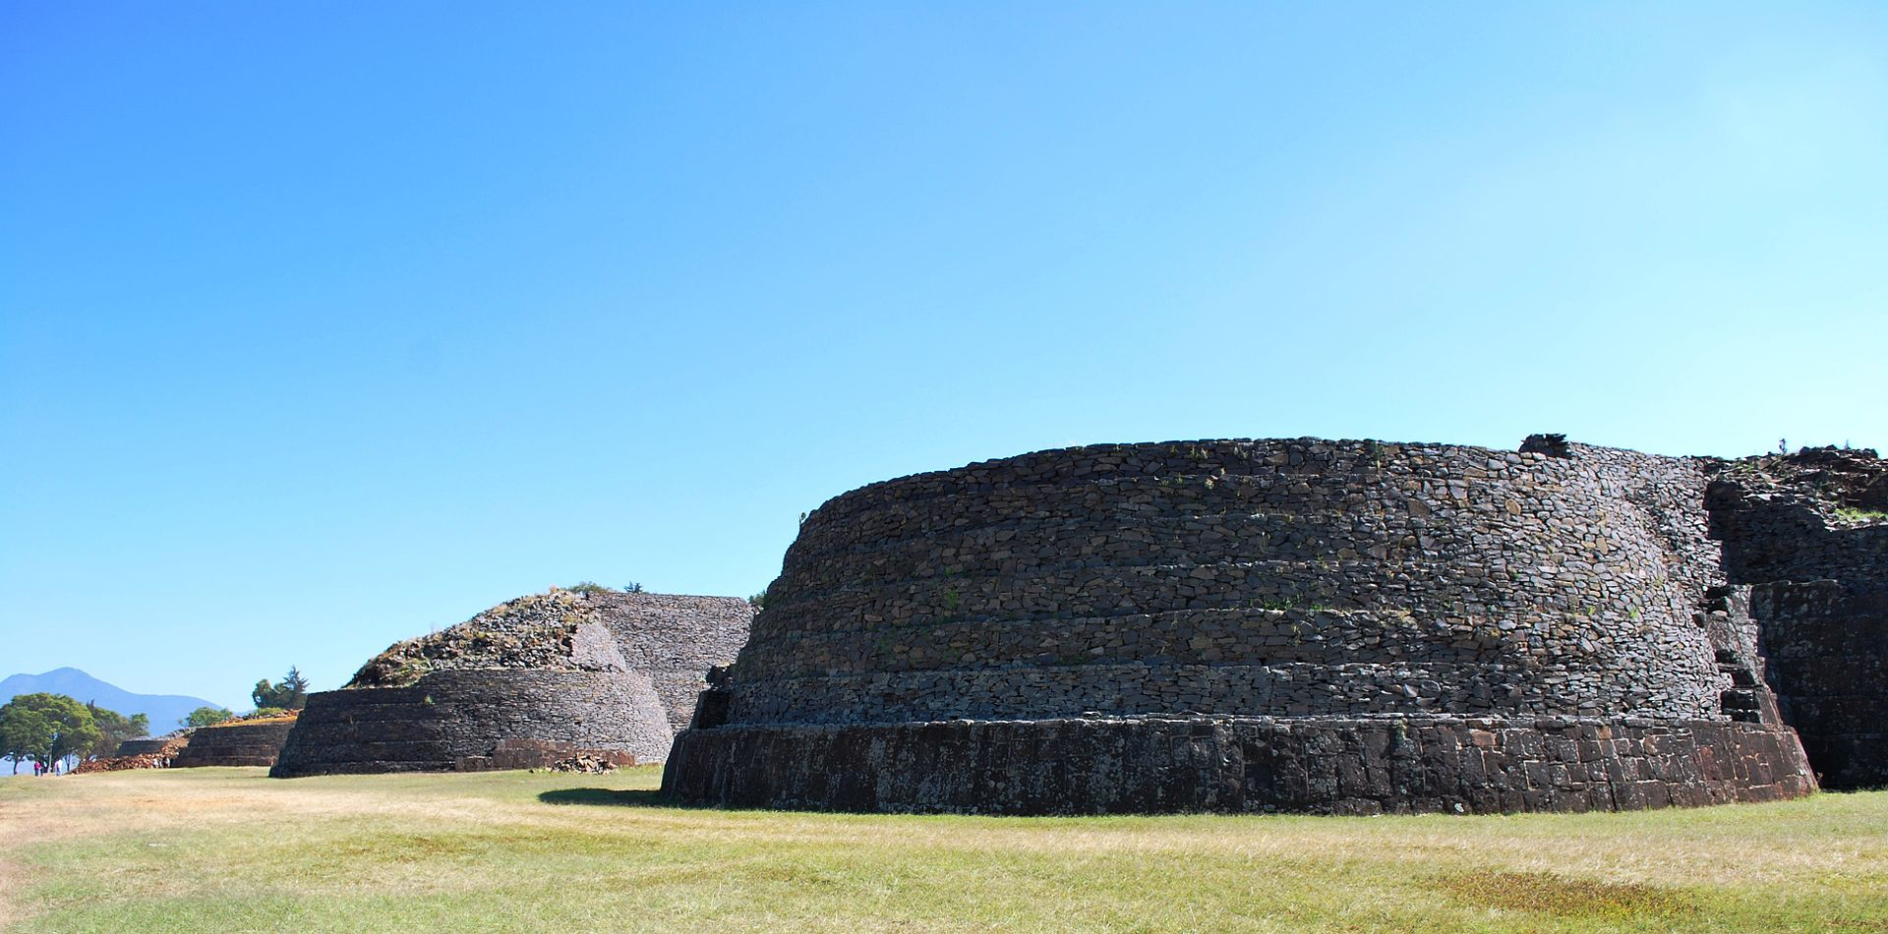

Fourth yacata pyramid on the south end of the line in Tzintzuntzan. [Location: 19° 37′ 24.63″ N, 101° 34′ 28.45″ W](https://tools.wmflabs.org/geohack/geohack.php?pagename=File:4thYacatatztztz.JPG&params=19.623508_N_101.574569_W_&language=en) Photo by San Antonio Molotla. 2009

Prior to the arrival of any Spaniard in the territory, then-ruler [Zuanga](https://en.wikipedia.org/w/index.php?title=Zuanga&action=edit&redlink=1) died of [smallpox](https://en.wikipedia.org/wiki/Smallpox), presumably carried by one of the Aztec delegations seeking military aid. He was succeeded by [Tanganxoan II](https://en.wikipedia.org/w/index.php?title=Tanganxoan_II&action=edit&redlink=1). The first Spaniard to the area was [Cristóbal de Olid](https://en.wikipedia.org/wiki/Cristóbal_de_Olid). The Spanish destruction of Tenochtitlan and their promise to allow him to remain ruler convinced Tanganxoan II to submit to Spanish rule. But, [Nuño de Guzmán](https://en.wikipedia.org/wiki/Nuño_de_Guzmán) reneged on this agreement and killed Tanganxoan II in 1530.[[11]](https://en.wikipedia.org/wiki/Michoacán" \l "cite_note-elochis-11)[[13]](https://en.wikipedia.org/wiki/Michoacán" \l "cite_note-hiscolonial-13)

The state is located in the center west of the Mexican Republic, on the extreme southwest of the central highlands. It borders the states of Mexico, Querétaro, Guerrero, Guanajuato, Jalisco and Colima, with a 217 kilometres (135 mi) coastline on the Pacific Ocean. The state has a territory of 58,836.95 square kilometres (22,717.07 sq mi), making it the sixteenth largest in Mexico (exactly at midpoint among Mexican states in Area). In addition, it also has 1,490 square kilometres (580 sq mi) of marine territory off its Pacific coast.[[10]](https://en.wikipedia.org/wiki/Michoacán" \l "cite_note-introduccion-10)[[17]](https://en.wikipedia.org/wiki/Michoacán" \l "cite_note-mediofisico-17)

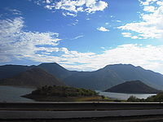

Sierra Madre del Sur

The state is crossed by the [Sierra Madre del Sur](https://en.wikipedia.org/wiki/Sierra_Madre_del_Sur), the [Trans-Mexican Volcanic Belt](https://en.wikipedia.org/wiki/Trans-Mexican_Volcanic_Belt) and the Inter-mountain Valleys region. The Sierra Madre del Sur crosses the state northwest to southeast for approximately 200 kilometres (120 mi) in the southwest between the municipalities of [Chinicuila](https://en.wikipedia.org/wiki/Chinicuila) and [Arteaga](https://en.wikipedia.org/wiki/Arteaga,_Michoacán) along the Pacific Coast. It is considered to be a continuation of the [Sierra Madre Occidental](https://en.wikipedia.org/wiki/Sierra_Madre_Occidental). Peaks in this range average about 2,900 metres (9,500 ft) above sea level, with the largest being the Cerro de las Canoas. The Mexican Trans Volcanic Belt crosses the state from west to east toward the [Toluca Valley](https://en.wikipedia.org/wiki/Toluca_Valley) and [Valley of Mexico](https://en.wikipedia.org/wiki/Valley_of_Mexico). This mountain range is marked by appearance of many volcanoes, active, dormant, and extinct alike. This system is subdivided into regions such as the Sierra de Tancítaro, Sierra de Periban, Sierra de San Angel and others. The best-known volcano in this region is the [Paricutín](https://en.wikipedia.org/wiki/Paricutín)volcano.[[17]](https://en.wikipedia.org/wiki/Michoacán" \l "cite_note-mediofisico-17)

The state has a considerable natural system of waterways, including parts of two of the country's largest rivers, the [Lerma](https://en.wikipedia.org/wiki/Lerma_River) and the Balsas. These waterways are divided into three regions, called the North, Central and South. The North region includes the Lerma Basin. On the Lerma River is the Tepuxtepec Dam which has a capacity of 371 million m³. Rivers that empty into the Lerma in Michoacán include the Tlalpuhahua, Cachivi and Duero. Another river basin here is that of [Lake Cuitzeo](https://en.wikipedia.org/wiki/Lake_Cuitzeo), which extends over an area of 3,618 square metres (38,940 sq ft). The two main rivers that feed this lake are the Grande de Morelia and Queréndaro.[[17]](https://en.wikipedia.org/wiki/Michoacán" \l "cite_note-mediofisico-17)

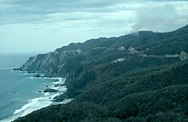

Sierra Madre del Sur along the Michoacán coast

The Central region is represented by lakes [Pátzcuaro](https://en.wikipedia.org/wiki/Lake_Pátzcuaro) and [Zirahuén](https://en.wikipedia.org/wiki/Lake_Zirahuén). Lake Pátzcuaro has a surface area of 1,525 km². This lake is fed by a number of surface and subterranean water flows with the principal rivers leading here including the San Gregorio and Chapultepec. This lake has five islands within it called [Janitzio](https://en.wikipedia.org/wiki/Janitzio), Yunuén, La Pacanda, Tecuén, Jarácuaro, Urandén and Carián. Lake Zirahuén has an area of 615 square kilometres (237 sq mi) and is fed by streams such as Manzanilla and Zinamba. These two lakes are considered to be the main tourist attraction of the state.[[17]](https://en.wikipedia.org/wiki/Michoacán" \l "cite_note-mediofisico-17)

Most of the state's rivers and streams are located in the South region of the state, with the Balsas River being the most important. The most important tributaries of this river include the Cutzamala, Carácuaro and Tepalcatepec rivers. Within this region is the coastal watershed, which is the area between the Sierra Madre del Sur and the coastline. This area includes small rivers such as the Coahuayana, Aquila, Ostula, Motín del Oro, Coire, Cachán and Nexpa which flow directly into the Pacific.[[17]](https://en.wikipedia.org/wiki/Michoacán" \l "cite_note-mediofisico-17)

Much of the climate of the state is determined by altitude and other geographical features. Average temperatures vary from 13 °C (55 °F) to 29 °C (84 °F). Lower temperatures correspond with the highland areas in the north and east which the lower south and west, called La Costa (the coast) or [Tierra Caliente](https://en.wikipedia.org/wiki/Tierra_Caliente_(Mexico)) (hot land) register the higher temperatures. In the hotter lowlands, high temperatures regularly exceed 30 °C (86 °F) and have been known to reach over 40 °C (104 °F) in the summer. The lowest temperatures are registered in highland areas such as the Sierra de Coalcomán and the Sierra del Centro located near the border with the State of Mexico. Except for the Tierra Caliente, most of the state can experience freezing temperatures in the winter. Rainfall is also dependent on altitude with the lowlands receiving less rain than the mountain areas. There is a well-defined rainy season which extends from June to October over the entire state.[[17]](https://en.wikipedia.org/wiki/Michoacán" \l "cite_note-mediofisico-17)

REFERENCES

## [La Historiografía Indígena de Michoacán: El Lienzo de Jucutácato y losTítulos de Carapan (CNWS Publications, 72) (Spanish Edition)](https://www.amazon.com/Historiografía-Indígena-Michoacán-Jucutácato-Publications/dp/905789016X/ref=sr_1_1?s=books&ie=UTF8&qid=1481051427&sr=1-1)

[1998](https://www.amazon.com/Historiografía-Indígena-Michoacán-Jucutácato-Publications/dp/905789016X/ref=sr_1_1?s=books&ie=UTF8&qid=1481051427&sr=1-1)

by [Hans Roskamp](https://www.amazon.com/Hans-Roskamp/e/B001JWP0I0/ref=sr_ntt_srch_lnk_1?qid=1481051427&sr=1-1)

1. [*"Las Diputaciones Provinciales"*](http://biblio.juridicas.unam.mx/libros/6/2920/11.pdf)(PDF)(in Spanish). p. 15.
2. **[Jump up](https://en.wikipedia.org/wiki/Michoacán" \l "cite_ref-2)^** [*"Gobernador"*](http://www.michoacan.gob.mx/gobernador/).
3. **[Jump up](https://en.wikipedia.org/wiki/Michoacán" \l "cite_ref-3)^** [*"Senadores por Michoacán LXI Legislatura"*](http://www.senado.gob.mx/index.php?ver=int&mn=4&sm=4&id=15). Senado de la Republica*. Retrieved March 24, 2010*.
4. **[Jump up](https://en.wikipedia.org/wiki/Michoacán" \l "cite_ref-4)^** [*"Listado de Diputados por Grupo Parlamentario del Estado de Michoacán"*](http://sitl.diputados.gob.mx/LXI_leg/listado_diputados_gpnp.php?tipot=Edo&edot=16). Camara de Diputados*. RetrievedMarch 28, 2010*.
5. **[Jump up](https://en.wikipedia.org/wiki/Michoacán" \l "cite_ref-5)^** [*"Resumen"*](http://cuentame.inegi.gob.mx/monografias/informacion/mich/default.aspx?tema=me&e=16). Cuentame INEGI*. Retrieved February 12, 2013*.
6. **[Jump up](https://en.wikipedia.org/wiki/Michoacán" \l "cite_ref-6)^** [*"Relieve"*](http://cuentame.inegi.gob.mx/monografias/informacion/mich/territorio/relieve.aspx?tema=me&e=16). Cuentame INEGI*. Retrieved March 28, 2011*.
7. **[Jump up](https://en.wikipedia.org/wiki/Michoacán" \l "cite_ref-7)^** [*"Encuesta Intercensal 2015"*](http://www.inegi.org.mx/est/contenidos/proyectos/encuestas/hogares/especiales/ei2015/doc/eic_2015_presentacion.pdf)(PDF)*. Retrieved December 8, 2015*.
8. **[Jump up](https://en.wikipedia.org/wiki/Michoacán" \l "cite_ref-8)^** [*"Michoacán."*](http://www.inegi.org.mx/sistemas/mexicocifras/default.aspx?ent=16). 2010*. Retrieved March 28, 2011*.
9. **[Jump up](https://en.wikipedia.org/wiki/Michoacán" \l "cite_ref-9)^** *["Reporte: Jueves 3 de Junio del 2010. Cierre del peso mexicano."](http://www.pesomexicano.com.mx/archivo/2010/junio/03/reporte-jueves-3-de-junio-del-2010--cierre-del-peso-mexicano.htm" \l "leermas)*. www.pesomexicano.com.mx*. RetrievedAugust 10, 2010*.
10. ^ [Jump up to:](https://en.wikipedia.org/wiki/Michoacán" \l "cite_ref-introduccion_10-0)***a*** ***[b](https://en.wikipedia.org/wiki/Michoacán" \l "cite_ref-introduccion_10-1)*** ***[c](https://en.wikipedia.org/wiki/Michoacán" \l "cite_ref-introduccion_10-2)*** ***[d](https://en.wikipedia.org/wiki/Michoacán" \l "cite_ref-introduccion_10-3)*** [*"El Estado de Michoacán Introduccion" [The State of Michoacan Introduction]*](http://www.umich.mx/mich/mich-intro.html)(in Spanish). Morelia, Michoacán: UMSNH*. Retrieved June 16, 2010*.
11. ^ [Jump up to:](https://en.wikipedia.org/wiki/Michoacán" \l "cite_ref-elochis_11-0)***a*** ***[b](https://en.wikipedia.org/wiki/Michoacán" \l "cite_ref-elochis_11-1)*** ***[c](https://en.wikipedia.org/wiki/Michoacán" \l "cite_ref-elochis_11-2)*** ***[d](https://en.wikipedia.org/wiki/Michoacán" \l "cite_ref-elochis_11-3)*** ***[e](https://en.wikipedia.org/wiki/Michoacán" \l "cite_ref-elochis_11-4)*** ***[f](https://en.wikipedia.org/wiki/Michoacán" \l "cite_ref-elochis_11-5)*** ***[g](https://en.wikipedia.org/wiki/Michoacán" \l "cite_ref-elochis_11-6)*** ***[h](https://en.wikipedia.org/wiki/Michoacán" \l "cite_ref-elochis_11-7)*** ***[i](https://en.wikipedia.org/wiki/Michoacán" \l "cite_ref-elochis_11-8)*** ***[j](https://en.wikipedia.org/wiki/Michoacán" \l "cite_ref-elochis_11-9)*** ***[k](https://en.wikipedia.org/wiki/Michoacán" \l "cite_ref-elochis_11-10)*** ***[l](https://en.wikipedia.org/wiki/Michoacán" \l "cite_ref-elochis_11-11)*** ***[m](https://en.wikipedia.org/wiki/Michoacán" \l "cite_ref-elochis_11-12)*** ***[n](https://en.wikipedia.org/wiki/Michoacán" \l "cite_ref-elochis_11-13)*** ***[o](https://en.wikipedia.org/wiki/Michoacán" \l "cite_ref-elochis_11-14)*** ***[p](https://en.wikipedia.org/wiki/Michoacán" \l "cite_ref-elochis_11-15)*** ***[q](https://en.wikipedia.org/wiki/Michoacán" \l "cite_ref-elochis_11-16)*** ***[r](https://en.wikipedia.org/wiki/Michoacán" \l "cite_ref-elochis_11-17)*** [*"Historia" [History]*](http://www.e-local.gob.mx/wb2/ELOCAL/EMM_michoacan).Enciclopedia de los Municipios de México Michoacán(in Spanish). Mexico: Instituto Nacional para el Federalismo y el Desarrollo Municipal,. 2009*. Retrieved June 16, 2010*.
12. ^ [Jump up to:](https://en.wikipedia.org/wiki/Michoacán" \l "cite_ref-prehis_12-0)***a*** ***[b](https://en.wikipedia.org/wiki/Michoacán" \l "cite_ref-prehis_12-1)*** [*"El Estado de Michoacán Epoca Prehispanica" [The State of Michoacan Pre-Hispanic Era]*](http://www.umich.mx/mich/historia/prehisp.html)(in Spanish). Morelia, Michoacán: UMSNH*. Retrieved June 16, 2010*.
13. ^ [Jump up to:](https://en.wikipedia.org/wiki/Michoacán" \l "cite_ref-hiscolonial_13-0)***a*** ***[b](https://en.wikipedia.org/wiki/Michoacán" \l "cite_ref-hiscolonial_13-1)*** ***[c](https://en.wikipedia.org/wiki/Michoacán" \l "cite_ref-hiscolonial_13-2)*** [*"El Estado de Michoacán Epoca Colonial" [The State of Michoacan Colonial Era]*](http://www.umich.mx/mich/historia/colonia.html)(in Spanish). Morelia, Michoacán: UMSNH*. Retrieved June 16, 2010*.

Sold by [qtroncollector](http://myworld.ebay.com/qtroncollector) ( [139](http://feedback.ebay.com/ws/eBayISAPI.dll?ViewFeedback&userid=qtroncollector) )

Estimated delivery Wednesday, Jan 4, 2017 - Friday, Jan 13, 2017

#### [Central Mexico figure terracotta pottery pre columbian.](http://www.ebay.com/itm/262734547749)

|  |  |
| --- | --- |
| Item price | $78.00 |
| Quantity | 1 |
| Item number | 262734547749 |
| Shipping service | Economy Shipping |

#### [Michoacan figurine warrior terracotta pottery pre columbian Mexico.](http://www.ebay.com/itm/262734564620)

|  |  |
| --- | --- |
| Item price | $78.00 |
| Quantity | 1 |
| Item number | 262734564620 |
| Shipping service | Economy Shipping |

#### [Michoacan figure pregnant in bed terracotta pottery pre columbian Mexico.](http://www.ebay.com/itm/262734567717)

|  |  |
| --- | --- |
| Item price | $75.00 |
| Quantity | 1 |
| Item number | 262734567717 |
| Shipping service | Economy Shipping |

#### [Michoacan figurine idol terracotta pottery pre columbian Mexico.](http://www.ebay.com/itm/262734570857)

|  |  |
| --- | --- |
| Item price | $69.00 |
| Quantity | 1 |
| Item number | 262734570857 |
| Shipping service | Economy Shipping |