A…. Mex-Chupícuaro-Early Classical-Figurine-300 BCE-100 CE

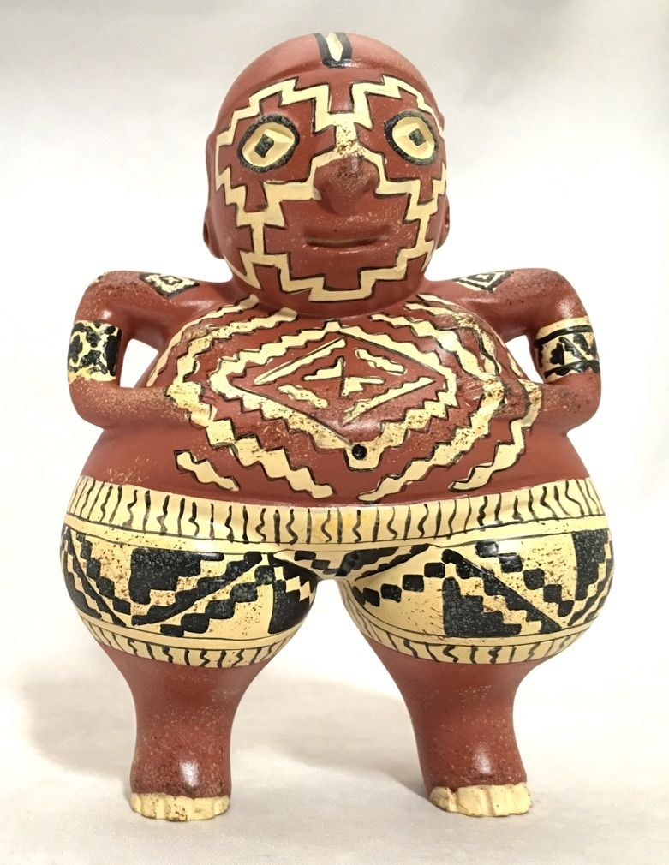 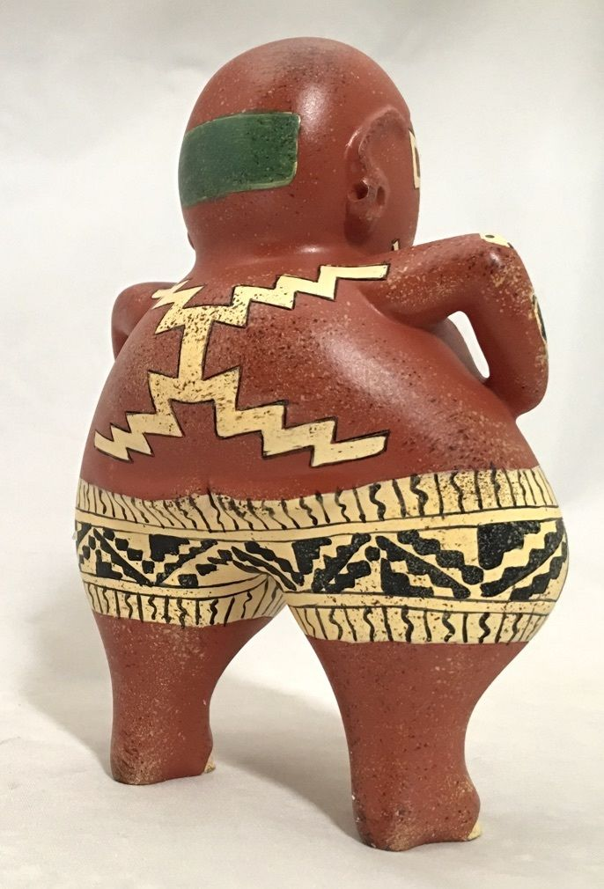 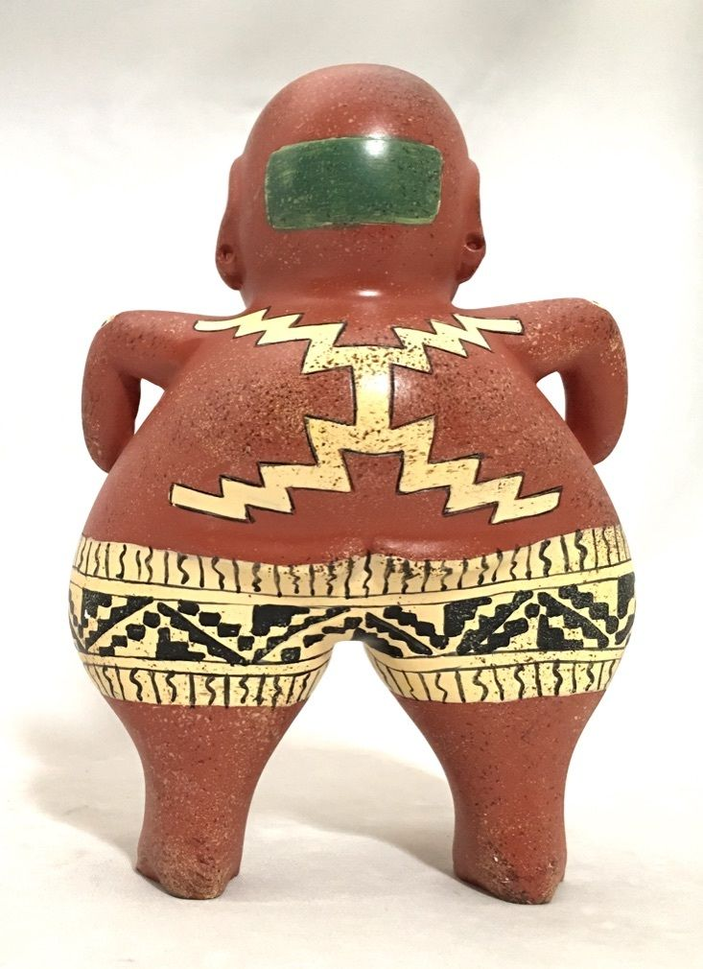

Formal Label: Chupícuaro-Early Classical-300 BCE-100 CE

Accession Number: A….

**LC Number:** N6504

Date or Time Horizon: 300 BCE-100 CE

**Display Description:**

Chupícuaro was a major ceramic center. Ceramics included many monochromatic forms and a variety of three-color polychrome (red, yellow, beige and black) with geometrical motifs. “Chupícuaro” derives from the Purépecha words "*chupicua*" (the "Ipomoea" plant, which was used to tint textiles blue) and "ro" (meaning a “place”). Therefore, “Chupícuaro” means "blue place". Purépecha is classified as a language isolate (Campbell 1997) that developed between 800 BCE and 300 CE.

Clay figurines used “*pastillaje*” techniques and made hollow figures with details that enable the study of clothing, headwear, hairstyles, painting of faces and bodies, types of footwear, necklaces, and earrings. Among the finely burnished examples we can distinguish several types: black, brown, bi-chrome or polychrome ceramic in three colors (red, yellow, black and brown), decorated with geometric patterns.

GPS Coordinates and Map: Acámbaro region, Mexico

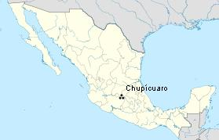

20° 01′ 20″ N, 100° 35′ 29″ W

Cultural Affiliation: Chupícuaro

Media: Terracotta, yellow and black paint.

Dimensions: H 5.5 in x W 4 in x D 2,5 in.

Weight:

Provenance: private Mexican collection ca. 1951.

**Description:**

Figurines are divided into several types. The "choker" figurines (Late Preclassical- 800 BCE to 300 BCE ) have a rectangular head and wear a kind of collar to which they owe their name. The H4 figurine (Late Preclassical- 800 BCE to 300 BCE ) has oblique eyes and a very elaborate headdress with clay pellets forming details (the first example above). A third type Chupícuaro polychrome (300 BCE-100 CE), is hollow, burnished with geometric decoration and between 30 and 40 cm high (the second example above).  
 This Chupícuaro, Mexico, ceramic dates to the late Pre-classical Period to the Early Classical Period. The site is located in the northern Mesoamerican zone, on hills nearby the Lerma and Coroneo Rivers, but currently most of the site is under water caused by the Solis dam. For this reason these ceramics extremely rare. The name Chupícuaro derives from the Purépecha language word "chupicua" name of the "Ipomoea" plant, used to tint blue, and the term "ro" place or that is, which can be translated as "blue place". Purépecha is classified as a language isolate (Campbell 1997) that developed between 800 BCE and 300 CE.

The many burials and offerings provide knowledge of the way of life of the ancient Chupícuaro inhabitants, it is inferred that they were farmers who lived in huts built from perishable materials forming a good extended rural village, built low platforms with clay floors, sometimes grouped together, over which their houses were built. They harvested corn, beans and pumpkin (Chan, 1967: 263)

**References:**

Braniff de Torres, Beatriz. 1975. *Estudios Arqueológicos en el Río de la Laja, Guanajuato*. México, D.F.: Instituto Nacional de Antropología e Historia

Campbell, Lyle. 1997. American Indian Languages: The Historical Linguistics of Native America. Oxford Studies in Anthropological Linguistics, no. 4. New York: [Oxford University Press](https://en.wikipedia.org/wiki/Oxford_University_Press).

Chán, Román Peña. 1967. *Una visión del México Prehispánico*. México, D.F.: UNAM.

Chán, Román Peña. 1988. La arqueología en Guanajuato. México, D.F.: Instituto Nacional de Antropología e Historia.

Crespo, Ana María.1988. *La arqueología en Guanajuato*. México, D.F.: Instituto Nacional de Antropología e Historia.

Flores, Dolores.1992. *Ofrendas funerarias de Chupícuaro, Guanajuato : catálogo de las colecciones arqueológicas del Museo Nacional de Antropología*.México, D.F.: Instituto Nacional de Antropología e Historia.

Moreno, Wigberto Jiménez. 1959. *Síntesis de la Historia Pre-Tolteca de Mesoamérica*. Mexico City: CIAM.