DIS-MEX-Mexcala-Figurine

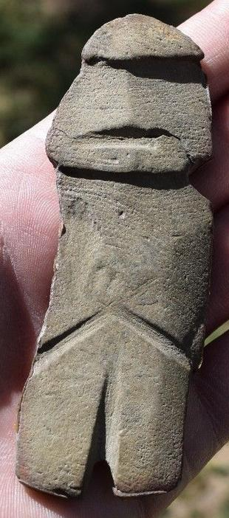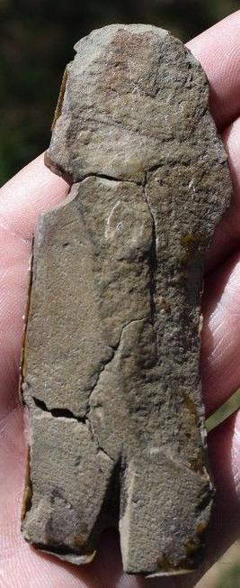Sold by The **Mezcala culture** (sometimes referred to as the **Balsas culture**) is the name given to a [Mesoamerican](https://en.wikipedia.org/wiki/Mesoamerica) culture that was based in the [Guerrero](https://en.wikipedia.org/wiki/Guerrero) state of southwestern [Mexico](https://en.wikipedia.org/wiki/Mexico),[[1]](https://en.wikipedia.org/wiki/Mezcala_culture" \l "cite_note-CoeKoontz6202p55-1) in the upper [Balsas River](https://en.wikipedia.org/wiki/Balsas_River) region.[[2]](https://en.wikipedia.org/wiki/Mezcala_culture" \l "cite_note-LopezLopez01p88-2) The culture is poorly understood but is believed to have developed during the Middle and Late Preclassic periods of [Mesoamerican chronology](https://en.wikipedia.org/wiki/Mesoamerican_chronology),[[1]](https://en.wikipedia.org/wiki/Mezcala_culture" \l "cite_note-CoeKoontz6202p55-1) between 700 and 200 BC.[[2]](https://en.wikipedia.org/wiki/Mezcala_culture" \l "cite_note-LopezLopez01p88-2) The culture continued into the Classic period (c.250-650 AD) when it coexisted with the great metropolis of [Teotihuacan](https://en.wikipedia.org/wiki/Teotihuacan).[[3]](https://en.wikipedia.org/wiki/Mezcala_culture" \l "cite_note-mm02c-3)

Archaeologists have studied the culture through limited controlled excavations, the examination of looted artifacts, and the study of Mezcala sculptures found as dedicatory offerings at the Aztec complex of [Tenochtitlan](https://en.wikipedia.org/wiki/Tenochtitlan).

## Contents

* [1](https://en.wikipedia.org/wiki/Mezcala_culture" \l "Archaeological_excavations) Archaeological excavations
* [2](https://en.wikipedia.org/wiki/Mezcala_culture" \l "History) History
* [3](https://en.wikipedia.org/wiki/Mezcala_culture" \l "Sculpture) Sculpture
* [4](https://en.wikipedia.org/wiki/Mezcala_culture" \l "See_also) See also
* [5](https://en.wikipedia.org/wiki/Mezcala_culture" \l "Notes) Notes
* [6](https://en.wikipedia.org/wiki/Mezcala_culture" \l "References) References
* [7](https://en.wikipedia.org/wiki/Mezcala_culture" \l "Further_reading) Further reading

## Archaeological excavations

The Mezcala cultural region has been heavily looted by the local population, as these items have proven desirable on the art market.[[4]](https://en.wikipedia.org/wiki/Mezcala_culture" \l "cite_note-4) In terms of its archaeological resources, the present-day state of [Guerrero](https://en.wikipedia.org/wiki/Guerrero) has not seen extensive professional excavations; prehistoric cultures found there are among the least understood in Mexico.[[1]](https://en.wikipedia.org/wiki/Mezcala_culture" \l "cite_note-CoeKoontz6202p55-1) Only one Preclassic Mezcala site, [Ahuinahuac](https://en.wikipedia.org/w/index.php?title=Ahuinahuac&action=edit&redlink=1), has been investigated by archaeologists undertaking controlled excavations.[[2]](https://en.wikipedia.org/wiki/Mezcala_culture" \l "cite_note-LopezLopez01p88-2) Excavations of Classic period Mezcala sites have taken place at [Organera Xochipala](https://en.wikipedia.org/wiki/Xochipala) and [El Mirador](https://en.wikipedia.org/w/index.php?title=El_Mirador_(Guerrero)&action=edit&redlink=1).[[5]](https://en.wikipedia.org/wiki/Mezcala_culture" \l "cite_note-5) The sculptural style of the Mezcala culture is largely known from looted [andesite](https://en.wikipedia.org/wiki/Andesite) and [serpentine](https://en.wikipedia.org/wiki/Serpentine_group) artifacts.[[1]](https://en.wikipedia.org/wiki/Mezcala_culture" \l "cite_note-CoeKoontz6202p55-1)

## History

Based on excavations in Guerrero, examination of looted artifacts, and excavation of Mezcala artifacts at Teotihuacan, archaeologists have given the name "Mezcala culture" to a [Mesoamerican](https://en.wikipedia.org/wiki/Mesoamerica) culture that was based in the present-day [Guerrero](https://en.wikipedia.org/wiki/Guerrero) state of southwestern [Mexico](https://en.wikipedia.org/wiki/Mexico),[[1]](https://en.wikipedia.org/wiki/Mezcala_culture" \l "cite_note-CoeKoontz6202p55-1) in the upper [Balsas River](https://en.wikipedia.org/wiki/Balsas_River) region.[[2]](https://en.wikipedia.org/wiki/Mezcala_culture" \l "cite_note-LopezLopez01p88-2) Archaeologists believe that the culture developed during the Middle and Late Preclassic periods of [Mesoamerican chronology](https://en.wikipedia.org/wiki/Mesoamerican_chronology),[[1]](https://en.wikipedia.org/wiki/Mezcala_culture" \l "cite_note-CoeKoontz6202p55-1) between 700 and 200 BC.[[2]](https://en.wikipedia.org/wiki/Mezcala_culture" \l "cite_note-LopezLopez01p88-2) and continued into the Classic period (c.250-650 AD). At this time, the great metropolis of [Teotihuacan](https://en.wikipedia.org/wiki/Teotihuacan) developed to the north in the [Valley of Mexico](https://en.wikipedia.org/wiki/Valley_of_Mexico).[[3]](https://en.wikipedia.org/wiki/Mezcala_culture" \l "cite_note-mm02c-3)

In the Mezcala area, Teotihuacan influence is pervasive. At the same time, there was also considerable influence going the other way, from the Mezcala area to Teotihuacan.[[6]](https://en.wikipedia.org/wiki/Mezcala_culture" \l "cite_note-6)

[Anthropologists](https://en.wikipedia.org/wiki/Anthropologists) characterized the western societies as [chiefdoms](https://en.wikipedia.org/wiki/Chiefdoms), at a time when states rose in Central Mexico. Unlike other areas of western Mexico, the Guerrero tradition in ceramics and site planning shows influence from Central Mexico. For instance, settlements along the Balsas River had [pyramids](https://en.wikipedia.org/wiki/Mesoamerican_pyramids), central plazas and [ball courts](https://en.wikipedia.org/wiki/Mesoamerican_ballcourt).[[7]](https://en.wikipedia.org/wiki/Mezcala_culture" \l "cite_note-LopezLopez01p123-124-7)

The later [Aztecs](https://en.wikipedia.org/wiki/Aztec) apparently excavated Mezcala sculptures and valued them, since the works have been found among the dedicatory offerings excavated at the [Great Temple](https://en.wikipedia.org/wiki/Templo_Mayor) of [Tenochtitlan](https://en.wikipedia.org/wiki/Tenochtitlan),[[8]](https://en.wikipedia.org/wiki/Mezcala_culture" \l "cite_note-8) built in the 14th and 15th centuries. These included over fifty-six masks and ninety-eight figurines.[[9]](https://en.wikipedia.org/wiki/Mezcala_culture" \l "cite_note-9) Twenty-six of the figurines were divided equally between two stone boxes and arranged in south-facing rows.[[10]](https://en.wikipedia.org/wiki/Mezcala_culture" \l "cite_note-10)

## Sculpture

Mezcala-style sculpture is characterised by abstract facial features, suggested by lines and differences in texture.[[3]](https://en.wikipedia.org/wiki/Mezcala_culture" \l "cite_note-mm02c-3) The sculptural style of the Mezcala culture may have been influenced by the [Olmecs](https://en.wikipedia.org/wiki/Olmec). In turn, it may have influenced the development of sculpture at the Classic-period metropolis of Teotihuacan in the [Valley of Mexico](https://en.wikipedia.org/wiki/Valley_of_Mexico).[[1]](https://en.wikipedia.org/wiki/Mezcala_culture" \l "cite_note-CoeKoontz6202p55-1)

## See also

* [Cuetlajuchitlán](https://en.wikipedia.org/wiki/Cuetlajuchitlán)
* [Teopantecuanitlan](https://en.wikipedia.org/wiki/Teopantecuanitlan)

## Notes

1. • Coe and Koontz 1962, 2002, p.55.
2. • • López Austin and López Luján 2001, p.88.
3. • • Matos Moctezuma 2002c, p.465.
4. • • López Austin and López Luján 2001, p.88. Coe and Koontz 1962, 2002, p.55.
5. • • López Austin and López Luján 2001, p. 124
6. • • Evans and Webster 2013, p.320.
7. • • López Austin and López Luján 2001, pp.123-124
8. • • Coe and Koontz 1962, 2002, pp.55-56.
9. • • Matos Moctezuma 2002b, p.460.
   1. • Matos Moctezuma 2002a, p.53.

## References

|  |  |
| --- | --- |
|  | Wikimedia Commons has media related to [***Mezcala culture***](https://commons.wikimedia.org/wiki/Category:Mezcala_culture). |

[*Coe, Michael D.*](https://en.wikipedia.org/wiki/Michael_D._Coe); Rex Koontz (2002) [1962]. Mexico: from the Olmecs to the Aztecs (5th, revised and enlarged ed.). London and New York: [*Thames & Hudson*](https://en.wikipedia.org/wiki/Thames_%26_Hudson). [*ISBN*](https://en.wikipedia.org/wiki/International_Standard_Book_Number) [*0-500-28346-X*](https://en.wikipedia.org/wiki/Special:BookSources/0-500-28346-X). [*OCLC*](https://en.wikipedia.org/wiki/OCLC) [*50131575*](https://www.worldcat.org/oclc/50131575).

Evans, Susan Toby; David L. Webster (eds.). [*Archaeology of Ancient Mexico and Central America: An Encyclopedia*](https://books.google.com.mx/books?id=vZ3DAAAAQBAJ&pg=PA320). Routledge. [*ISBN*](https://en.wikipedia.org/wiki/International_Standard_Book_Number) [*1136801855*](https://en.wikipedia.org/wiki/Special:BookSources/1136801855).

López Austin, Alfredo; Leonardo López Luján (2001) [1996]. Bernard R. Ortiz de Montellano, ed. *[Mexico's Indigenous Past](https://books.google.com/books?id=tzB4rfXObCwC&printsec=frontcover" \l "v=onepage&q&f=false)*. Norman, Oklahoma: [*University of Oklahoma Press*](https://en.wikipedia.org/wiki/University_of_Oklahoma_Press). [*ISBN*](https://en.wikipedia.org/wiki/International_Standard_Book_Number) [*0-8061-3214-0*](https://en.wikipedia.org/wiki/Special:BookSources/0-8061-3214-0). [*OCLC*](https://en.wikipedia.org/wiki/OCLC) [*45879556*](https://www.worldcat.org/oclc/45879556).

[*Matos Moctezuma, Eduardo*](https://en.wikipedia.org/wiki/Eduardo_Matos_Moctezuma) (2002a). "The Templo Mayor, the Great Temple of the Aztecs". In Eduardo Matos Moctezuma and [*Felipe Solis Olguín*](https://en.wikipedia.org/wiki/Felipe_Solis_Olguín). Aztecs. London: [*Royal Academy of Arts*](https://en.wikipedia.org/wiki/Royal_Academy_of_Arts). pp. 48–55. [*ISBN*](https://en.wikipedia.org/wiki/International_Standard_Book_Number) [*1-90397-322-8*](https://en.wikipedia.org/wiki/Special:BookSources/1-90397-322-8). [*OCLC*](https://en.wikipedia.org/wiki/OCLC) [*56096386*](https://www.worldcat.org/oclc/56096386).

[*Matos Moctezuma, Eduardo*](https://en.wikipedia.org/wiki/Eduardo_Matos_Moctezuma) (2002b). "239: Tlaloc". In Eduardo Matos Moctezuma and [*Felipe Solis Olguín*](https://en.wikipedia.org/wiki/Felipe_Solis_Olguín). Aztecs. London: [*Royal Academy of Arts*](https://en.wikipedia.org/wiki/Royal_Academy_of_Arts). pp. 459–460. [*ISBN*](https://en.wikipedia.org/wiki/International_Standard_Book_Number) [*1-90397-322-8*](https://en.wikipedia.org/wiki/Special:BookSources/1-90397-322-8). [*OCLC*](https://en.wikipedia.org/wiki/OCLC) [*56096386*](https://www.worldcat.org/oclc/56096386).

[*Matos Moctezuma, Eduardo*](https://en.wikipedia.org/wiki/Eduardo_Matos_Moctezuma) (2002c). "261: Mask". In Eduardo Matos Moctezuma and [*Felipe Solis Olguín*](https://en.wikipedia.org/wiki/Felipe_Solis_Olguín). Aztecs. London: [*Royal Academy of Arts*](https://en.wikipedia.org/wiki/Royal_Academy_of_Arts). p. 465. [*ISBN*](https://en.wikipedia.org/wiki/International_Standard_Book_Number) [*1-90397-322-8*](https://en.wikipedia.org/wiki/Special:BookSources/1-90397-322-8). [*OCLC*](https://en.wikipedia.org/wiki/OCLC) [*56096386*](https://www.worldcat.org/oclc/56096386).

[induringart](http://myworld.ebay.com/induringart) ( [1493](http://feedback.ebay.com/ws/eBayISAPI.dll?ViewFeedback&userid=induringart) )

### Delivery package 1 of 1

Estimated delivery Thursday, Mar 24, 2016 - Thursday, Mar 31, 2016

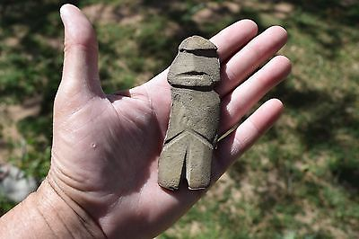

#### [Museum Quality pre columbian stone mezcala figure](http://www.ebay.com/itm/141930797017)

|  |  |
| --- | --- |
| Item price | $65.99 |
| Quantity | 1 |
| Item number | 141930797017 |
| Shipping service | Standard Shipping |

## Shipping address

Ralph J Coffman Jr

149 Atlantic Ave

Swampscott MA 01907-2427

United States

## Order total

|  |  |
| --- | --- |
| Subtotal | $65.99 |
| Shipping | $4.99 |

**Total**

$70.98

Order placed onThursday, Mar 17, 2016 Payment methodPayPal Payment dateThursday, Mar 17, 2016