Dis-Mex-Nayarit

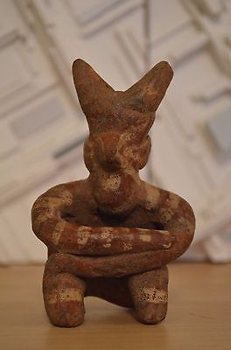

#### [Pre-Columbian Nayarit Mexico Tomb Figure Ixtlan del Rio 200 BC - AD 250](http://www.ebay.com/itm/151878374925)

|  |  |
| --- | --- |
| Item price | $100.00 |
| Quantity | 1 |
| Item number | 151878374925 |
| Shipping service | USPS Priority Mail |