DIS-CAN-BC-MASK-Pookmis

his mask, created by British Columbia First Nations Kwakwaka'wakw **Kwicksutaineuk/Ah/Kwaw/Ah/Mish Nation, Alert Bay, British Columbia**

# Pookmis Carving Mask

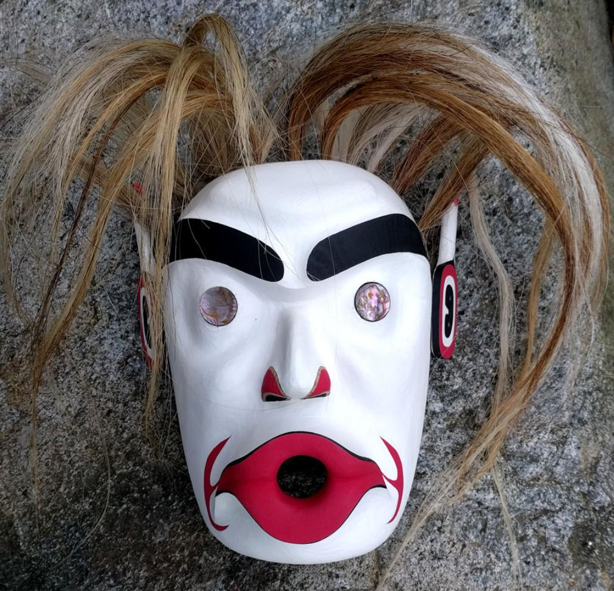

Pookmis, the sea counterpart of Bakwas, is often associated with the spirit of the drowned. It is believed that when a fisherman dies at sea, Pookmis swallows their spirit and takes it back to their village, releasing the soul during the memorial potlatch. The lips of Pookmis are generally puckered to indicate the of sucking up and blowing out of an individual's spirit.

The eyes of Pookmis often look like whirlpools and his skin painted white as an indication of death or hypothermia. Skulls are often incorporated into this mask as an indication of death.