Dis-Afr-Ghana-Tchamba

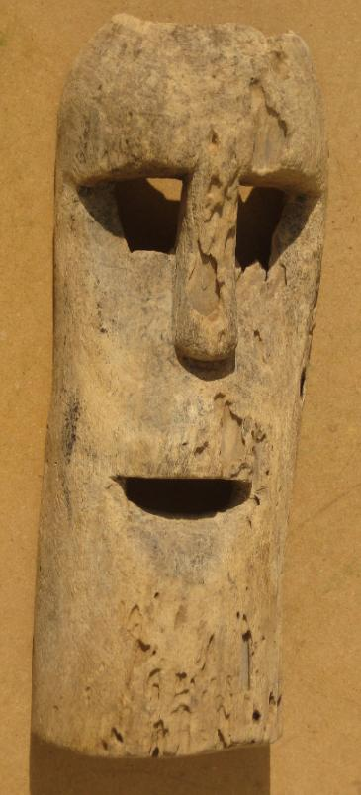 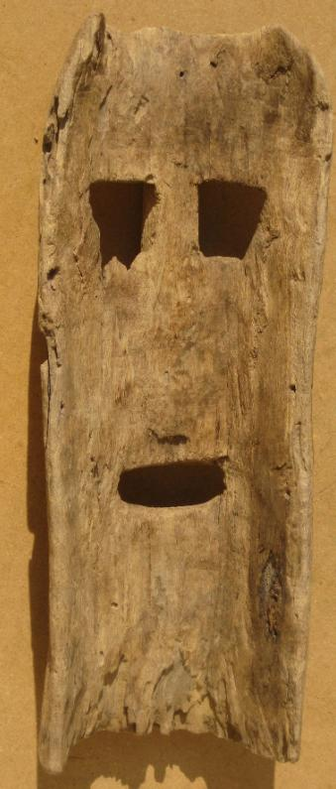

An old intact wooden mask from the Tchamba people originally a tribe in present day Ghana who were known as the aborigines ( indigenous) of Northern Ghana, in Tamale, Bim Billa, Tikokonba (known as Konkonba) Nanumba and other areas. Due to major tribal wars , they had to flee to present day Tchamba in Northern Togo. This mask was possibly carvedbefore these migrations. of Togo.  Light-to-medium density wood, with superficial insect damage. Two drill holes (one field repaired) on either side for raffia decoration or hold-strap. 14 inches tall by 5.4 inches wide. 1.1 lbs.

**Tchamba** today is a city located in [Tchamba Prefecture](http://en.wikipedia.org/wiki/Tchamba_Prefecture) in the [Centrale Region](http://en.wikipedia.org/wiki/Centrale_Region) of [Togo](http://en.wikipedia.org/wiki/Togo).

