DIS-AM,C-Moche-Mask-Copper

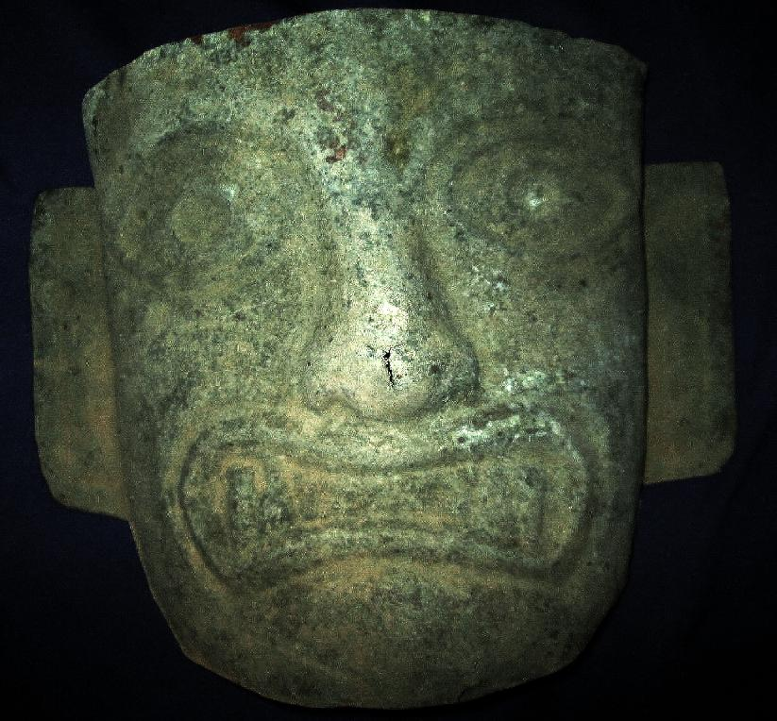

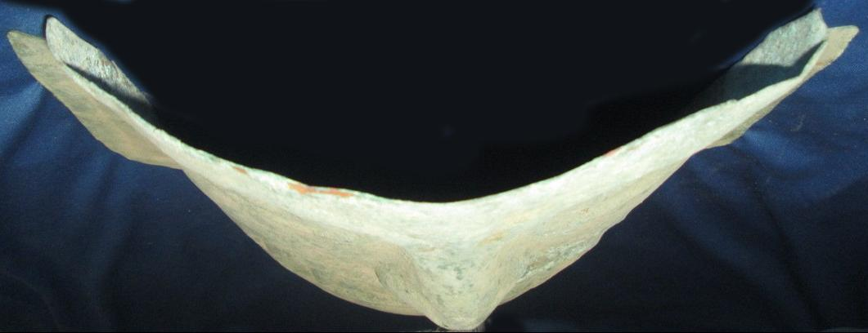

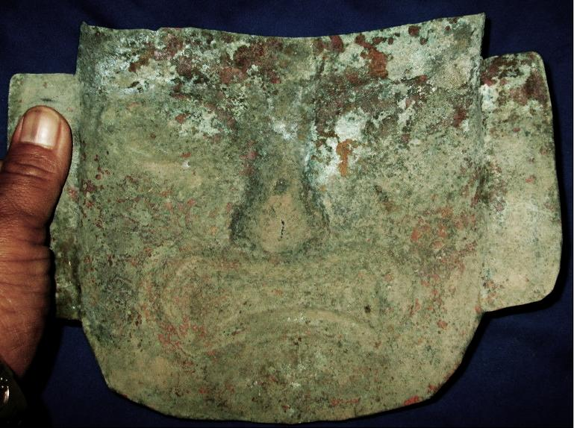

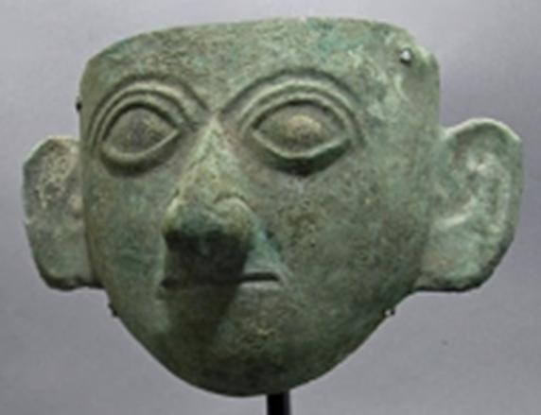

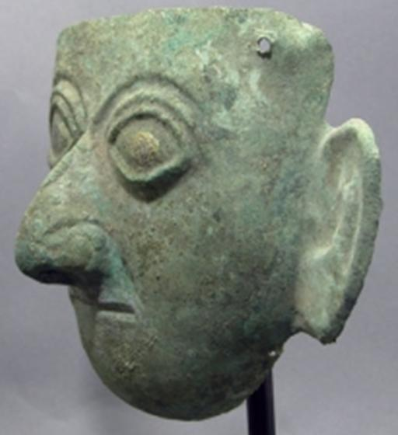

|  |  |  |  |
| --- | --- | --- | --- |
| Moche Copper Funerary Mask | | | |
| Price: $4995.00 | | |  |
|  |  |  |  |
|  |  |  |  |
|  |  |  |  |
| A very striking piece of Moche art! Moche, north-coast Peru, Ca 400 AD. Hammered copper sheet, in the form of a Moche dignitary, strong almond-shaped eyes, pronounced nose and ears and down-turned mouth. Masks like these were laid over/incorporated into mummy bundles of the face of important members of the society. Measures 10" H x 7" W x 4" D - not counting custom museum-quality stand. Ex private Hawaii collection. Very striking! Category:Moche Material:Copper Dimensions:10" H x 7" W x 4" D Condition:Intact   |  | | --- | | **Seller Details :** | | Artemis Gallery Ancient Art | |  | | **Contact Details :** | | Email : [artemisgallery@gmail.com](mailto:artemisgallery@gmail.com) | | Phone : 1 (720) 890-7700 | | | | |

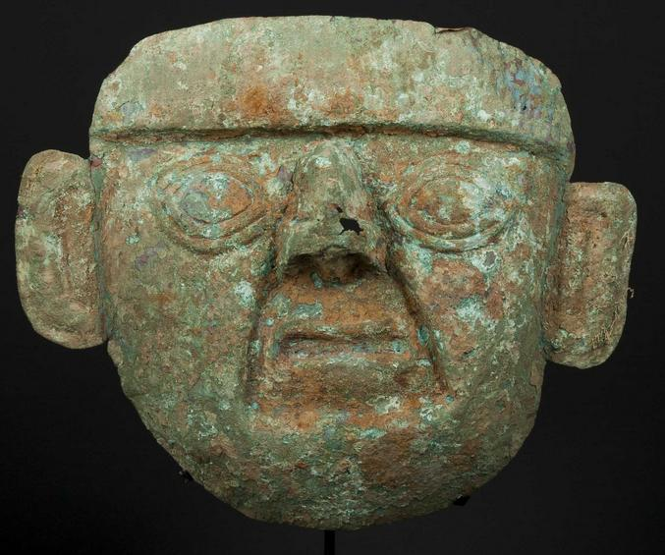

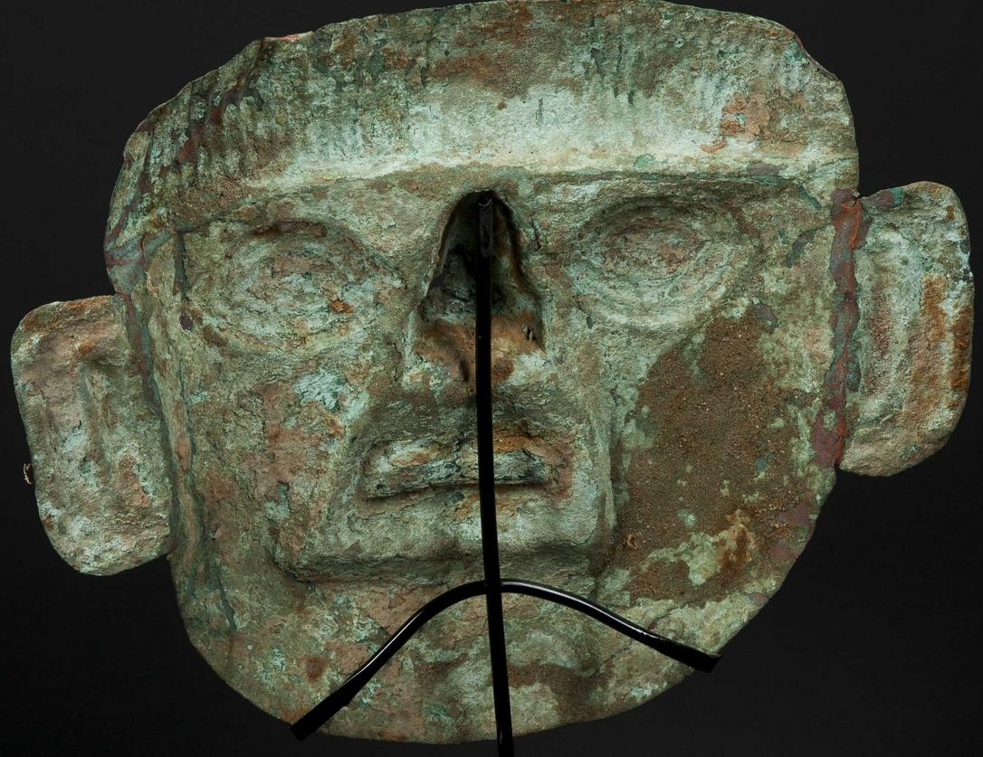Of classical form, Moche, Peru; H: 10", the mask hammered from sheet copper, the large eyes beneath raised hairline, the nose large with nostrils depicted, the mouth with small lips. The sides with large well worked ears. Heavy encrusted verdigris patina with a few minor areas of breakage through the surface that are unobtrusive, though otherwise in excellent condition.

Provenance:   
Ex. Arte Primitivo, NY  
  
Price Realized: $550