A1316-AM,S-Peru-Paracas-Figurine-Terracotta-800-100 BCE

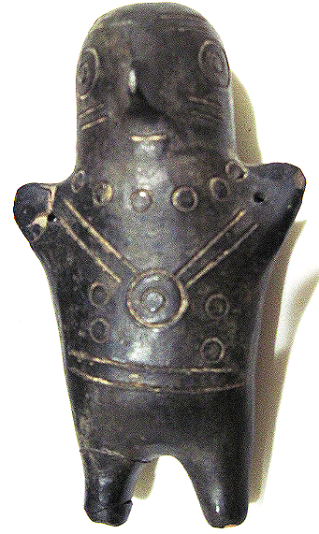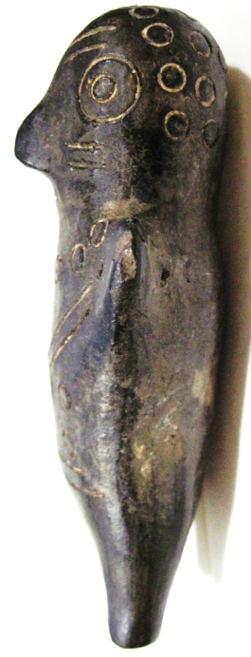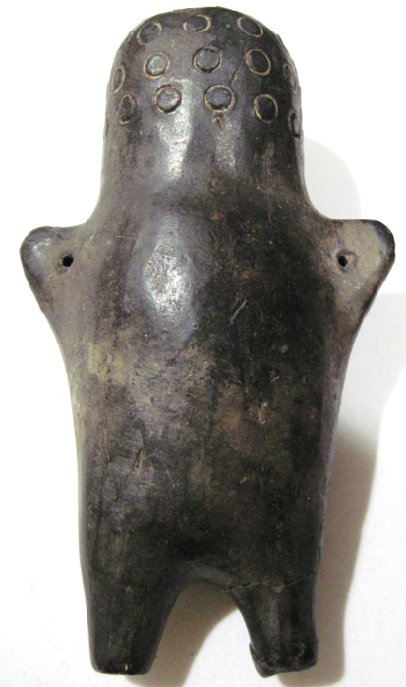

The **Paracas culture** (800-100 BCE) was focused at the large seaside Paracas site on the Paracas Peninsula in the Ica Region of Peru, first investigated by the Peruvian archaeologist Julio Tello in the 1920s. *Paracas Cavernas* are shaft tombs set into the Cerro Colorado, each containing multiple burials probably reused over centuries with heads of previous deceased families exhumed, subjected to rituals and reburied. Textiles include many complex weave structures as well as elaborate plaiting and knotting techniques.

*Wari Kayan’s*  burials were excavated on the steep north slope of Cerro Colorado inside theseburials were mortuary artifacts including fine plain wares with white and red slips and pattern-burnished decorations with intrusive Topara wares. Conical textile-wrapped mortuary bundles house single bodies in a seated position and after binding with cord have additional wrappings of intricate, ornate, and finely woven textiles many like those of early Nazca. Paracas Necropolis embroideries are some of the finest ever produced by Pre-Columbian Andean societies, and are the primary works of art by which Paracas is known.