AM,C-Moche-Crown-Tumbaga

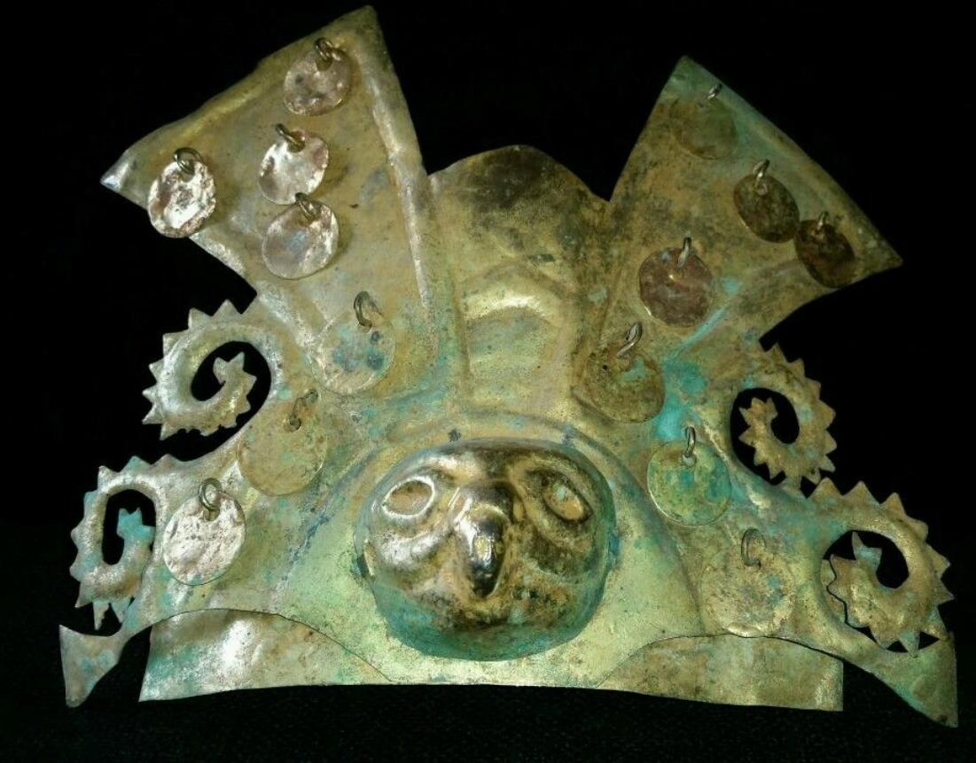

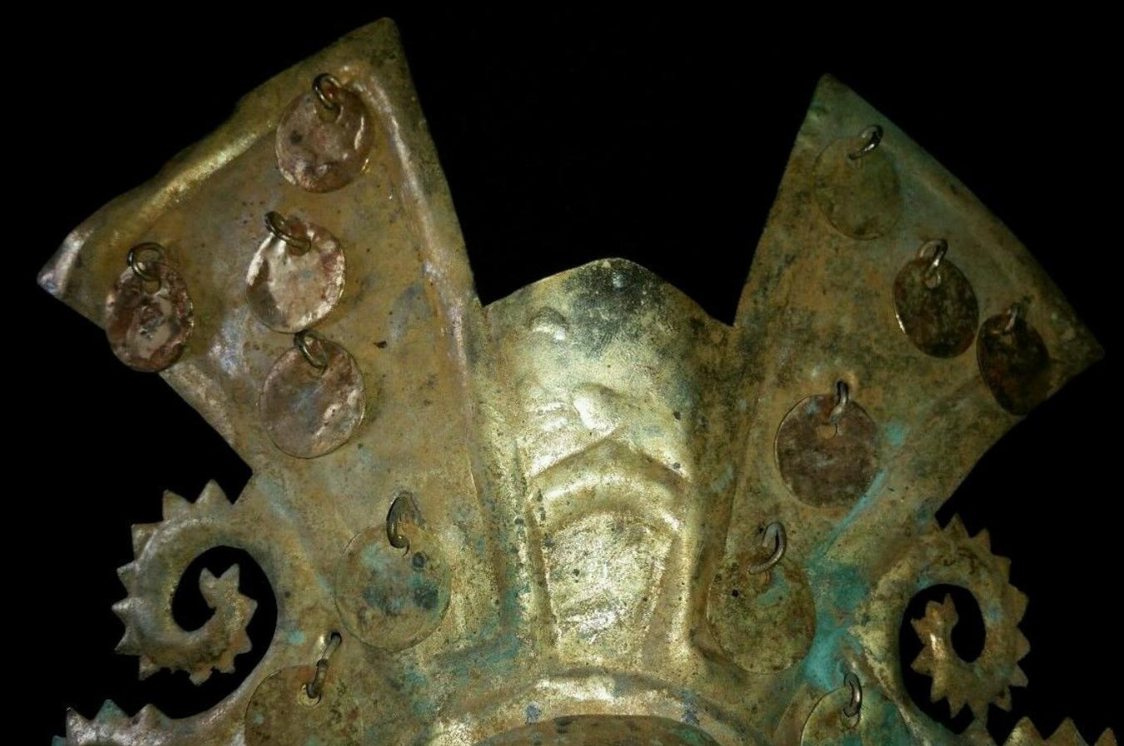 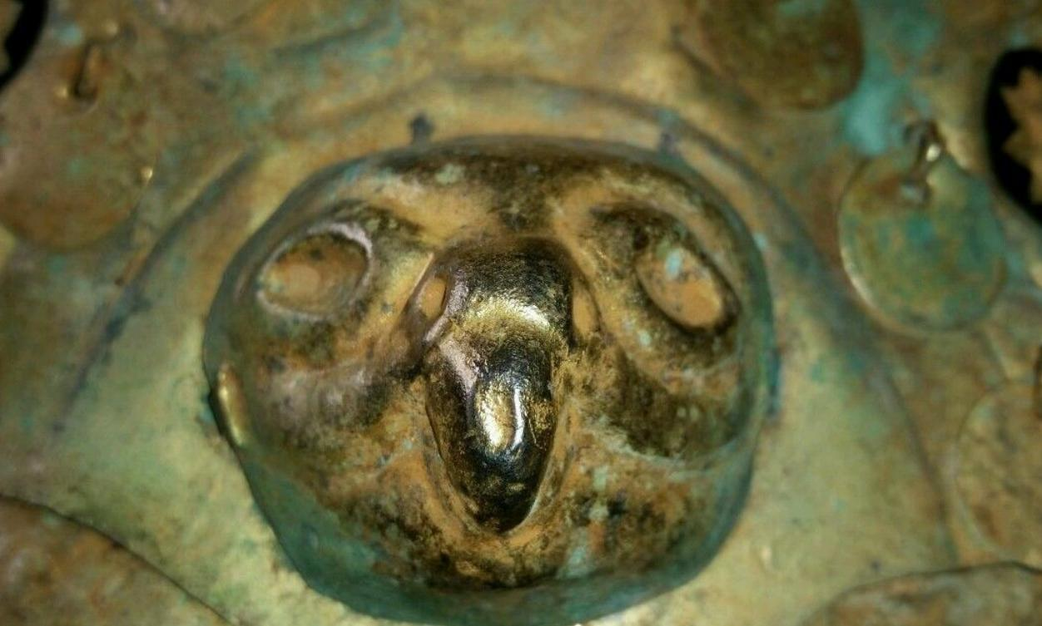

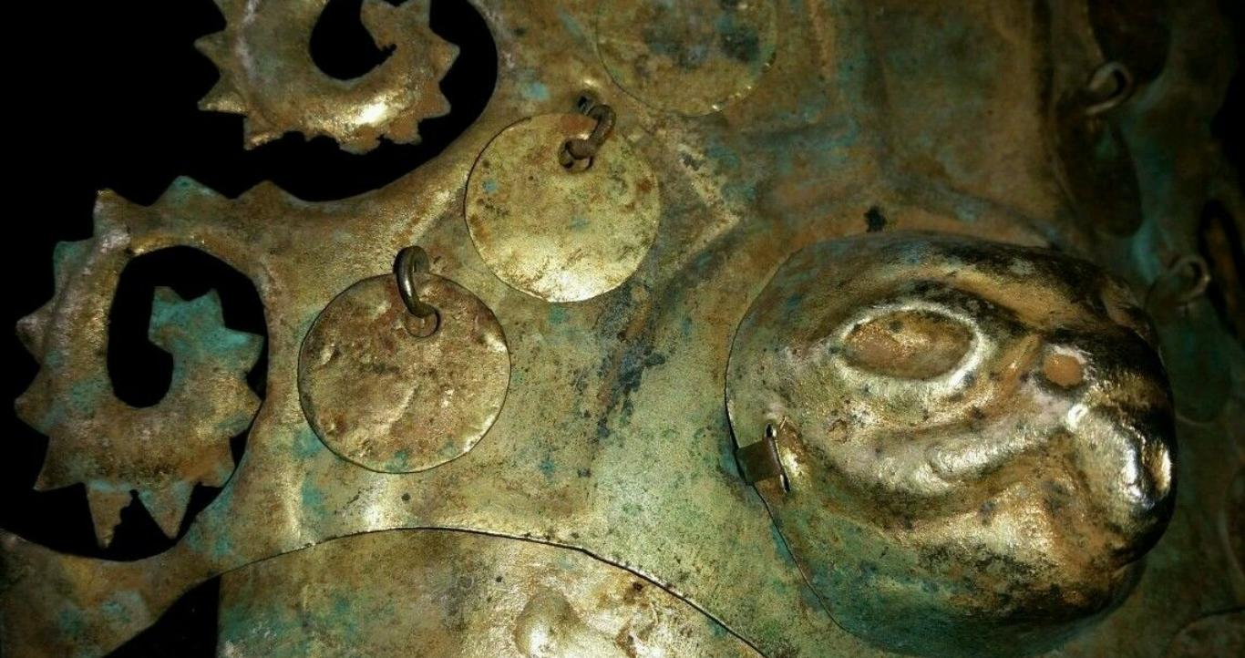 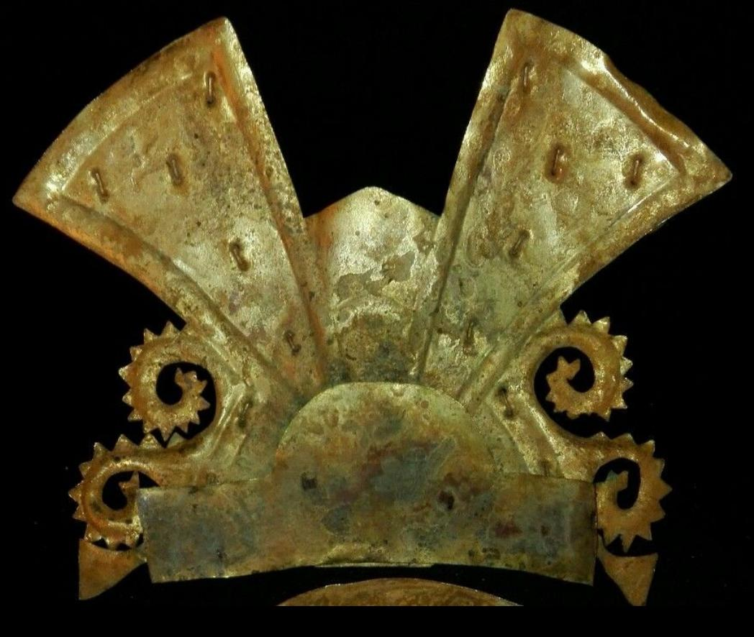

|  |  |
| --- | --- |
| ORDER DATEMar 18, 2016 | ORDER TOTAL  US $820.00  + US $25.00  shipping  **Order PRE-COLUMBIAN CROWN GOLD TUMBAGA MOCHE** [Leave feedback - ORDER DATE Mar 18, 2016](http://feedback.ebay.com/ws/eBayISAPI.dll?LeaveFeedbackShow&useridto=mmda.ludisa&transactID=0&item=252317368132&_trksid=p2057872.m2749.l2665)[View order details](http://payments.ebay.com/ws/eBayISAPI.dll?ViewPaymentStatus&transId=0&itemid=252317368132&_trksid=p2057872.m2749.l2673) - ORDER DATE Mar 18, 2016  [More actions - ORDER DATE Mar 18, 2016](http://www.ebay.com/myb/PurchaseHistory) |

1 item sold by [mmda.ludisa](http://www.ebay.com/usr/mmda.ludisa?_trksid=p2057872.m2749.l2754)

|  |  |  |
| --- | --- | --- |
| [PRE-COLUMBIAN CROWN GOLD TUMBAGA MOCHE](http://www.ebay.com/itm/252317368132?_trksid=p2057872.m2749.l2649&ssPageName=STRK%3AMEBIDX%3AIT)  ( 252317368132 )  Delivered on Thu, Mar 24  Tracking number: [**Tracking number**9505500024846082000105](javascript:;)  [Add note](javascript:;) | ITEM PRICE:  US $820.00 |  |

2 items sold by [mmda.ludisa](http://www.ebay.com/usr/mmda.ludisa?_trksid=p2057872.m2749.l2754)

|  |  |  |
| --- | --- | --- |
| [PRE-COLUMBIAN MASK OF COPPER MOCHE](http://www.ebay.com/itm/252309300914?_trksid=p2057872.m2749.l2649&ssPageName=STRK%3AMEBIDX%3AIT)  ( 252309300914 )  Delivered on Mon, Mar 21  Tracking number: [**Tracking number**9505500024846078000188](javascript:;)  [Add note](javascript:;) | ITEM PRICE:  US $550.00 | **Item PRE-COLUMBIAN MASK OF COPPER MOCHE Orders 252309300914-0-0**[Leave feedback](http://feedback.ebay.com/ws/eBayISAPI.dll?LeaveFeedbackShow&useridto=mmda.ludisa&transactID=0&item=252309300914&_trksid=p2057872.m2749.l2665)[Return this item](http://postorder.ebay.com/Return/ReturnViewSelectedItem?transactionId=0&itemId=252309300914&_trksid=p2057872.m2749.l3185)  [More actions](http://www.ebay.com/myb/PurchaseHistory) |

|  |  |
| --- | --- |
| [PRE-COLUMBIAN IDOL GOLD TUMBAGA CHAVIN -VICUS](http://www.ebay.com/itm/252309372325?_trksid=p2057872.m2749.l2649&ssPageName=STRK%3AMEBIDX%3AIT)  ( 252309372325 )  Delivered on Mon, Mar 21  Tracking number: [**Tracking number**9505500024846078000188](javascript:;)  [Add note](javascript:;) | ITEM PRICE:  US $500.00 |