DIS-AM,C-Moche-Headdress

# Order details

## Sales order

Sold by [mmda.ludisa](http://myworld.ebay.com/mmda.ludisa) ( [19](http://feedback.ebay.com/ws/eBayISAPI.dll?ViewFeedback&userid=mmda.ludisa) )

### Delivery package 1 of 1

Estimated delivery Monday, Mar 28, 2016

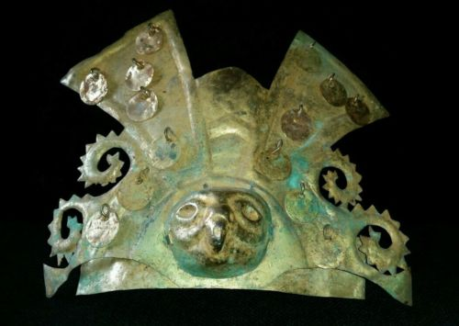

#### [PRE-COLUMBIAN CROWN GOLD TUMBAGA MOCHE](http://www.ebay.com/itm/252317368132)

|  |  |
| --- | --- |
| Item price | $820.00 |
| Quantity | 1 |
| Item number | 252317368132 |
| Shipping service | Standard Shipping |

## Shipping address

Ralph J Coffman Jr

149 Atlantic Ave

Swampscott MA 01907-2427

United States

## Order total

|  |  |
| --- | --- |
| Subtotal | $820.00 |
| Shipping | $25.00 |

**Total**

$845.00

Order placed on

Friday, Mar 18, 2016

Payment method

PayPal

Payment date

Friday, Mar 18, 2016