DIS-AM,S-Peru-Paracas

# 

Precolumbian Paracas Terra Cotta figure Peru

Esman collection

Purchased 1950 s 4" tall

The **Paracas culture** was an [Andean](https://en.wikipedia.org/wiki/Andean) society between approximately 800 BCE and 100 BCE, with an extensive knowledge of [irrigation](https://en.wikipedia.org/wiki/Irrigation) and water management and significant contributions in the textile arts. It was located in what today is the [Ica Region](https://en.wikipedia.org/wiki/Ica_Region) of [Peru](https://en.wikipedia.org/wiki/Peru). Most information about the lives of the Paracas people comes from excavations at the large seaside Paracas [site](https://en.wikipedia.org/wiki/Archaeological_site) on the Paracas Peninsula, first investigated by the Peruvian archaeologist [Julio Tello](https://en.wikipedia.org/wiki/Julio_Tello) in the 1920s.

The *Paracas Cavernas* are [shaft tombs](https://en.wikipedia.org/wiki/Shaft_tomb) set into the top of Cerro Colorado, each containing multiple burials. There is evidence that these tombs were reused over centuries. In some cases, the heads of the deceased were taken out, apparently for rituals, and later reburied. The associated ceramics include incised [polychrome](https://en.wikipedia.org/wiki/Polychrome), "negative" resist decoration and other wares of the Paracas tradition. The associated textiles include many complex [weave](https://en.wikipedia.org/wiki/Weaving) structures as well as elaborate plaiting and knotting techniques.

The [necropolis](https://en.wikipedia.org/wiki/Necropolis) of *Wari Kayan* consisted of two clusters of hundreds of burials set closely together inside and around abandoned buildings on the steep north slope of Cerro Colorado. The associated ceramics are very fine plain wares, some with white and red slips and other with pattern-burnished decoration, and other wares of the Topara tradition. Each burial consisted of a conical textile-wrapped bundle, most containing a seated individual facing north across the bay of Paracas, next to offerings such as ceramics, foodstuffs, baskets and weapons. Each body was bound with cord to hold it in a seated position, before being wrapped in many layers of intricate, ornate, and finely woven textiles. The Paracas Necropolis embroideries are now known as some of the finest ever produced by [Pre-Columbian](https://en.wikipedia.org/wiki/Pre-Columbian) Andean societies, and are the primary works of art by which Paracas is known. Burials at the necropolis of *Wari Kayan* continued until about 250 CE, and many of the mortuary bundles include textiles like those of early Nazca.

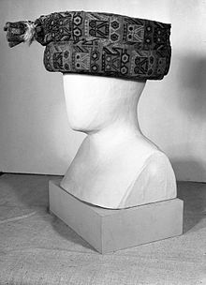

*Turban*, Paracas, 300 B.C.E.-100 C.E, [Brooklyn Museum](https://en.wikipedia.org/wiki/Brooklyn_Museum)

## Contents

* [1](https://en.wikipedia.org/wiki/Paracas_culture" \l "Topara) Topara
* [2](https://en.wikipedia.org/wiki/Paracas_culture" \l "See_also) See also
* [3](https://en.wikipedia.org/wiki/Paracas_culture" \l "References) References
* [4](https://en.wikipedia.org/wiki/Paracas_culture" \l "External_links) External links

## Topara

While the Paracas culture developed in this region between about 1200 BCE and 100 BCE, the Topará culture is thought to have "invaded" from the north at approximately 150 BCE. The two cultures then coexisted for one or more generations, both on the Paracas Peninsula and in the nearby Ica Valley, and their interaction played a key role in the development of the Nazca culture and ceramic and textile traditions. Though the elaborate textiles have only been preserved in the coastal desert sites, there is growing evidence that people associated with these cultures lived and traveled between the Pacific lowlands and the Andean highland valleys and mountain pastures to the east.

[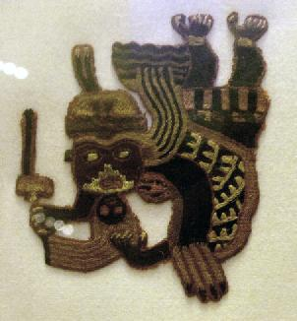](https://en.wikipedia.org/wiki/File:Paracas_textile,_British_Museum.jpg)

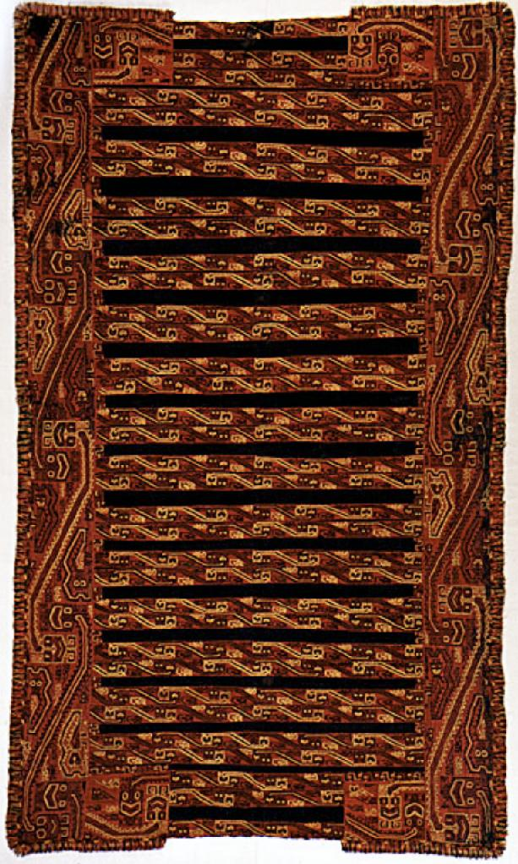 Mantle -- Peru, Paracas -- 200 BCE - 200 CE

[LACMA](https://en.wikipedia.org/wiki/LACMA) textile collections

[Paracas textiles](https://en.wikipedia.org/wiki/Paracas_textile) at the [British Museum](https://en.wikipedia.org/wiki/British_Museum). Object 24 of [A History of the World in 100 Objects](https://en.wikipedia.org/wiki/A_History_of_the_World_in_100_Objects).

## See also

* [Nazca culture](https://en.wikipedia.org/wiki/Nazca_culture)
* [Artificial cranial deformation](https://en.wikipedia.org/wiki/Artificial_cranial_deformation)

## References

* Paracas Art and Architecture: Object and Context in South Coastal Peru by Anne Paul, Publisher: University Of Iowa Press, 1991 [ISBN 0-87745-327-6](https://en.wikipedia.org/wiki/Special:BookSources/0877453276)
* Ancient Peruvian Textiles by Ferdinand Anton, Publisher: Thames & Hudson, 1987, [ISBN 0-500-01402-7](https://en.wikipedia.org/wiki/Special:BookSources/0500014027)
* Textile art of Peru by Jose Antoni Lavalle, Publisher: Textil Piura in the Textile (January 1, 1989), ASIN: B0021VU4DO

# Order details

## Sales order

Sold by [bibliovendor](http://myworld.ebay.com/bibliovendor) ( [863](http://feedback.ebay.com/ws/eBayISAPI.dll?ViewFeedback&userid=bibliovendor) )

### Delivery package 1 of 1

Estimated delivery Monday, Apr 4, 2016 - Friday, Apr 8, 2016

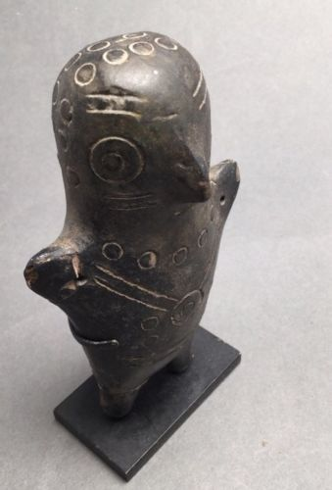

#### [Precolumbian Paracas Terra Cotta Figure Peru Esman Collection](http://www.ebay.com/itm/272171801797)

|  |  |
| --- | --- |
| Item price | $149.00 |
| Quantity | 1 |
| Item number | 272171801797 |
| Shipping service | USPS First Class Package |

## Sales order

Sold by [flapast](http://myworld.ebay.com/flapast) ( [13390](http://feedback.ebay.com/ws/eBayISAPI.dll?ViewFeedback&userid=flapast) )

### Delivery package 1 of 1

Delivered on Wednesday, Mar 30, 2016

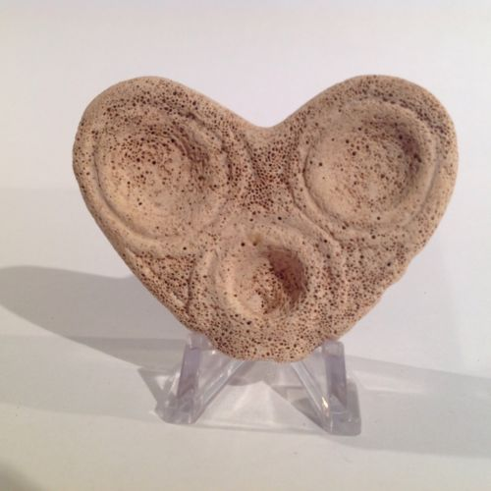

#### [Taino Owl Face Cohoba Hallucinogenic Inhaler pre-Columbian](http://www.ebay.com/itm/262339688374)

|  |  |
| --- | --- |
| Item price | $112.50 |
| Quantity | 1 |
| Item number | 262339688374 |
| Shipping service | USPS First Class Package |

## Sales order

Sold by [induringart](http://myworld.ebay.com/induringart) ( [1509](http://feedback.ebay.com/ws/eBayISAPI.dll?ViewFeedback&userid=induringart) )

### Delivery package 1 of 1

Delivered on Wednesday, Mar 30, 2016

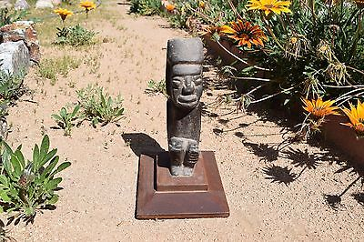

#### [Museum Quality pre columbian Teotihuacan Stone Idol/Figure](http://www.ebay.com/itm/131758874176)

|  |  |
| --- | --- |
| Item price | $153.50 |
| Quantity | 1 |
| Item number | 131758874176 |
| Shipping service | Standard Shipping |

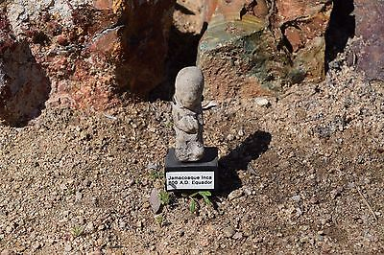

#### [Museum Quality pre columbian inca Jamacoaque female w/c classic period 2 1/2 in.](http://www.ebay.com/itm/141936238572)

|  |  |
| --- | --- |
| Item price | $21.50 |
| Quantity | 1 |
| Item number | 141936238572 |
| Shipping service | Standard Shipping |

## Shipping address

Ralph J Coffman Jr

149 Atlantic Ave

Swampscott MA 01907-2427

United States

## Order total

|  |  |
| --- | --- |
| Subtotal | $436.50 |
| Shipping | $25.93 |

**Total**

$462.43

Order placed on

Sunday, Mar 27, 2016

Payment method

PayPal

Payment date

Sunday, Mar 27, 2016