A000-Asia-China-Chüeh- Erlitou

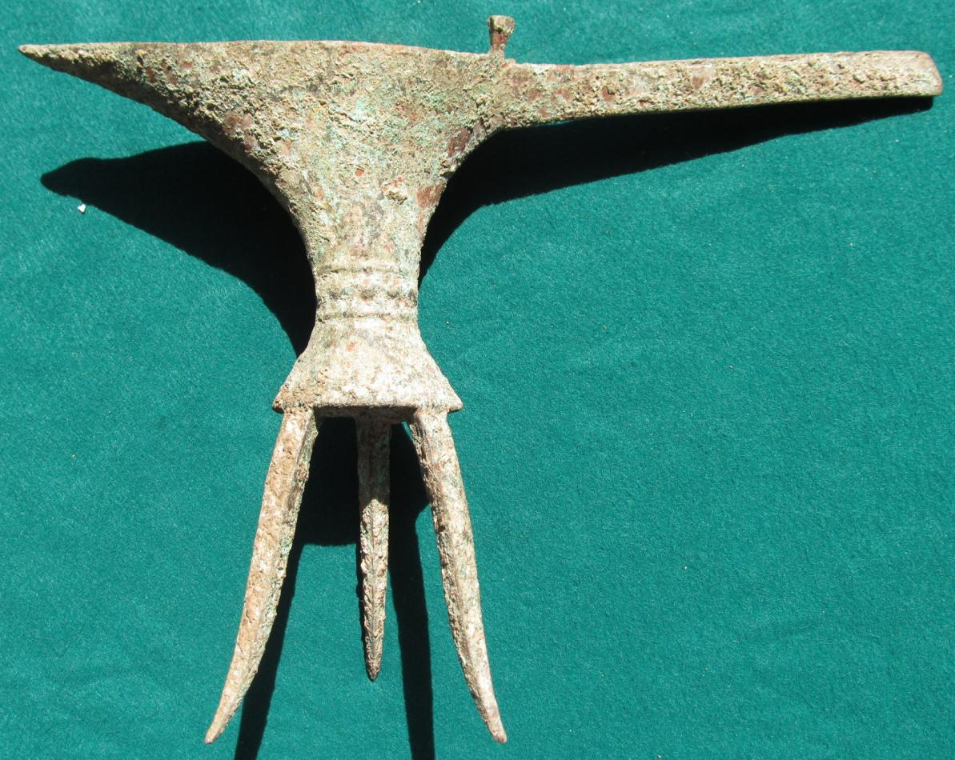

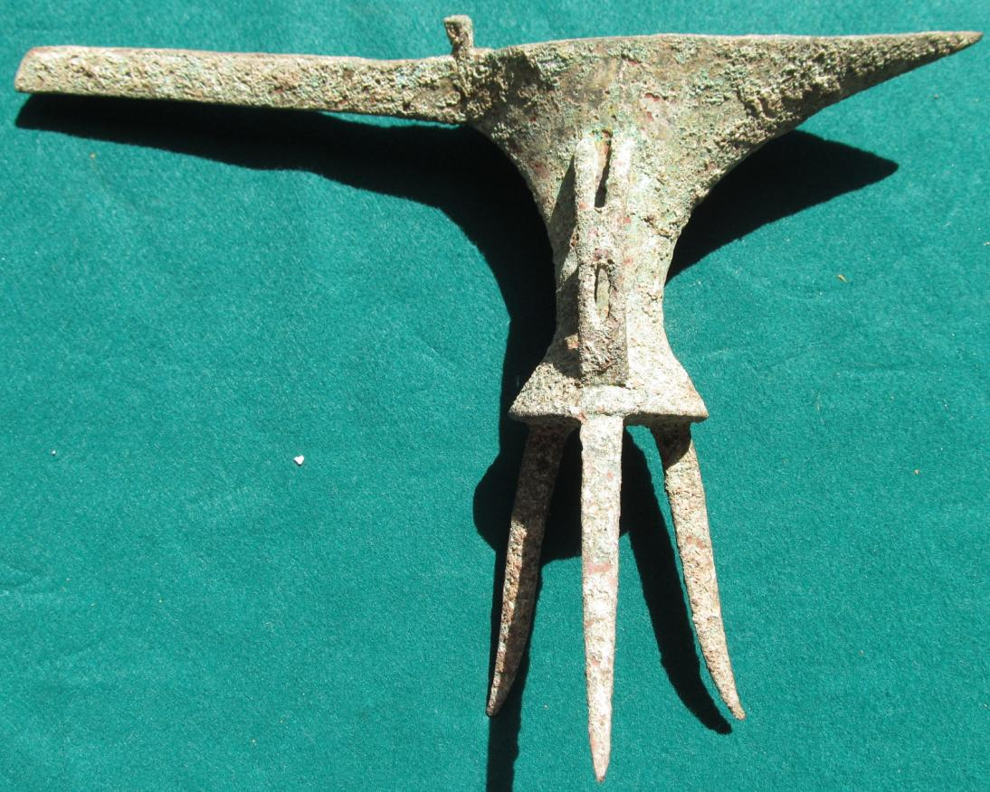

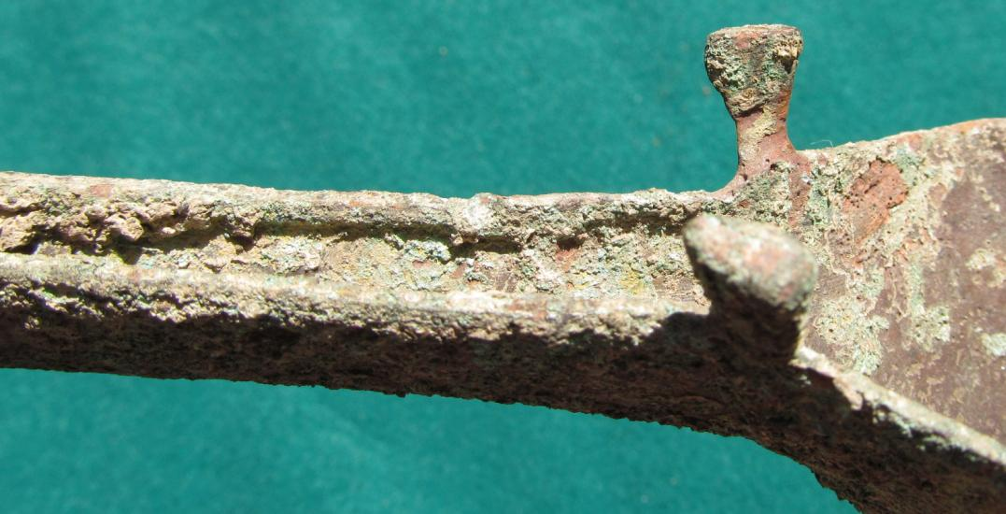

Case No.: 5

Accession No.

Formal Label:

**Display Description:**

This distinctive wine serving bronze ewer was the product of the Erlitou culture. The Erlitou early Bronze Age culture (1750 to 1530 BCE, Zhang et al. 2007) flourished in the Huang Ho (Yellow River) valley and diffused throughout Henan and Shanxi and later appeared in Shaanxi and Hubei.

Accession Number:

**LC Classification:**

Date or Time Horizon:

Geographical Area:

**Map:**

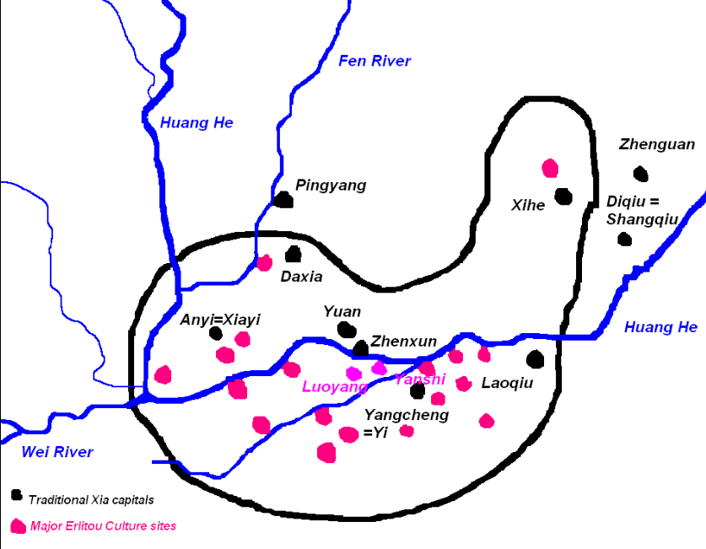

The Erlitou cultyure in red and the Xia culture in black after https://upload.wikimedia.org/wikipedia/commons/3/30/ErlitouXia.PNG

**GPS coordinates: Luoyang**

Cultural Affiliation:

Media:

Dimensions:

Weight:

Condition:

Provenance:

**Discussion:**

**References:**

Zhang, Xuelian; Qiu, Shihua; Cai, Lianzhen; Bo, Guancheng; Wang, Jinxia; Zhong, Jian (2014). Translated by Zhang, Xuelian; Lee, Yun Kuen. [*"Establishing and refining the archaeological chronologies of Xinzhai, Erlitou and Erligang cultures"*](http://www.kaogu.cn/en/Research_work/Other_topics/2014/0728/46977.html). Chinese Archaeology. **8** (1): 197–210. Original article in [*Kaogu*](https://en.wikipedia.org/wiki/Kaogu) 2007.8: 74–84.