DIS-Asia-China-Chüeh-Shang-2

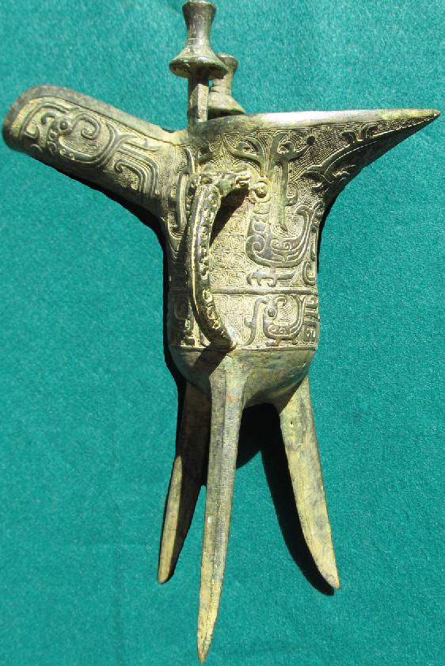

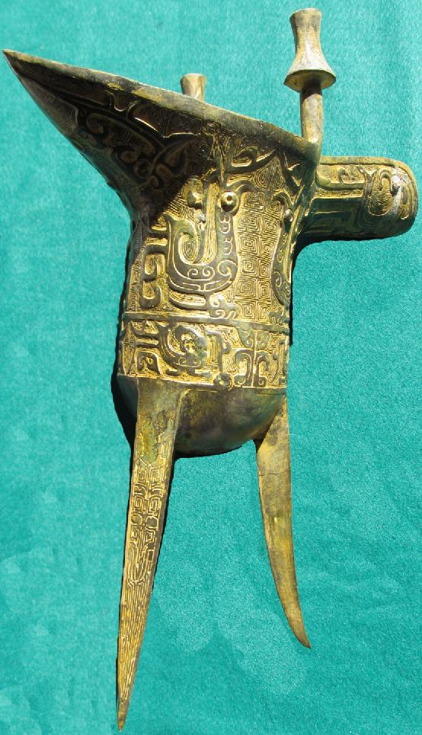

SHAPE \\* MERGEFORMAT 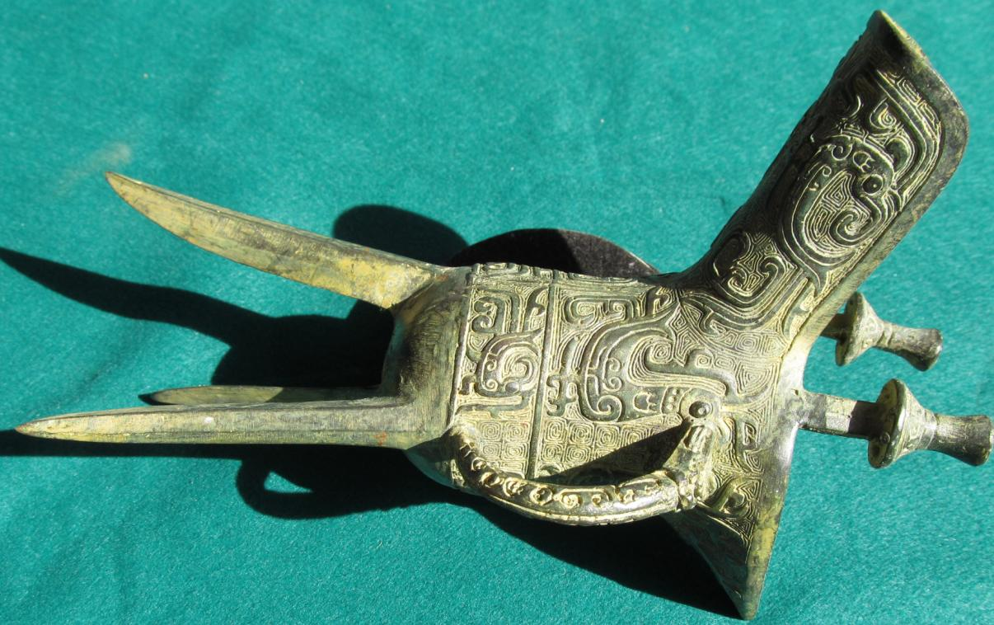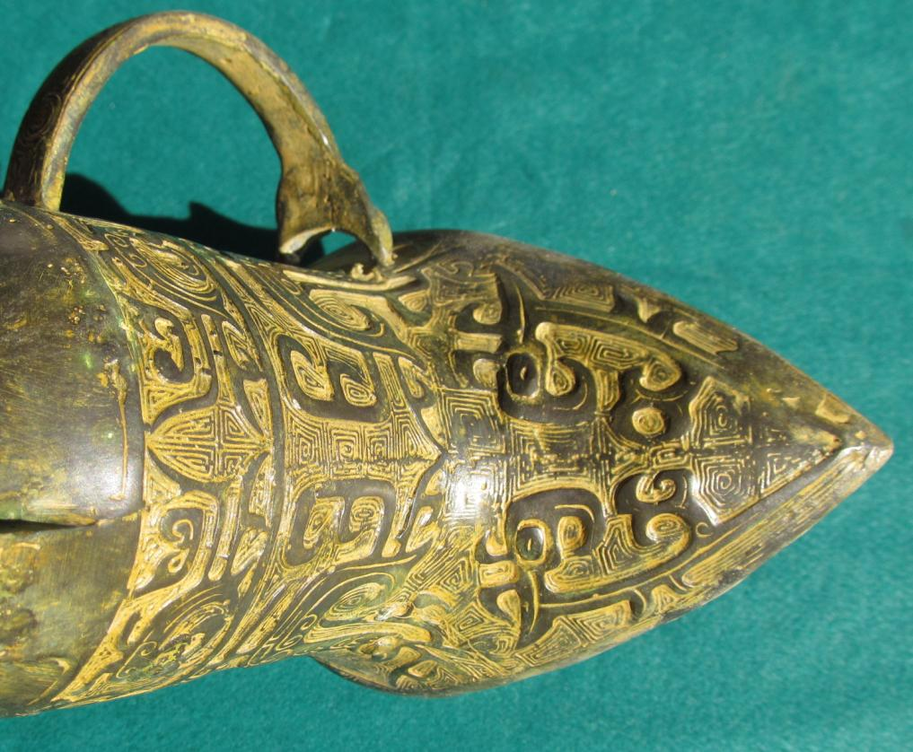 SHAPE \\* MERGEFORMAT 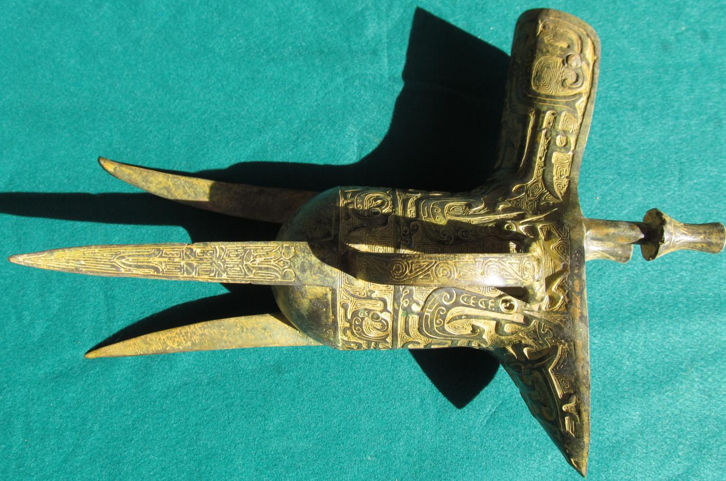

SHAPE \\* MERGEFORMAT 