COINS-Eur-Constantine

**Flavius Valerius Constantinus, as he was originally named, was born in the city of Naissus, Dardania province of Moesia, in present-day Niš, Serbia, on 27 February of an uncertain year, probably near 272. His father was Flavius Constantius, a native of Dardania province of Moesia (later Dacia Ripensis). Constantius was a tolerant and politically skilled man. Constantine probably spent little time with his father. Constantius was an officer in the Roman army in 272, part of the Emperor Aurelian's imperial bodyguard. Constantius advanced through the ranks, earning the governorship of Dalmatia from Emperor Diocletian, another of Aurelian's companions from Illyricum, in 284 or 285. Constantine's mother was Helena, a Bithynian woman of low social standing. It is uncertain whether she was legally married to Constantius or merely his concubine. In July 285, Diocletian declared Maximian, another colleague from Illyricum, his co-emperor. Each emperor would have his own court, his own military and administrative faculties, and each would rule with a separate praetorian prefect as chief lieutenant. Maximian ruled in the West, from his capitals at Mediolanum (Milan, Italy) or Augusta Treverorum (Trier, Germany), while Diocletian ruled in the East, from Nicomedia (İzmit, Turkey). The division was merely pragmatic: the Empire was called "indivisible" in official panegyric, and both emperors could move freely throughout the Empire. In 288, Maximian appointed Constantius to serve as his praetorian prefect in Gaul. Constantius left Helena to marry Maximian's stepdaughter Theodora in 288 or 289. Diocletian divided the Empire again in 293, appointing two Caesars (junior emperors) to rule over further subdivisions of East and West. Each would be subordinate to their respective Augustus (senior emperor) but would act with supreme authority in his assigned lands. This system would later be called the Tetrarchy. Diocletian's first appointee for the office of Caesar was Constantius; his second was Galerius, a native of Felix Romuliana. According to Lactantius, Galerius was a brutal, animalistic man. Although he shared the paganism of Rome's aristocracy, he seemed to them an alien figure, a semi-barbarian. On 1 March, Constantius was promoted to the office of Caesar, and dispatched to Gaul to fight the rebels Carausius and Allectus. In spite of meritocratic overtones, the Tetrarchy retained vestiges of hereditary privilege, and Constantine became the prime candidate for future appointment as Caesar as soon as his father took the position. Constantine went to the court of Diocletian, where he lived as his father's heir presumptive.**

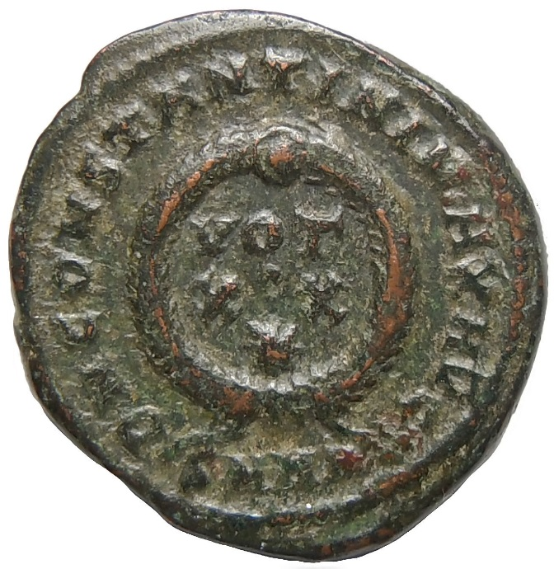 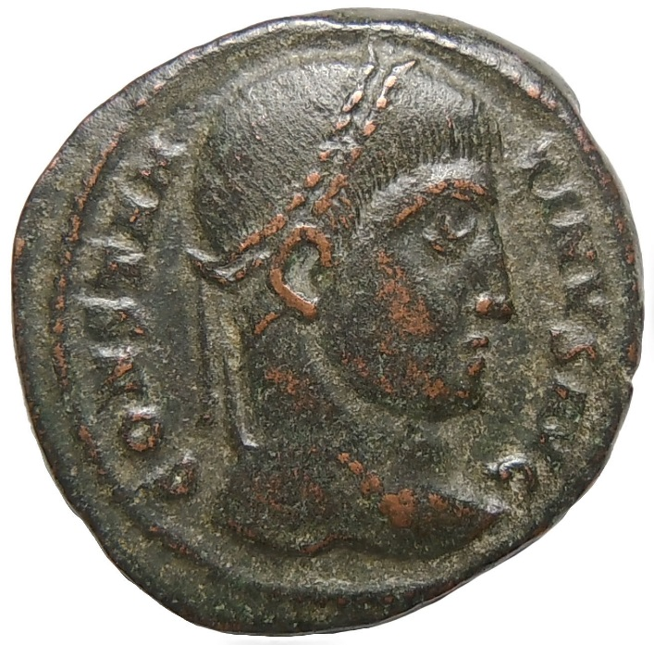

**Bronze coin 19 mm , 2.2  grams of Constantine I The Great 307 - 337 AD . Obv . CONSTANTINVS AVG . Laureate head right . Rev . DN CONSTANTINI MAX AVG. VOT.XX and star in wreath . SMHA in ex. Heraclea Mint**

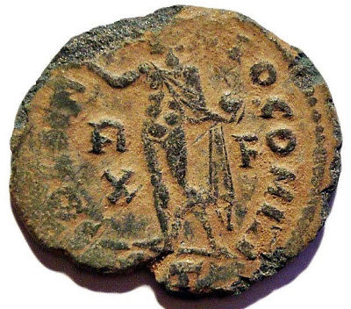 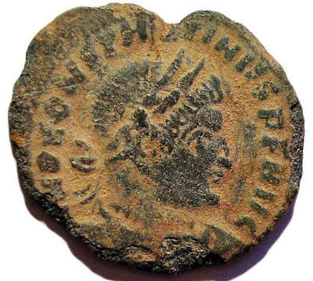

**CONSTANTINE I 314-315 AD Æ3 Roman Bronze Coin**

**Obverse legend: IMP CONSTANTINVS PF AVG (laureate, draped, cuirassed bust right)  
Reverse legend: SOLI INVICTO COMITI (Sol, radiate, standing left, chlamys across left shoulder, holding globe in left hand, R over X left field, F right)  
RIC VII 27 - Rome Mintmark(RT) (Rome, Italy)(34c55)**

**Diameter: 20,4 mm  
Weight: 1,84 g**

 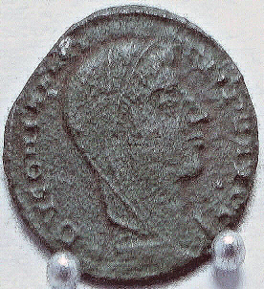

Ancient Roman Imperial coin DIVUS CONSTANTINE I. AE4,Alexandria mint,Scarce.  
DV CONSTANTINVS PT AVGG. Vieled hd.right.

Emperor in quadriga galloping right.

 Mintmark-SMALdelta.  
REF# RIC VIII53.

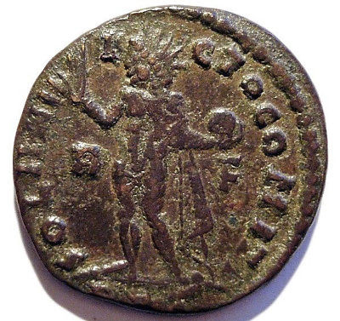 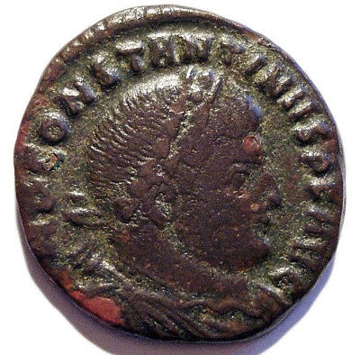

**CONSTANTINE I 314 AD Æ3 Roman Bronze Coin**

**Obverse legend: IMP CONSTANTINVS PF AVG (laureate, draped, cuirassed bust right)  
Reverse legend: SOLI INVICTO COMITI (Sol, radiate, standing left, chlamys across left shoulder, holding globe in left hand, R left field, F right)  
RIC VII 19 - Rome Mintmark(R✶T) (Rome, Italy)(66e69)**

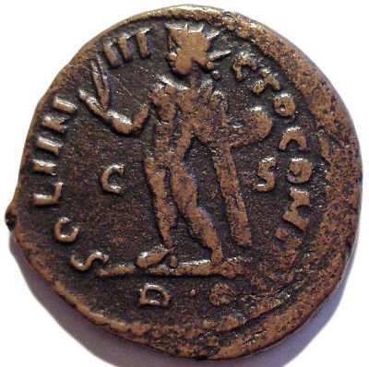 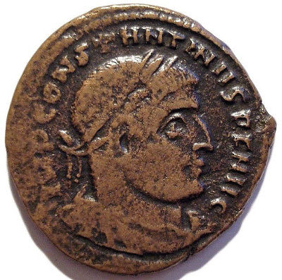

**CONSTANTINE I 315-316 AD Æ3 Roman Bronze Coin**

**Obverse legend: IMP CONSTANTINVS PF AVG (laureate, draped, cuirassed bust right)  
Reverse legend: SOLI INVICTO COMITI (Sol, radiate, standing left, chlamys across left shoulder, holding globe in left hand, C left field, S right)  
RIC VII 40 - Rome Mintmark(R?) (Rome, Italy) (38b46)**

**Diameter: 20,7 mm  
Weight: 3,75 g**