COINS-Eur-Asclepius

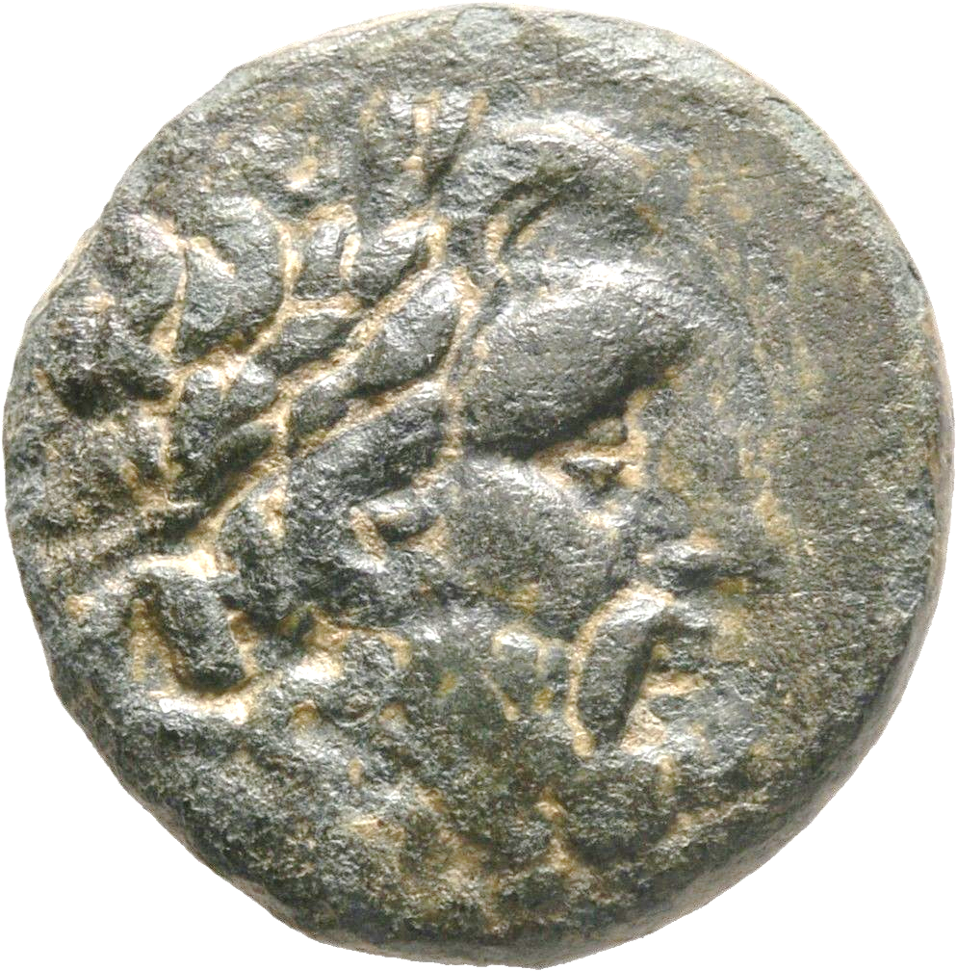 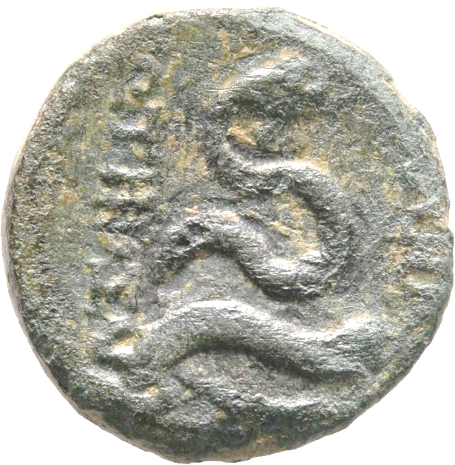

**MYSIA**

**PERGAMON**

Bronze. 133-27 BC.  
20 mm., 6,45 g.

Obv: Laureate head of Asklepios right.  
Rev: AΣΚΛΗΠΙΟΥ ΣΩΤΗΡΟΣ; Serpent coiled around omphalos.  
SNG France 1803-1827; SNG von Aulock 1372.