COINS-Crusader

*Crusaders coins survive in surprising abundance and have much to tell us about this distant era, which has so many parallels to contemporary events.*

By **Mike Markowitz** for **[CoinWeek](https://www.coinweek.com/" \t "_blank)** ….  
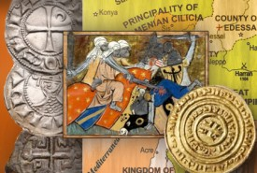

Between 1096 and 1291, the Church of Rome, the aristocracy, and the peoples of Western Europe launched a series of military campaigns against the Muslim rulers of the Eastern Mediterranean. These “ Crusaders ” established short-lived feudal states: the County of Edessa, the Principality of Antioch, the County of Tripoli and the Kingdom of Jerusalem. Collectively, these Crusader states were known as *Outremer* (“over the sea”) and their inhabitants as “Franks”, although they were not all French.

What sort of money did these crusaders carry to the Holy Land? The circulating coinage of eleventh-century Europe consisted of “feudal pennies” (*denier, denaro, pfennig*) weighing about 1.3g, made of *billon*, a copper alloy, with 30-40% silver. Some bore the name of a king or emperor, but local barons, bishops, or abbots struck most of them.

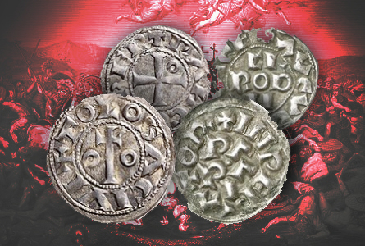

*Deniers* had little purchasing power – a rabbit might cost five, a fat chicken six. Large sums were reckoned in “monies of account” like the *livre*, equal to 240 *deniers*. A good warhorse might cost eighty *livres* – a knight’s armor, half that.

In sharp contrast, the Muslim world and the Byzantine Empire (through which many Crusaders passed on their way to war) were on a gold standard. The *dinars* of the Fatimid dynasty (909-1171) struck in Egypt were better than 95% gold and weighed 4 grams. The Byzantine *hyperpyron* of **Alexios Komnenos** (emperor in Constantinople at the time of the first Crusade) was 85% gold and weighed 4.4 grams. Silver coinage was scarce in Muslim and Byzantine economies, but there was an abundant supply of copper small change in the cities – something that had disappeared in the Medieval West.

Antioch (1098-1268)

Strongly walled and backed against a mountain, the ancient city of Antioch on the Orontes (now Antakya, Turkey) was held by a garrison of Seljuk Turks, 16,000 strong. After a bitter nine-month siege an Armenian tower guard was bribed to let a band of Crusaders scale the wall and open a gate. On June 3, 1098, the Crusaders massacred Muslim defenders and Greek Orthodox residents of the city with equal fury. A Norman knight, **Bohemond of Taranto** (1058 – 1111), claimed the city as his own, despite the Crusaders’ promise to return conquered territory to the Byzantine Empire. Bohemond founded a dynasty that lasted until Antioch was taken by the Egyptian Mamluks in 1268 (in exile even after that).

The early Crusader coinage of Antioch consists of crude 3-5 gram coppers modeled on the Byzantine *follis*. Anonymous billon *deniers* appeared around 1130, and the deniers of the long-lived Bohemond III (reigned 1144-1201) are relatively common, with a distinctive mailed and helmeted knight on the obverse.

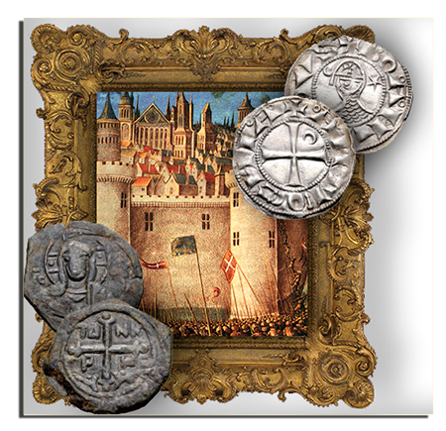

Jerusalem (1099-1291)

After storming Antioch and defeating a Muslim army from Mosul, the Crusaders slowly advanced toward their goal, Jerusalem. On July 15, 1099, using siege towers constructed from the timbers of dismantled Genoese ships, the walls of the city were breached. On the Temple Mount, according to a Frankish chronicler, “the slaughter was so great that our men waded in blood up to their ankles…” (Gesta).

**Godfrey of Bouillon** (c. 1060-1100), who led the Franks, refused the kingship of Jerusalem, feeling that the city was too sacred for any earthly King. He took the title “Defender of the Holy Sepulcher.”

Upon Godfrey’s death, his brother **Baldwin** (who had established the County of Edessa – see below) accepted the title of King of Jerusalem, which was borne by some 16 successors down to the fall of the kingdom in 1291.

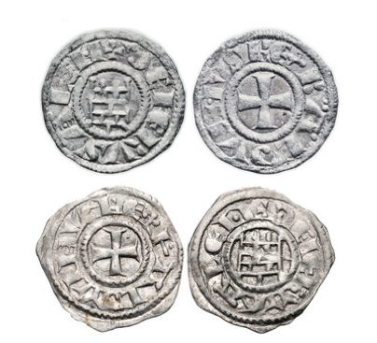

Except for a unique copper *follis*attributed to Baldwin I, the earliest Crusader coinage of Jerusalem was a series of billon *deniers* struck under **Baldwin III** beginning in 1143.

Baldwin III’s extensive coinage is divided into a crudely executed “rough” series and a later “smooth” series of finer style. The obverse bears a short cross, surrounded by the king’s name and title: BALDVINUS REX. The reverse depicts the “Tower of David” – an ancient stone citadel built against the city walls that served as a fortified palace. The reverse inscription DE IERUSALEM “of Jerusalem” continues from the obverse.

Baldwin’s successor **Amaury** (or **Amalric**) changed the obverse design to a stylized image of the Church of the Holy Sepulcher, believed to be the site of the Crucifixion and Resurrection of **Jesus**.

The Kingdom also produced an anonymous series of *deniers* known as “pilgrim” coins bearing a double-barred cross, flanked by palm fronds. These may have been elite presentation pieces or Easter souvenirs. The design recalls the rare “ceremonial silver” coinage of seventh century Byzantine emperors. (When numismatists don’t know the actual purpose of a coin, it is often described as “ceremonial.”)

About 1140 Jerusalem began minting “imitations” of the gold *dinars* of the Fatimid caliphs of Egypt. In Crusader documents these are called “Saracenic bezants.”

Saracen was a medieval term for “Muslim”, and *bezant* (or *bexant*) was the generic word for a gold coin–from “Byzantium”, the ancient name of Constantinople. The Saracenic bezant was lighter than the Fatimid coin and inferior in purity. The Arabic legends, carefully executed on early pieces, gradually become blundered and eventually just a series of strokes, dots and circles.

Cut gold triangular or rectangular fragments weighing a fraction of a gram often turn up in Crusader hoards. Since no complete coins bearing the same designs are found, archaeologists believe that these were made as “offering pieces” for pilgrims who wished to make a donation in gold at a holy site but could not afford an entire dinar (a month’s salary for a foot soldier).

[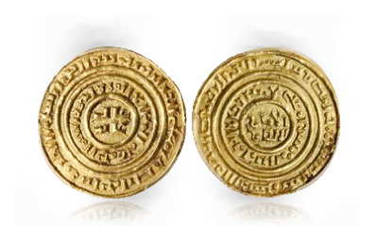](https://www.coinweek.com/wp-content/uploads/2014/08/jerusalemgold.jpg)

Edessa (1098-1150) and Tripoli (1104-1289)

Far inland from the Syrian coast, Edessa (now the town of Şanlıurfa, Turkey) became the seat of a short-lived County established by Baldwin of Boulogne, who broke away from the main Crusader army to carve out his own territory. After Baldwin became King of Jerusalem (see above), his cousins succeeded him at Edessa.  
Edessa mainly minted copper *folles*. The coins are usually crudely struck, with a standing figure of the Count in armor and abbreviated Greek inscriptions like BAGDOINOS DOULO STAU – “Baldwin, Servant of the Cross.” A few base silver deniers were overstruck on Muslim *dirhems*. Edessa fell to a Muslim army in 1144. Joscelin II, the last Count, was captured, blinded and imprisoned in a dungeon at Aleppo until he died (1159). His coins are very rare.

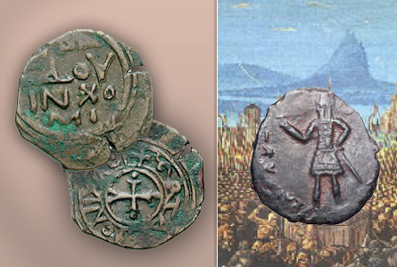

Captured by **Bertrand of Toulouse** in 1109, the port of Tripoli on the coast of Lebanon became the seat of the longest-surviving Crusader state.

Bertrand struck some rare deniers, but the coinage of Tripoli took definitive form under Count **Raymond II** (ruled 1137-1152) and his son **Raymond III** (1152-1187) — their coins are mostly identical. The obverse bears a cross surrounded by the name and title of the count, while the reverse carries the Latin inscription CIVITAS TRIPOLIS (“City of Tripolis”) around an eight-rayed starburst above a crescent. The same design appears on a series of small coppers.

Like Jerusalem, Tripoli struck gold, including a very rare “Agnus Dei” bezant with the image of the Lamb of God. The last Counts of Tripoli, **Bohemund VI** (1251-75) and his son, **Bohemund VII** (1275-1287), struck handsome coins in good silver on the 4.2 gram standard of the new Venetian *grosso*.

During the final two years of the County’s existence, **Lucia**, the sister of Bohemund VII, ruled over a city torn by civil strife. As far as we know, she issued no coins.

Collecting the Crusaders

Like most medieval coinage (excepting the ever-popular “hammered British” coinage) Crusader coins are not widely collected. Often badly struck in poor metal, with blundered or illegible inscriptions, few have the sort of eye appeal that makes a collector’s pulse race. So, except for great rarities or examples in superb condition, Crusader coins are relatively affordable, with nice coppers going for under US$100, and average billon *deniers* for under $200. Gold Saracenic bezants can be found for under $500.

The numismatic Prime Directive–“Buy the book before you buy the coin”–applies here. Although the standard reference by Metcalf (1983) is out of print and very costly, the 2004 edition of Malloy *et al*., *Coins of the Crusader States*, can still be purchased for US$85 or less.

References

Baldwin, M. W. (ed.) *A History of the Crusades, Volume I: The First Hundred Years.*Wisconsin. (1969)

Boas, Adrian J. “Archaeological Sources for the History of Palestine: The Frankish Period: A Unique Medieval Society Emerges.” *Near Eastern Archaeology* 61: 3 (1998)

Crusades: A Guide to Online Resources <http://www.the-orb.net/encyclop/religion/crusades/crusade.html>

Ehrenkreutz, Andrew S. “Arabic Dinars Struck by the Crusaders: A Case of Ignorance or of Economic Subversion.” *Journal of the Economic and Social History of the Orient* 7:2 (1964)

Ehrenkreutz, Andrew S., Theresa Emington and Sālih Sārī. “Contributions to the Knowledge of the Standard of Fineness of Silver Coinage Struck in Egypt and Syria during the Period of the Crusades.” *Journal of the Economic and Social History of the Orient 31:3* (1988)

Gesta Francorum et aliorum Hierosolimitanorum. Rosalind Hill, editor and translator. Oxford, (1967). Latin text with facing-page English translation.

Grierson, Philip. Coins of Medieval Europe. Seaby (1991)

**Metcalf, D.M. Coinage of the Crusades and the Latin East. Ashmolean Museum, Oxford. (1983)**

**Malloy, A. G., Preston, I. F. and Seltman, A. J. Coins of the Crusader States 1098-1291. Second Edition. Connecticut (2004)**

Walker, Ralph. Reading Medieval European Coins. Attic Books (2000)

Zacour, N. P.; Hazard, H. W. (ed.) The Impact of the Crusades on Europe. Wisconsin. (1989)  
Chapter X: Crusader Coinage with Greek or Latin Inscriptions  
Chapter XI: Crusader Coinage with Arabic Inscriptions