Dis-Ship-Roman-Münster-Cosmographia-1544

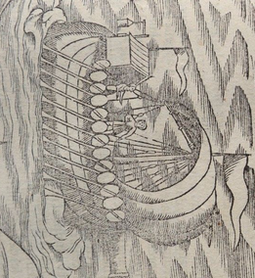

Münster (Sebastian) La Cosmographie Universelle, , [Basel], Heinrich Petri, 1552.

THIS IS A SMALL FOLIO AND MEASURES APPROX 13 BY 8 INCHES

SUBJECT: SICILY THIS HAS A LARGE ANCIENT SHIP IN THE SEA WITH OARS AND WHAT LOOKS LIKE A BATTERING RAM ON THE PROW THOUGH RATHER HIGH UP.

Sebastian Munster was a German cartographer, cosmographer, and Hebrew scholar whose Cosmographia (1544; "Cosmography") was the earliest German description of the world and a major work - after the Nuremberg Chronicle of 1493 - in the revival of geographic thought in 16th-century Europe. Altogether, about 40 editions of the Cosmographia appeared during 1544

THIS WENT THROUGH MULTIPLE EDITIONS IN DIFFERENT LANGUAGES AND WAS PRINTED INTO THE 17th CENTURY