Eur-Rome-Baetyl-Coins

|  |
| --- |
| Ancient Coins Showing Sacred Stones |

|  |
| --- |
| You can click on any coin image to see the full coin. |

Sacred stones appeared on many ancient coins, Greek and Roman Provincial, and even Roman Imperial. Some of these were an interesting type, unusual to us, called a baetyl.

#### What was a baetyl?

The Greek word baetyl, or baetylos, probably originated from the Punic "betel" or the Semitic "bethel," both meaning the house of god. There were many of these stones across the ancient world, and it seems that they represented the spirit or essence of a deity. So, they were revered aniconic symbols of gods, indicating that they were present and accessible; they were not regarded as the gods themselves.

You might read elswehere that these stones were meteorites. This is what Wikipedia says. But that is at best an oversimplification. Some might have been meteorites; some definitely were not. If the surface of a baetyl looked black and shiny, it was not because it had been melted in its passage through the atmosphere, but because it had been drenched in offerings of wine, oil, honey or milk for centuries.

Of course, not all sacred stones were baetyls.

#### The Omphalos at Delphi

Probably the most famous sacred stone was the Omphalos at Delphi. It was named "Navel" because it was supposed to be at the centre of the world. Other towns also had Omphalos stones, but these were copies or imitations of the revered original.

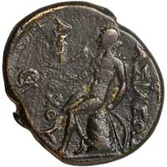A bronze coin of Antiochos I showing Apollo seated on the Omphalos of Delphi.

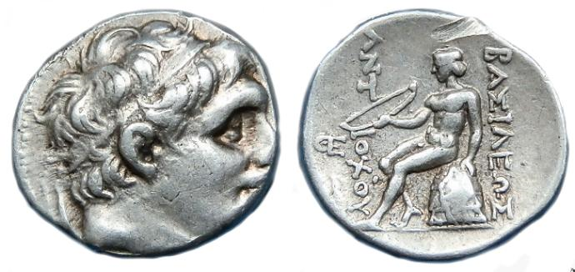

ANTIOCHOS I  
AR DRACHM

Description:

Date: C. 280-261 BC

Reverse: Apollo seated left holding bow; monogram before

Condition: Super detail and surfaces

Weight: 4.30g

Size: 17mm

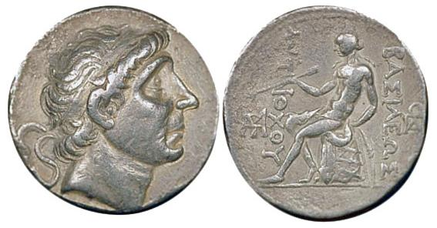

Seleucid Kingdom

Antiochos I Soter - 280-261 BC

AR tetradrachm - 16,7 gram

Obv: his diademed head right

Rev: Apollo seated left, holding arrow and bow, sitting on omphalos, monogram left and right

S 6866

SNG Spear 336

GR2189

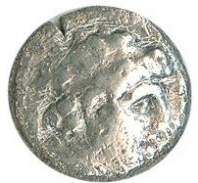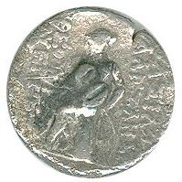

Alexander l Balos  
Silver Drachm

AR (Silver) Drachm. 18mm, 4.03g. Struck c. 150/149 BC, Antioch.

Obverse: Diademed head right.

 Reverse: Apollo standing left, arrow in right, resting left on bow

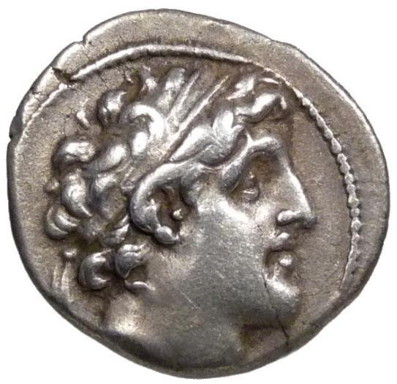 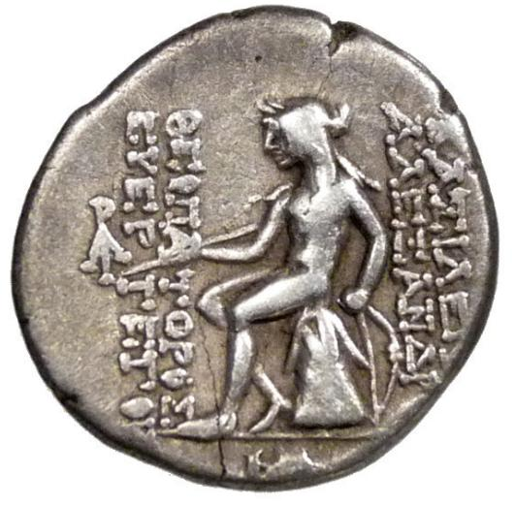

S E L E U K I D   K I N G D O M ALEXANDER I Balas 152-145  BC.

AR (Silver) Drachm. 18mm, 4.03g. Struck c. 150/149 BC, Antioch.

Obverse: Diademed head right.

Reverse: Apollo seated left on omphalos; monograms in left field and exergue.

Ref. SNG Spaer 1400; Newell SMA 145. Nice VF+ attractively toned.

The site at Delphi was originally called Pytho, and was a centre of worship of the earth goddess Gê or Gaia. It seems that a sacred stone existed then, maybe as far back as Mycenaean times, 1400 to 1100 BCE. It is now thought that this original stone might have been where sacrifices were made to Gê, maybe an altar over which blood was poured, and was neither the embodiment of a deity nor a marker that indicated a god's accessible presence, so not a true baetyl.

Joseph E. Fontenrose, in an early edition of the Oxford Classical Dictionary, notes the existence of a stone block which might have been this original, sited in the adytum of Apollo's temple. It had the rough lettering ΓAΣ carved into it, meaning a dedication to the earth goddess Gê, though we don't know when these letters were carved or even, really, the shape of the block.

The site under Gê was said to have been protected by a dragon or serpent called the Python, and just a few days after [Apollo](http://www.forumancientcoins.com/moonmoth/reverse_apollo.html) was born on Delos, he came to fight it. He defeated it and took over the precincts, complete with its real prize, the most famous oracle of the ancient world, the source of Delphi's fame.

The whole site then became dedicated to Apollo. Many came to his temple, to consult the oracle. On the seventh day of the month, a priestess called the Pythia would sit on a tripod, inhale fumes from a crack in the earth, and make mysterious pronouncements said to come from the deity, which were then gracefully reworded by a college of interpreters. There are records of many famous prophecies.

The Omphalos became a symbol which represented the Delphic Apollo. So, symbols of Apollo would appear on coins which showed the Delphi Omphalos. There were many such coins and quite a few symbols.

The coin above on the right, of the Seleukid Antiochos I, shows one of the most common of such images: [Apollo](http://www.forumancientcoins.com/moonmoth/reverse_apollo.html) himself seated on the Omphalos, holding his bow and examining an arrow. Some similar coins show him grasping a laurel branch and with his [kithara](http://www.forumancientcoins.com/moonmoth/glossary.html" \l "KITHARA) standing nearby. A lyre, a larger professional version of the simple folk instrument called a [chelys](http://www.forumancientcoins.com/moonmoth/glossary.html" \l "CHELYS). "Kithara" is the Greek word; the Latin version is "cithara."

The coin of Neapolis below left, although not very beautiful, is here because it shows Apollo's [kithara](http://www.forumancientcoins.com/moonmoth/glossary.html" \l "KITHARA) leaning against the Omphalos. Apollo was a master musician, and was sometimes called the leader of the muses.

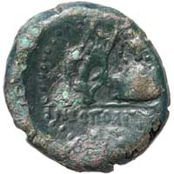A bronze coin of Neapolis showing a kithara leaning against the Omphalos of Delphi.

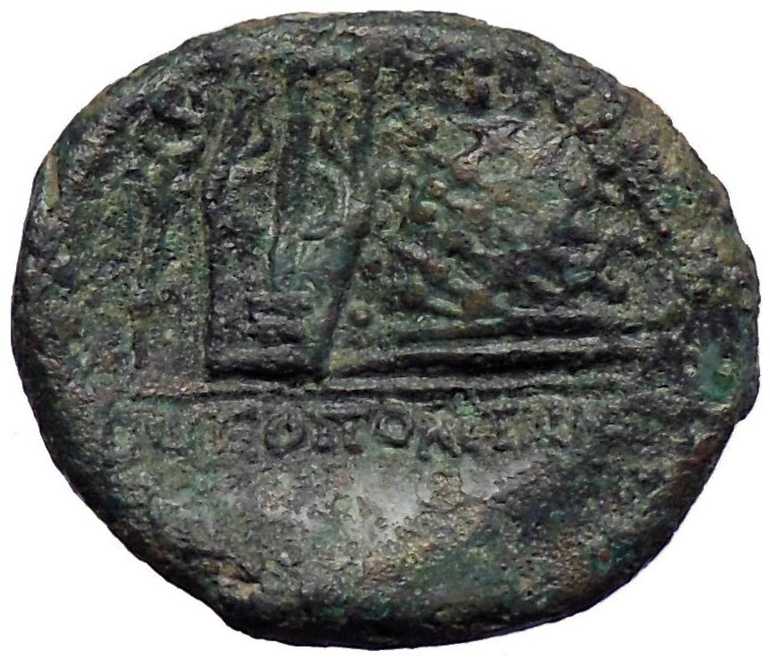 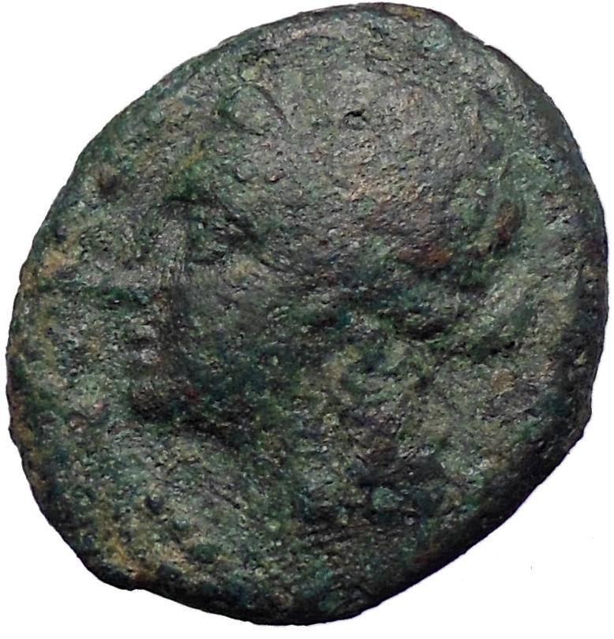

**Greek city of Neapolis in Campania**Bronze 20mm (4.00 grams) 250-225 B.C.  
Reference: Cf. SNG ANS 530; cf. HN Italy 592Laureate head of Apollo left within laureate wreath  
Lyre leaning against omphalos; caduceus left, NEOΠΟΛIΤΩΝ in exergue.

The original inhabitants of Campania were three defined groups of the Ancient peoples of Italy, who all spoke the Oscan language which is part of the Italic family; their names were the Osci, the Aurunci and the Ausones. During the 8th century BC, people from Euboea in Greece known as Cumaeans began to establish colonies in the area roughly around the modern day province of Naples. Another Oscan tribe, the Samnites, had moved from central Italy down into Campania. Since the Samnites were more warlike than the civilised Campanians, they easily took over the cities of Capua and Cumae, in the area which was one of the most prosperous and fertile in the Italian Peninsula at the time. During the 340s BC, the Samnites were engaging in warfare with the Roman Republic in a dispute known as the Samnite Wars, with the Romans securing rich pastures of northern Campania during the First Samnite War. Originally a Rhodian colony of very early foundation under the name of Parthenope, the city was recolonized by Kymaians circa 600 B.C. and its name finally changed to Neapolis circa 450 B.C. Allied with Rome from 326 BCE.

As the patron of [Delphi](http://en.wikipedia.org/wiki/Delphi) (*Pythian Apollo*), Apollo was an [oracular](http://en.wikipedia.org/wiki/Oracular) god — the prophetic deity of the [Delphic Oracle](http://en.wikipedia.org/wiki/Pythia). Medicine and healing were associated with Apollo, whether through the god himself or mediated through his son [Asclepius](http://en.wikipedia.org/wiki/Asclepius), yet Apollo was also seen as a god who could bring ill-health and deadly [plague](http://en.wikipedia.org/wiki/Plague_(disease%2529) as well as one who had the ability to cure. Amongst the god's custodial charges, Apollo became associated with dominion over [colonists](http://en.wikipedia.org/wiki/Colonies_in_antiquity), and as the patron defender of herds and flocks. As the leader of the [Muses](http://en.wikipedia.org/wiki/Muse) (*Apollon Musagetes*) and director of their choir, Apollo functioned as the patron god of music and [poetry](http://en.wikipedia.org/wiki/Poetry). [Hermes](http://en.wikipedia.org/wiki/Hermes) created the [lyre](http://en.wikipedia.org/wiki/Lyre) for him, and the instrument became a common [attribute](http://en.wikipedia.org/wiki/Apollo" \l "Attributes_and_symbols) of Apollo. Hymns sung to Apollo were called [paeans](http://en.wikipedia.org/wiki/Paean).

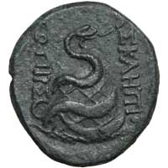A bronze coin of Pergamon showing a serpent winding around the Omphalos of Delphi.

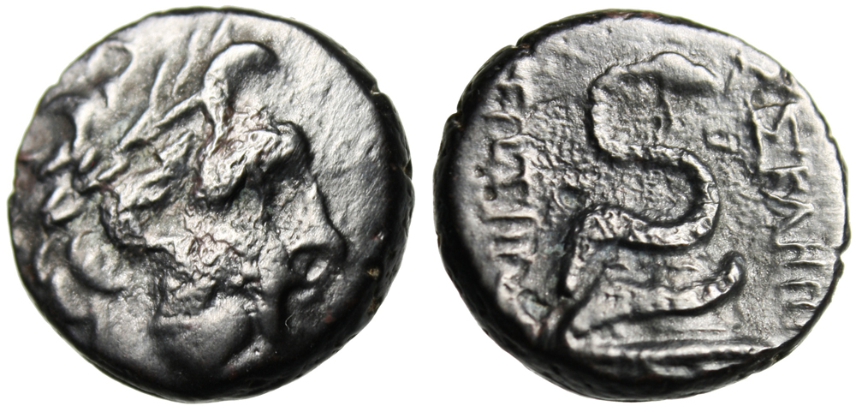

Mysia, Pergamon (Pergamum)

After 133 BC

Obverse: Laureate head of Asklepios right

Reverse:  ASKLHPIOY SWTHROS Serpent coiled around omphalos

SNG France: 1803, SNG von Aulock 1372, SNG Copenhagen -

Size: 18mm, 7.20g

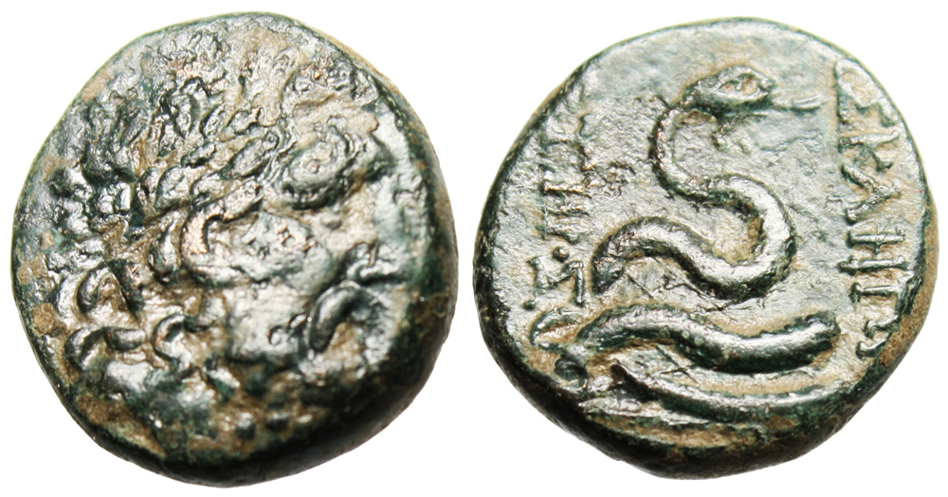

|  |
| --- |
| Mysia, Pergamon  After 133 BC  Obverse: Laureate head of Asklepios right  Reverse: ASKLHPIOY SWTHROS Serpent coiled around omphalos  SNG France: 1803, SNG von Aulock 1372, SNG Copenhagen-  Size: 20mm, 8.57g |

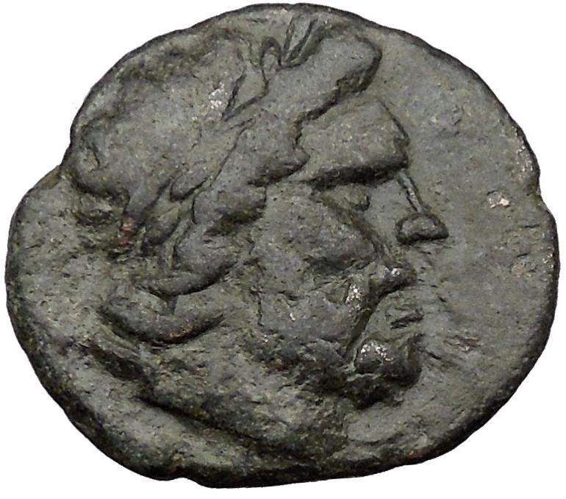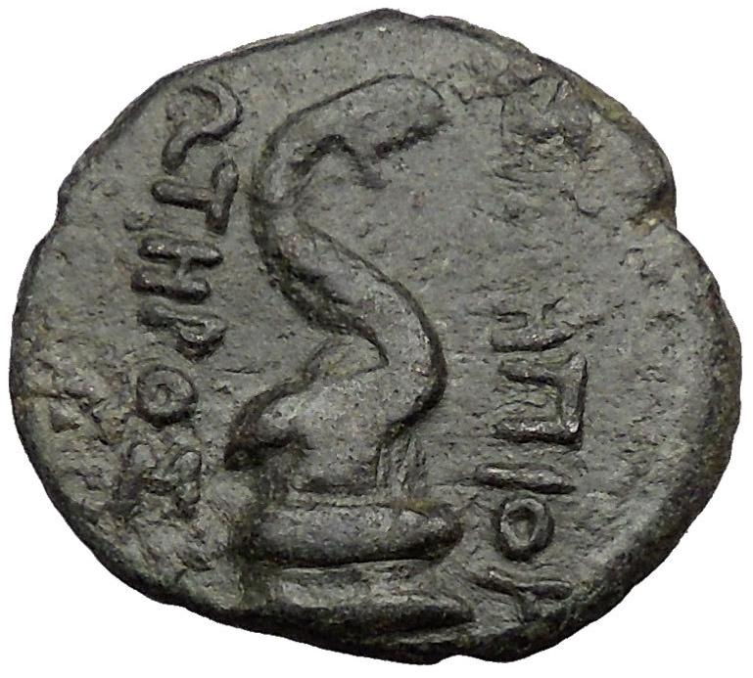 **Greek city of Pergamon in Asia Minor**Bronze 21mm (6.83 grams) Struck circa 100-50 B.C.   
Reference: Sear 3967; B.M.C. 15.129,158   
Laureate head of Asclepius right.   
ΑΣΚΛΗΠΙΟΥ / ΣΩΤΗΡΟΣ either side of a Asclepian snake coiled right around omphalos.

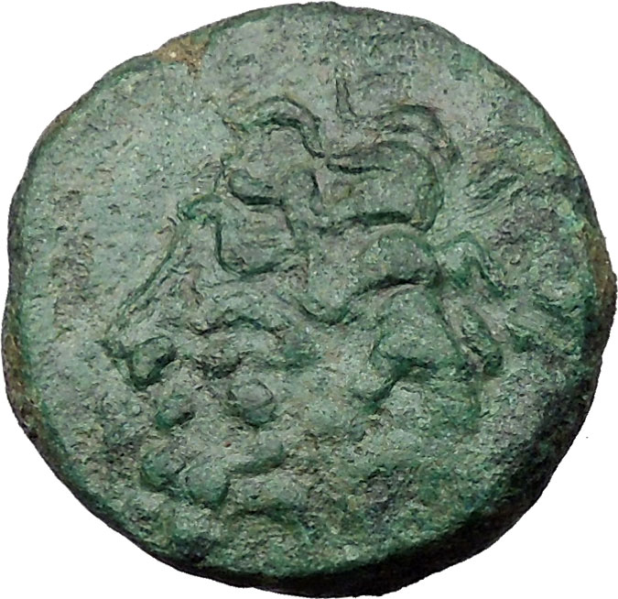 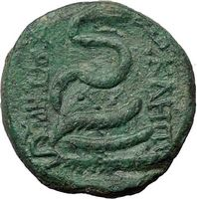

**Greek city of Pergamon in Asia Minor**Bronze 19mm (7.91 grams) Struck circa 100-50 B.C.   
Reference: Sear 3967; B.M.C. 15.129,158   
Laureate head of Asclepius right.   
ΑΣΚΛΗΠΙΟΥ / ΣΩΤΗΡΟΣ either side of a Asclepian snake coiled right around omphalos.

Situated in the Kaikos valley, about 15 miles from the coast, Pergamon was a city of uncertain origin and of no great importance before the time of Alexander the Great. In the 3rd century B.C. it became the center of the independent kingdom ruled by the Attalid dynasty founded by Philetairos. The city was extended and beautified as the prosperity of the kingdom increased, and by the late Hellenistic times Pergamon ranked as one of the great cultural centers of the Greek world. After the end of the kingdom, 133 B.C., Pergamon became capital of the Roman province of Asia.

You are bidding on the exact item pictured, provided with a Certificate of Authenticity and Lifetime Guarantee of Authenticity.

An [**omphalos**](http://en.wikipedia.org/wiki/Omphalos) (ὀμφαλός) is an ancient religious stone [artifact](http://en.wikipedia.org/wiki/Artifact_(archaeology%2529), or [baetylus](http://en.wikipedia.org/wiki/Baetylus). In [Greek](http://en.wikipedia.org/wiki/Greek_language), the word *omphalos* means "[navel](http://en.wikipedia.org/wiki/Navel)" (compare the name of Queen [Omphale](http://en.wikipedia.org/wiki/Omphale)). According to the ancient Greeks, [Zeus](http://en.wikipedia.org/wiki/Zeus) sent out two eagles to fly across the world to meet at its center, the "navel" of the world. Omphalos stones used to denote this point were erected in several areas surrounding the [Mediterranean Sea](http://en.wikipedia.org/wiki/Mediterranean_Sea); the most famous of those was at the [oracle](http://en.wikipedia.org/wiki/Oracle) in [Delphi](http://en.wikipedia.org/wiki/Delphi). It is also the name of the stone given to [Cronus](http://en.wikipedia.org/wiki/Cronus) in Zeus' place in Greek mythology.

The Omphalos was the centre of much ceremony. It was said to have been anointed every day with oil, and it was certainly wrapped with a netting of raw wool (carded, but not spun or dyed) called the [agrenon](http://www.forumancientcoins.com/moonmoth/glossary.html" \l "AGRENON). Coins, vase paintings and stone copies all show the Omphalos with this ceremonial netting, which was sometimes worn by soothsayers. Similar netting is shown on some sacrificial animals, and was also depicted as being worn by Apollo.

(A Greek word for the white wool netting which covered the [Omphalos](http://www.forumancientcoins.com/moonmoth/glossary.html" \l "OMPHALOS), and was also worn by soothsayers. It was related to the casting nets used by hunters. It was made of raw wool which had been carded, but not spun or died. Paintings and copies of the Omphalos showed it with this netting. It can be seen on the example to the right, criss-crossing between the body of a snake.)

A stone which some take to be the original Omphalos can be seen at Delphi today, out in the open, adjacent to the Treasury of the Athenians. It is of limestone and has been carved into a half-ovoid shape. But this is unlikely to be the original, and in fact shows too little weathering to have been in the open for long.

There is a Roman copy of the stone in the Delphi museum. Like other copies, it has thick netting carved onto its surface. Beware of sources like Wikipedia which say that this is the original Omphalos. It is not.

The right-hand coin above shows a snake wound around the Omphalos, and here the netted surface is obvious. Among other things, Apollo was as a deity of medicine and healing, and this is what the [snake](http://www.forumancientcoins.com/moonmoth/snake_coins.html) represents on this coin from Pergamon, which was famous for its sanctuary of the minor healing deity [Asklepios](http://www.forumancientcoins.com/moonmoth/reverse_salus.html" \l "ASKLEPIOS).

The oracular sanctuary declined in importance during the period of the Roman Empire, and was closed in 395 CE on the orders of the Emperor Theodosius I.

#### A Baetyl from Tyre

Tyre was an ancient Phoenician city, which still exists on the coast of modern Lebanon. The main city was originally on an island just off the coast, a very good defensive position, but Alexander the Great built up a causeway to join it to the mainland, so as to conquer it, and so it remains today.

|  |  |
| --- | --- |
|  | Coin Type: Bronze AE30 of Elagabalus, 218-222 CE.  Mint and Date: Tyre in Phoenicia, 218-222 CE  Size and Weight: 28mm x 30mm, 11.55g.  Obverse: IMP (...) AV AN-TONINVS AVG  Laureate, draped and cuirassed bust right, seen from behind.  Reverse: TYRIORVM  Serpent entwined around ovoid baetyl; fruiting palm tree to left; murex shell to right.  Provenance: parvaneh81 (eBay), November 2009.  Ref: BMC Phoenicia pg. 278, 413.  BW Ref: 044 044 149 |
| Click on the picture for a larger scale view of the coin |
| Note: The baetyl on this coin is an odd shape. It looks fat at its base, but then it seems to have been altered to a thinner shape for the middle and top, to allow space for the murex shell on its right.  The neck of the snake has been damaged, so that the head appears to float above it; this damage is on the coin, not the die. | |

The city was known in antiquity for the production of an expensive dye, Tyrian Purple, which was made from the murex, a species of predatory sea-snail. This colour was reserved for royalty or aristocracy in several cultures.

The name of the city means "Rock." In myth, Tyre was said to have been founded on a group of floating rocks upon which an olive tree grew, the Ambrosial Rocks, which then became fixed in place to form the base of the city. These are shown on a coin of Gordian III as two rocks with a tree between them. But the coin shown here, although it has a rock and a tree, has to be something else.

This particular coin shows a date palm, the type called Phoenix, which was spread by the Phoenicians and which produces the kind of dates we still eat today. On the right is a murex shell, signifying the dye trade. The stone in the centre is oddly shaped, as though the engraver started to make it fat at the base, and then changed his mind part way up and made it thinner to allow space for the murex shell on the right.

The coin shows a baetyl with a snake winding around it. But which baetyl is this? Its shape, and the snake, are reminiscent of the Omphalos on the coin shown above. Perhaps this snake is the Python that Apollo defeated. But this is a coin of Elagabalus, and he is known for his worship of the baetyl of Emesa, shown below. So perhaps it is that stone, though this does not explain the snake.

And there is a third possibility. In the mythology of the Phoenicians, Ouranos (the sky) and Gê (the earth) gave birth to four sons, one of whom was named Baitylos. (Greek mythology has a different account.) So this stone might be a representation of a Phoenician deity.

#### The Sacred Stone of Emesa

In the town of Emesa in Syria, now called Hims (or Homs), a sun god was worshipped. He was called Elah-Gabal, Heliogabalus or Elagabalus, or sometimes other variations of this name.

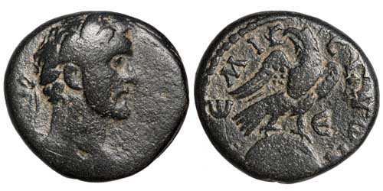Coin Type: Bronze AE22 of Antoninus Pius, Caesar 138 CE, Augustus 138-161 CE  
Mint and Date: Emesa in Seleucis and Pieria, Syria, 142-143 CE.  
Size and Weight: 20mm x 22mm, 8.92g   
Obverse: (AVT KAI TI AIΛ ANTONЄINOC CЄB ЄV)   
Laureate head right.   
Reverse: ЄMI-CHNΩN   
Eagle with closed wings standing right on the conical [baetyl](http://www.forumancientcoins.com/moonmoth/glossary.html" \l "BAETYL) (holy stone) of Emesa, head left, holding wreath in beak; (stone decorated with crescent and two stars below.)   
Field Marks: Є in right field (year 5).   
Provenance: Zurqieh Co. LLC (Vcoins), October 2009   
Ref: SNG Copenhagen 309 var (Γ in reverse field).   
BW Ref: 031 044 149 It happened that an Emperor of Rome, Septimius Severus, had married a Syrian princess from Emesa before he became Emperor. Julia Domna was the youngest daughter of the local high priest Gaius Julius Bassianus, and through this heredity, her grand-nephew Varius Avitus Bassianus was also a priest of that sun god in his home town.

In due course, this young man, now renamed Marcus Aurelius Antoninus, became Emperor in his turn. We know him best by neither of those names, but by the name of the god whose priest he was. Because [Elagabalus](http://www.forumancientcoins.com/moonmoth/coins/elagabalus_011.html), perhaps the weirdest of all the Roman Emperors, decided to bring his god to Rome and place it at the head of the Roman pantheon.

The baetyl of Emesa was the stone of the sun-god Elagabalus. It is shown on the coin on the right. It was black, and is sometimes said to have an eagle engraved on it. Certainly an eagle was often shown in front of it or standing upon it, as on this coin, but it is not clear what, if anything, was really engraved on it. Some examples of the coin on the right might show a crescent and stars, or something more complicated, or maybe only an irregular shape. An Imperial denarius shows an eagle clearly in front of the stone, and stars that might be on it.

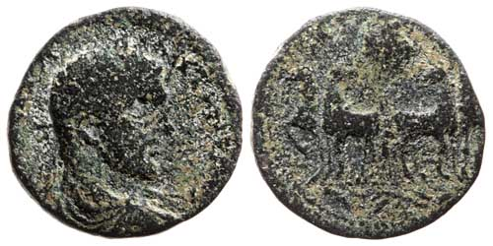Coin Type: Bronze AE30 of Elagabalus, 218-222 CE.   
Mint and Date: Aelia Capitolina (Jerusalem) in Judaea, 218-222 CE   
Size and Weight: 21mm x 22mm, 6.53g.   
Obverse: (IM C MA ANTONINVS)   
Laureate, draped and cuirassed bust right, seen from the front.   
Reverse: COL A C C P F   
[Baetyl](http://www.forumancientcoins.com/moonmoth/glossary.html" \l "BAETYL) of Emesa, decorated with eagle, in frontal [quadriga](http://www.forumancientcoins.com/moonmoth/glossary.html" \l "QUADRIGA).   
Exergue: Wavy branch.   
Provenance: Sahar Coins (Vcoins), November 2009.   
Ref: BMC Palestine 89; Hendin 816; Sear 3124.   
BW Ref: 045 044 150

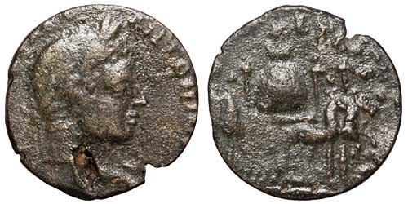Coin Type: Bronze AE27 of Elagabalus, 218-222 CE.   
Mint and Date: Laodikeia ad Mare in Syria, 218-222 CE   
Size and Weight: 26mm x 27mm, 7.44g.   
Obverse: (IMP CΛ ...) ANTONIN(...)   
Laureate head right.   
Reverse: (...)   
[Baetyl](http://www.forumancientcoins.com/moonmoth/glossary.html" \l "BAETYL) of Emesa in frontal [quadriga](http://www.forumancientcoins.com/moonmoth/glossary.html" \l "QUADRIGA), parasols above.   
Provenance: coin.medal.collection (eBay), November 2009.   
Ref: Meshorer 149. As part of the process of making his sun-god supreme in Rome, the emperor Elagabalus brought the baetyl to the capital and installed it in a new temple, the Elagabalium.

There are many coins, including Roman Imperial denarii and aurei, which show the stone in a ceremonial procession, set in a slow [quadriga](http://www.forumancientcoins.com/moonmoth/glossary.html" \l "QUADRIGA), shaded by parasols. It is said that Elagabalus the Emperor walked backwards in front of the quadriga in these processions, his eyes fixed on the stone, the object of his reverence.

The left-hand coin is so worn that you can only just see the stone in the background. This coin is from Aelia Capitolina, the name the Romans gave to Jerusalem.

To its right is a clearer coin from Laodikeia ad Mare in Syria. This coin shows the stone clearly, as well as the parasols surrounding the quadriga.

When Elagabalus the Emperor was finally killed, his successor, Severus Alexander, had the stone returned to Emesa. Some have conjectured that this is the same Black Stone that can now be found in the Grand Mosque in Mecca. If so, it is quite small compared to the depictions on these last two coins, maybe a foot in diameter; more consistent with the stone on the coin from Emesa itself, above right.

#### The Shrine of Astarte

Astarte was an ancient goddess from the Phoenician region, sometimes calles Ashtoreth. She was a goddess of sexuality, love and war. She was equivalent to the Mesopotamian Ishtar, a goddess associated with holy prostitution.

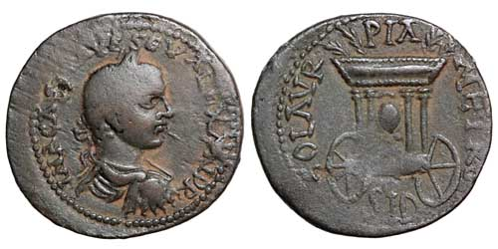Coin Type: Bronze AE28 of Severus Alexander, 222-235 CE.   
Mint and Date: Sidon in Phoenicia, 222-235 CE   
Size and Weight: 26mm x 28mm, 8.23g.   
Obverse: IMR CAE M AVR SEV ALEXANDR   
Laureate, draped, and cuirassed bust right, seen from behind.   
Reverse: COL AVR PIA METRO SID   
Shrine of Astarte on two wheels; within, a round [baetyl](http://www.forumancientcoins.com/moonmoth/glossary.html" \l "BAETYL) above two pyramidal supports between four columns; four palm branches on baldaquin.   
Provenance: amphoracoins (eBay), May 2010.   
Ref: SNG Copenhagen 268; BMC 318-319.   
BW Ref: 048 049 159

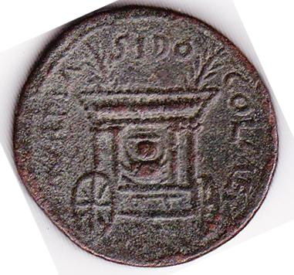 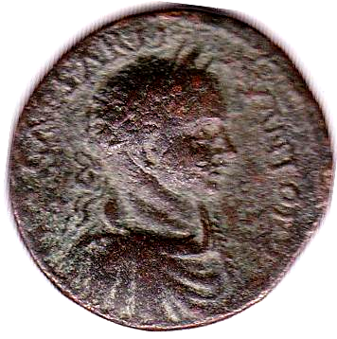

Elagabalus, 218-222 AD, bronze of 29.4 mm. Struck at   
the mint of Sidon in Phoenicia.  
Obverse: Laureate and cuirassed bust right.  
Reverse: Cart of Astarte with the Stone of Elagabalus within it.

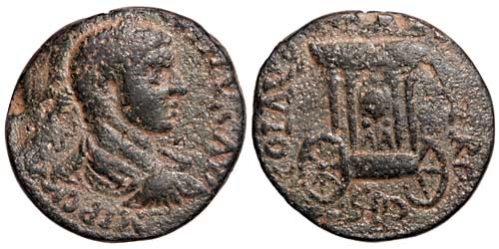 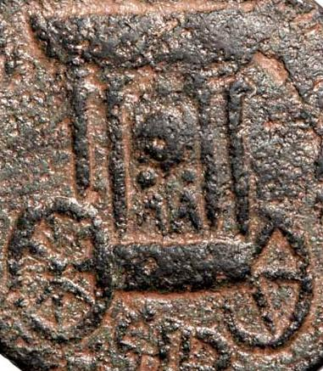

Coin Type: Bronze AE26 of Elagabalus, 218-222 CE.   
Mint and Date: Sidon in Phoenicia, 218-222 CE   
Size and Weight: 24mm x 26mm, 12.12g.   
Obverse: IMP C M A(VR ANTO)NINVS AVG   
Laureate, draped, and cuirassed bust right, seen from behind.   
Reverse: COL AVR (PIA MET)RO SID   
Shrine of Astarte on two wheels; within, a round [baetyl](http://www.forumancientcoins.com/moonmoth/glossary.html" \l "BAETYL) above two pyramidal supports between four columns; four palm branches on roof.   
Provenance: Den of Antiquity Int Ltd (Vcoins), March 2010.   
Ref: BMC Phoenicia pg.186, 251; SNG Copenhagen 256 var. (frontal bust); AUB pg. 204, 261; L&K 2338.   
BW Ref: 049 048 155 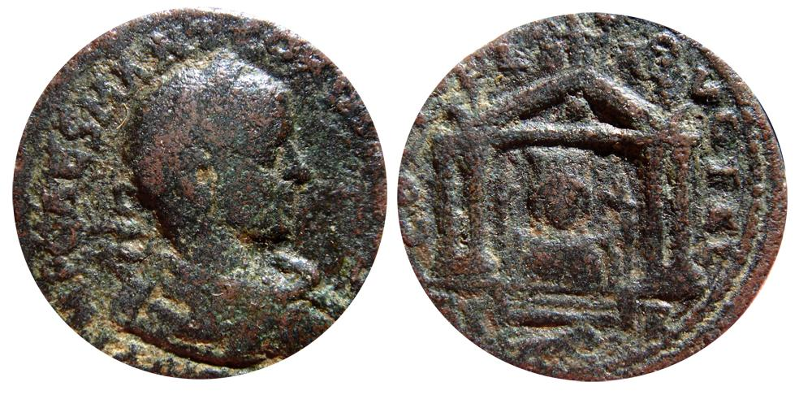

Elagabalus AE27 minted in Tyre, Phoenicia between 218-222 A.D. Autonomic Issues. Attractive laureated bust right. Nice reverse, Astarte within temple. BMC Phoenicia 171.

Nice tone. 15,13 gm. 27 mm.

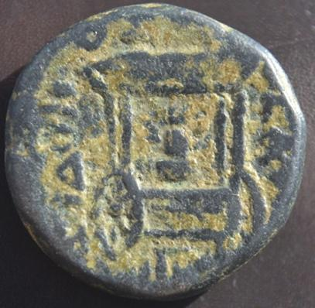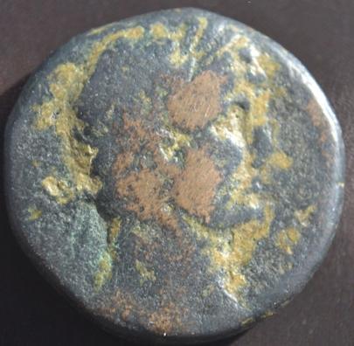

PHOENICIA, Sidon. Hadrian. AD 117-138. Æ 21mm (9.81 g). Dated CY 228 (AD 117/118). Laureate bust right, slight drapery on left shoulder / SIDONO-S QEAS, HKS below, Baetyle within Car of Astarte. BMC Phonicia pg. 181, 227.

The Greeks took her up under the name Aphrodite, and later, the Romans evoked her into the Empire from Sicily as [Venus Erycina](http://www.forumancientcoins.com/moonmoth/reverse_venus.html" \l "ERYCINA). This ancient deity had a long and complex history.

One of the Phoenician cities in which she was worshipped was Sidon. These coins comes from that city in the time of the emperor Elagabalus and his successor Severus Alexander, and show what is sometimes called the Cart of Astarte, a two-wheeled carriage containing a round or ovoid baetyl on two oddly-shaped supports, underneath a protective baldaquin.

This is one of the best known baetyl coins.

It is normally presumed that this is specifically a baetyl of Astarte, though I have also seen it conjectured that — as it appears on coins of Elagabalus — the baetyl is his personal holy stone of Emesa. However, the carriage is not the type that appears on coins from Rome or Emesa, where Elagabalus' stone had actually been taken in procession. For example, it lacks the decorative parasols and instead cas a cover with palm branches. You would have to assume that the Sidonites had heard of those processions, but not the fine details, and given the stone their own local appurtenances. And as the Phoenicians were quite familiar with baetyls, such assumptions do not appear to be necessary.

You would also have to explain why the same stone appears on coins of Severus Alexander, who became emperor after Elagabalus' violent overthrow and sent his stone back to Emesa. That would be carelessness by the Sidonites, at best.

#### The Stone of Zeus Kasios

[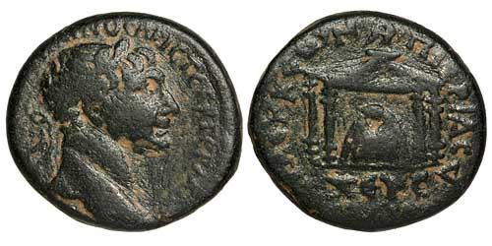](http://www.forumancientcoins.com/moonmoth/coins/trajan_032.html) 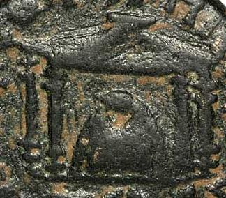

Coin Type: Bronze AE24 of Trajan, 98-117 CE  
Mint and Date: Seleukia Pieria in Syria, 98-117 CE.  
Size and Weight: 22mm x 24mm, 12.35g   
Obverse: AVTOKP KAIC NЄP TPAIANOC APICT ΓЄPM ΔAK   
Laureate head right.   
Reverse: CЄLЄYKЄΩN ΠЄIЄPIAC   
[Sacred stone](http://www.forumancientcoins.com/moonmoth/glossary.html" \l "BAETYL) of Zeus Kasios in a [tetrastyle](http://www.forumancientcoins.com/moonmoth/glossary.html" \l "TETRASTYLE) shrine with a pyramidal roof surmounted by an eagle.   
Exergue: ZЄYC KACIOC (Z retrograde)   
Provenance: Gert Boersema (Vcoins), May 2009.   
Ref: BMC Galatia, etc. pg. 274, 36   
BW Ref: 032 041 140 A bronze coin of Trajan showing the baetyl of Zeus Kasios in a shrine.

In the north-west of Syria, by the seashore near the mouth of the river Orontes, is Jebel Aqra, Bald Mountain.

This mountain is particularly prone to thunderstorms, and had been the place of worship of more than one local thunder god before the arrival of the Euboean Greeks. When they settled on the north side of the mountain, they called the main peak Mount Kasios.

They adopted the local thunder deity into their own pantheon and called him Zeus Kasios, the Zeus of this particular mountain.

This coin comes from Seleukia Pieria, a nearby town which had been built by [Seleukos I Nikator](http://www.forumancientcoins.com/moonmoth/hellenic_names.html" \l "nikator) in 300 BCE. This town no longer exists; its ruins are near the town of Samandağ in Turkey. The coin was struck in the reign of the Emperor Trajan, at the beginning of the second century CE, and shows the baetyl of Zeus Kasios in his shrine.

The hollow near the top of this stone appears on nearly all coins that show it, so must have been there in reality. Perhaps it was used to place offerings, or to hold a statuette or other holy object.

#### Saturn's Stone

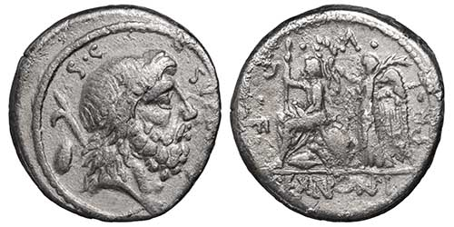 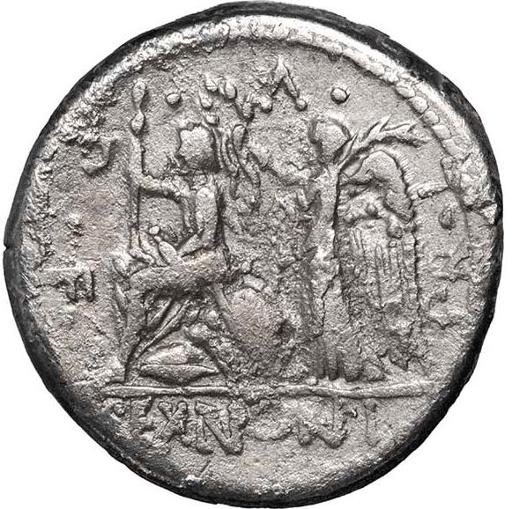

Coin Type: Silver Roman Republican denarius of M. Nonius Sufenas, Roman Republic, 59 BCE.   
Mint and Date: Rome, 59 BCE.  
Size and Weight: 18mm, 3.67g.   
Obverse: Bearded head of Saturn right; [harpa](http://www.forumancientcoins.com/moonmoth/glossary.html" \l "HARPA) and [baetyl](http://www.forumancientcoins.com/moonmoth/glossary.html" \l "BAETYL) behind.   
S.C. behind, SVFENAS in front.  
Reverse: Roma seated left on cuirass and shields, holding sceptre and sword; behind, Victory standing left, holding a palm frond and crowning Roma with a wreath.  
PR L V P F around.   
Exergue: SEX NONI   
Provenance: numismatiklanz (eBay), December 2012.   
Ref: [RCV](http://www.forumancientcoins.com/moonmoth/references.html" \l "RCV) (2000) 377; Crawford 421/1; Sydenham 885; Nonia 1.   
BW Ref: 069 054 000 A silver Roman Republican denarius of M. Nonius Sufenas showing a bust of Saturn with harpa and baetyl.

The Romans considered the era of Saturn to have been a golden age, when no-one needed to work because the earth's abundance was freely available to all. His festival, Saturnalia, was a very merry time. But not everything about Saturn was so lovely. He was also equated with the Greek god Kronos, son of the sky, Ouranos. Kronos overthrew his father by attacking him with a sickle or a [harpa](http://www.forumancientcoins.com/moonmoth/glossary.html/HARPA), castrating him.

Kronos had been given a prophecy that he would be overthrown by his own sons, so whenever Rhea gave birth, he devoured the child. But eventually, Rhea made a plan. When she gave birth to Zeus, she gave Kronos a stone wrapped in swaddling clothes, and he swallowed that. The eventual outcome when Zeus grew up included the forced disgorging of the stone and all the other children, who became part of the Greek pantheon.

So, when Saturn is shown on a rebuplican coin like this one with a [harpa](http://www.forumancientcoins.com/moonmoth/glossary.html/HARPA) over his shoulder and a stone behind him, it is a reference to the Roman version of the Kronos myth, with Saturn in the leading role and Ops as the mother of the unlucky children. There is a very alarming [painting by Goya depicting this](http://en.wikipedia.org/wiki/Saturn_Devouring_His_Son). Perhaps the coin is not so pretty when the full story is known!

But the harpa was not just a weapon. Saturn was supposed to have brought agriculture to the Romans, and he is sometimes shown with a long-handled harpa, an implement for cutting grain that symbolised fruitful cropping and the cycle of the years. There are some more Saturn and Harpa coins on my [Saturn page](http://www.forumancientcoins.com/moonmoth/reverse_saturn.html).

#### Artemis of Perge

The town or Perge (Perga to the Romans) had a temple to Artemis which was probably ancient, perhaps dating back to the 5th century CE. In it was an object which is usually referred to as a cult statue of Artemis of Perge, or Artemis Pergaia.

This object is shown on the coin on the left, which dates from the 2nd or 1st century BCE.

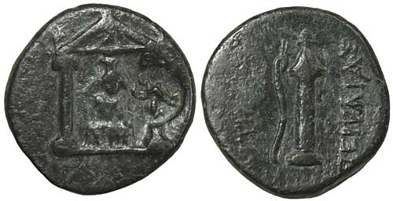 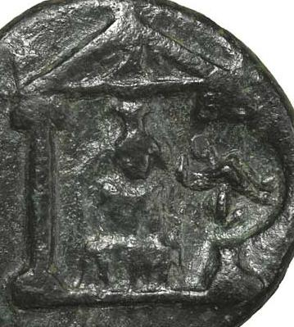

Coin Type: Bronze AE18 of Perge in Pamphylia, 2nd-1st century BCE   
Size and Weight: 17mm x 18mm, 3.5g   
Obverse: Cult statue of Artemis Pergaia, in the form of a [baetyl](http://www.forumancientcoins.com/moonmoth/glossary.html" \l "BAETYL) or similar object on a votive support, in [distyle](http://www.forumancientcoins.com/moonmoth/glossary.html" \l "DISTYLE) temple with eagle-decorated [pediment](http://www.forumancientcoins.com/moonmoth/glossary.html" \l "PEDIMENT). Countermark of a circle containing a seated sphinx.  
Reverse: APTE(MIΔOΣ) ΠEPΓAIAΣ   
Bow and arrow case.   
Provenance: cojo-collector (eBay), January 2007   
Ref: [GCV](http://www.forumancientcoins.com/moonmoth/references.html" \l "GCV) 5422 var (countermark); SNG Fr. 373 var.   
BW Ref: 001 030 109

A bronze coin of Perge in Pamphylia showing the cult statue of Artemis Pergaia.

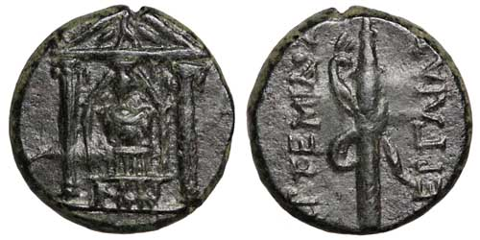 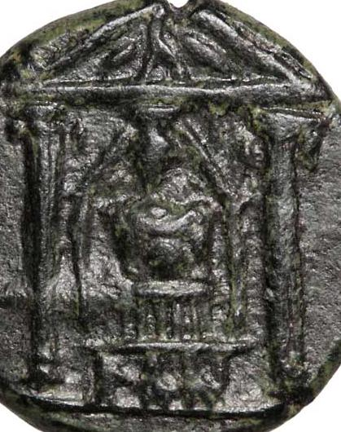

Coin Type: Bronze AE17 of Perge in Pamphylia, 2nd-1st century BCE   
Size and Weight: 17mm, 4.01g   
Obverse: Cult statue of Artemis Pergaia, in the form of a [baetyl](http://www.forumancientcoins.com/moonmoth/glossary.html" \l "BAETYL) or similar object on a votive support, in [distyle](http://www.forumancientcoins.com/moonmoth/glossary.html" \l "DISTYLE) temple with eagle-decorated [pediment](http://www.forumancientcoins.com/moonmoth/glossary.html" \l "PEDIMENT). Countermark of a circle containing a seated sphinx.  
Reverse: APTEMIΔOΣ ΠEPΓAIAΣ   
Bow and arrow case.   
Provenance: numismatiklanz (eBay), February 2010   
Ref: [GCV](http://www.forumancientcoins.com/moonmoth/references.html" \l "GCV) 5422; SNG Fr. 373.   
BW Ref: 002 048 154 A bronze coin of Perge in Pamphylia showing the cult statue of Artemis Pergaia.

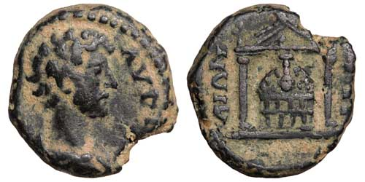 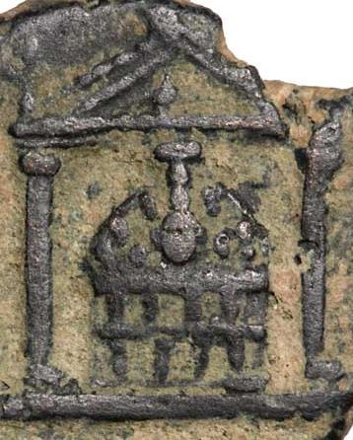

Coin Type: Bronze AE15 of Marcus Aurelius, Caesar 139-161 CE, Augustus 161-180 CE  
Mint and Date: Perga in Pamphylia, 139-161 CE.  
Size and Weight: 14mm x 15mm, 3.07g   
Obverse: AVPH(ΛIOC KAICAP)   
Bare-headed, draped bust right.   
Reverse: (ΠEPΓ)-AIΩN   
Temple with two columns; inside, votive structure surmounted by the [baetyl](http://www.forumancientcoins.com/moonmoth/glossary.html" \l "BAETYL) of Artemis Pergaia   
Provenance: Gerhard Rohde (Vcoins), February 2010   
Ref: Unpublished.   
BW Ref: 020 047 154 It is vague enough that you might take it for a rather blocky seated figure wearing a cylindrical headdress. But if you look carefully, the detail is not quite right for that.

In the centre is another coin from the same period, much clearer without the countermark, which has a slightly different shape.

On this coin you can see a multistoried structure with a vase-shaped object prominently displayed at its top. This time there is an irregularly shaped object, perhaps with a carved surface, between the vase and the lower layers.

Later coins, like the bronze of Marcus Aurelius from the mid-second-century CE on the right of the row, also show a good deal of detail, but again, with differences. This object looks nothing at all like a cult statue. The two niched layers are not in tiers, but the same width as each other; and instead of that irregular object, there is a regular dome with a decorated surface. However, the vase-shaped object is still there, now even more prominently displayed.

Marvin Tameanko, in his book "[Monumental Coins"](http://www.forumancientcoins.com/moonmoth/references.html" \l "MONUMENTAL), reconstructs this structure and calls the whole thing a baetyl. But I think this is not quite the correct use of the word.

Perhaps the small object with the long neck was actually a baetyl. The rest of the structure is there to support and display that object, with niches in which to place offerings or perhaps cult objects.

The baetyl itself, if this is the correct interpretation, is an unusual shape, and is clearly not a found stone but something made with care.

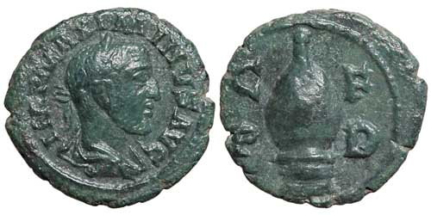Coin Type: Bronze AE18 of Maximinus I, 235-238 CE.   
Mint and Date: Deultum in Thrace, 235-238 CE.  
Size and Weight: 17mm x 18mm, 3.58g   
Obverse: IMP MAXIMINVS AVG   
Laureate, draped and cuirassed bust right.   
Reverse: C F P D   
Baetyl or civic fountain.   
Provenance: numismatiklanz (eBay), April 2010.   
Ref: [Varbanov](http://www.forumancientcoins.com/moonmoth/references.html" \l "VARBANOV) II (English) 2424.   
BW Ref: 004 049 158 Click on the picture for a larger scale view of the coin

Note: The reverse type on this coin was described as a beehive by Jurukova, based on a superficial similarity in form, and that description has been followed in reference works since (including [Varbanov](http://www.forumancientcoins.com/moonmoth/references.html" \l "VARBANOV)).

Dragonov, following Michel Amandry, says that the object is a civic fountain like the Meta Sudans in Rome, a type in which water flows from outlets at the top and over the shaped stone, to be collected below. This is an interesting, but unproven, idea, which is at least more likely than the beehive conjecture.

The object also bears a resemblance to the baetyl of the Pergaian Artemis. This interpretation, that the stone is a baetyl, requires the object sometimes visible at the base to be a temple, which presumably would contain the object of worship shown in large scale above it.

See also this [coin of Philip I from Deultum](http://www.forumancientcoins.com/moonmoth/coins/philip_i_027.html), which shows the same object with a structure visible below it.

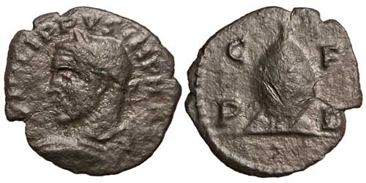Coin Type: Bronze AE16 of Philip I from Deultum in Thrace.   
Mint and Date: Deultum, 244-249 CE.  
Size and Weight: 15mm x 16mm, 1.93g   
Obverse: PHILIPPVS IMP M I(VL)   
Laureate bust left holding shield and spear.   
Reverse: C F P D   
Baetyl on ornamental base resembling a temple.   
Exergue: Pellet   
Provenance: Ancient Caesar, LLC (Vcoins), February 2010   
Ref: [Varbanov](http://www.forumancientcoins.com/moonmoth/references.html" \l "VARBANOV) II (English) 3041; Jurukova 452.   
BW Ref: 027 047 154 Click on the picture for a larger scale view of the coin

Note: The reverse type on this coin was described as a beehive by Jurukova, based on a superficial similarity in form, and that description has been followed in reference works since (including [Varbanov](http://www.forumancientcoins.com/moonmoth/references.html" \l "VARBANOV)).

Dragonov, following Michel Amandry, says that the object is a civic fountain like the Meta Sudans in Rome, a type in which water flows from outlets at the top and over the shaped stone, to be collected below. This is an interesting, but unproven, idea, which is at least more likely than the beehive conjecture.

The object also bears a resemblance to the baetyl of the Pergaian Artemis. This interpretation, that the stone is a baetyl, requires the object sometimes visible at the base to be a temple, which presumably would contain the object of worship shown in large scale above it.

See also this [coin of Maximinus I from Deultum](http://www.forumancientcoins.com/moonmoth/coins/maximinus_i_004.html), which shows the same object without the structure visible below it.

#### Deultum's "Beehive"

Coins of several emperors from Deultum in Thrace show an oddly-shaped object, which in the references is usually labelled a beehive. This follows Jurukova, who called it that because he thought the shape was similar.

A more likely conjecture was put forward by Michel Amandry, and followed by Dragonov. They call the object a civic fountain, like the Meta Sudans ("sweating cone") in Rome; a type in which water flows from outlets at the top and over the shaped stobe, to be collected at the base.

A similarity in shape to the stone (if that is what is is) of Artemis Pergaia, shown in the previous paragraph, is no doubt just a potentially confusing coincidence. But it has been conjectured that this might be a sacred stone.

It is often shown with a tiny structure below or in front of it; sometimes sketchy, as on the left-hand coin, sometimes in much clearer detail. If the object is a sacred stone, then the structure below might be the temple that contains the holy object, shown in small scale just to indicate its existence. But it could also be part of a fountain.

Beehive, fountain or baetyl? All these are only imaginative conjectures. But the beehive is certainly the least likely explanation of the three, and the fountain perhaps the most likely.

#### A Pyramidical Baetyl

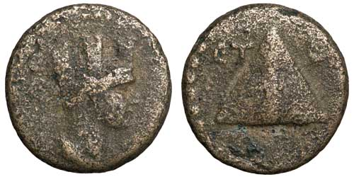Coin Type: Bronze AE14 of Caesarea in Cappadocia   
Mint and Date: Caesarea, 99 or 102 CE   
Size and Weight: 13mm x 14mm, 1.99g   
Obverse: Draped and turreted bust of Tyche right.   
Reverse: Pyramidical baetyl.   
ЄT to left, B or Є to right.   
Provenance: saxbys-coins (eBay), November 2009   
Ref: Sydenham 241.   
BW Ref: 001 044 150 This coin, from Caesarea in Cappadocia, now called Kayseri, shows what appears to be a pyramidical baetyl. Another idea is that it might be a stylised representation of Mount Argaeus. That mountain was in plain view from Caesarea; it is a huge volcano, now called Erciyes Daği by the Turks.

Not surprisingly, the mountain appears on many coins of Caesarea, but usually in the form of a pile of rocks.

Baetyls in conical form are known on coins from Kaunos and elsewhere, so it is not unreasonable to accept that a pyramidical form could be a baetyl. Perhaps this one has to remain uncertain.

#### Other Baetyls and Sacred Stones

Also appearing on coins, but not represented here, are:

• A conical baetyl (sometimes with two handles) on coins of Kaunos in Caria which have winged Iris on the obverse;

• A conical baetyl of Aphrodite in a courtyard on coins from Byblos in Phoenicia;

• A baetyl between tables and under a tree on coins from Lyrbe in Cilicia;

• Three baetyls on an altar in a small scene inset into a founder's ploughing scene, on a coin of Severus Alexander from Bostra in Arabia Petraea (Gemini VI lot 691; Spijkerman 51; Meshorer 241);

• A dome-shaped baetyl of Dusares (the Arabian equivalent of Dionysus) on an altar on a coin of Marcus Aurelius from Adraa in Arabia Petraea (Gemini VI lot 674; Spijkerman 3, pl. 10; SNG ANS 1130; Hendin 809 var);

• Two small baetyls on either side of a tall column surmounted by a globe in a phallic arrangement on a coin of Elagabalus from Charachmoba in Arabia Petraea. The **globe on the column may be intended to represent a baetyl of Dusares.** (Gemini VI lot 699; Spijkerman 5; Rosenberger 2; Hendin 302);

• The Black Stone of Paphos in Cyprus, a baetyl of Aphrodite, on coins of several Emperors. This stone still exists, in a museum near Kouklia. It is 130 by 90 cm, and is a smooth piece of andesite, a volcanic rock. It is definitely not a meteorite.

Other holy stones that have existed include:

• A stone of [Cybele](http://www.forumancientcoins.com/moonmoth/reverse_cybele.html), which was brought to Rome from Pergamon on 204 BCE, accompanied by Cybele and Attis' self-castrated priests which were probably rather alarming to the Romans, when Cybele's cult was evoked into the Republic as the Magna Mater.

• A cubical stone of Dusares, whose name could also be transliterated as Dushara, in the god's sanctuary at Petra. This is presumably not the same stone as the conical or globular ones mentioned above.

• A stone of the Ephesian [Artemis](http://www.forumancientcoins.com/moonmoth/reverse_diana.html), which was in the goddess' great temple at Ephesus, one of the seven wonders of the ancient world.

Just because I have not listed these last three as being on coins does not mean such coins don't exist; it means that I have not come across any. There are probably many other sacred stones too, which I will add to the list if I hear or read about them.

|  |
| --- |
| ————————  Some Relevant References  ———————— |

These books provided some, but not all, of the information on this page. Thanks also to the contributors to the [Forum](http://www.forumancientcoins.com/) [Classical Numismatics Discussion Board](http://www.forumancientcoins.com/board/index.php), a group of people who are both helpful and knowledgeable. In particular, Jochen and Pat Lawrence have been very helpful in clearing a view through the fog of just plain wrong material about the Omphalos which can be found on the web and elsewhere. Thanks also to Lloyd T. for his personal observation of the limestone half-ovoid now visible at Delphi. Any mistakes or misapprehensions that remain are mine alone.

Thanks are also due to participants in [Forum](http://www.forumancientcoins.com/) for the conjecture about Deultum's "beehive".

Collier's Encyclopaedia, 1995 edition.

[The Oxford Classical Dictionary](http://www.forumancientcoins.com/moonmoth/references.html" \l "OCD2) by various writers, edited by N.G.L. Hammond and H.H. Scullard. Second edition.

[A Dictionary of Roman Coins](http://www.forumancientcoins.com/moonmoth/references.html" \l "DICTCOINS) by Seth William Stevenson, F.S.A., C Roach Smith, F.S.A., and Frederic W. Madden, M.R.A.S. First published by George Bell and Sons, 1889. Reprinted by B A Seaby Ltd, London in 1964.

[Monumental Coins — Buildings & Structures on Ancient Coinage](http://www.forumancientcoins.com/moonmoth/references.html" \l "MONUMENTAL) by Marvin Tameanko. Published in 1999 by krause publications.

[Religions of Rome: Volume 1, A History](http://www.forumancientcoins.com/moonmoth/references.html" \l "RELROME) by Mary Beard, John North and Simon Price. Published by Cambridge University Press in 1998.