DIS-Lekythos

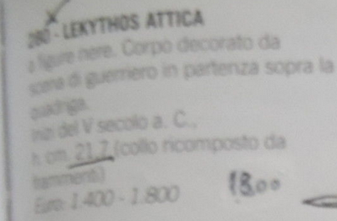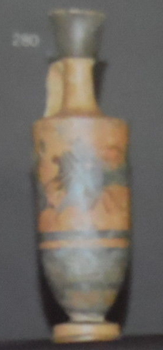

Ancient Greek Attic Black Figure Pottery Lekythos -  490 - 500 B.C BC

Culture: Greek

Date: 490-500 B.C.

Medium: Pottery

Condition: Intact, reattached the neck

Provenance: Auction House Antonina Roma

Dimensions: H. 8,6 in. (21.7 cm.)

Description: Classic form, the piriform body sits upon a disc base, with a strap handle and tall neck flaring gracefully into a trumpet mouth, the shoulders decorated with a black starburst motif. The central register with a procession scene, a lady perhaps Ariadne is shown standing on a chariot,  accompanied by  a warrior Theseus.

**Certificates of Authenticity**: We stand by the authenticity of our pieces 100%. Our perfect eBay feedback speaks for itself in terms of our clientele satisfaction. A signed certificate of authenticity will be issued and included with every object.

**Returns**: We want you to be completely satisfied with your purchase from us. We firmly believe that the customer is always right. If, for whatever reason, you are not content with your purchase, you can kindly send it back within 7 days of sale date for a full refund (buyer pays return shipping).

