DIS-EUR-Paleolithic-Figurine-Amber

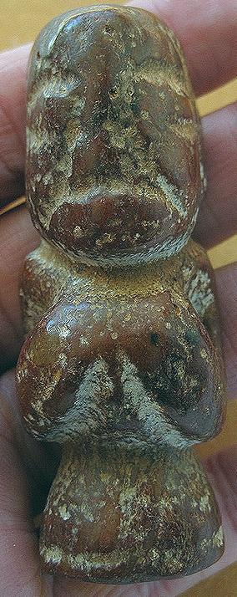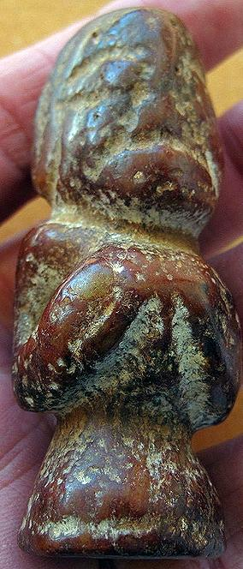 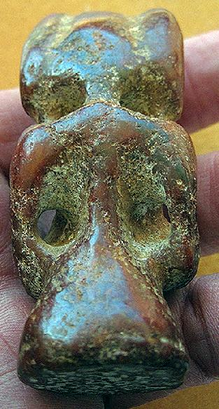

Formal Label:

Accession Number:

**LC Classification:**

Date or Time Horizon:

Geographical Area:

Cultural Affiliation:

Media:

Dimensions:

Weight:

Condition:

Provenance:

**Discussion:**

**References:**