DIS-Eur-Vinca-Figurine-male-135mm

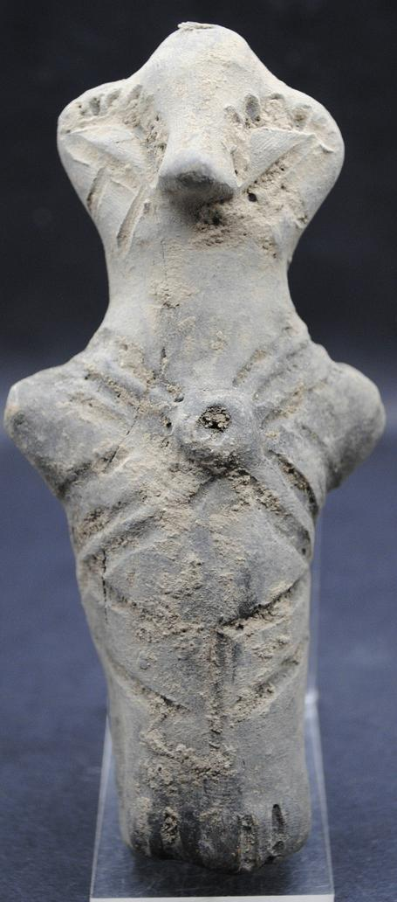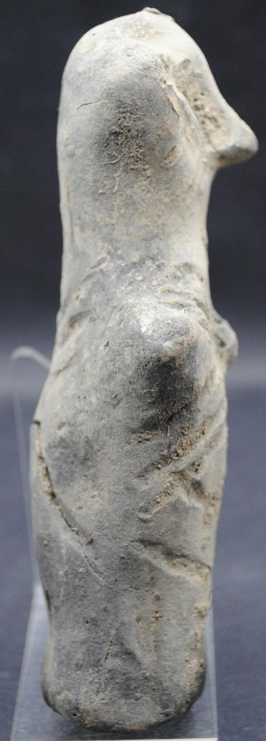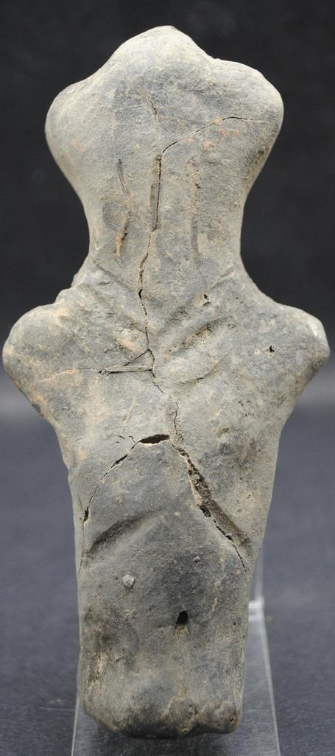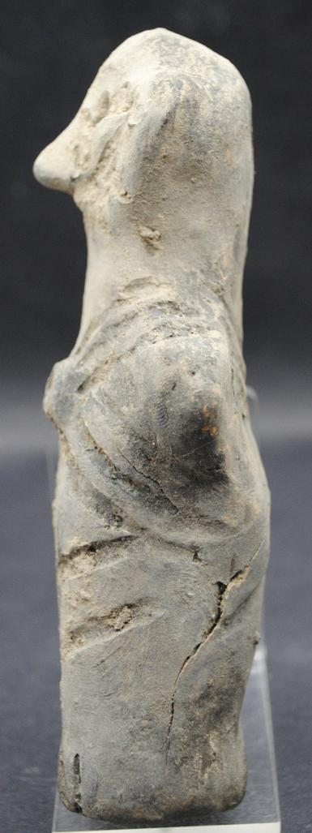

Formal Label: Vinca Neolithic ceramic anthromorphic figurine, ca. 4500 BCE-135 mm

Accession Number:

Date or Time Horizon:

Geographical Area:

Cultural Affiliation:

Medium: Fired clay

Dimensions: H 135 x W 62mm

Weight:

Condition: Some cracks but no repairs

Provenance: Michael Davies 2 hanover court Didcot Oxfordshire ox11 8nu United Kingdom.

**References:**

**Discussion:**

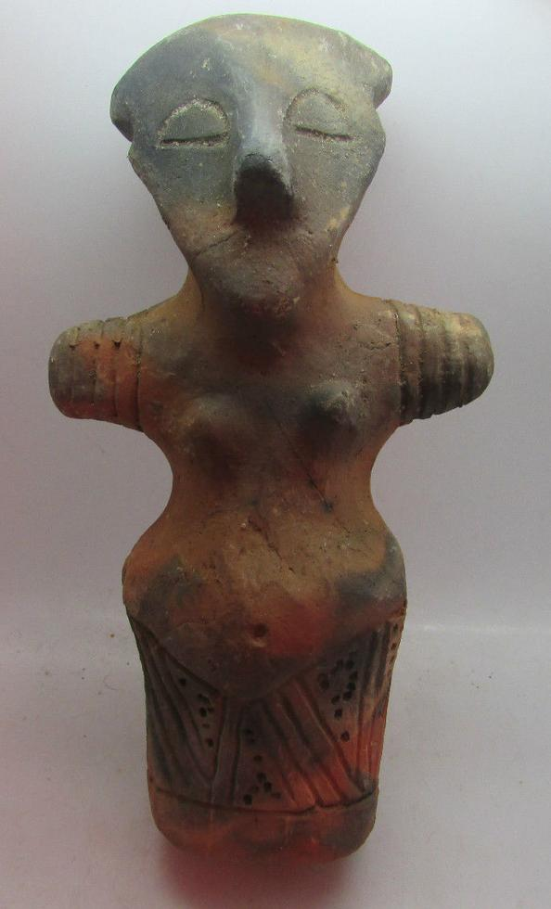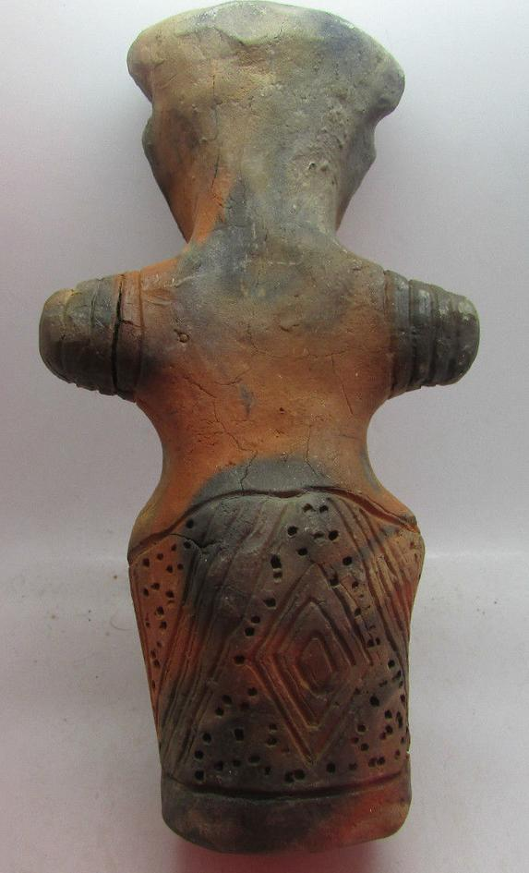

Formal Label: Vinca Neolithic ceramic female anthromorphic figurine, ca. 4500 BCE-13.5 cm

Accession Number:

Date or Time Horizon: ca. 4500 BCE

Geographical Area: Balkans

Cultural Affiliation: Vinca

Medium: Fired clay

Dimensions: H 13.5 cm

Weight:

Condition: Excellent

Provenance: Michael Davies 2 hanover court Didcot Oxfordshire ox11 8nu United Kingdom

**References:**

**Discussion: Intricate diamond and chevron pattern incised in skirt area**

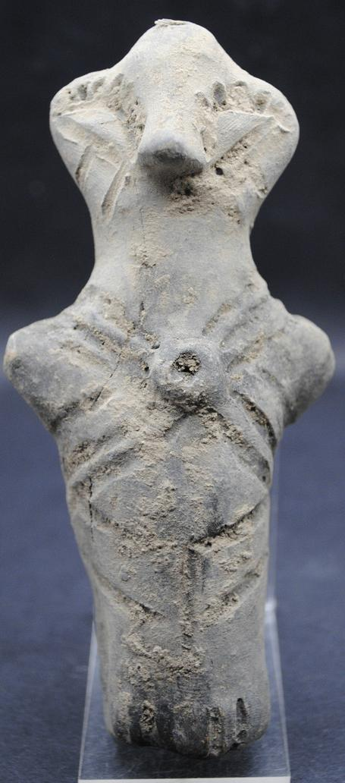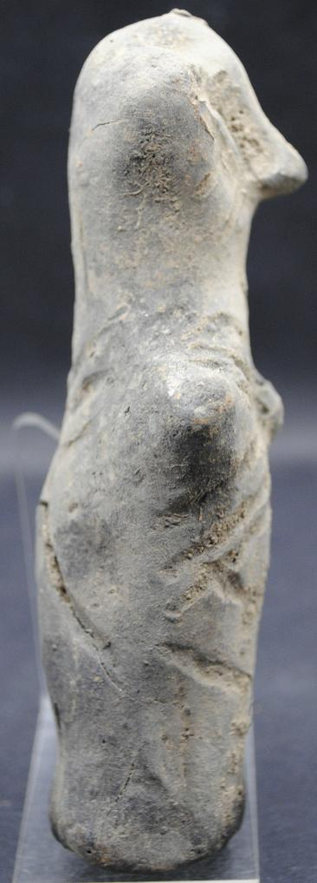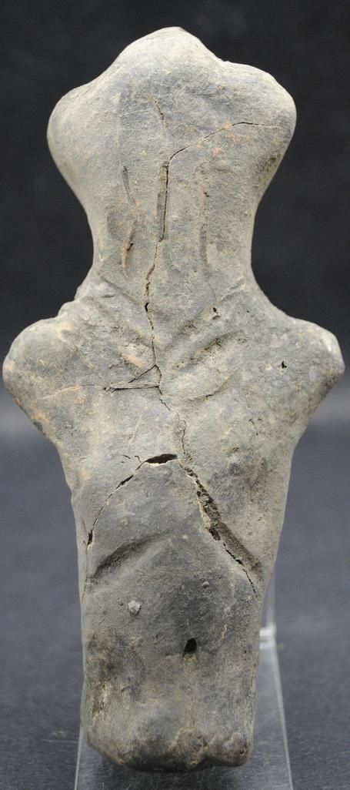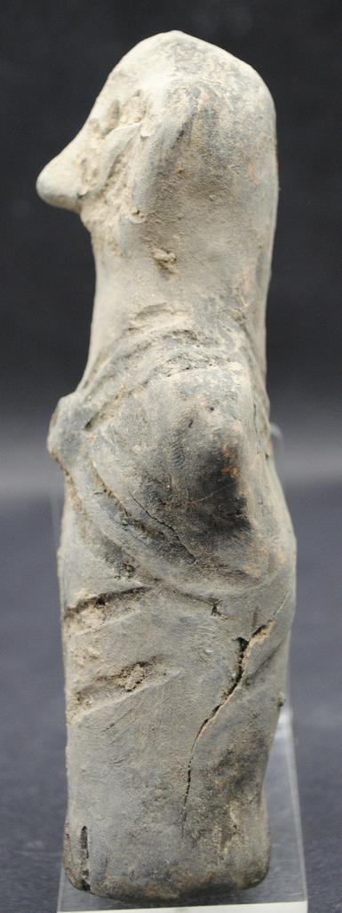

Neolithic ceramic Vinca anthromorphic figurine, ca. 4500 BCE. Some cracks but no repairs. **Measurements:** 135 x 62mm. Ex: Ancient-Artefacts-UK 11 Wessex Road, Didcot, Oxfordshire, ox11 8bu, United Kingdom.

Formal Label:

Accession Number:

Date or Time Horizon:

Geographical Area:

Cultural Affiliation:

Media:

Dimensions:

Weight:

Condition:

Provenance:

**References:**

**Discussion:**