DIS-BANNERSTONE-IN

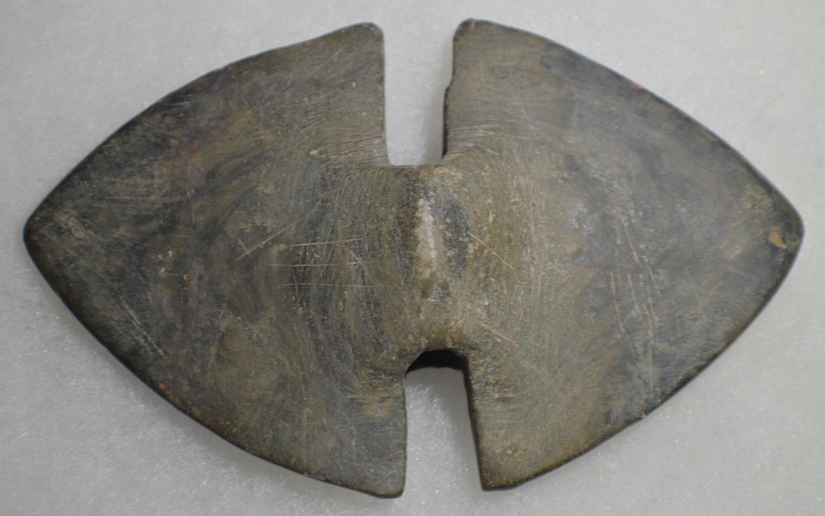

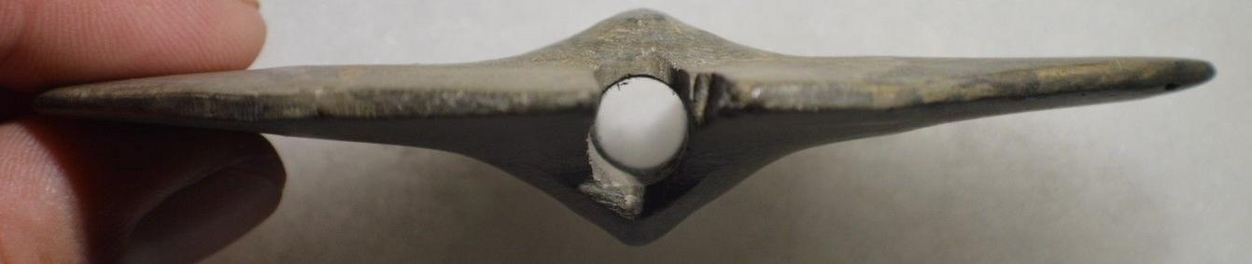 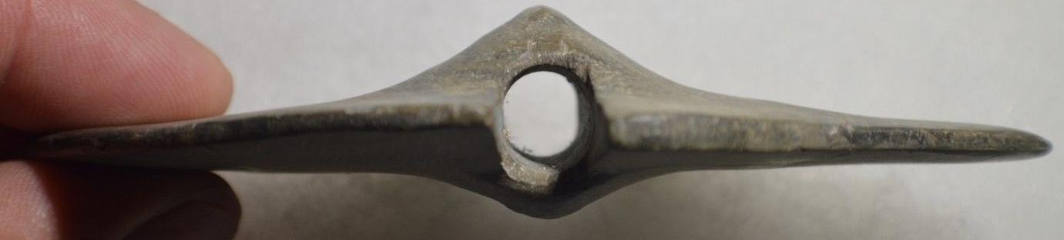

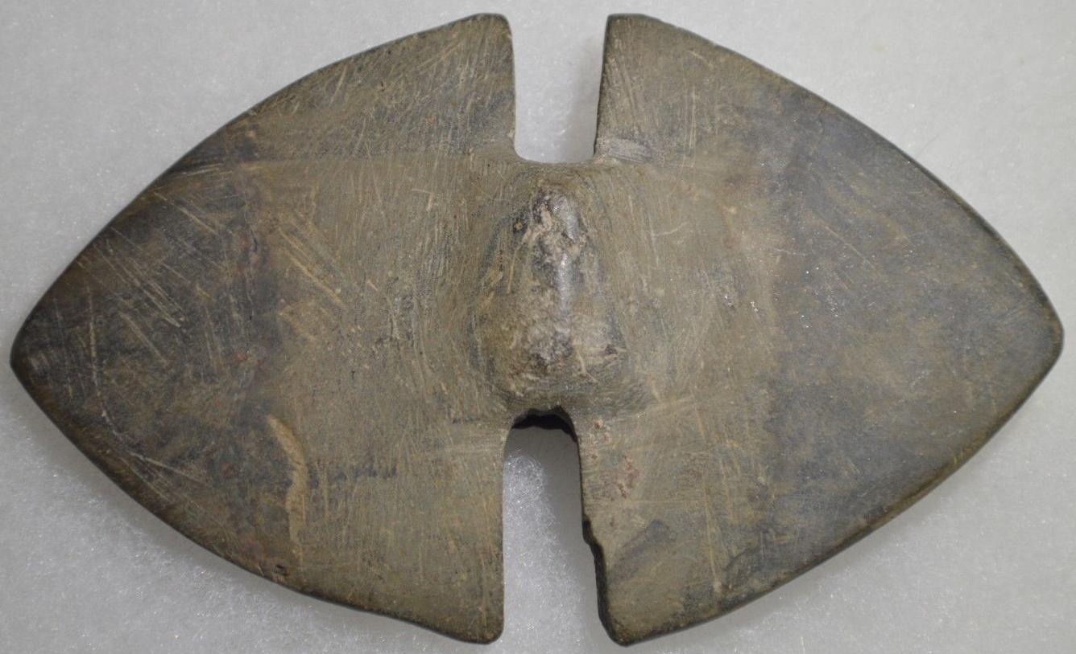

Sold by [missouri-arrowhe...](http://myworld.ebay.com/missouri-arrowhead-store) ( [1220](http://feedback.ebay.com/ws/eBayISAPI.dll?ViewFeedback&userid=missouri-arrowhead-store) )

### Delivery package 1 of 1

Delivered on Thursday, Oct 1, 2015

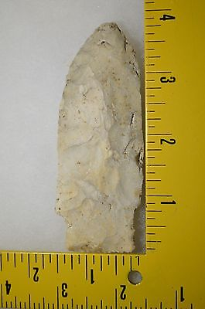

#### [Etley Missouri Arrowhead Authentic Indian Artifact](http://www.ebay.com/itm/321865600876)

|  |  |
| --- | --- |
| Item price | $36.99 |
| Quantity | 1 |
| Item number | 321865600876 |
| Shipping service | USPS First Class Package |

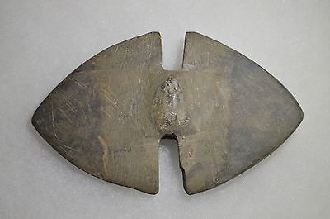

#### [Bannerstone Indiana Authentic Indian Artifact "Restored"](http://www.ebay.com/itm/321865747947)

|  |  |
| --- | --- |
| Item price | $73.00 |
| Quantity | 1 |
| Item number | 321865747947 |
| Shipping service | USPS First Class Package |

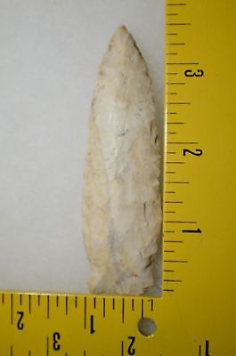

#### [Matanzas Missouri Arrowhead Authentic Indian Artifact](http://www.ebay.com/itm/321865749253)

|  |  |
| --- | --- |
| Item price | $19.00 |
| Quantity | 1 |
| Item number | 321865749253 |
| Shipping service | USPS First Class Package |