A000-INDO-Borneo-Dayak-Ancestor-Mask-Wood-1890’s

# 

Figs. 1-6. INDO-Borneo-Dayak-Ancestor-Mask-Wood-1890’s

Case No.: 15

**Accession No.**

**Formal Label:** INDO-Borneo-Dayak-Ancestor-Mask-Wood-1890’s

**Display Description:**

The Dayak believed that a shaman under possession of an ancestor could then be asked for advice as to the proper course of action in a world affair. This mask which is fully sculpted in the round depicts an ancestor albeit generically with his lips pursed when he is about to give a pronouncementas an oracle.

**LC Classification: DS646.32**

**Date or Time Horizon: 1890’s**

**Geographical Area: Borneo (Kalimantan)**

**Map:**

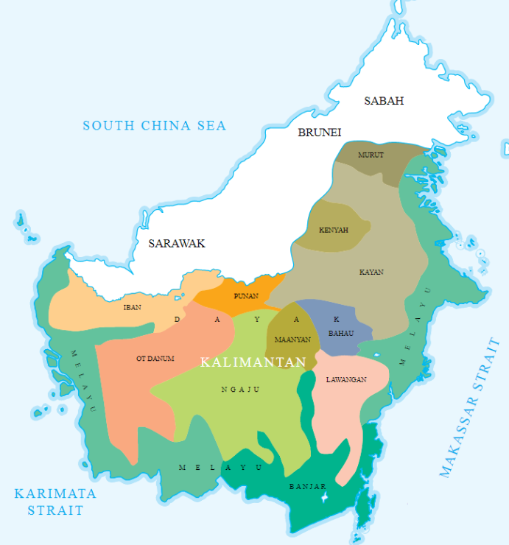

The map of ethnic groups in Borneo (Kalimantan). The map was redrawn and made based on a large map of "Peta Suku Bangsa di Indonesia" displayed in Ethnography Room in National Museum of Indonesia, Jakarta. The image was simply a cropped version highlighting the ethnic groups in Kalimantan from the original.

**GPS coordinates:**

**Cultural Affiliation: Dayak, Kenyah**

**Media: wood, pigment**

**Dimensions:**

**Weight:**

**Condition: original**

**Provenance:** French ethnological collection

**References:**

# Harrisson, T., 1959. Innermost Borneo: Ten Years' Exploration and Research. *The Geographical Journal*, *125*(3/4), pp.299-311.

# Harrisson, T., 1964. Inside Borneo: The Dickson Asia Lecture. *The Geographical Journal*, *130*(3), pp.329-336.

# KNAPEN, H., 2003. Innermost Borneo; Studies in Dayak cultures.

# Sather, C., 2003. Innermost Borneo: Studies in Dayak Cultures. *Asian Ethnology*, *62*(2), p.349.

# Sellato, B., 2002. How Tribes Come into Being: The Ethnogenesis of the Aoheng. *Innermost Borneo: Studies in Dayak Culture*, pp.163-194.