Indo-Korwar

Korwars

Korwars are carved wooden reliquaries that date to the late nineteenth or early twentieth century from Biak Island in Cenderawasih Bay at the western end of the northern Province of West Papua New Guinea, Indonesia, (1oS, 136oE).

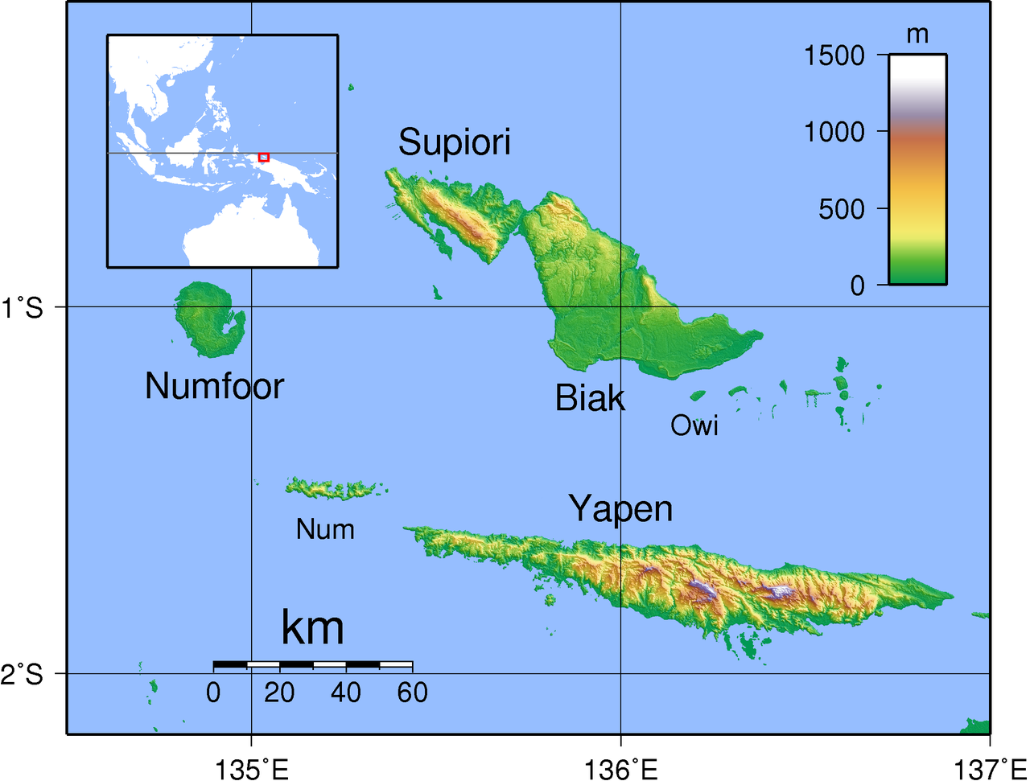

Topographical map of Biak in the Schouten Islands, Cenderawasih Bay, Indonesia. Created [by Sadalmelik](https://commons.wikimedia.org/wiki/User:Sadalmelik) in 2007 with GMT from publicly released SRTM data.

Korwars are carved wooden reliquaries that function as receptacles for spirits of deceased ancestors. They serve as supernatural intermediaries the permit communication with the deceased, who can remain actively involved in family and community affairs, if the shamanic sculptor of the korwar can entice the spirit of the deceased to enter it. Since death in Biak is regarded as an imbalance that has to be mediated, the deceased is invoked as a spiritual medium that should be venerated.

Each korwar is carved to represent the spirit-face of a specific deceased ancestor. Sometimes the actual skull of the ancestor is placed atop of the visage of the *korwar*. The *korwar’s* carved head, with its exaggerated proportions with respect to the rest of the sculpture, reinforces its sanctity as being the receptacle of the ancestral spirit.

Below the carved head is an intricately carved curvilinear design that represents a snake. Since snakes shed their skin they are regarded by the Biaks as symbols of rebirth. These snake sculptures are also carved on the prows of spirit-canoes that house a coffin and are placed in mortuary contexts such as caves. On some *korwars* there is a representation of teeth like dentles within the snake design and for this reason it is probable that the amethystine python ([*Morelia amethystina*](https://en.wikipedia.org/wiki/Morelia_amethystina)) is intended with its teeth-like design on the side of its jaw.

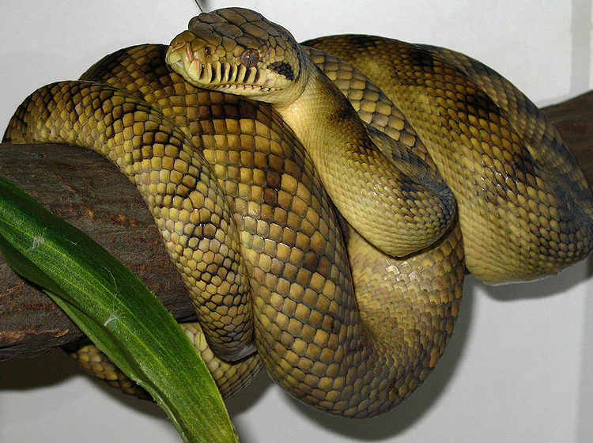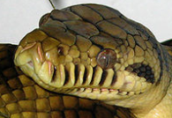

# [***Morelia amethystina***](https://en.wikipedia.org/wiki/Morelia_amethystina)photographed in 2007 by Mike Wagner.

The *korwar* has three functions. Firstly, it provides a protective role for homes, childbirths, weddings, and funerals. In the last instance, Korwars serve as guardians of the coffin of the deceased that is placed in mortuary canoes in which each spirit voyages on its journey to the afterworld. These canoes are often placed in mortuary caves that are sometimes embellished with pictographs of these spirit canoes. Secondly, the *korwar* may also be dedicated as a village emblem when a leader is considered to be exemplary by local people. Thirdly, *korwars* may act as oracles when a village shaman invokes it to advise about specific actions that should be undertaken in village matters, such as resolving disputes or waging peace or war.