A000-Indo-Lombok-Figurine

**Lombok** [island](https://en.wikipedia.org/wiki/Island) in [West Nusa Tenggara](https://en.wikipedia.org/wiki/West_Nusa_Tenggara) province, [Indonesia](https://en.wikipedia.org/wiki/Indonesia), forms part of the chain of the [Lesser Sunda Islands](https://en.wikipedia.org/wiki/Lesser_Sunda_Islands), with the [Lombok Strait](https://en.wikipedia.org/wiki/Lombok_Strait) separating it from [Bali](https://en.wikipedia.org/wiki/Bali) to the west and the [Alas Strait](https://en.wikipedia.org/wiki/Alas_Strait) between it and [Sumbawa](https://en.wikipedia.org/wiki/Sumbawa) to the east.

It is roughly circular, with a "tail" ([Sekotong Peninsula](https://en.wikipedia.org/wiki/Sekotong_Peninsula" \o "Sekotong Peninsula)) to the southwest, about 70 kilometres (43 miles) across and a total area of about 4,514 square kilometres (1,743 square miles). The provincial capital and largest city on the island is [Mataram](https://en.wikipedia.org/wiki/Mataram_%28city%29). It is somewhat similar in size and density with neighboring [Bali](https://en.wikipedia.org/wiki/Bali) and shares some cultural heritage, but is administratively part of Nusa Tenggara Barat along with sparsely populated [Sumbawa](https://en.wikipedia.org/wiki/Sumbawa). It is surrounded by a number of smaller islands locally called [*Gili*](https://en.wikipedia.org/wiki/Gili_Islands).

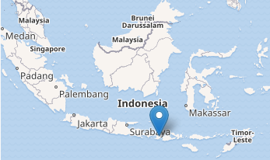

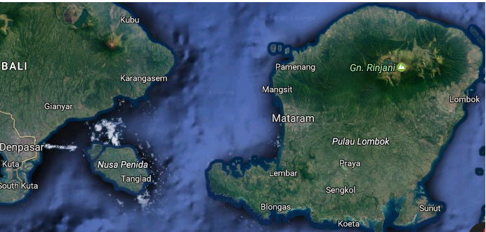

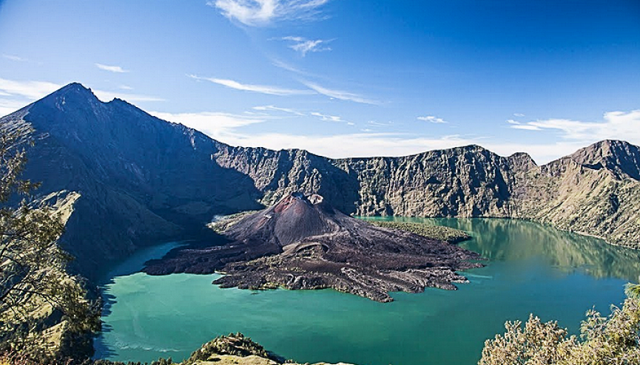

Rinjani Volcano

