DIS-PAC-POLY-Hawai’i-Menehune

Large, 23-inch, pre-contact, ca. 1200 AD/CE, pregnant female Hawai’ian Menehune figure, extremely rare.

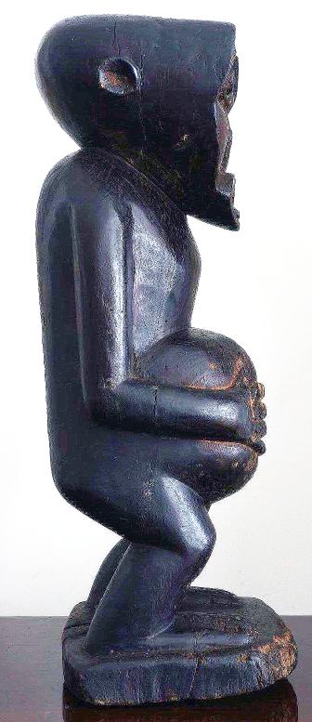 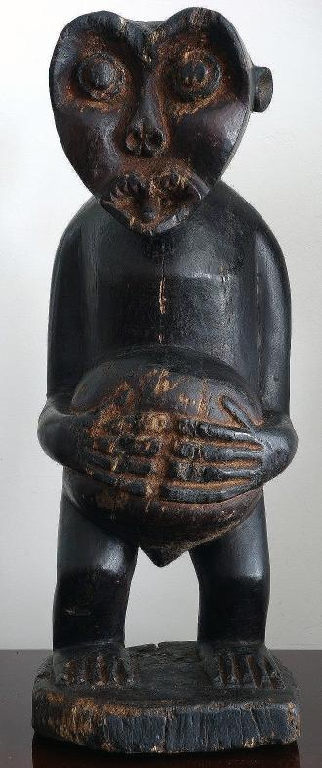 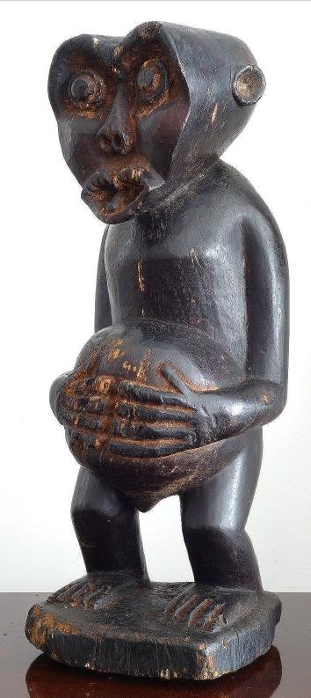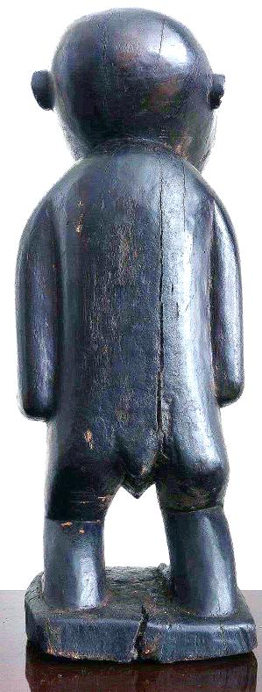

This wooden sculpture is carved of indigenous kou wood that is indigenous to Kaua’i. It show a heart-shaped face that is also found on petroglyphs of these so-called “little” people, who were invoked by the putative first Tahitian settlers of Kaua’i, as commoner inhabitants of the island. When the Tahitians, who had settled the Tahiti archipelago ca. 200 BCE, after a long migration from South East Asia via the Fijian, Samoan and Tongan Archipelagos (Kirch 2002: 230-231), migrated to Hawai’i the ruling *ali’i* or hereditary nobles oppressed the "commoners," or *manahune* (in the Tahitian language) who fled to the mountains to escape servitude. With the arrival of later Hawai’ian immigrants “*manahune”*, became “*menehune”* in the Hawai’ian language. The sense of “little” people, therefore, is not a physical description of the *menehune* but a metaphoric one, identifying them as “little” in the sense of being lower in social status and not of the elevated élite hereditary *ali’i* nobles. Proponents of this theory point to an 1820 census of Kaua’i by Kaumuali’i, the ruling Ali’i Aimoku of the island, which listed 65 people as *menehune* (Joesting 1987, pp. 20-22). Although folklorist Katherine Luomala (1951) believes that the legends of the *menehune* and similar diminutuve creatures are a post-European contact mythology, this sculpture definitively places the origin of the *menehune* in the pre-contact era. It is completely polished and painted with a natural black pigment, further emphasizing the commoner status of the individual who is different from the fairer skinned *ali’i*, who do not get sun-tanned from gardening in the taro fields.

Provenance: From the Godeffroy Collection, Umlauf Trading, Leipzig via Frankfurt, Germany. Guaranteed authentic and as described.

References:

1. Beckwith, Martha. 1970. Hawai’ian Mythology. Honolulu: University of Hawai’i Press.
2. Joesting, Edward. 1984. Kaua’i, The Separate Kingdom. Honolulu, Hawaii: [University of Hawai’i Press](https://en.wikipedia.org/wiki/University_of_Hawaii_Press) and Kaua’i Museum Association.
3. P.V. Kirch. 2002. *On the Road of the Winds – An Archaeological History of the Pacific Islands Before European Contact*. Berkeley, Los Angeles, London: 2002,
4. Luomala, Katharine. 1951. The Menehune of Polynesia and other mythical little people of Oceania. Bernice P. Bishop Museum Bulletin  no. 203. Honolulu: Bernice P. Bishop Museum.

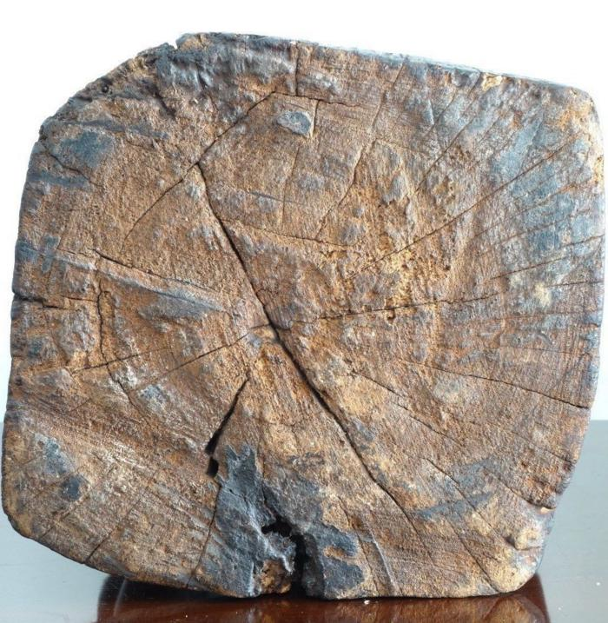

Photograph showing the tree rigs of the kou wood of the sculpture’s base.