PAC-POLY-Tonga-Anamooka-Cook-1784

## A View at Anamooka

34.5 cm x 21 cm copperplate engraving, 36.5 cm x 24 cm sheet size, Alexander Hogg, London, 1784-1786

We are pleased to offer this scarce original fine art engraving after an [original drawing](http://www.captcook-ne.co.uk/ccne/exhibits/C3118-05/index.htm) by the [*HMS Resolution*](http://en.wikipedia.org/wiki/HMS_Resolution_(1771))ship's artist [John Webber](http://en.wikipedia.org/wiki/John_Webber) (1751-1793) on James Cook's third and final voyage from the *New, Authentic, Entertaining, Instructive, Full and Complete Historical Account of Captain Cook's First, Second, Third and Last Voyages*[1](http://vi.vipr.ebaydesc.com/ws/eBayISAPI.dll?ViewItemDescV4&item=251765247346&t=1395522164000&tid=10&category=360&seller=regiomontanus&excSoj=1&excTrk=1&lsite=0&ittenable=false&domain=ebay.com&descgauge=1" \l "1) published serially between 1784 and 1786.  This historically important drawing (the original of which survives in the collection of the British Library) was sketched in May 1777 on Nomuka where Cook replenished his ships with food, water and wood.  Undoubtedly a composite of many individual sketches, Webber creates a broad panorama reflecting maintenance, logistics, trade and interaction between the native Tongans and Cook's crew.  One of the most complex and comprehensive scenes Webber recorded on the entire voyage, we see a tiny figure of Cook on shore as he had discovered that the natives were reluctant to trade with his officers and more or less insisted on dealing directly with him.  Cook was eventually able to delegate trade, noting in his journal:

"During the whole day, the Indians would hardly part with any one thing to any body but me, Captain Clerke did not get above one or two hogs. Knowing from experience, that if every body was allowed to traffick with the natives according to thier own caprice, perpetual quarrels would essue, to prevent this I ordered that particular person should manage the traffick both on board and ashore, and prohibited the trade to all others. I also ordered that no curiosities should be purchased till the Ships were supplyed with Provisions."

Webber was recommended to the Admiralty for appointment as artist for the voyage by the Swedish botanist [Daniel Carlsson Solander](http://en.wikipedia.org/wiki/Daniel_Solander) (1733-1782) who had accompanied Cook on his first voyage.  Just 24 years old when he joined the *Resolution* at Plymouth one week prior to departure,  Webber's skill in both portraiture and landscape resulted in a visual record of Cook's third voyage that is unsurpassed in the annals of 18th century exploration.  In their monumental four-volume work *The Art of Captain Cook's Voyages*[2](http://vi.vipr.ebaydesc.com/ws/eBayISAPI.dll?ViewItemDescV4&item=251765247346&t=1395522164000&tid=10&category=360&seller=regiomontanus&excSoj=1&excTrk=1&lsite=0&ittenable=false&domain=ebay.com&descgauge=1" \l "2) authors Rüdiger Joppien and Bernard Smith observe that Webber's relationship with Cook was unique, noting that:

"Cook clearly had it in mind on this voyage to publish his own account on his return and it is also clear that he regarded Webber as his visual collaborator in that undertaking from the beginning... Webber is frequently on the spot with Cook and often depicts incidents, scenes or portraits of individuals mentioned by Cook in his journal... In Webber's drawings with their emphasis upon description, the recording of notable events, and linear accuracy, we may perhaps see something of Cook's guiding hand..."

An iconic image that Joppien and Smith go on to note showed that "Not only at Tonga, but at all major ports of call…Webber observed similar scenes, vignettes of daily life…. By [recording] them, Webber reflected the expedition as a history-making event in itself…. Webber’s tendency to demonstrate the complexity of action is historical in an eventful and documentary sense but it is also anti-heroic" going on to compare the scene to 17th century Flemish paintings such as Jan Brueghel's [Market on a River](http://upload.wikimedia.org/wikipedia/commons/a/a7/Jan_il_Vecchio_Bruegel_Fish_Market_on_the_Banks_of_the_River.jpg).  An exceptionally strong impression with an essentially pristine image area, this well-preserved example will make an important addition to any collection related to Captain Cook or Tonga and a fine presentation if matted and framed.  Moreover, your purchase will also serve as a reminder of an important charitable contribution - **100%** of the proceeds from this listing will be donated to [Médecins Sans Frontières](http://www.doctorswithoutborders.org/) (Doctors Without Borders) whose important humanitarian work sadly remains in high demand around the globe, so that along with acquiring this rare 18th century print a significant donation can be made to this worthwhile organisation.

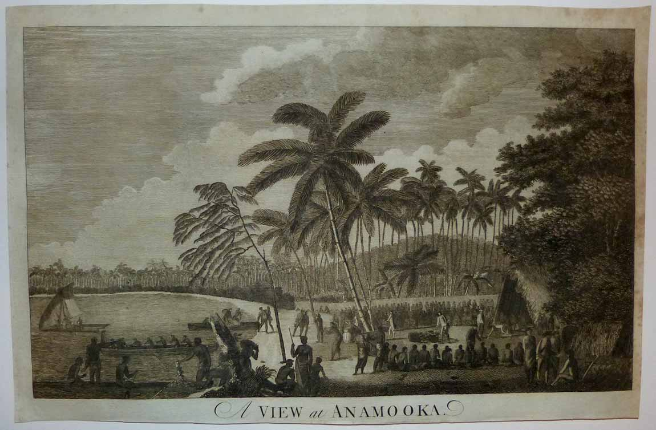

Webber's original composite drawing is slightly truncated for the format of this plate - at the far right edge two horses from the *Resolution* were shown in the original which are not depicted here, with Cook noting that the presence of Marines (seen in shelter with a pyramid of rifles) were there to protect the horses and the "waterers", two of whom are seen transporting a barrel to shore as they approach the beach.  The pile of goods at the centre of the clearing surrounding by seated Tongans was said to be primarily yams and platains.  To get a sense of print detail consider that the officer standing near to this cache of foodstuffs stands just 2 cm tall actual size:

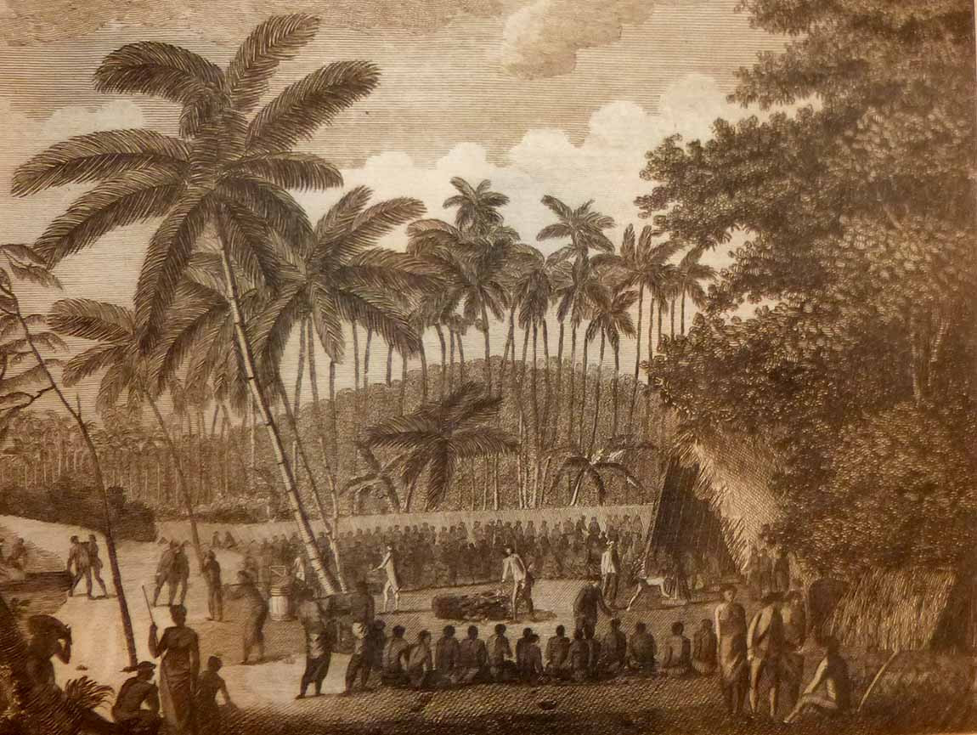

Here we see both native boats and boats from Cook's ships coming and going as commerce continues apace.  Note that the engraver took care to copy Webber's original in mirror image onto the plate so that the resultant intaglio imprint maintains fidelity to Webber's drawing and is not "backwards" as was often the case with engravings made after the work of the various artists on Cook's voyages.  Webber did not draw the *Resolution* and *Discovery* at anchor as they were too far off shore to be included in this panorama:

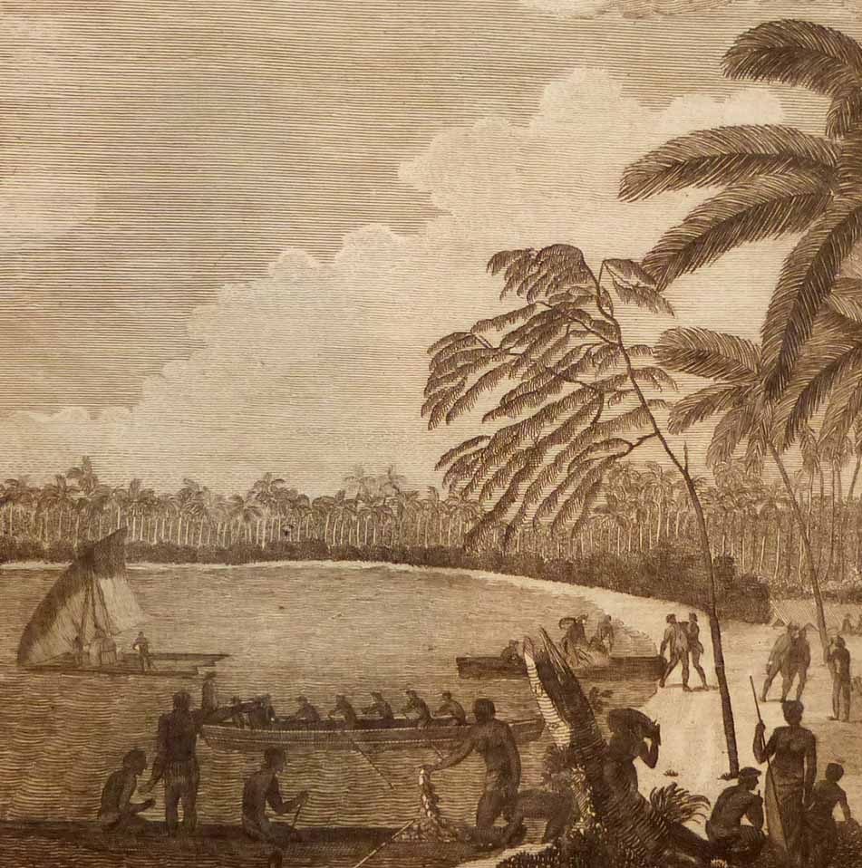

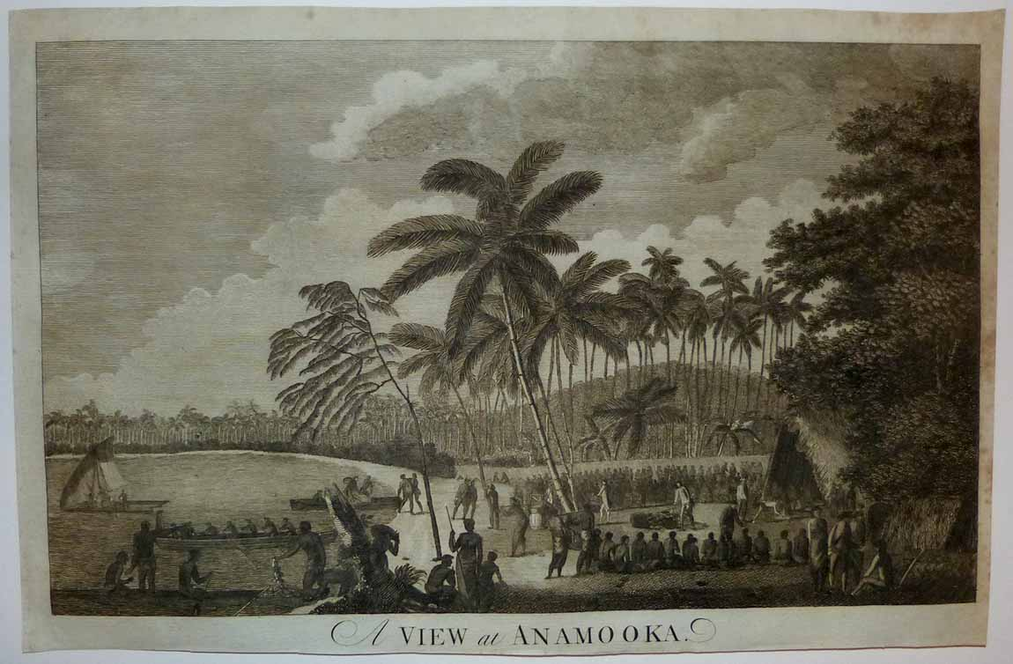

Condition - Please note carefully:  The print is in very good condition as can be ascertained from photos, image area essentially pristine, no text on verso, no folds, very strong and dark impresssion with distinct platemark on fine quality laid paper.  Very close and slightly uneven trim to all margins, with right margin and upper right corner margin exhibiting scattered spotting and soiling although not affecting image area as can be evaluated in photo.  Image of print shows it lying flat in free state with all edges shown for evaluation.  [Inquiries](mailto:jfazli@ix.netcom.com) welcome and we encourage you to visit our other [listings](http://cgi6.ebay.com/aw-cgi/eBayISAPI.dll?ViewListedItems&userid=regiomontanus&sort=3&since=-1) on eBay.  
  
NOTES:  
  
1. The editor of the *New, Authentic, Entertaining, Instructive, Full and Complete Historical Account of Captain Cook's First, Second, Third and Last Voyages* was named as one "George William Anderson",  almost certainly a pseudonym for the publisher Alexander Hogg.  In a recent exhibition of these historically important engravings made for this publication the Lowe Art Museum in Miami noted that the pseudonym was "a device Hogg employed in a number of his publications" intended to convey an "aura of authoritative knowledge" regarding his editing of the official publications of the voyages.  Hogg shrewdly elected to publish the work (which eventually included accounts of other circumnavigations) in a relatively affordable serial format from 1784-1786 to reach a broad audience, noting in his marketing copy that this was "due to the many thousands of Persons who would wish to peruse the Discoveries... and view the astonishing fine Copper-Plates, who have hitherto been excluded from gratifying their eager curiosity.  These installments would allow every Person, whatever may be his Circumstances, to read about the voyages of which such vast Sums of the Public Money have been expended."  Note that we are offering this "astonishing fine Copper-Plate" as published and without hand colour - while some of the engravings after Webber's drawings lend themselves quite nicely to modern hand colour, this print is not in that category as the result would inevitably obscure the engraved line of such a strong and dark impression.  
   
2.  New Haven; Four Volumes, Published for the Paul Mellon Centre for Studies in British Art by Yale University Press 1985-1988.