PAC-Poly-Harbors-TahitiHuaheine-Raiatea-Cook-1784

## Matavia Bay in Otaheite - Owharre Harbour in Huaheine - Ohamaneno Harbour in Ulietea - Oopoa Harbour in Ulietea

33.5 cm x 22 cm copperplate engraving, 37 cm x 24.5 cm sheet size, Alexander Hogg, London, 1784

We are pleased to offer this scarce and important original four-part chart of the harbours of Matavai Bay in Tahiti, Owharre Harbour in Huaheine, Ohamaneno Harbour and Oopoa Harbour in Raiatea (Ulietea), all compiled in 1773 under the direction of James Cook on his [second voyage](http://en.wikipedia.org/wiki/Second_voyage_of_James_Cook) of exploration and engraved for the *New, Authentic, Entertaining, Instructive, Full and Complete Historical Account of Captain Cook's First, Second, Third and Last Voyages*[1](http://vi.vipr.ebaydesc.com/ws/eBayISAPI.dll?ViewItemDescV4&item=251625754602&t=1406847579000&tid=10&category=37961&seller=regiomontanus&excSoj=1&excTrk=1&lsite=0&ittenable=false&domain=ebay.com&descgauge=1" \l "1) published serially between 1784 and 1786.  Anchoring in these harbours in the Society Islands of what is now French Polynesia, Cook and his officers meticulously recorded depth soundings, reefs, rocks, shoals, sandbars and presented coastal topography via hachures. Masterfully engraved, the four-part chart is further enhanced by hand colour of the finest order will make an important addition to any collection related to the voyages of James Cook and an elegant presentation if matted and framed.

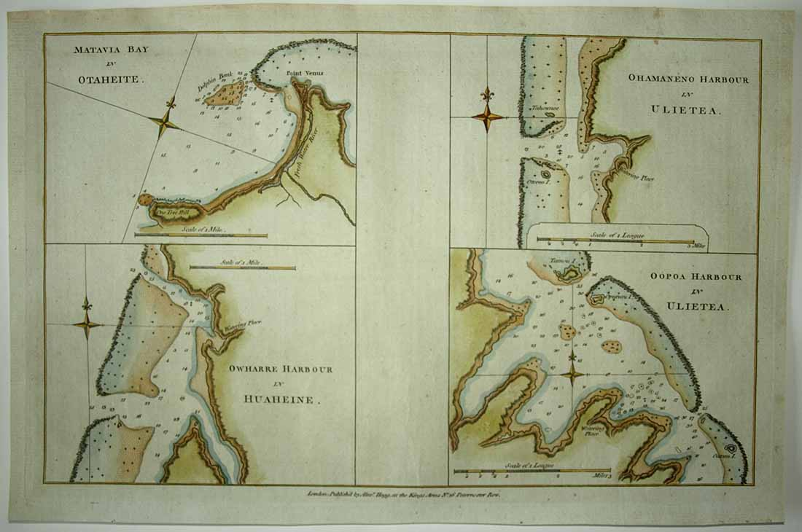

Note "Point Venus" where Cook had earlier [observed and recorded the Transit of Venus](http://en.wikipedia.org/wiki/1769_Transit_of_Venus_observed_from_Tahiti) in 1769:

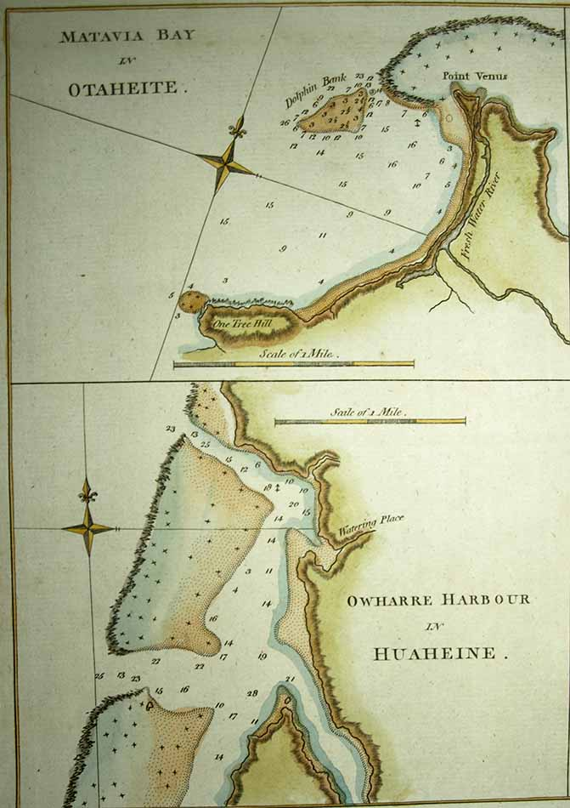

Each quadrant of the chart features an elegant compass rose with fleur-de-lis pointer:

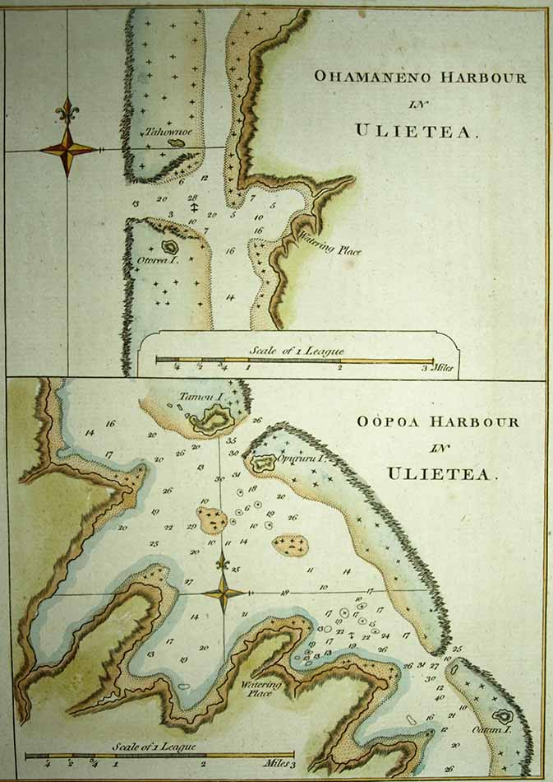

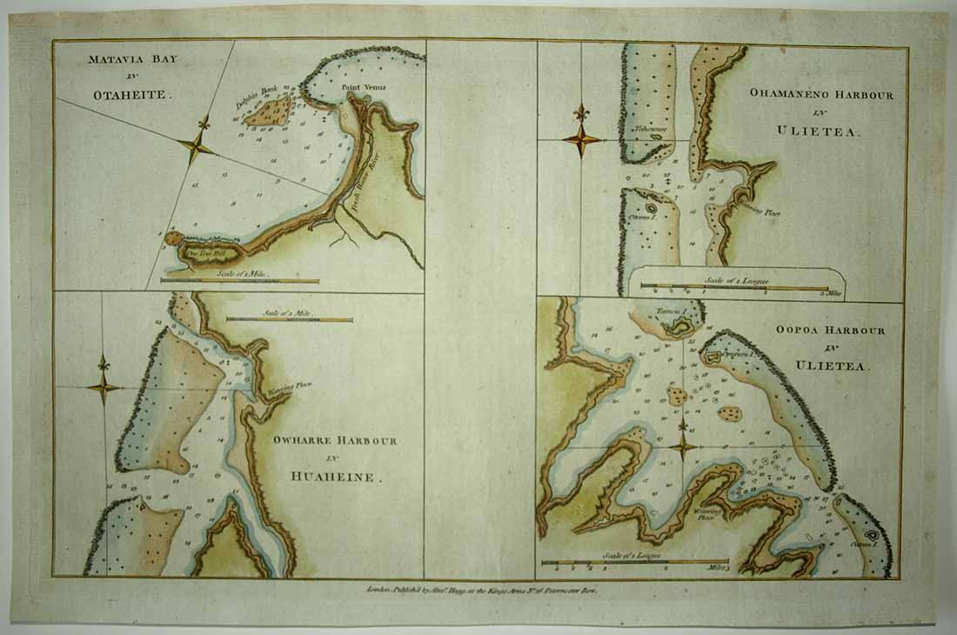

Condition - Please note carefully:  The chart, nearly 230 years old, is in overall excellent condition as can be ascertained from photos, image area essentially pristine, strong impresssion with distinct platemark on fine quality laid paper, no text on verso, no folds, trivial soiling to margin extremities, trivial soft creasing in unprinted centre area between chart quadrants.  Image of chart shows it lying flat in free state with all edges shown for evaluation.  [Inquiries](mailto:jfazli@ix.netcom.com) welcome and we encourage you to visit our other [listings](http://cgi6.ebay.com/aw-cgi/eBayISAPI.dll?ViewListedItems&userid=regiomontanus&sort=3&since=-1) on eBay.  
  
NOTES:  
  
1. The editor of the *New, Authentic, Entertaining, Instructive, Full and Complete Historical Account of Captain Cook's First, Second, Third and Last Voyages* was named as one "George William Anderson",  almost certainly a pseudonym for the publisher Alexander Hogg.  In a recent exhibition of these historically important engravings made for this publication the Lowe Art Museum in Miami noted that the pseudonym was "a device Hogg employed in a number of his publications" intended to convey an "aura of authoritative knowledge" regarding his editing of the official publications of the voyages.  Hogg shrewdly elected to publish the work (which eventually included accounts of other circumnavigations) in a relatively affordable serial format from 1784-1786 to reach a broad audience, noting in his marketing copy that this was "due to the many thousands of Persons who would wish to peruse the Discoveries... and view the astonishing fine Copper-Plates, who have hitherto been excluded from gratifying their eager curiosity.  These installments would allow every Person, whatever may be his Circumstances, to read about the voyages of which such vast Sums of the Public Money have been expended."