DIS-PAC-Poly-Hawaii-Tiki

Hand carved and with adze. 11.25 in. height, 4.5 in wide

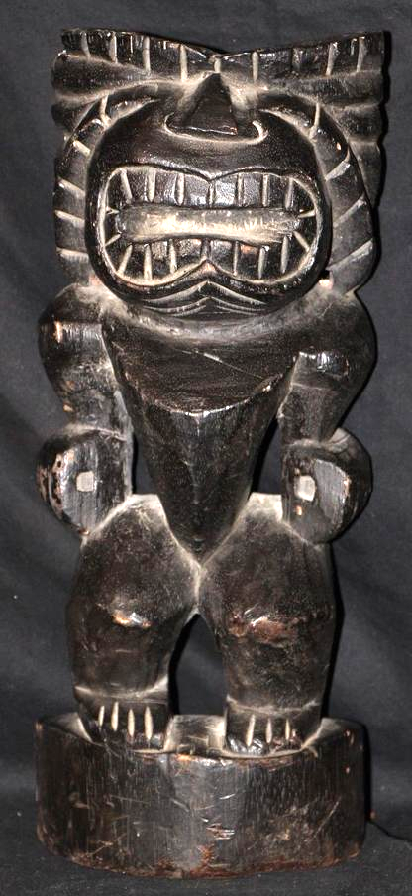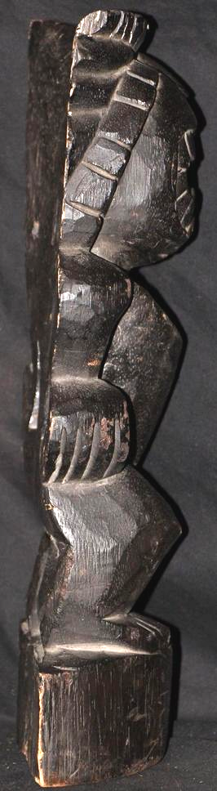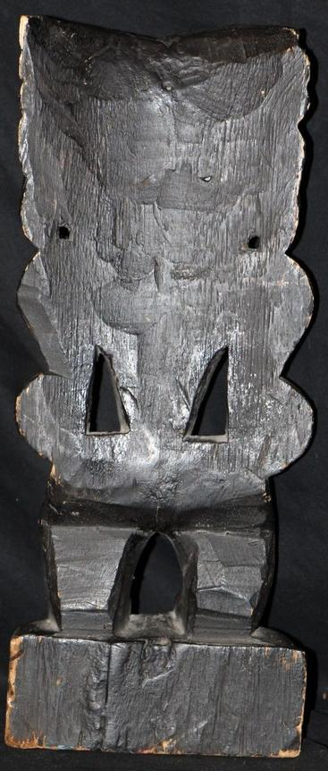

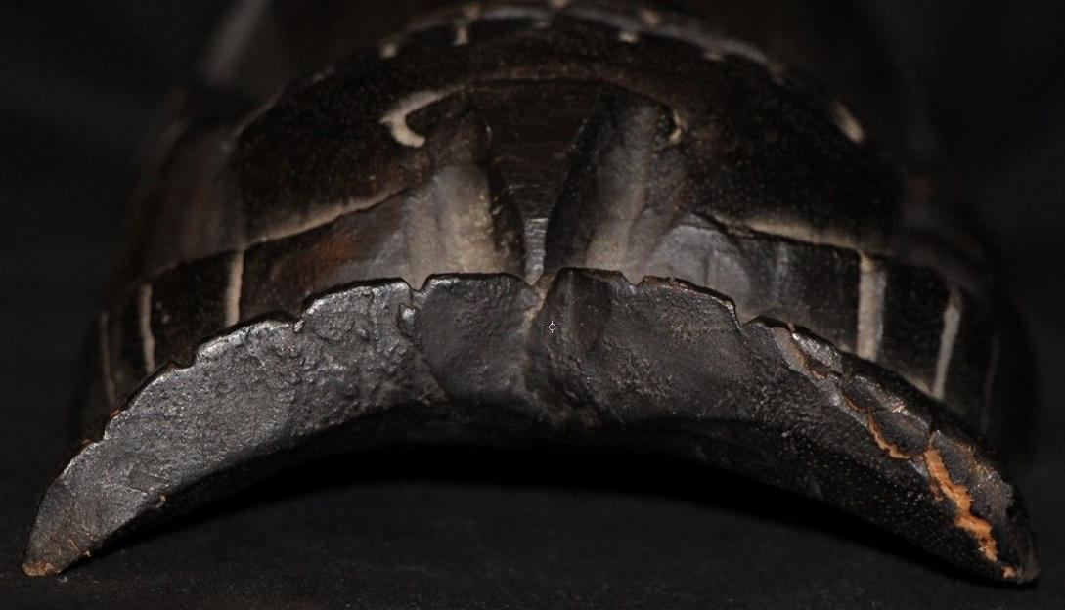

### Delivery package 1 of 1

Estimated delivery Monday, Oct 12, 2015

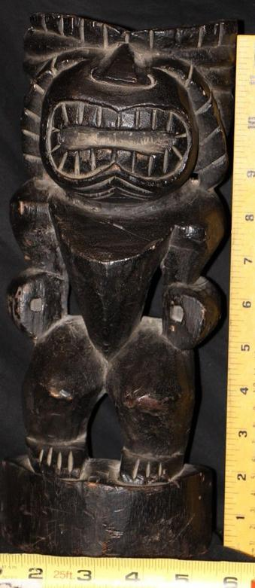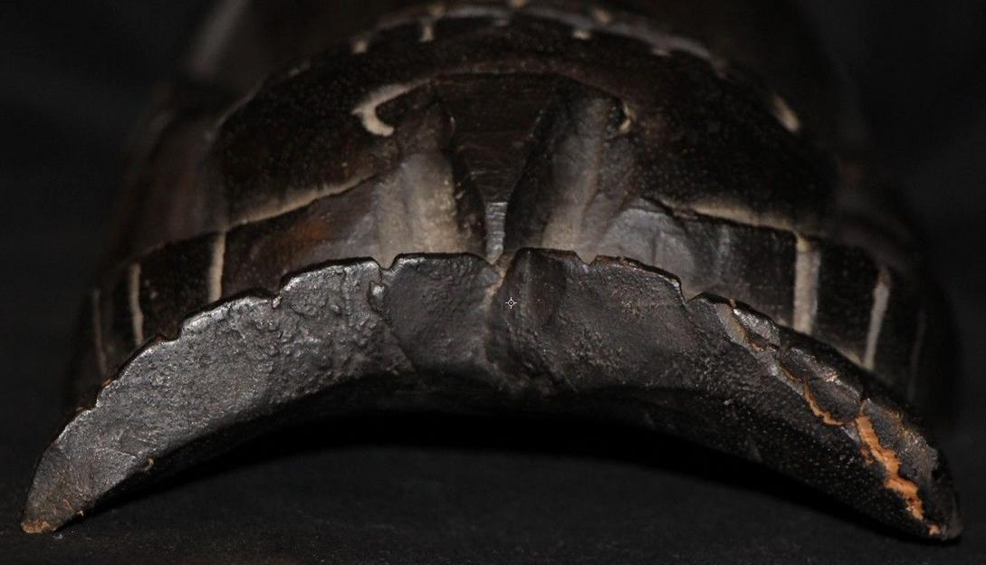

#### [Vintage wood 12" Warrior Statue Carving Mask Totem Pole](http://www.ebay.com/itm/252088465141)

|  |  |
| --- | --- |
| Item price | $16.00 |
| Quantity | 1 |
| Item number | 252088465141 |
| Shipping service | Economy Shipping |